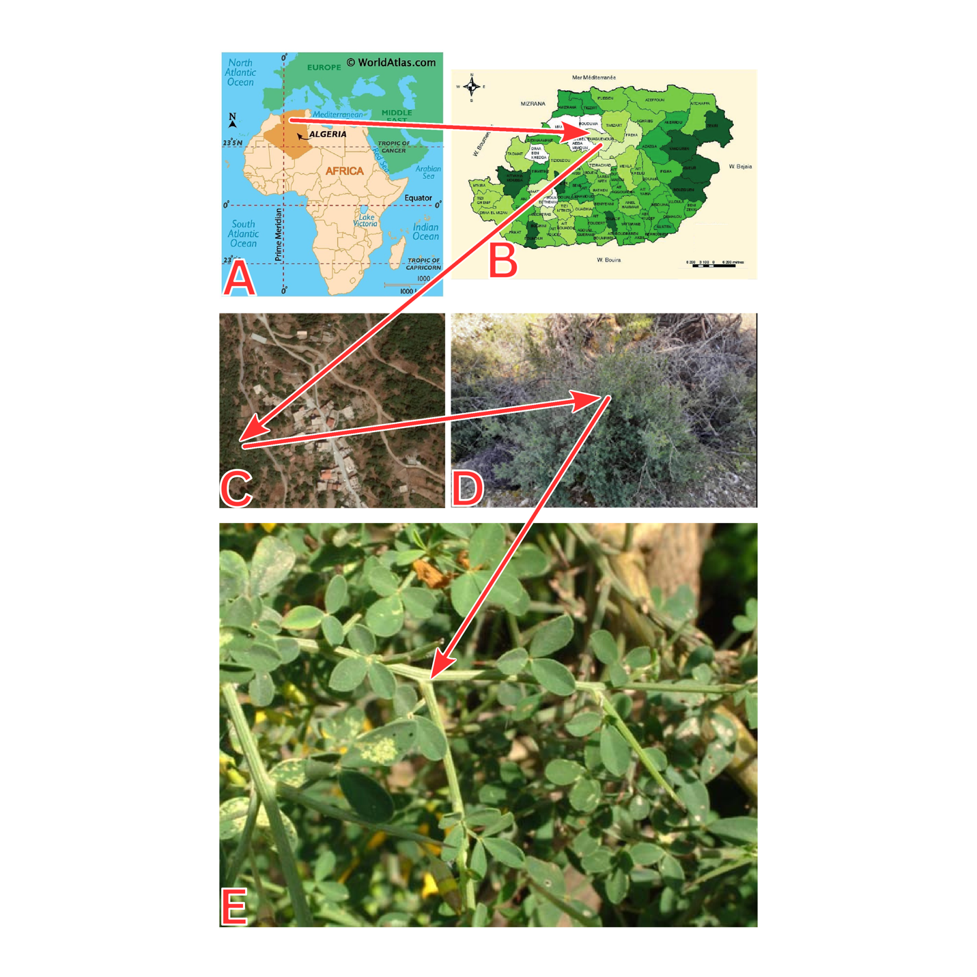
Supplementary Fig 1 The geographical location of the sampling site. (A-B) Ouaguenoun Tizi-Ouzou, Algeria. (C) View of the main site of the sampling (D-E) and details of Calicotome spinosa.
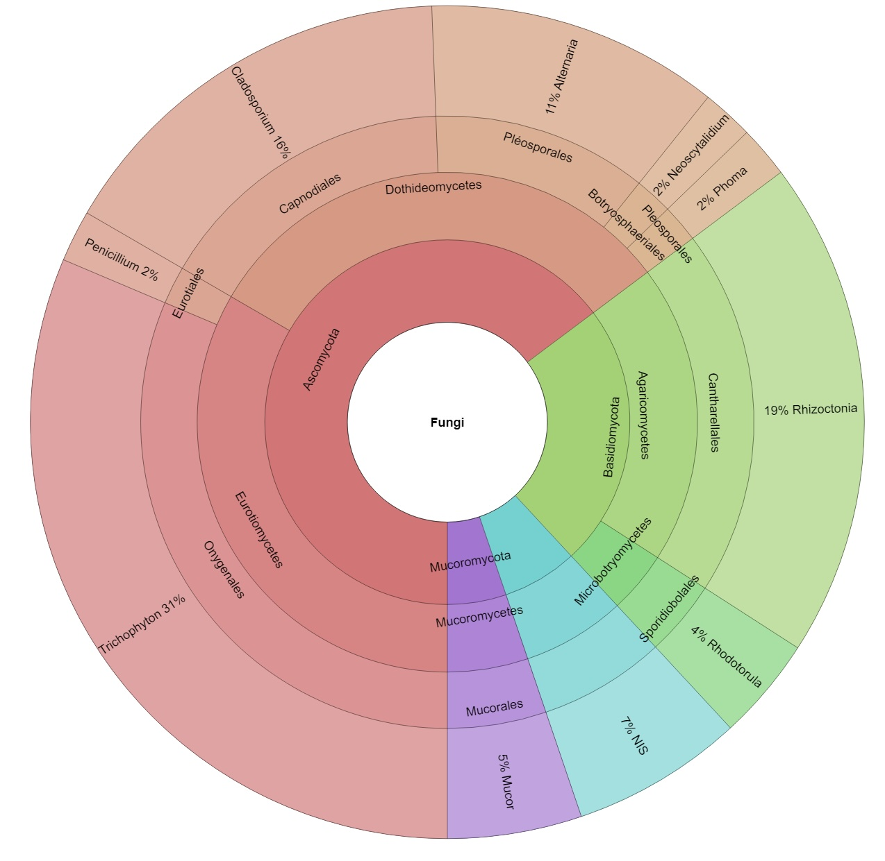
Supplementary Fig 2 The abundance of morphologically identified fungal endophytes in C. spinosa leaves

Supplementary Table 1. Primers details and applied PCR conditions.
Locus | Primer description | Primer sequence 5'-3' | PCR conditions | Reference
Internal Transcribed Spacer (ITS) region of the rRNA | ITS1F | CTT GGT CAT TTA GAG GAA GTA A | 1. 95 ̊C – 5 min  2. 95 ̊C– 30 s  3. 52 ̊C– 30 s  4. 72 ̊C– 1 min  5. Steps 2–4 x 35 cycles 6. 72 ̊C– 8 min  7. 4 ̊C on hold | White et al. (1990)
Internal Transcribed Spacer (ITS) region of the rRNA | ITS4 | TCC TCC GCT TAT TGA TAT GC |  | White et al. (1990)
beta-tubulin (tub2/BenA | Bt2a | GGT AAC CAA ATC GGT GCT GCT TTC | 1. 95 ̊C – 5 min  2. 94 ̊C – 45 s  3. 55 ̊C – 45 s  4. 72 ̊C – 1 min  5. Steps 2-4 x 35 cycles  6. 72 ̊C – 7 min  7. 4 ̊C on hold | Glass and Donaldson (1995)
beta-tubulin (tub2/BenA | Bt2b | ACC CTC AGT GTA GTG ACC CTT GGC |  | Glass and Donaldson (1995)
Translation elongation factor 1-alfa (tef1) | ef1 | ATG GGT AAG GA(A/G) GAC AAG AC | 1. 95 ̊C – 8 min  2. 95 ̊C – 30 s  3. 53 ̊C – 60 s  4. 72 ̊C – 1 min  5. Steps 2-4 x 35 cycles  6. 72 ̊C – 5 min  7. 4 ̊C on hold | Geiser et al. (2004)
Translation elongation factor 1-alfa (tef1) | ef2 | GGA (G/A)GT ACC AGT (G/C)AT CATGTT |  | Geiser et al. (2004)
Small Subunit (SSU, 18S) of the rRNA | NS1 | GTA GTC ATA TGC TTG TCT C | 1. 95 ̊C – 5 min  2. 95 ̊C– 30 s  3. 52 ̊C– 30 s  4. 72 ̊C– 1 min  5. Steps 2–4 x 35 cycles 6. 72 ̊C– 8 min  7. 4 ̊C on hold | White et al. (1990)
Small Subunit (SSU, 18S) of the rRNA | NS4 | CTT CCG TCA ATT CCT TTA AG |  | White et al. (1990)
Large Subunit (LSU, 28S) of the rRNA | LROR | ACC CGC TGA ACT TAA GC | 1. 95 ̊C – 5 min  2. 95 ̊C– 30 s  3. 52 ̊C– 30 s  4. 72 ̊C– 1 min  5. Steps 2–4 x 35 cycles 6. 72 ̊C– 8 min  7. 4 ̊C on hold | Vilgalys and Hester (1990)  Rehner and Samuels (1995)
Large Subunit (LSU, 28S) of the rRNA | LR6 | CGC CAG TTC TGC TTA CC |  | Vilgalys and Hester (1990)  Rehner and Samuels (1995)

