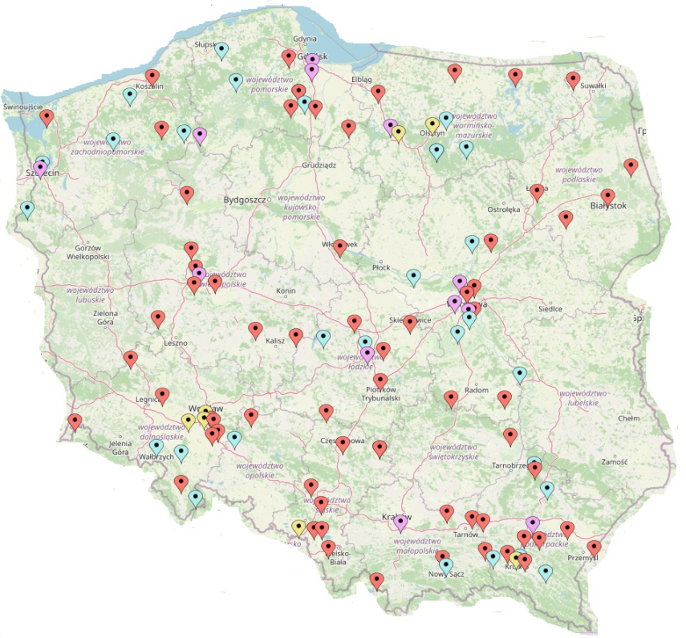
Map of study and control groups domicile

Legend:
Study group – 1 proband domicile
Study group – 2 probands domicile
Control group – 1 person domicile
Control group – 2 or more persons domicile (no more than 5)

