Supplementary material

When genetics meets immunology: The assessment of genetic and immunological backgrounds in advanced NSCLC patients treated with immunotherapy – preliminary study
Journal of Applied Genetics
Natalia Krzyżanowska1*, Marcin Nicoś1*, Kamila Wojas-Krawczyk, Paweł Krawczyk, Izabela Chmielewska, Tomasz Jankowski, Tomasz Kucharczyk, Magdalena Wójcik-Superczyńska, Anna Sroka-Bartnicka, Tomasz Stokowy, Janusz Milanowski
1Department of Pneumonology, Oncology and Allergology, Medical University of Lublin, Lublin, Poland
*Corresponding authors, e-mail address: natalia.krzyzanowska97@gmail.com;
marcinnicos@gmail.com
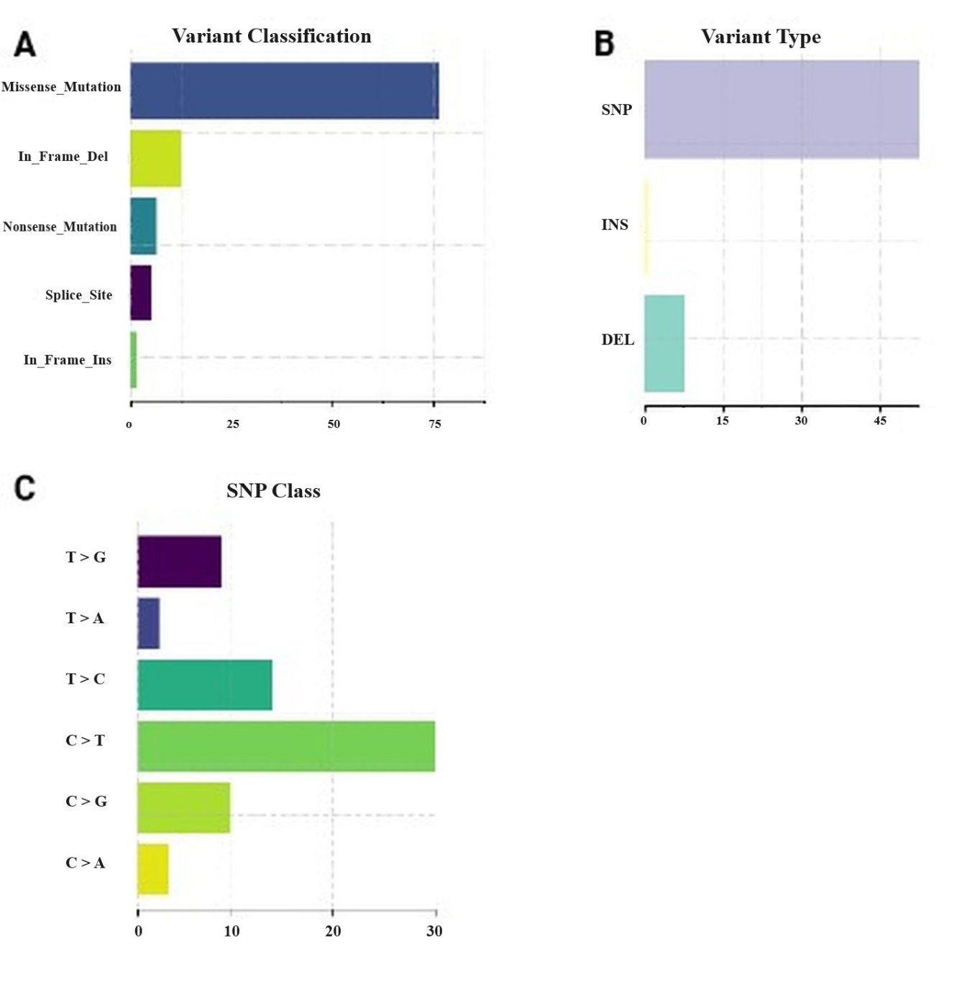

Supplementary Figure 1. The genetic overview of the studied group. A – The representation of the variant classification; B – The representation of variant types; C – The distribution of the amino acids changes.

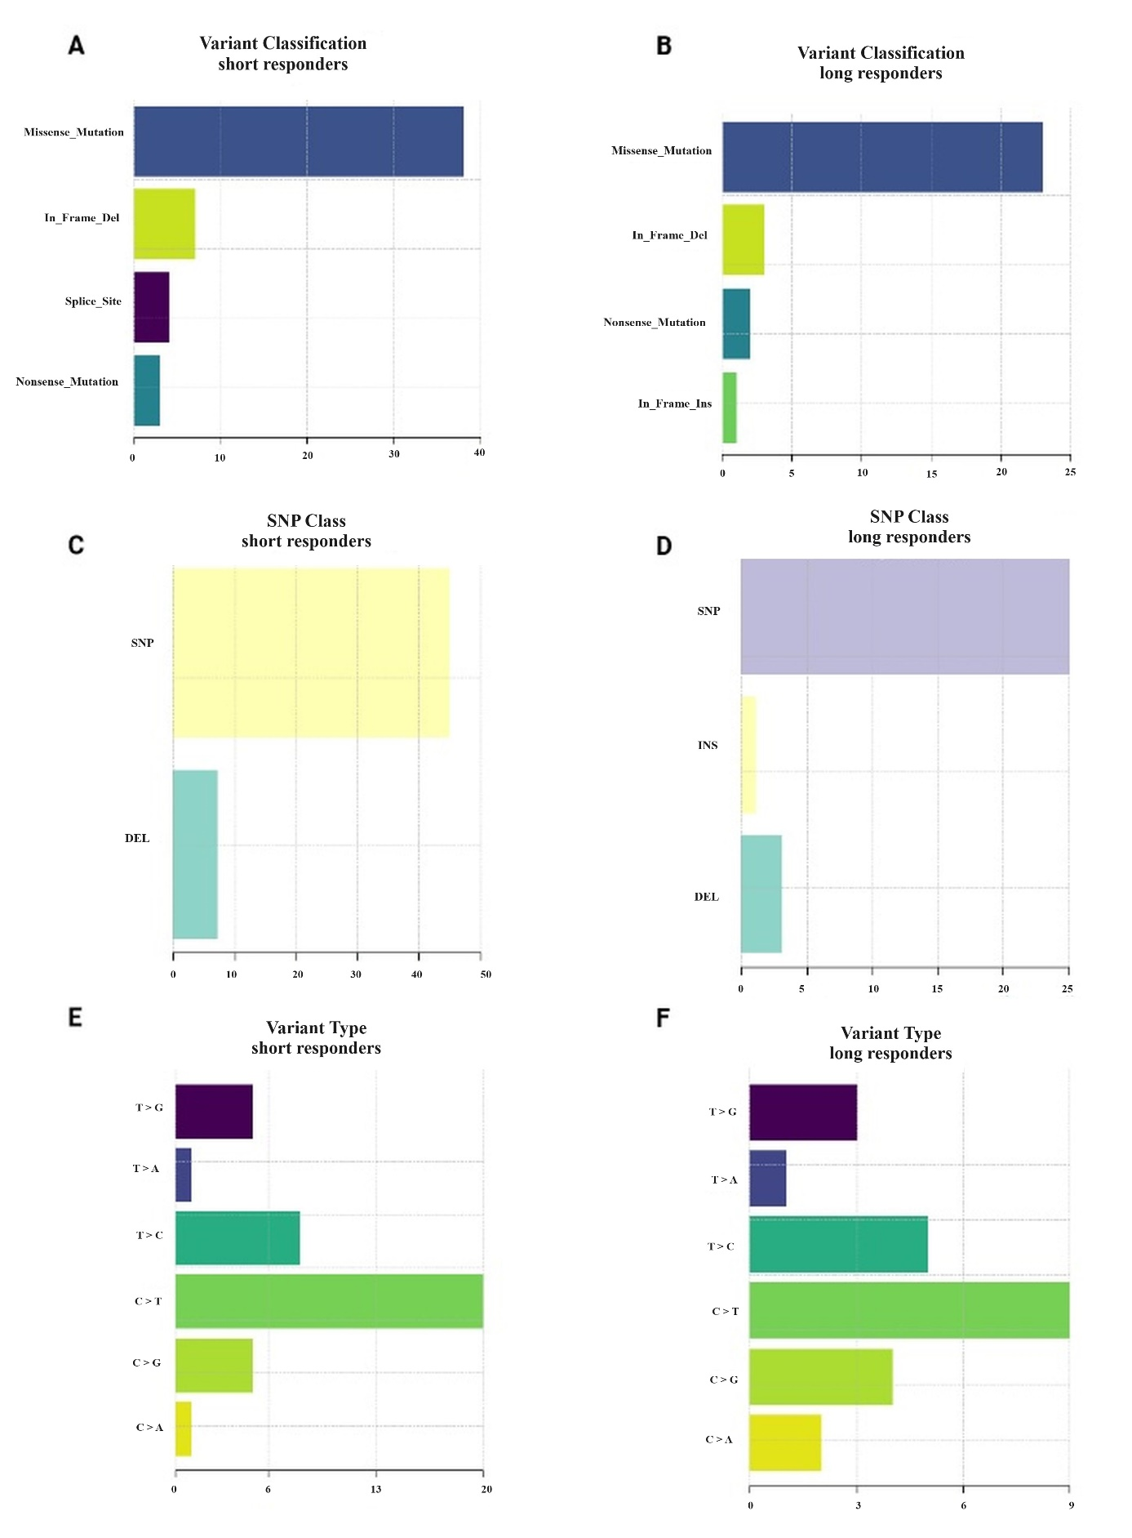
Supplementary Figure 2. The characteristic of genetic discrepancies between short and long responders. Distribution of missense and nonsense mutations or indels in short responders (A) and long responders (B). Distribution of SNPs and indels in short responders (C) and long responders (D). Distribution of amino acid changes in short responders (E) and long responders (F).

Short and long responders comparison
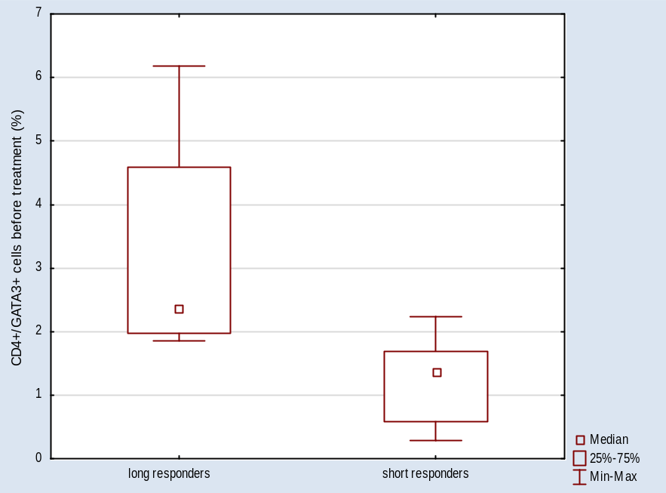
Supplementary Figure 3. CD4⁺/GATA3⁺ cells percentage in long and short responders (p=0,0003).

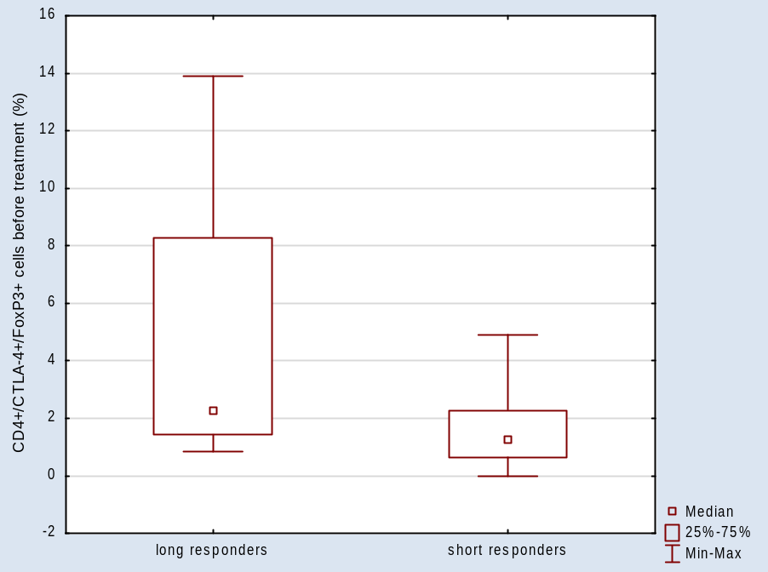
Supplementary Figure 4. CD4⁺/CTLA-4⁺/FoxP3⁺ cells percentage in long and short responders (p=0,0417).

Genetic groups comparison

KDR

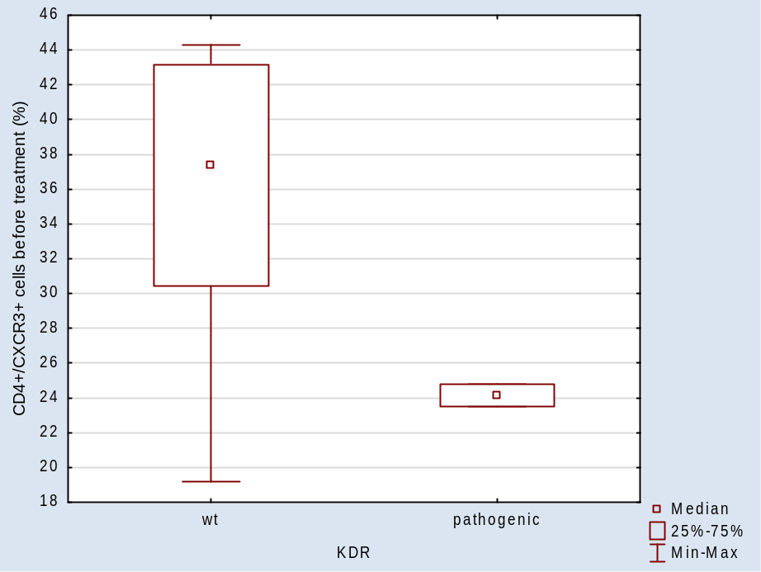
Supplementary Figure 5. CD4⁺/CXCR3⁺ cells (%) (p=0,0279).

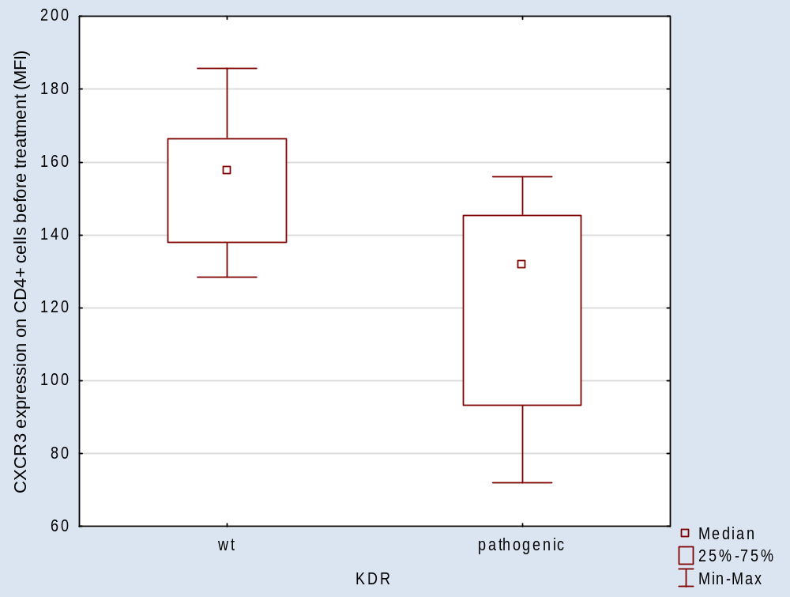
Supplementary Figure 6. CXCR3 expression on CD4⁺ cells (p=0,0186).

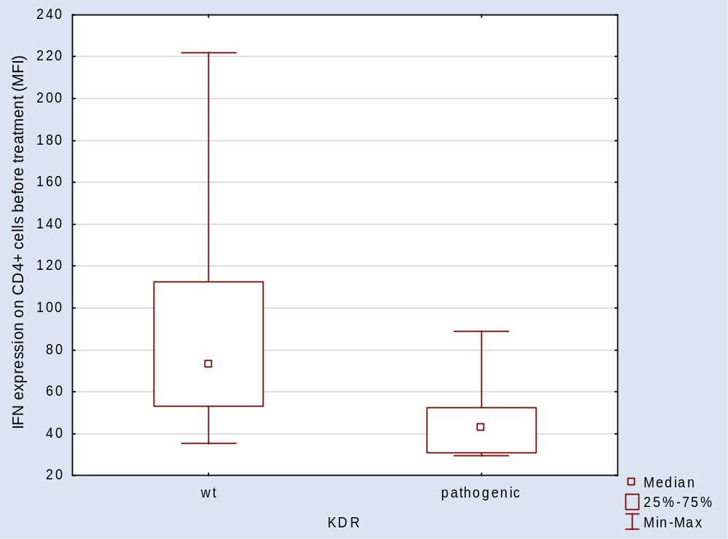
Supplementary Figure 7. IFN expression on CD4⁺ cells (p=0,0218).

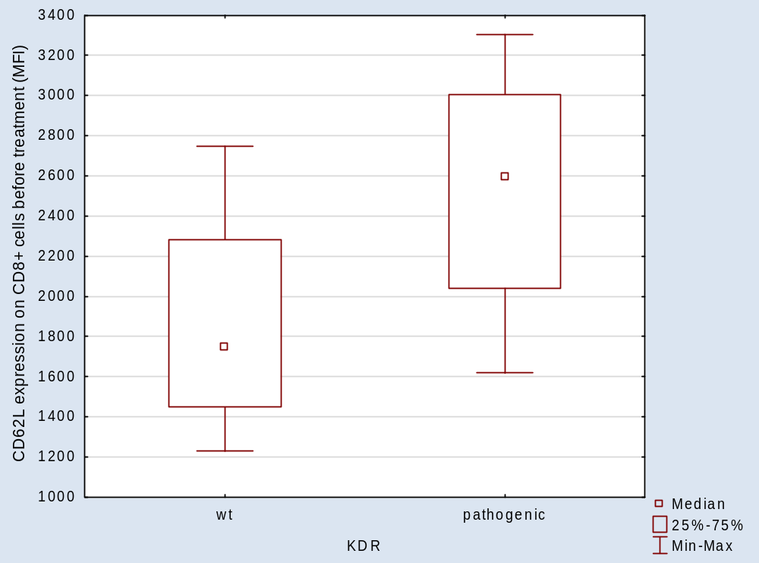
Supplementary Figure 8. CD62L expression on CD8⁺ cells (p=0,0339).

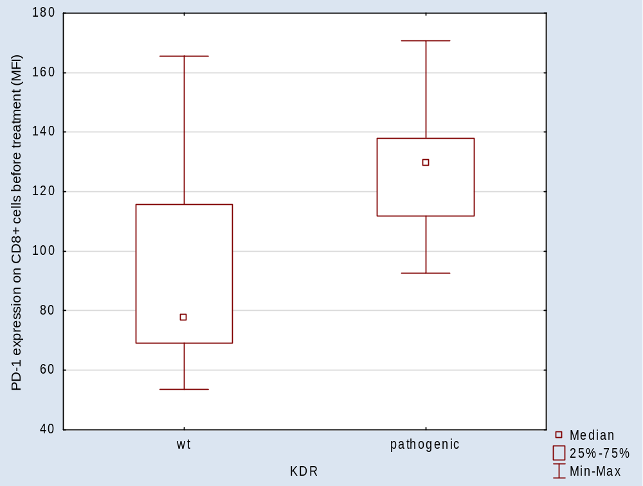
Supplementary Figure 9. PD-1 expression on CD8⁺ cells (p=0,0339).

NOTCH4

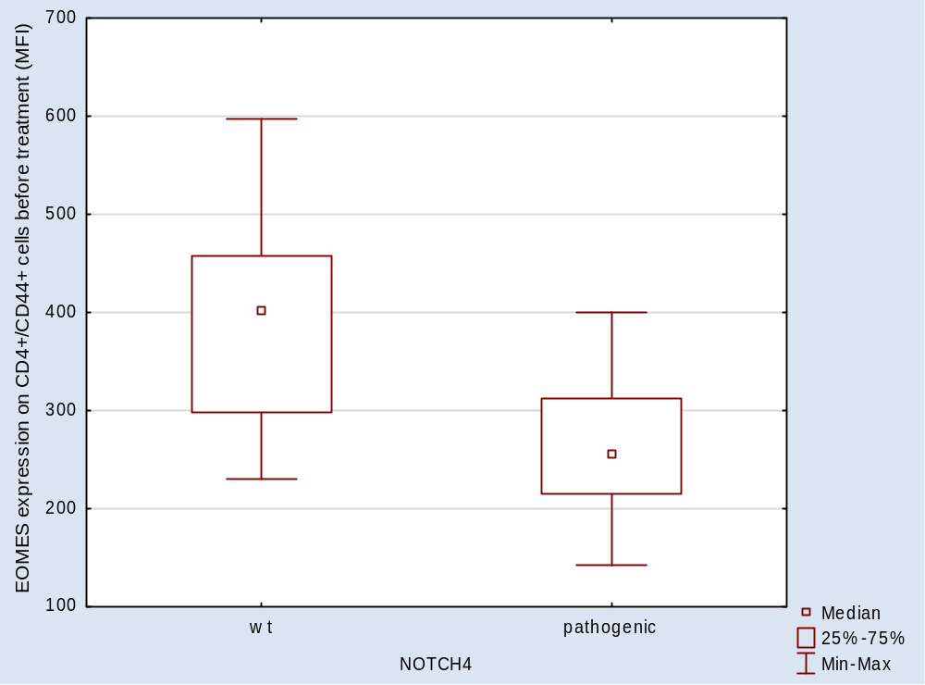
Supplementary Figure 10. EOMES expression on CD4⁺/CD44⁺ cells (p= 0,0185)

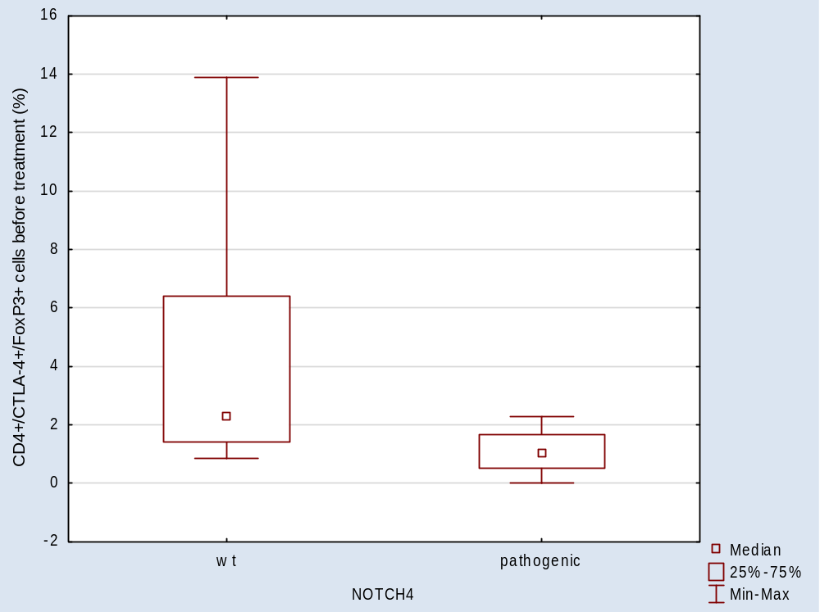
Supplementary Figure 11. CD4⁺/CTLA-4⁺/FoxP3⁺ cells percentage (p= 0,0186).

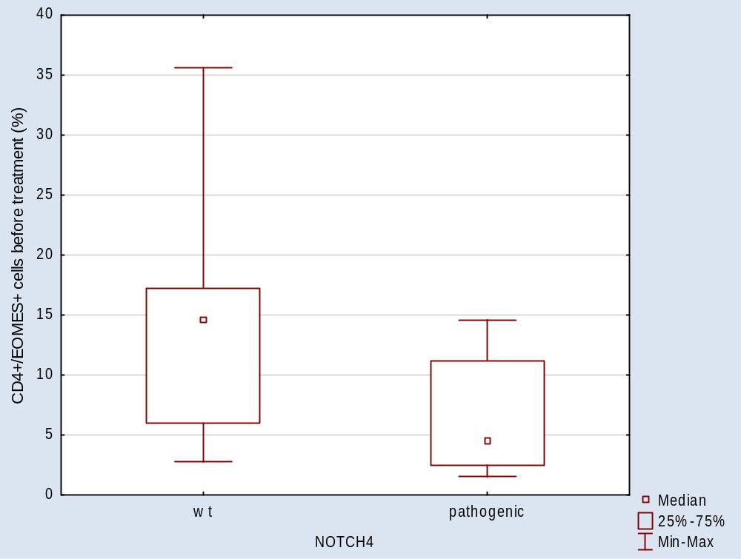
Supplementary Figure 12. CD4⁺/EOMES⁺ cells percentage (p= 0,0279).

RAS

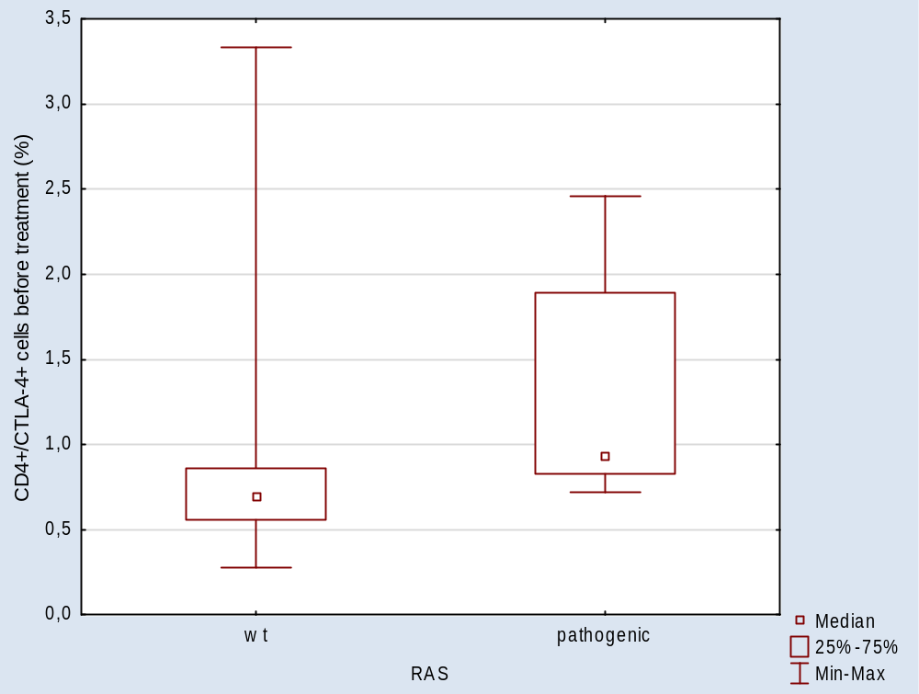
Supplementary Figure 13. CD4⁺/CTLA-4⁺ cells percentage (p= 0,0494).

KRAS/STK11

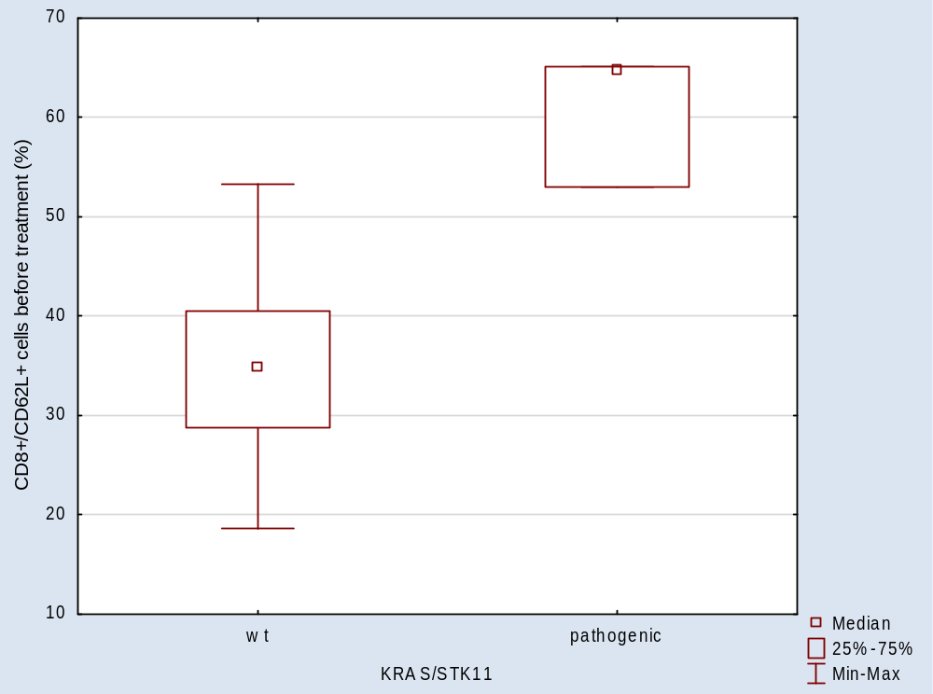
Supplementary Figure 14. CD8⁺/62L⁺ cells percentage (p= 0,0111).

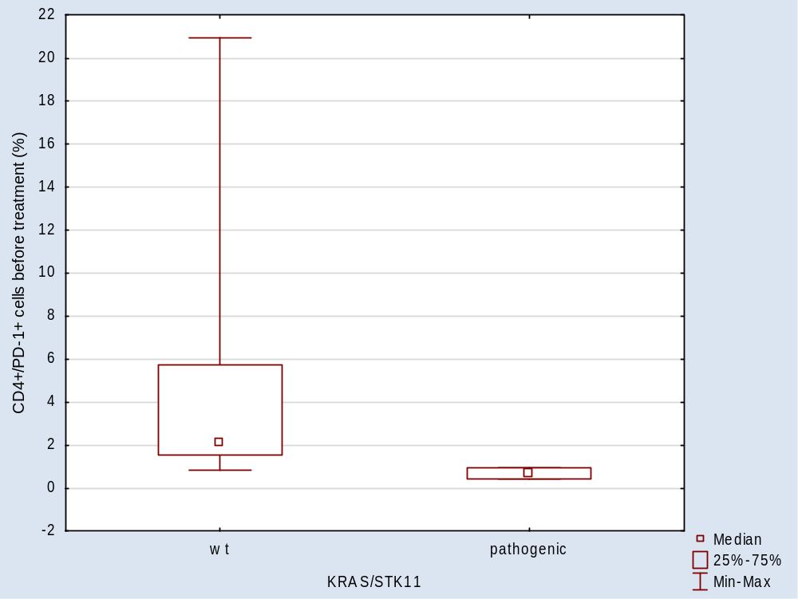
Supplementary Figure 15. CD4⁺/PD-1⁺ cells percentage (p= 0,0111).

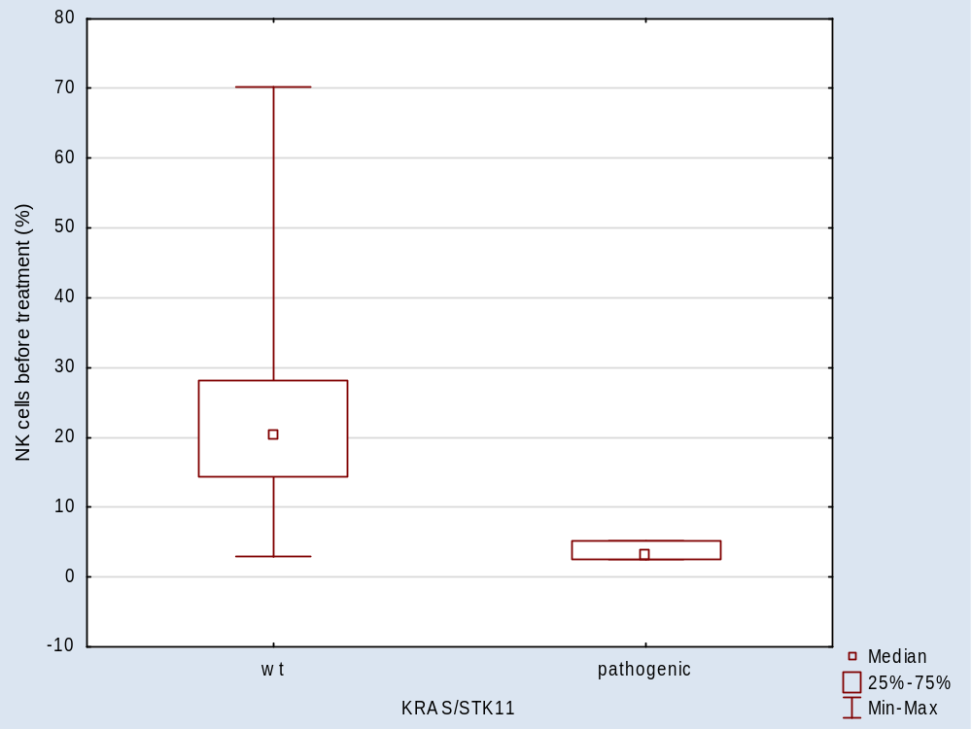
Supplementary Figure 16. NK cells percentage (p= 0,0162).

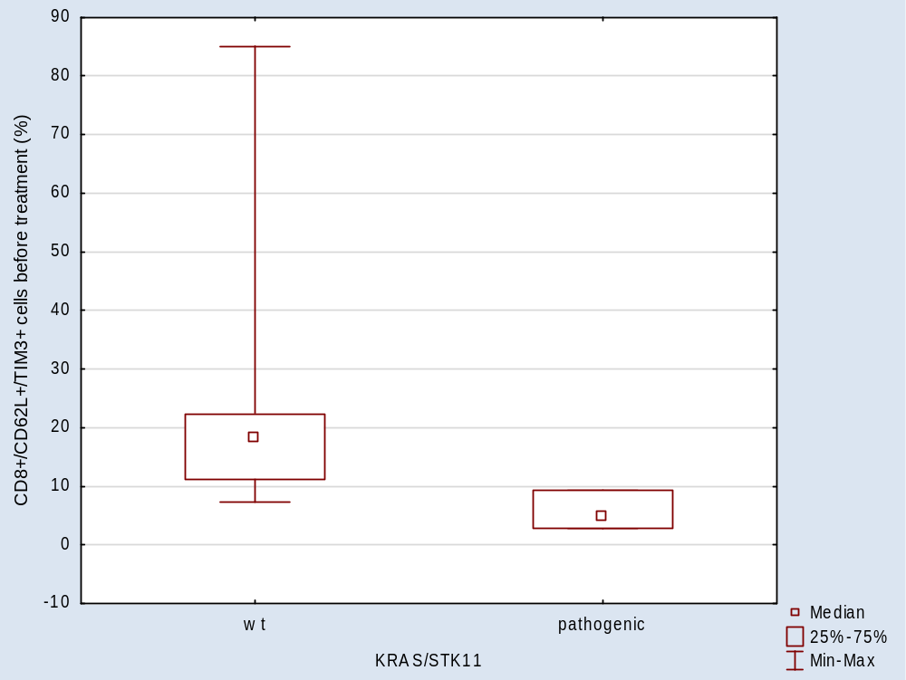
Supplementary Figure 17. CD8⁺/CD62L⁺/TIM-3⁺ cells percentage (p= 0,0199).

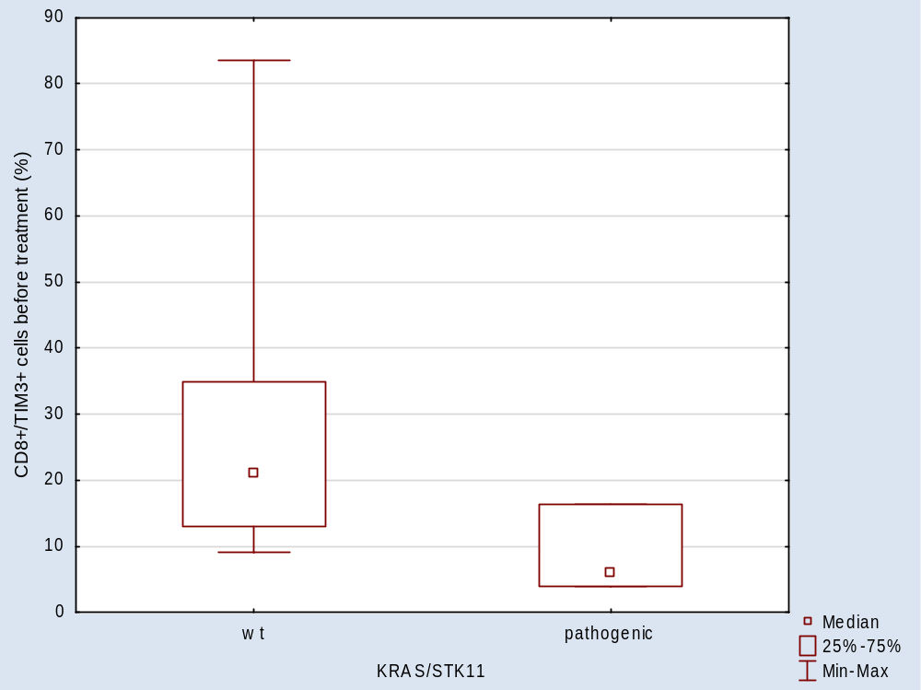
Supplementary Figure 18. CD8⁺/TIM-3⁺ cells percentage (p=0,0343).

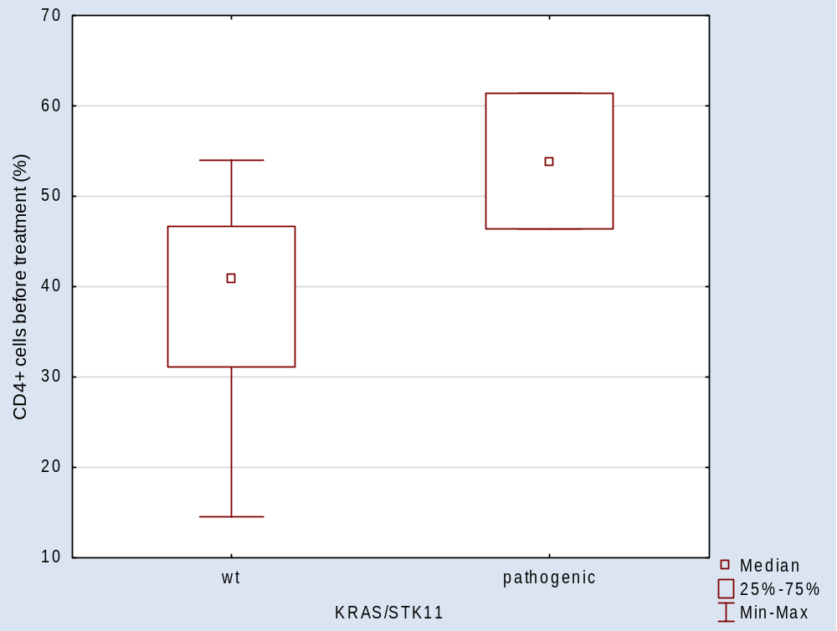
Supplementary Figure 19. CD4⁺ cells percentage (p=0,0443).

TP53

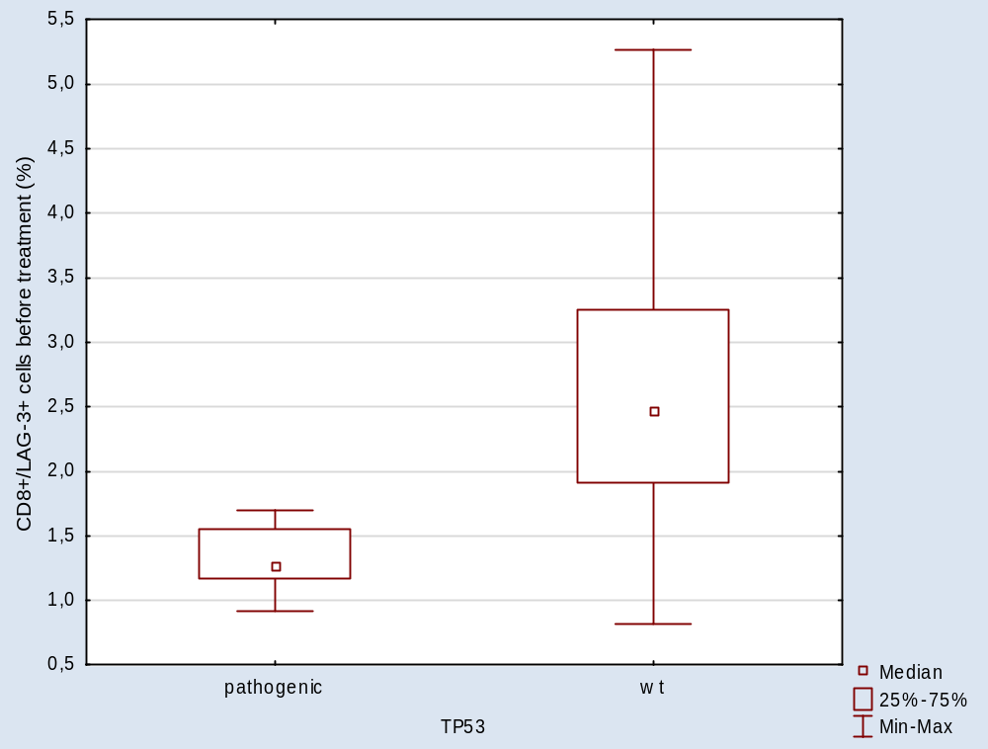
Supplementary Figure 20. CD8⁺/LAG-3⁺ cells percentage (p= 0,0063).

PMS2

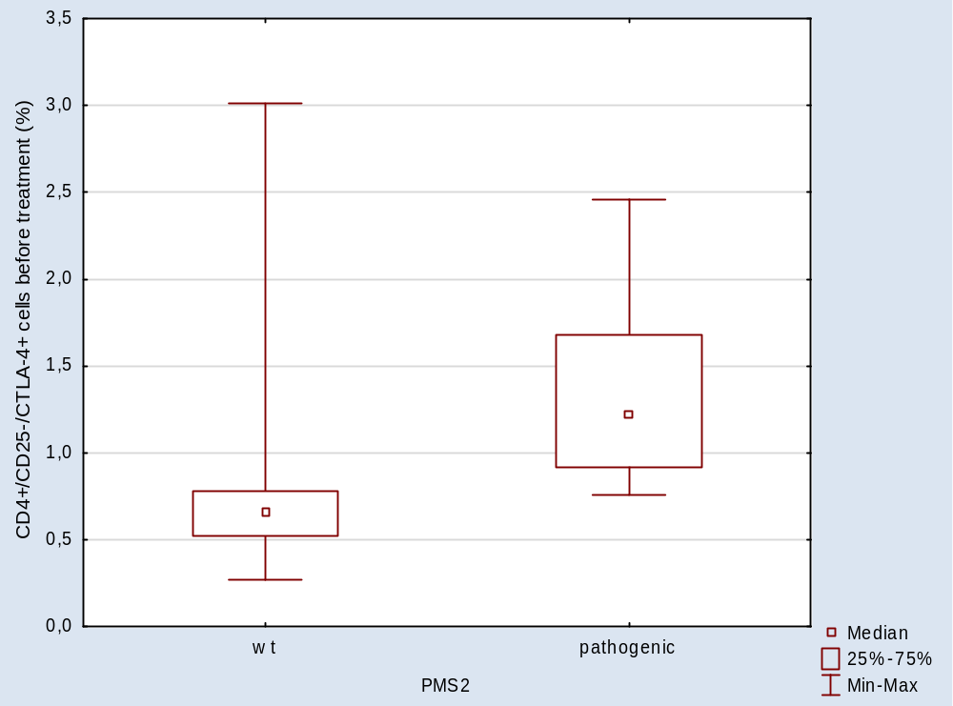
Supplementary Figure 21. CD4⁺/CD25⁻/CTLA-4⁺ cells percentage (p= 0,0145).

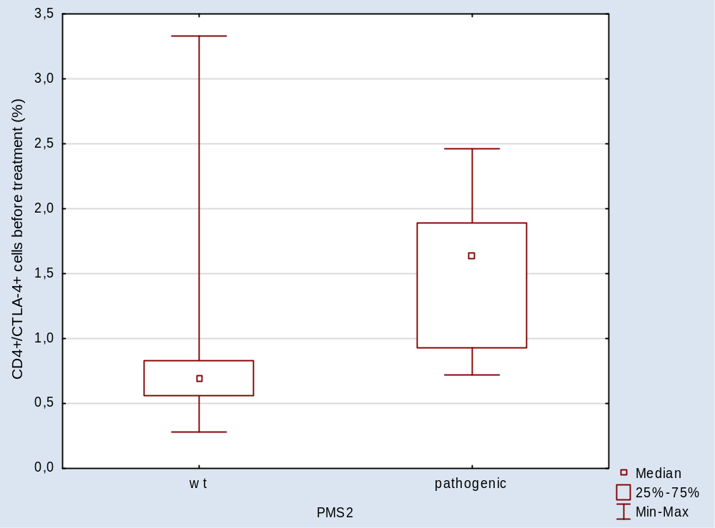
Supplementary Figure 22. CD4⁺/CTLA-4⁺ cells percentage (p=0,0207).

Receptor genes

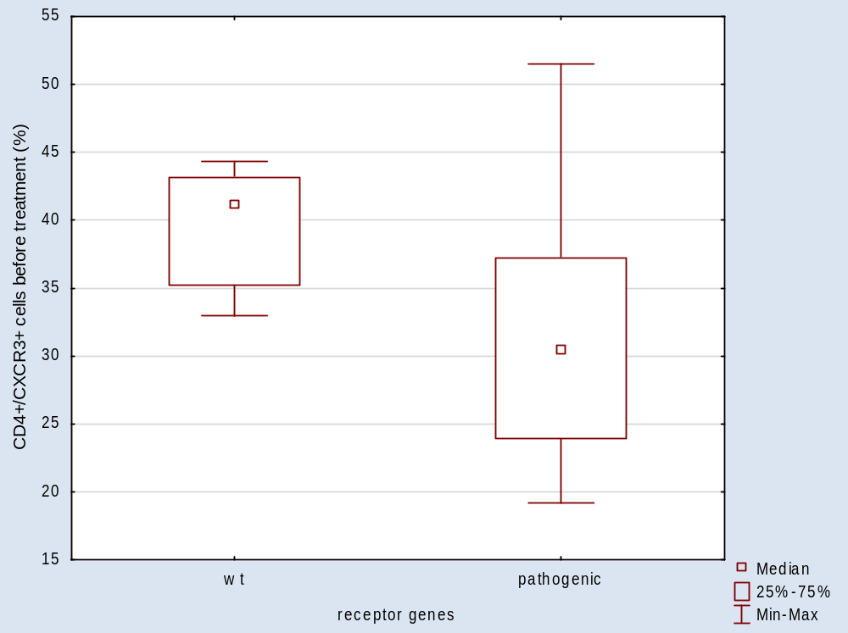
Supplementary Figure 23. CD4⁺/CXCR3⁺ cells percentage (p= 0,0324).

Transcription factor genes

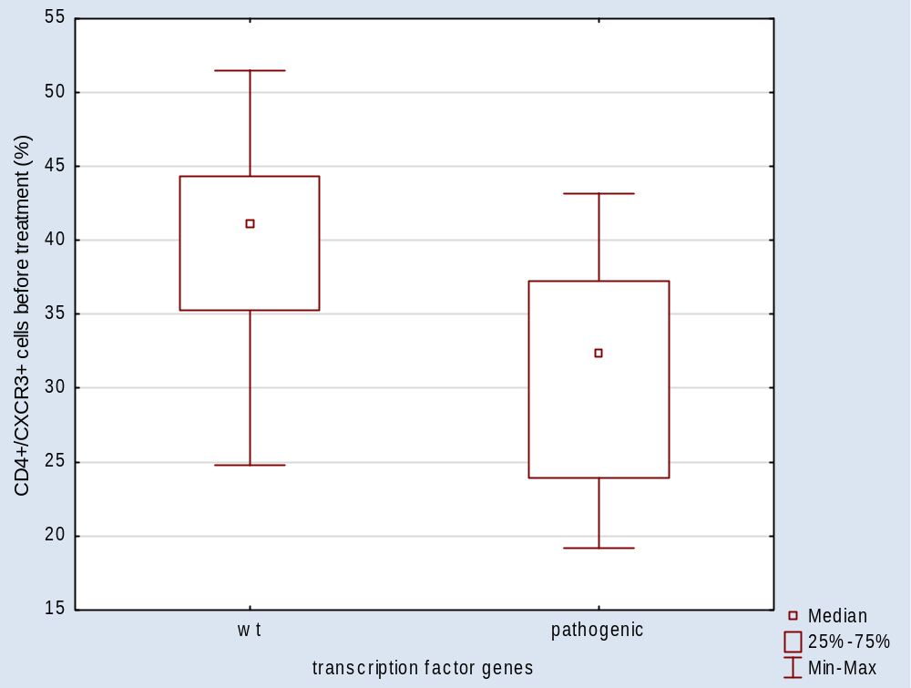
Supplementary Figure 24. CD4⁺/CXCR3⁺ cells percentage (p= 0,0216).

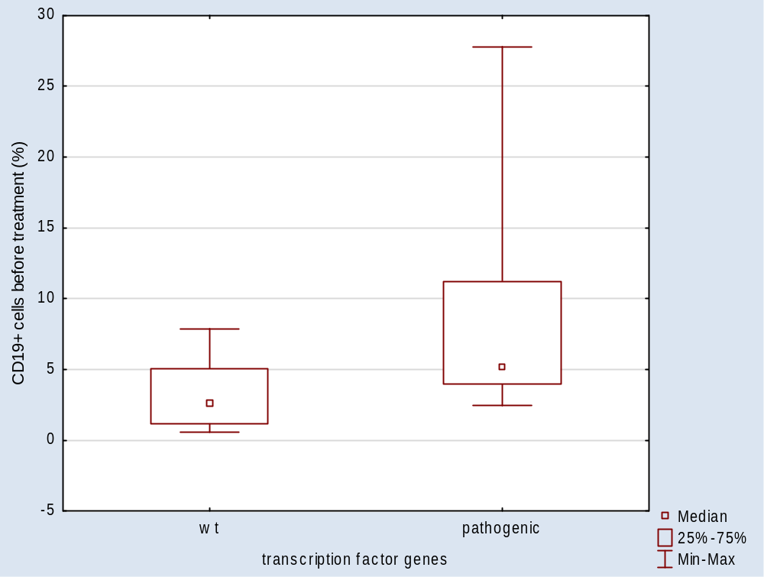
Supplementary Figure 25. CD19⁺ cells percentage (p= 0,0441).

Genes related to DNA repair

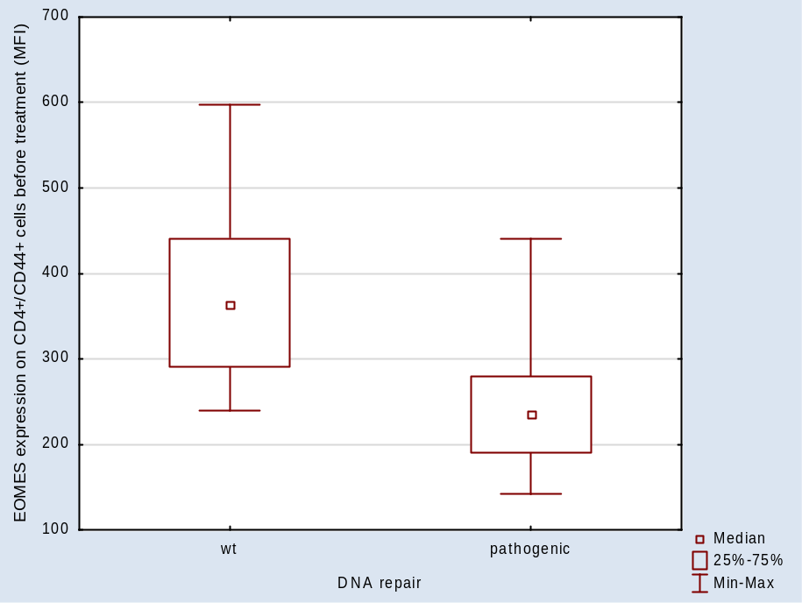

Supplementary Figure 26. EOMES expression on CD4⁺/CD44⁺ cells (p= 0,0277).

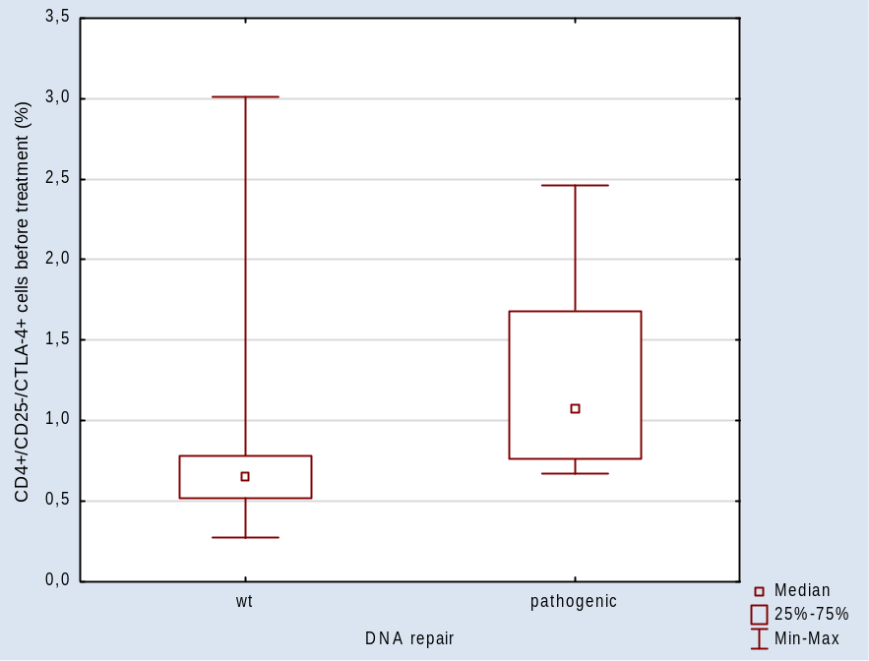
Supplementary Figure 27. CD4⁺/CD25⁻/CTLA-4⁺ cells percentage (p= 0,0288).

Genes related to cell cycle

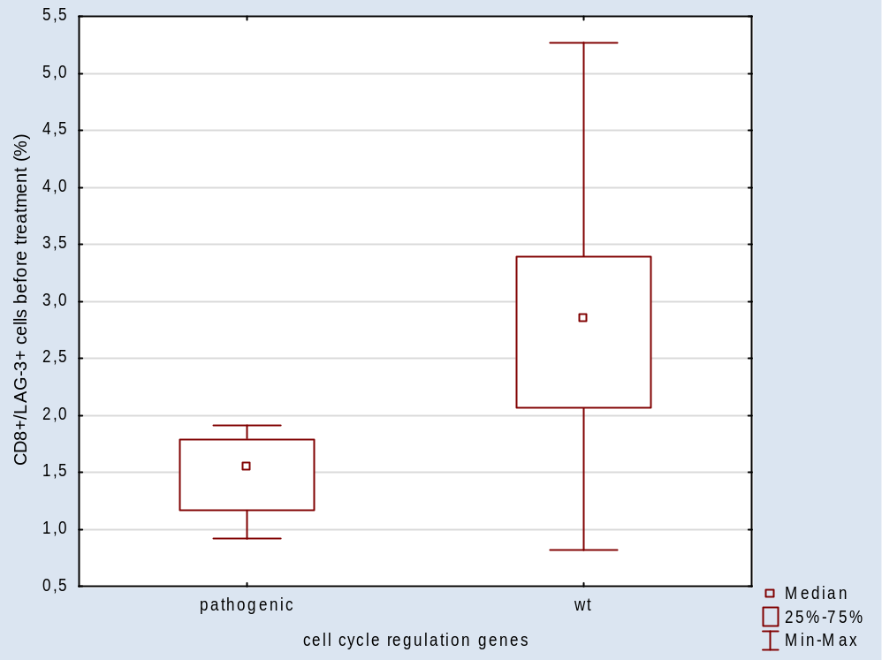
Supplementary Figure 28. CD8⁺/LAG-3⁺ cells percentage (p= 0,006).

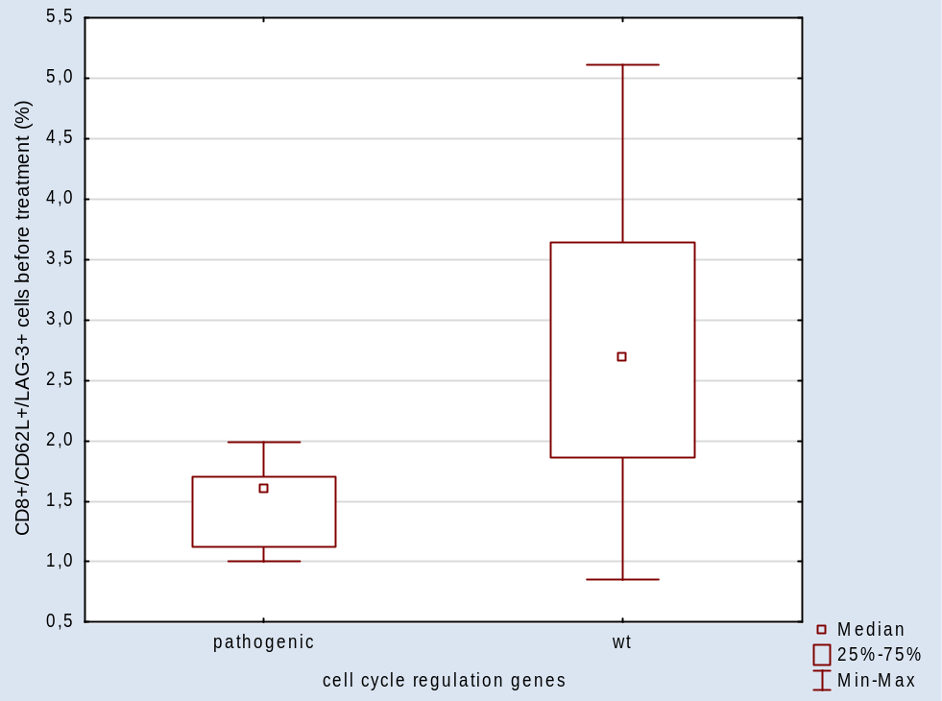
Supplementary Figure 29. CD8⁺/CD62L⁺/LAG-3⁺ cells percentage (p= 0,0201).

Epigenetic factor genes

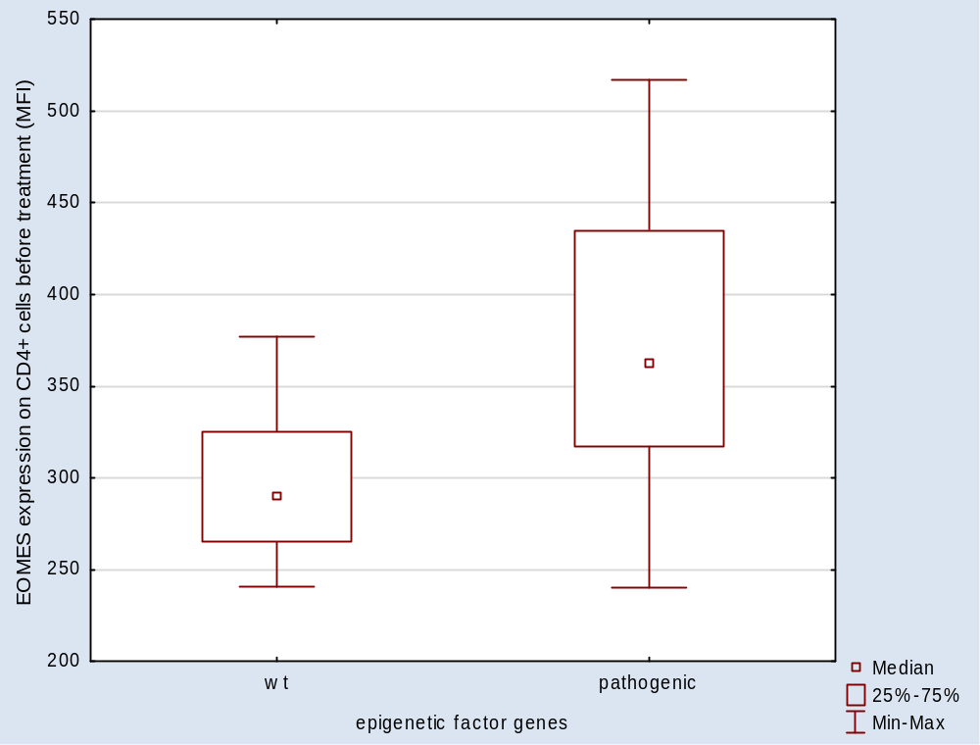
Supplementary Figure 30. EOMES expression on CD4⁺ cells (p= 0,0305).

