Supplementary Table 1. Results of statistical analyses comparing the control and study groups by covariates.
Factor | Test | p-value | t/χ² statistic | 95% CI
Age | Student's t-test | 0.280 | 1.07 | -0.92 – 3.12
Height | Student's t-test | 0.100 | -1.65 | -3.69 – 0.32
Weight | Student's t-test | 0.082 | -1.54 | -5.44 – 0.32
BMI | Student's t-test | 0.26 | -1.13 | -0.99 – 0.27
Sex | chi-square test | 0.008 | 6.91 | –

Supplementary Table 2. Hardy–Weinberg equilibrium test p-values for each subgroup
rsID | All participants | Control group | Study group | One injury | Multiple injuries | Muscle strain or tear | Other injuries | Female participants | Male participants
rs331079 | 0.272 | 0.303 | 0.513 | 0.999 | 0.300 | 0.524 | 0.999 | 0.016 | 0.999
rs2071307 | 0.532 | 0.468 | 0.118 | 0.999 | 0.0813 | 0.158 | 0.0278 | 0.999 | 0.456
rs486055 | 0.840 | 0.999 | 0.591 | 0.468 | 0.772 | 0.576 | 0.725 | 0.522 | 0.999
rs1799750 | 0.116 | 0.084 | 0.734 | 0.999 | 0.700 | 0.610 | 0.590 | 0.024 | 0.888
rs2276109 | 0.172 | 0.999 | 0.036 | 0.130 | 0.120 | 0.024 | 0.594 | 0.379 | 0.307
rs516115 | 0.317 | 0.625 | 0.066 | 0.468 | 0.0163 | 0.0407 | 0.216 | 0.565 | 0.424
rs13312816 | – | – | – | – | – | – | – | – | –
rs1042103 | <0.00001 | <0.00001 | <0.00001 | 0.00680 | <0.00001 | <0.00001 | <0.00001 | 0.999 | <0.00001

Supplementary Table 3. Haplotype frequencies in DCN and association with muscle injuries.
Allele  rs13312816 | Allele rs516115 | Haplotype frequency | Odds ratio | Lower 95% CI | Upper 95% CI | p-value
T | A | 0.762 | Reference haplotype
A | G | 0.072 | 1.30 | 0.65 | 2.59 | 0.463
T | G | 0.166 | 1.04 | 0.66 | 1.65 | 0.872
A | A | 0 | NA | NA | NA | NA
* Haplotype frequencies were estimated with the expectation–maximization (EM) algorithm, and associations were assessed using generalized linear models (GLMs).

Supplementary Table 4. Haplotype frequencies in MMPs and association with muscle injuries.
Allele rs1799750 | Allele rs486055 | Allele rs2276109 | Haplotype frequency | Odds ratio | Lower 95% CI | Upper 95% CI | p-value
- | C | A | 0.356 | Reference haplotype
- | T | A | 0.153 | 0.77 | 0.45 | 1.34 | 0.361
C | C | A | 0.355 | 0.77 | 0.51 | 1.17 | 0.222
C | C | G | 0.106 | 0.94 | 0.53 | 1.67 | 0.840
Other haplotypes |  |  | 0.030 | 2.9 | 0.68 | 12.31 | 0.145
* Haplotype frequencies were estimated with the expectation–maximization (EM) algorithm, and associations were assessed using generalized linear models (GLMs).

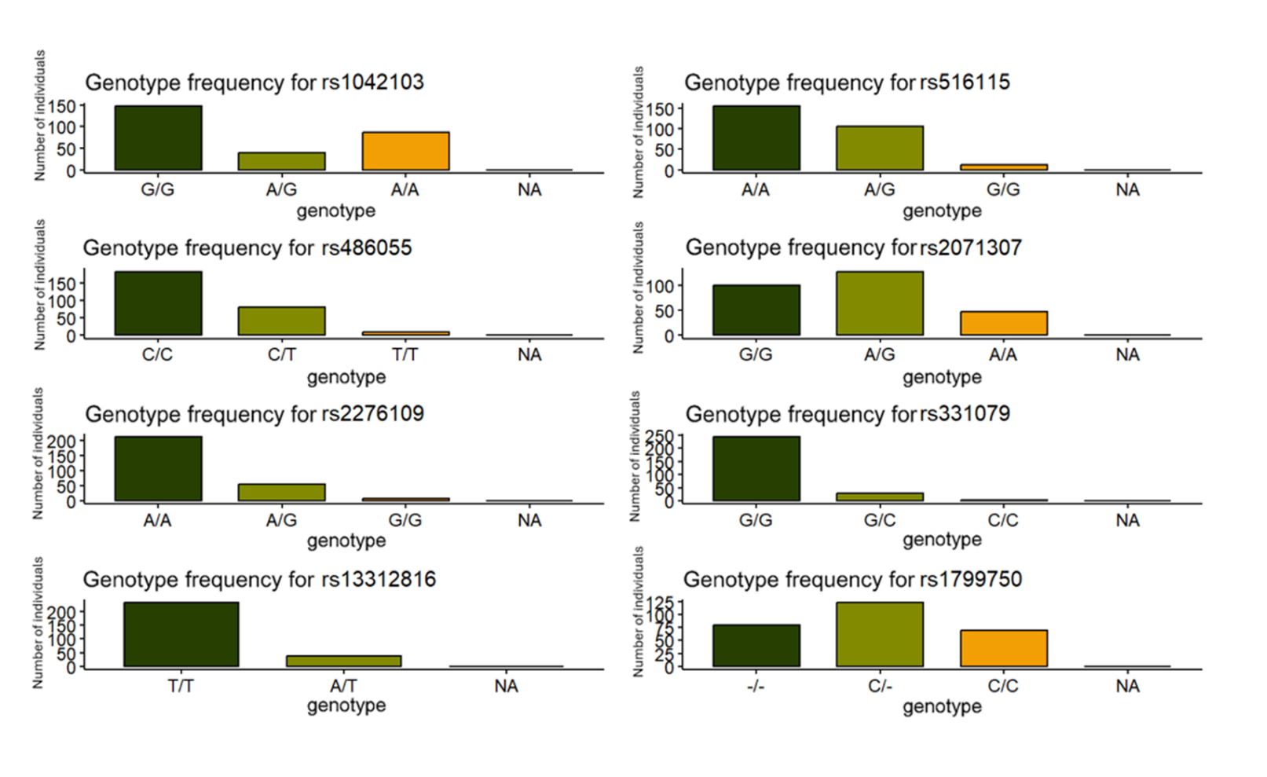
Supplementary Figure 1. Bar charts showing the number of homozygotes, heterozygotes, and individuals with no genotype call for each studied polymorphism.

