Supplementary Material

MALDI Mass Spectral Imaging of Bile Acids Observed as Deprotonated Molecules and Proton-Bound Dimers from Mouse Liver Sections

Ignacy Rzagalinski¹, Nadine Hainz², Carola Meier², Thomas Tschernig², Dietrich A. Volmer^{1,3}*

¹Institute of Bioanalytical Chemistry, Saarland University, 66123 Saarbrücken, Germany
²Institute of Anatomy and Cell Biology, Saarland University, 66421 Homburg, Germany
³Department of Chemistry, Humboldt University of Berlin, 12489 Berlin, Germany

*To whom correspondence should be addressed:
Prof. Dr. Dietrich A. Volmer
Department of Chemistry
Humboldt University of Berlin
Brook-Taylor-Str. 2
12489 Berlin, Germany
Tel: +49 30 2093 7575
Email: dietrich.volmer@hu-berlin.de
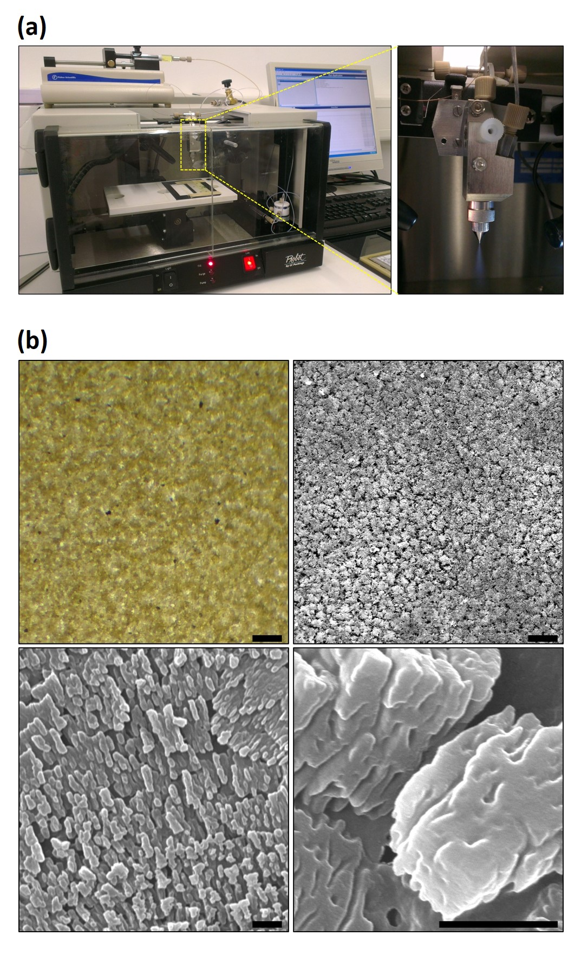

Figure S1. (a) Home-built robotic sprayer based on the Probot micro fraction collector platform, syringe pump and micro spraying nozzle, providing a fine and highly reproducible spray. (b) Images of 9-AA matrix sprayed onto the surface of the control liver section: light microscope image at 5× magnification (top left) and SEM images at 50× magnification (top right), 5,000× (bottom left) and 20,000× (bottom right). Scale bars: 100 µm (top left and right) and 1 µm (bottom left and right).

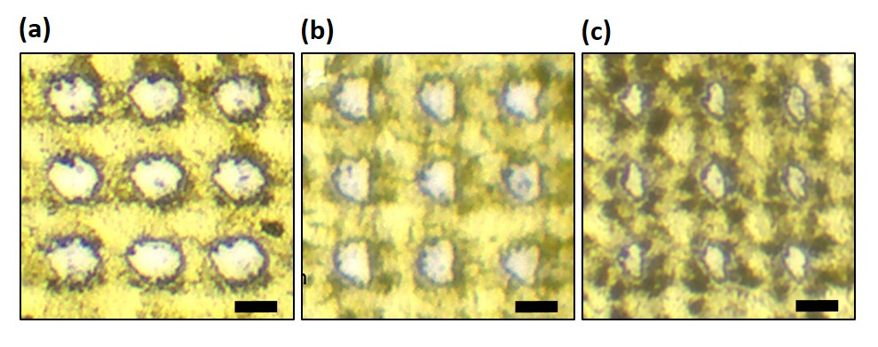

Figure S2. Light microscope images of the ablated areas of 9-AA matrix deposited onto the mouse liver section and irradiated with different number of laser shots per pixel: 1000 (a), 500 (b) and 200 (c). Other laser settings were: minimum laser beam focus setting (smallest option on commercial Bruker solariX 7T instrument); laser power, 10%; repetition rate, 1 kHz. Scale bar: 50 µm.

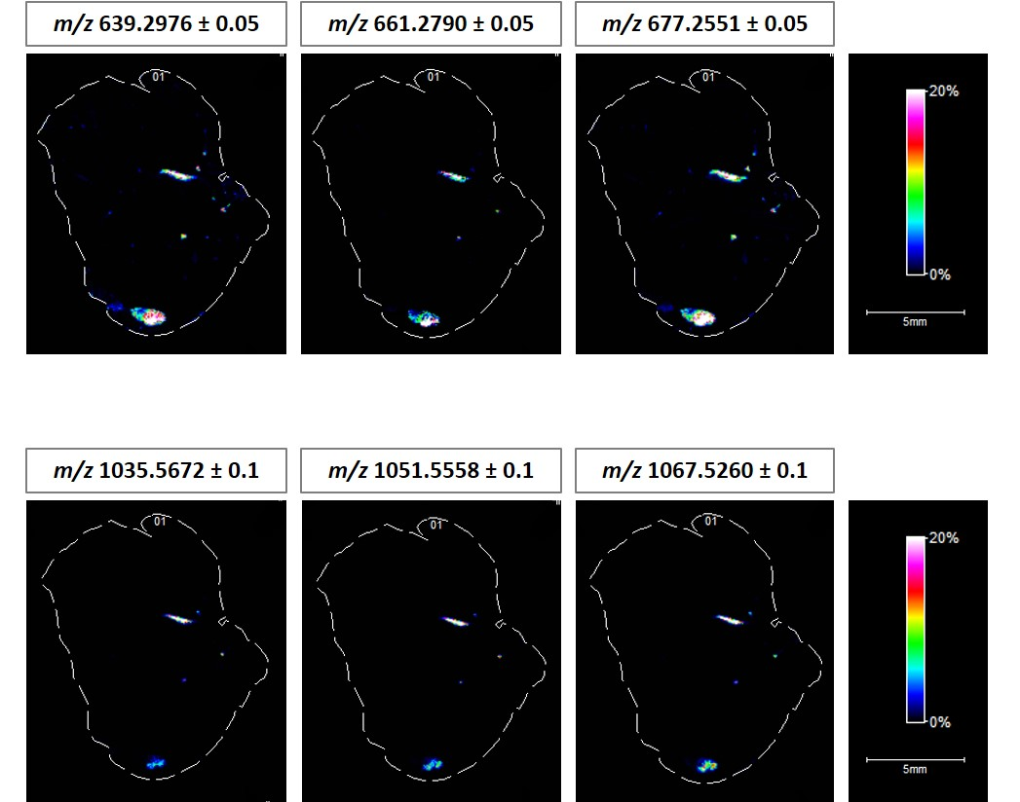

Figure S3. MS ion images representing spatial distributions of the identified TCA/TMCA-containing proton-bound dimers at m/z 639.2976 ± 0.05, m/z 661.2790 ± 0.05, m/z 677.2556 ± 0.05, m/z 1035.5672 ± 0.05, m/z 1051.5558 ± 0.05, and m/z 1067.5260 ± 0.05 across the whole section of mouse liver (pixel size, 70 µm). All ion images were normalized to the 9-AA matrix signal.

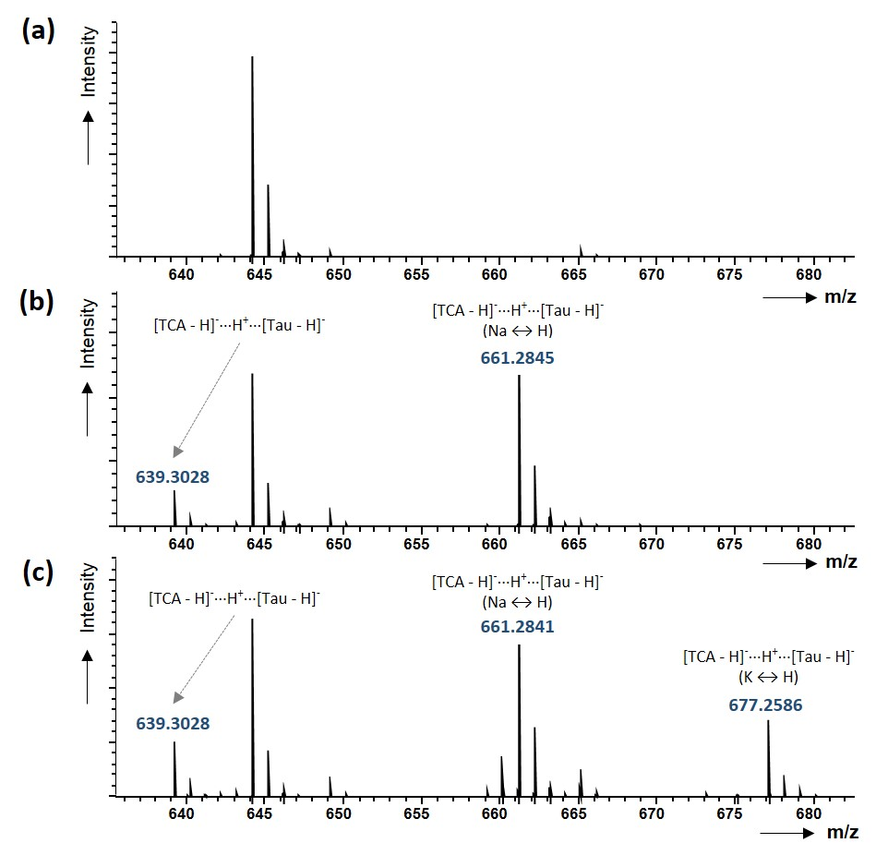

Figure S4. MALDI-FTICR mass spectra acquired after dried-droplet sample preparation using 9-AA matrix + standard mixtures of TCA (a), TCA + taurine (b) and TCA + taurine + KCl (c).

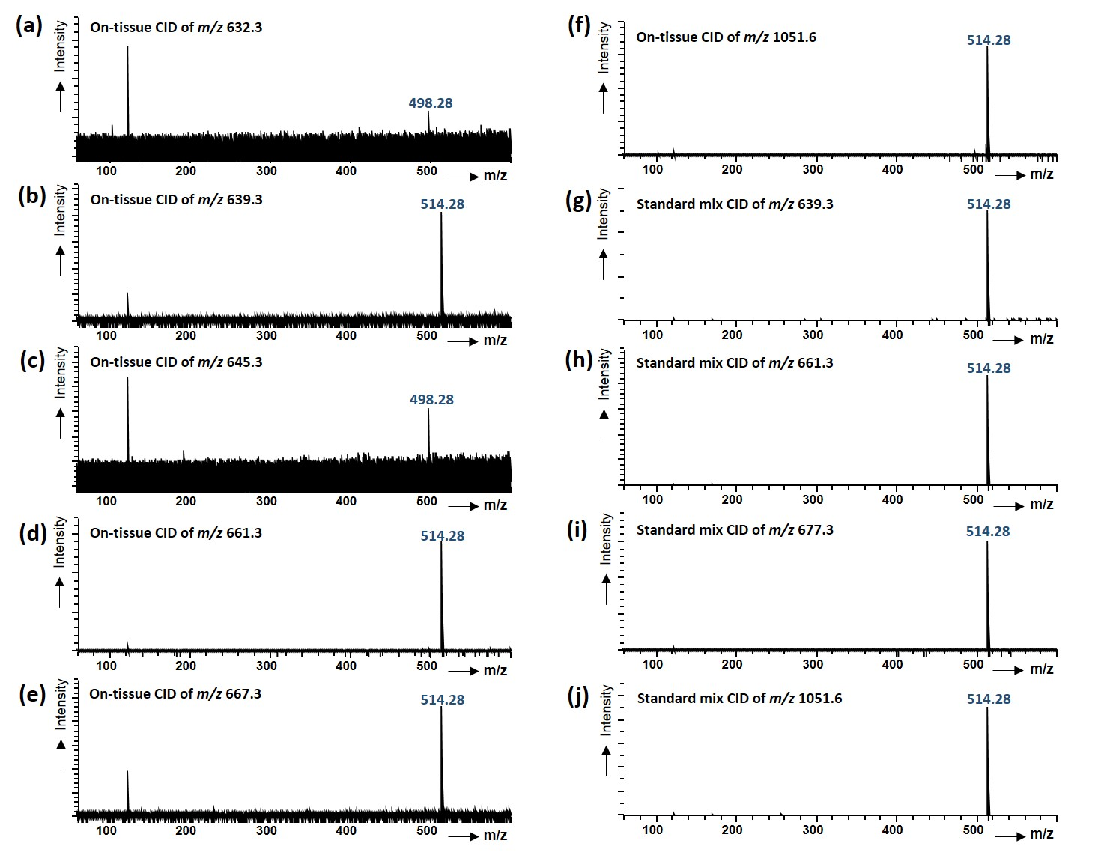

\

Figure S5. CID experiments of m/z selected dimers obtained directly from mouse liver tissue sections (a-f) or from standard mixture of TCA, taurine and potassium chloride (g-j). (Note: m/z 123 is an artifact of the FTICR instrument used in the study.)

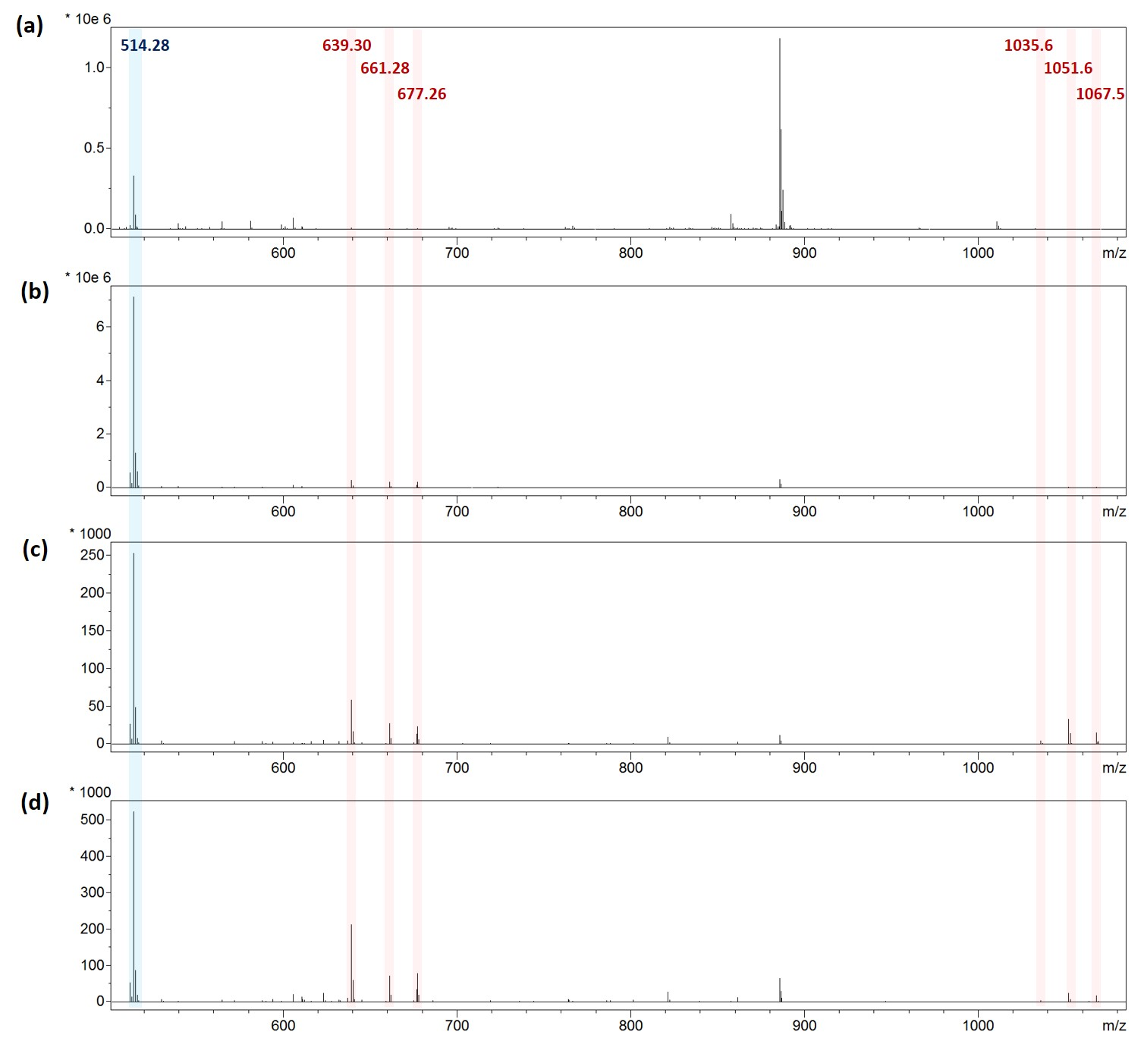

Figure S6. Averaged mass spectra from different selected regions of interest (ROI): whole liver tissue section (22,136 single mass spectra averaged) (a), gall bladder (125 single mass spectra averaged) (b), the large bile duct of which the MS image is shown in Figure 4c (29 single mass spectra (c), and the small bile duct of which the MS image is shown in Figure 4e (4 single mass spectra averaged) (d). All mass spectra were obtained from MS imaging experiments performed at 70 µm spatial resolution.

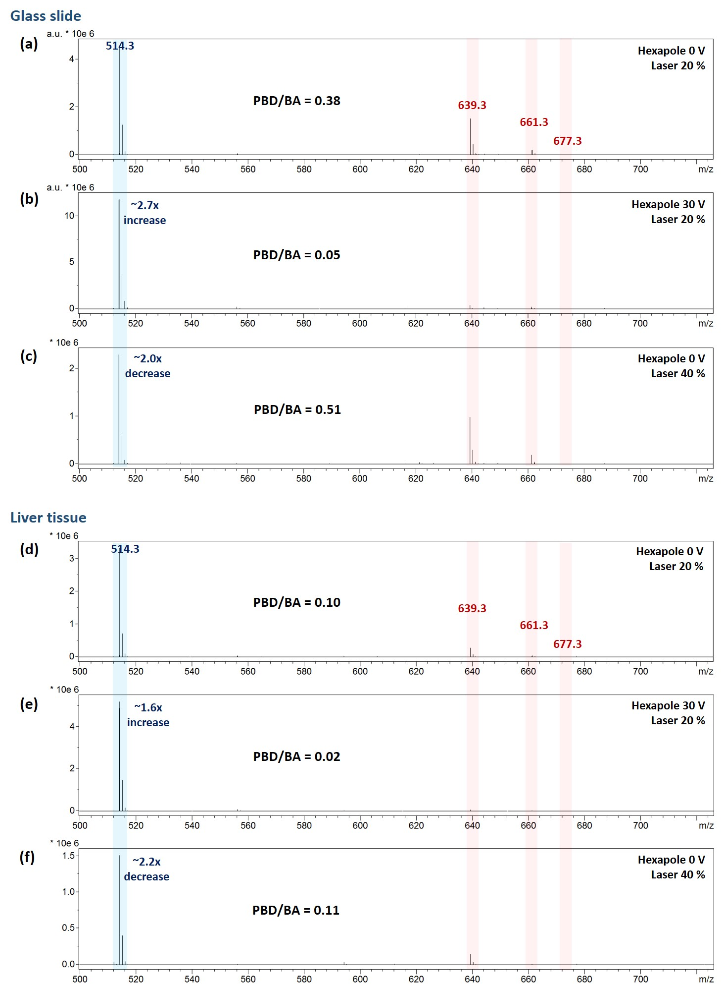

>>a
Figure S7. Average mass spectra from model MALDI imaging experiments conducted on glass slide (a-c) and liver tissue (d-f) regions sprayed homogenously with an equimolar mixture of TCA and taurine and imaged using three different instrumental settings: no collision voltage at hexapole (0 V) and laser energy set to optimum conditions (20%) (a, d); 30 V at hexapole and laser power at 20 % (b, e); 0 V at hexapole and doubled laser power (40 %) (c, f). All average mass spectra were obtained from at least 200 single points (pixel size, 70 µm). The PBD/BA values were calculated based on the average sum intensity of all heterodimers (TCA/taurine) and average intensity of deprotonated TCA.

Table S1. Ratios of average signal intensities of different TCA/TMCA-containing proton-bound dimers and the average signal intensity of deprotonated TCA/TMCA. The values were obtained from four different regions of interest (ROIs) – whole liver section, gall bladder, large bile duct and small bile duct – by averaging mass spectra from 22136, 125, 29 and 4 single points, respectively (pixel size, 70 µm).
