Supplementary Information

Subunit pI can influence protein complex dissociation characteristics

Aneika C. Leney
School of Biosciences, University of Birmingham, Edgbaston, Birmingham, B15 2TT, UK.
B-phycoerythrin – P cruentum

Figure S1. Collision induced dissociation of allophycocyanin hexamer at collision energies 5, 10, 20, 30 and 35 V. In all cases, only the monomer corresponding to the alpha subunit of allophycocyanin was detected.
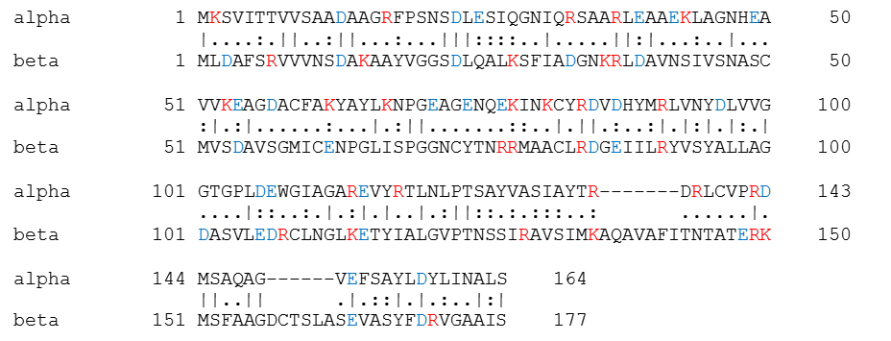
Figure S2. Sequence alignment of the alpha and beta subunits of B-phycoerythrin. The positive and negative charged residues are highlighted in red and blue, respectively.

Figure S3. Native mass spectrum of B-phycoerythrin in 100 mM ammonium acetate pH ~7. The mass spectrum shows phycoerythrin in equilibrium between its larger assembly (α₆β₆γ) and its hexameric state (α₃β₃). It is important to note that with the instrument parameters used, the relative abundances of the species in the spectrum likely does not reflect their abundances in solution. Nevertheless, it is clear that both the hexameric and larger assembly are present in solution.

