Supporting Information

Chemometric Strategies for Sensitive Annotation and Validation of Anatomical Regions of Interest in Complex Imaging Mass Spectrometry Data

Patrick M. Wehrli¹, Wojciech Michno¹, Kaj Blennow^{1,2}, Henrik Zetterberg^{1,2,3,4} and Jörg Hanrieder^{1,4}*

- Department of Psychiatry and Neurochemistry, Sahlgrenska Academy at the University of Gothenburg, Mölndal, Sweden
- Clinical Neurochemistry Laboratory, Sahlgrenska University Hospital, Mölndal, Sweden
- UK Dementia Research Institute at UCL, London, United Kingdom
- Department of Neurodegenerative Disease, Institute of Neurology, University College London, London, United Kingdom

* Contact:
  - Jörg Hanrieder, PhD
  - Dept. Psychiatry and Neurochemistry, Sahlgrenska Academy at the University of Gothenburg, Mölndal Hospital, House V, Biskopsbogatan 27, SE-43180 Mölndal, Sweden
  - jh@gu.se; +46313432377

Table of content
Figure S-1a-e : PCA scores images, dataset 1, various processing methods
Figure S-2a-c : PCA scores images, dataset 2, various processing methods
Figure S-3a-c : PCA scores images, dataset 3, various processing methods
Figure S-4. Binary maps, dataset 2, dataset 3.
Figure S-5. OPLS-DA modelling results, dataset 2.
Figure S-6. OPLS-DA modelling results, dataset 3.
Figure S-7: Box plots of ion intensities, dataset 2, dataset 3

t1 t2 t3 t4 t5 t6 t7
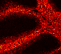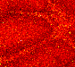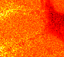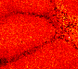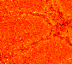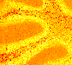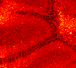
t8 t9 t10 t11 t12 t13 t14
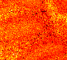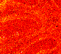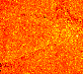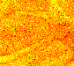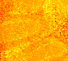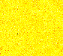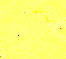
t15 t16 t17 t18 t19 t20 t21
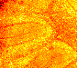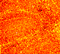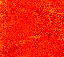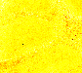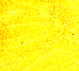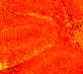
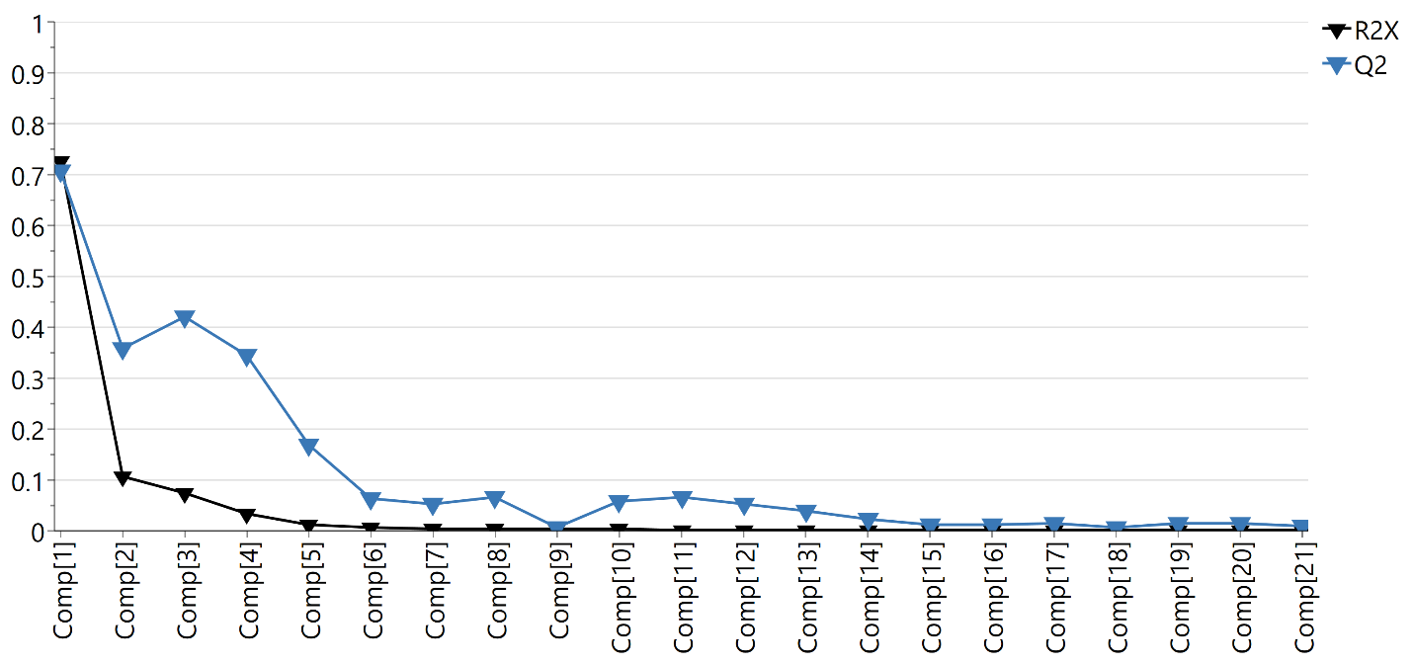
Figure S-1a. PCA scores images and corresponding R² and Q² values, raw data, dataset 1; cumulative R² 0.98, cumulative Q² 0.96.

t1 t2 t3 t4 t5 t6 t7
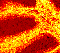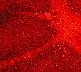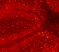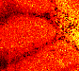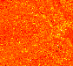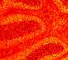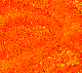
t8 t9 t10 t11 t12 t13 t14
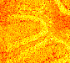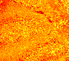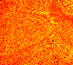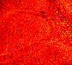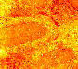
t15 t16 t17 t18 t19 t20
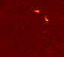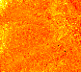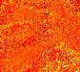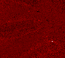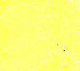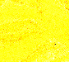
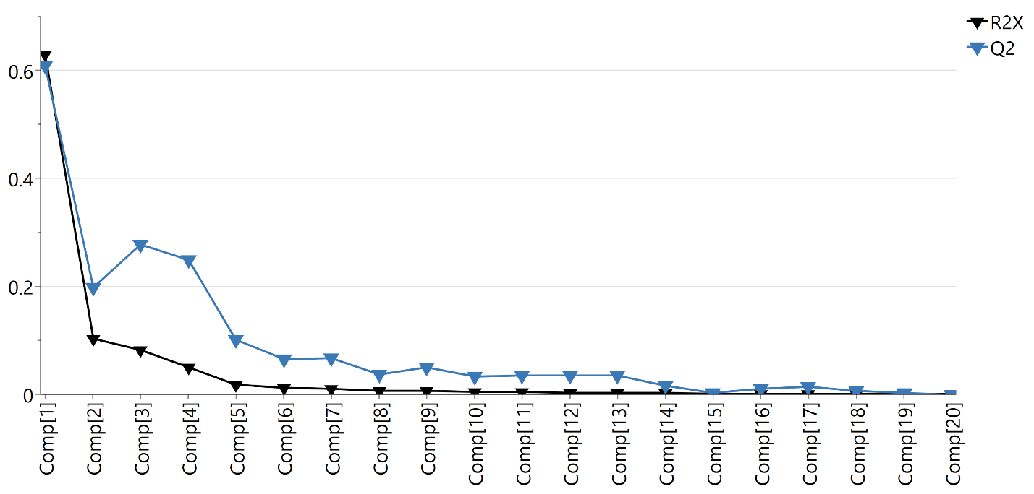
Figure S-1b. PCA scores images and corresponding R² and Q² values, TIC normalized data, dataset 1; cumulative R² 0.95, cumulative Q² 0.90.

t1 t2 t3 t4 t5 t6 t7
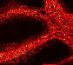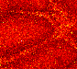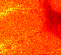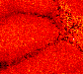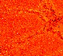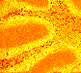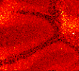
t8 t9 t10 t11 t12 t13 t14
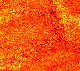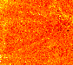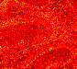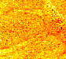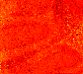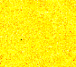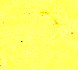
t15 t16 t17 t18 t19 t20 t21
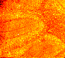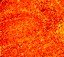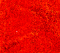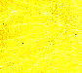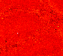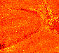
t22 t23 t24 t25 t26
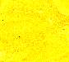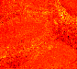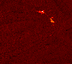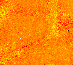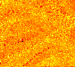
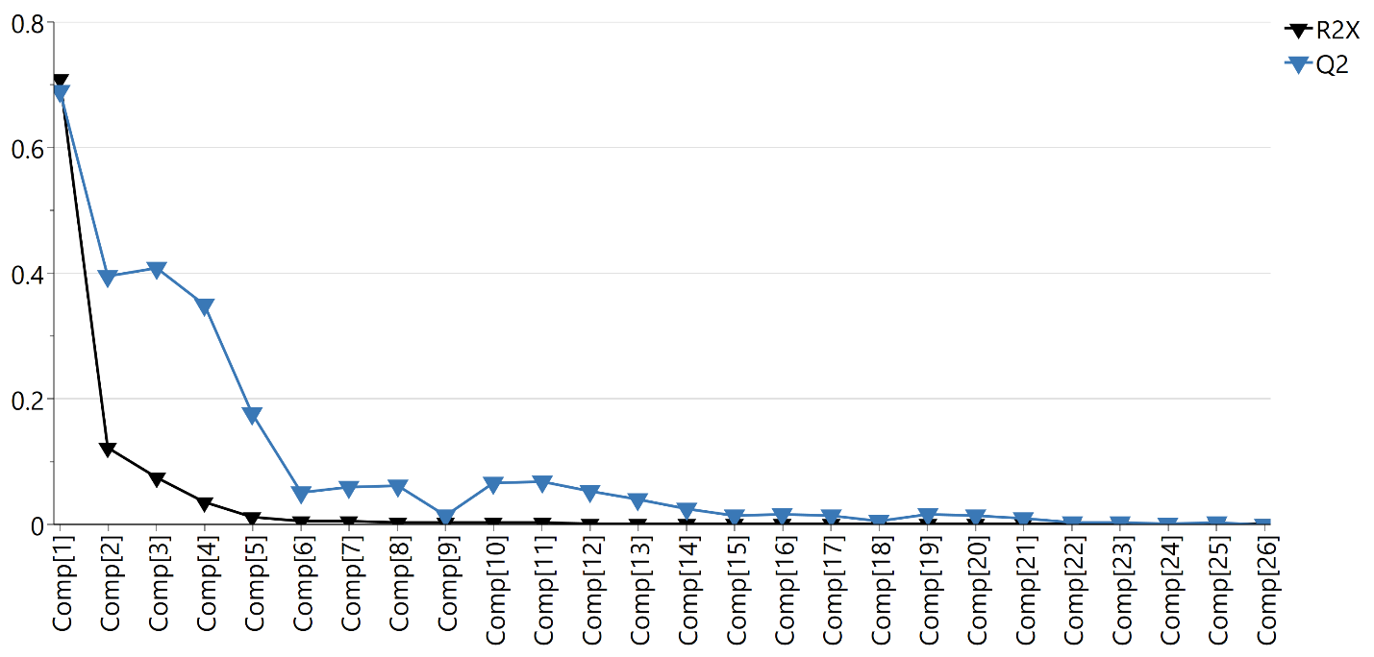
Figure S-1c. PCA scores images and corresponding R² and Q² values, median normalized data, dataset 1; cumulative R² 0.98, cumulative Q² 0.97.

t1 t2 t3 t4 t5 t6 t7
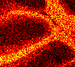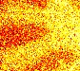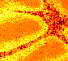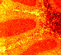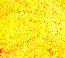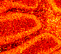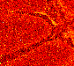
t8 t9 t10 t11 t12 t13 t14
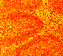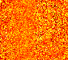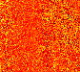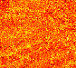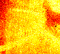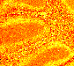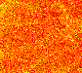
t15 t16 t17 t18 t19 t20 t21
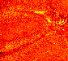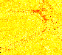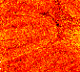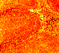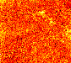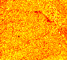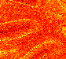
t22 t23 t24
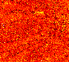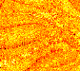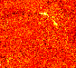
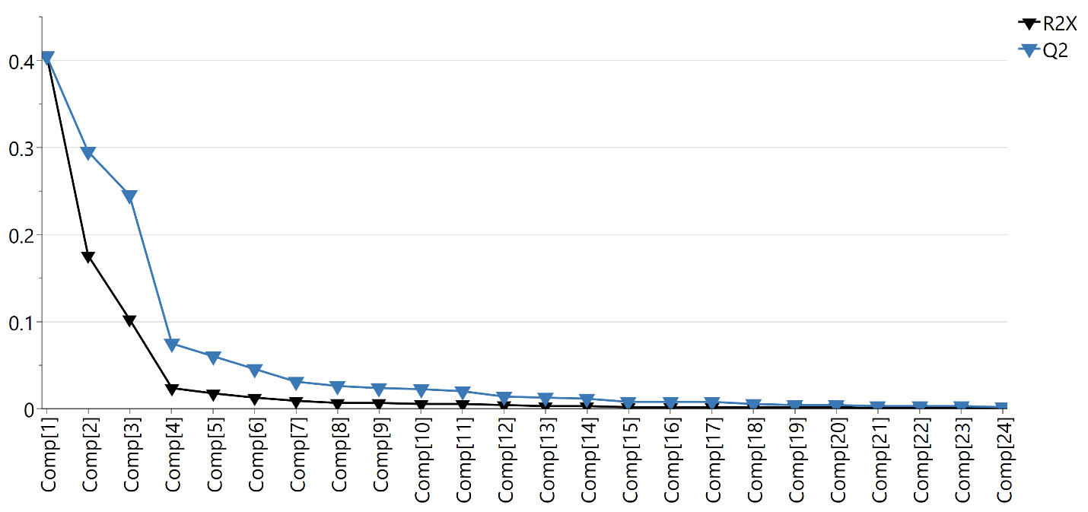
Figure S-1d. PCA scores images and corresponding R² and Q² values, ln-transformed data, dataset 1; cumulative R² 0.80, cumulative Q² 0.79.

t1 t2 t3 t4 t5 t6 t7
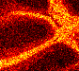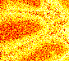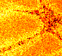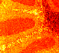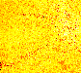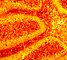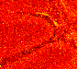
t8 t9 t10 t11 t12 t13 t14
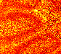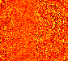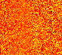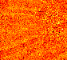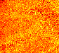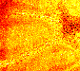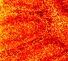
t15 t16 t17 t18 t19 t20 t21
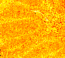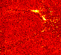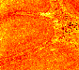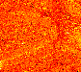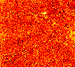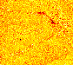
t22 t23 t24 t25 t26
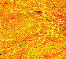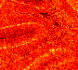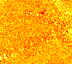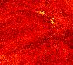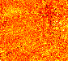
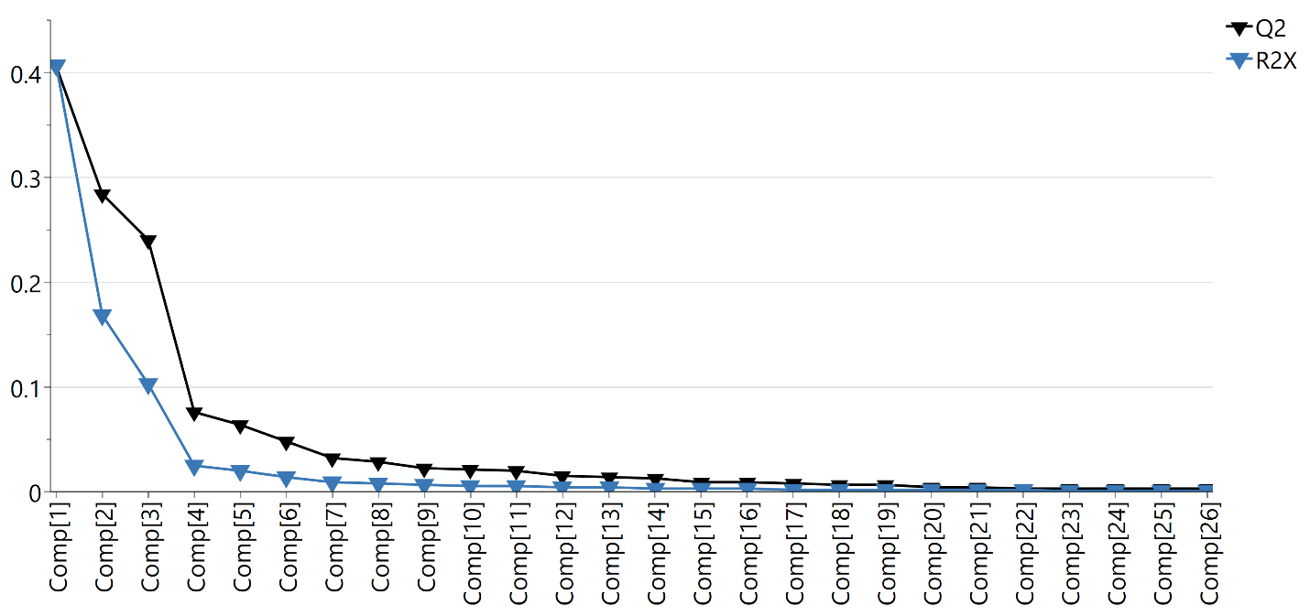
Figure S-1e. PCA scores images and corresponding R² and Q² values, ln-median-processed data, dataset 1; cumulative R² 0.80, cumulative Q² 0.79.

t1 t2 t3 t4 t5 t6
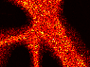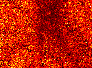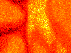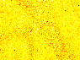
t7 t8 t9 t10 t11 t12
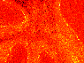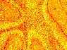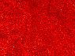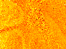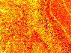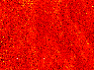
t13 t14 t15 t16
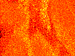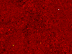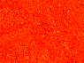
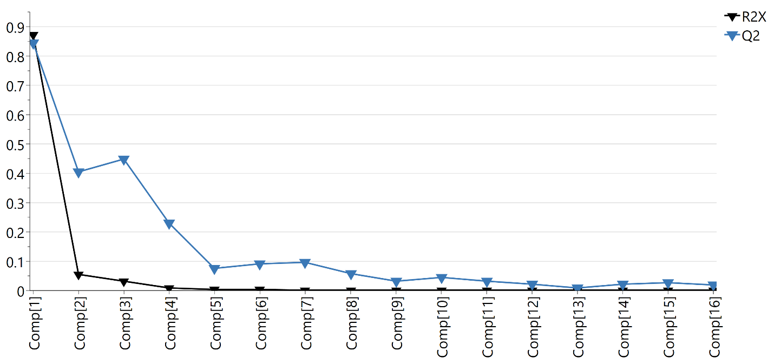
Figure S-2a. PCA scores images and corresponding R² and Q² values, raw data, dataset 2; cumulative R² 0.99, cumulative Q² 0.98.

t1 t2 t3 t4 t5 t6
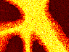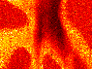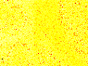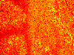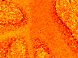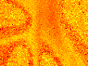
t7 t8 t9 t10 t11 t12
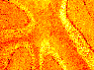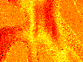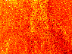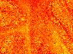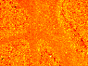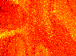
t13 t14 t15
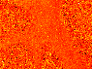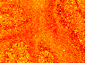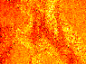
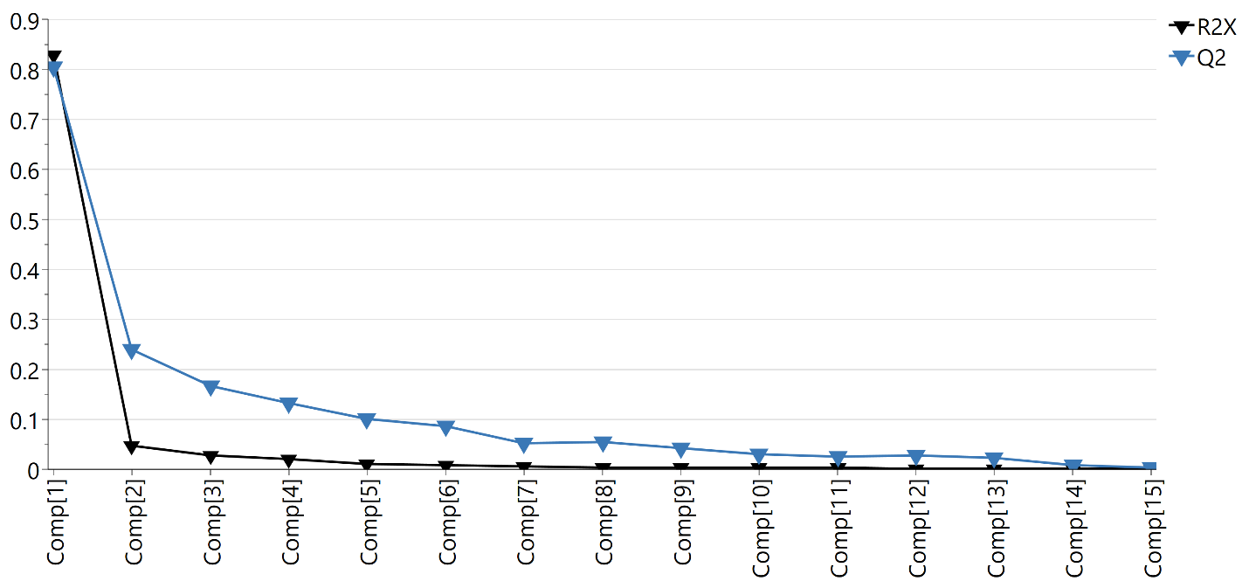
Figure S-2b. PCA scores images and corresponding R² and Q² values, TIC normalized data, dataset 2; cumulative R² 0.97, cumulative Q² 0.93.

t1 t2 t3 t4 t5 t6
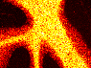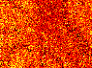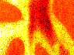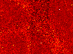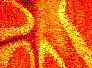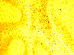
t7 t8 t9 t10 t11 t12
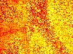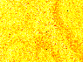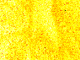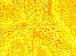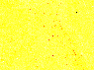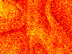
t13 t14 t15 t16 t17 t18
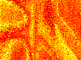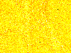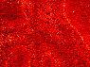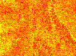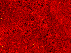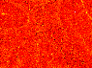
t19 t20 t21 t22 t23 t24
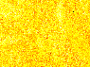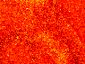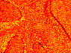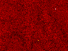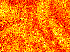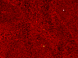
t25 t26 t27
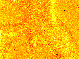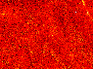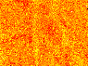
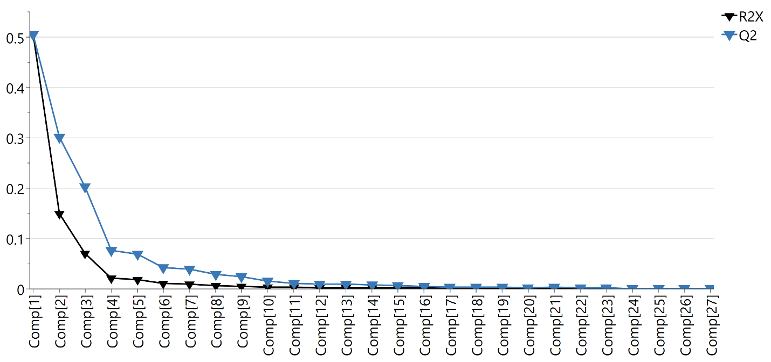
Figure S-2c. PCA scores images and corresponding R² and Q² values, ln-transformed data, dataset 2; cumulative R² 0.84, cumulative Q² 0.81.
t1 t2 t3 t4 t5 t6
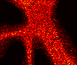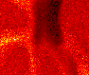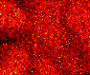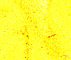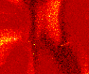
t7 t8 t9 t10 t11 t12
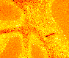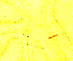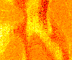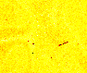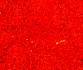
t13 t14 t15 t16 t17 t18
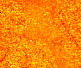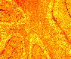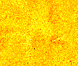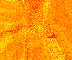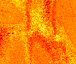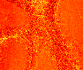
t19 t20
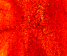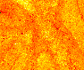
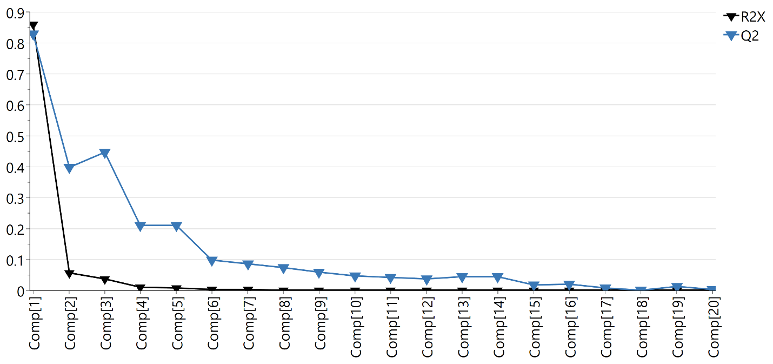
Figure S-3a. PCA scores images and corresponding R² and Q² values, raw data, dataset 3; cumulative R² 0.99, cumulative Q² 0.98.

t1 t2 t3 t4 t5 t6
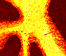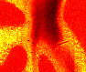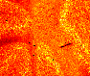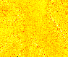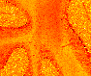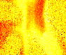
t7 t8 t9 t10 t11 t12
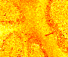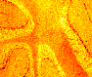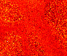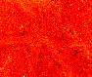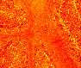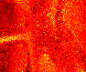
t13 t14 t15 t16 t17
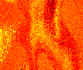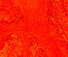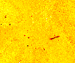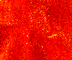
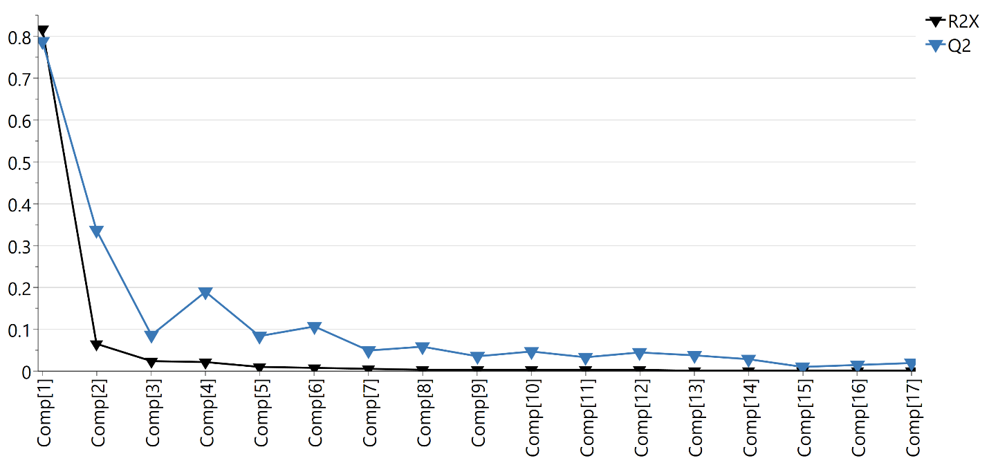
Figure S-3b. PCA scores images and corresponding R² and Q² values, TIC normalized data, dataset 3; cumulative R² 0.97, cumulative Q² 0.94.

t1 t2 t3 t4 t5 t6
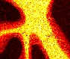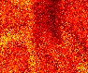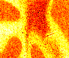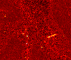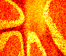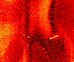
t7 t8 t9 t10 t11 t12
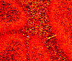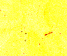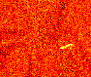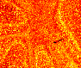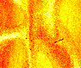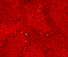
t13 t14 t15 t16 t17 t18
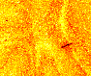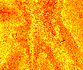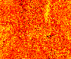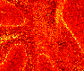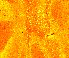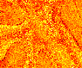
t19 t20 t21 t22 t23 t24
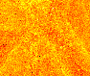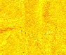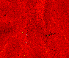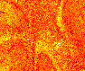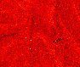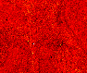
t25 t26 t27
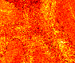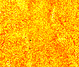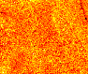
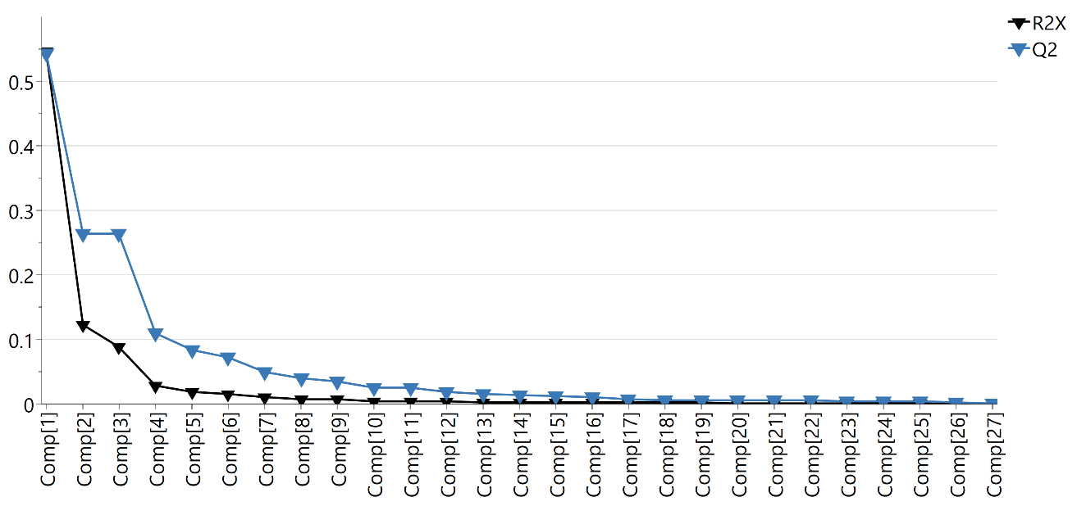
Figure S-3c. PCA scores images and corresponding R² and Q² values, ln-transformed data, dataset 3; cumulative R² 0.88, cumulative Q² 0.86.
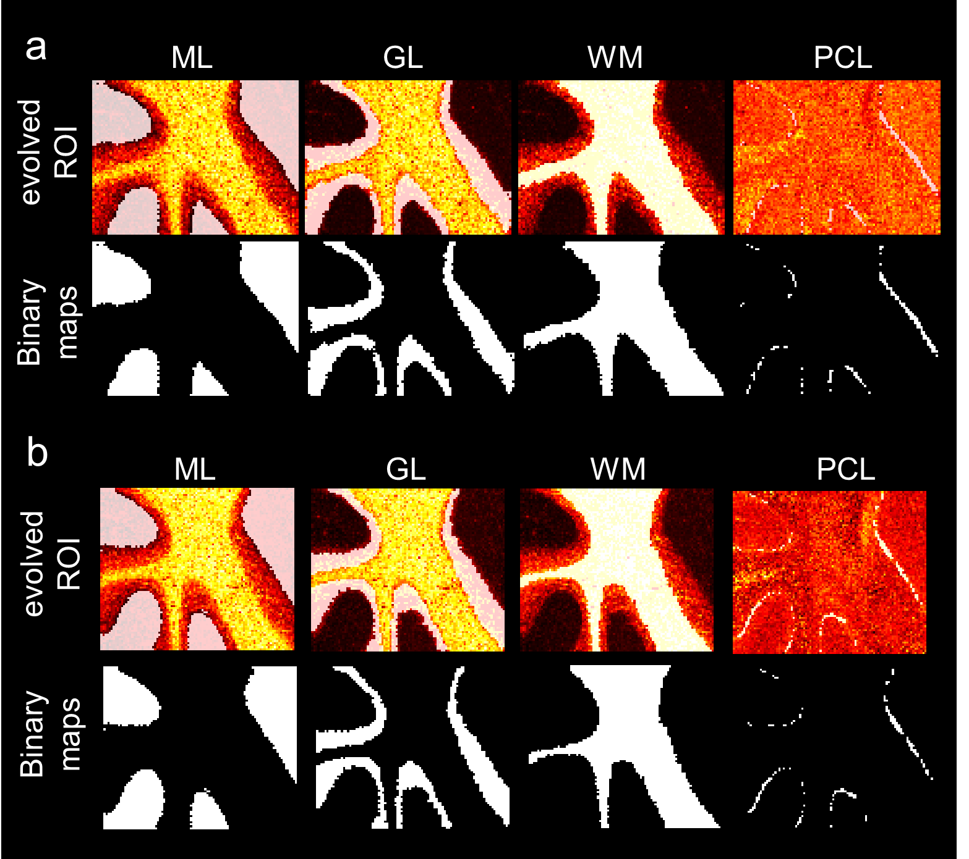
Figure S-4. Binary maps obtained through AC segmentation for (a) dataset 2 and (b) dataset 3.

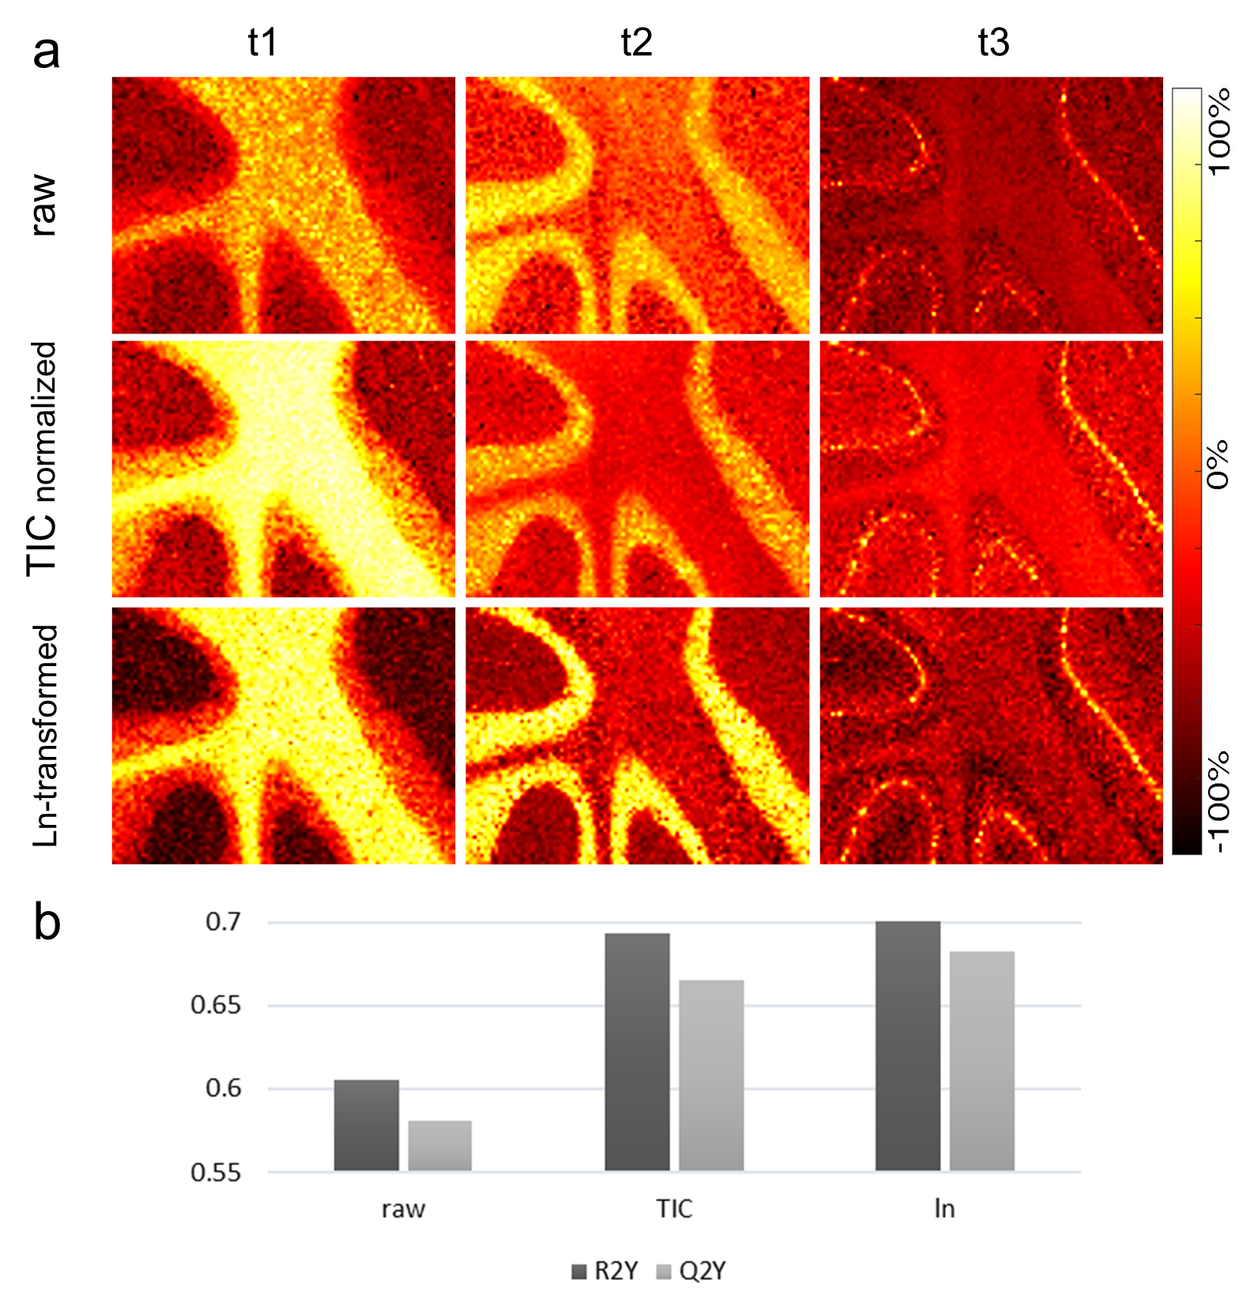
Figure S-5. OPLS-DA modelling results from differentially processed data for dataset 2. (a) OPLS-DA scores images; (b) OPLS-DA model quality metrics, R²Y and Q²Y, signifying the cumulative explained, respectively, predicted fraction of variation in the Y-block.

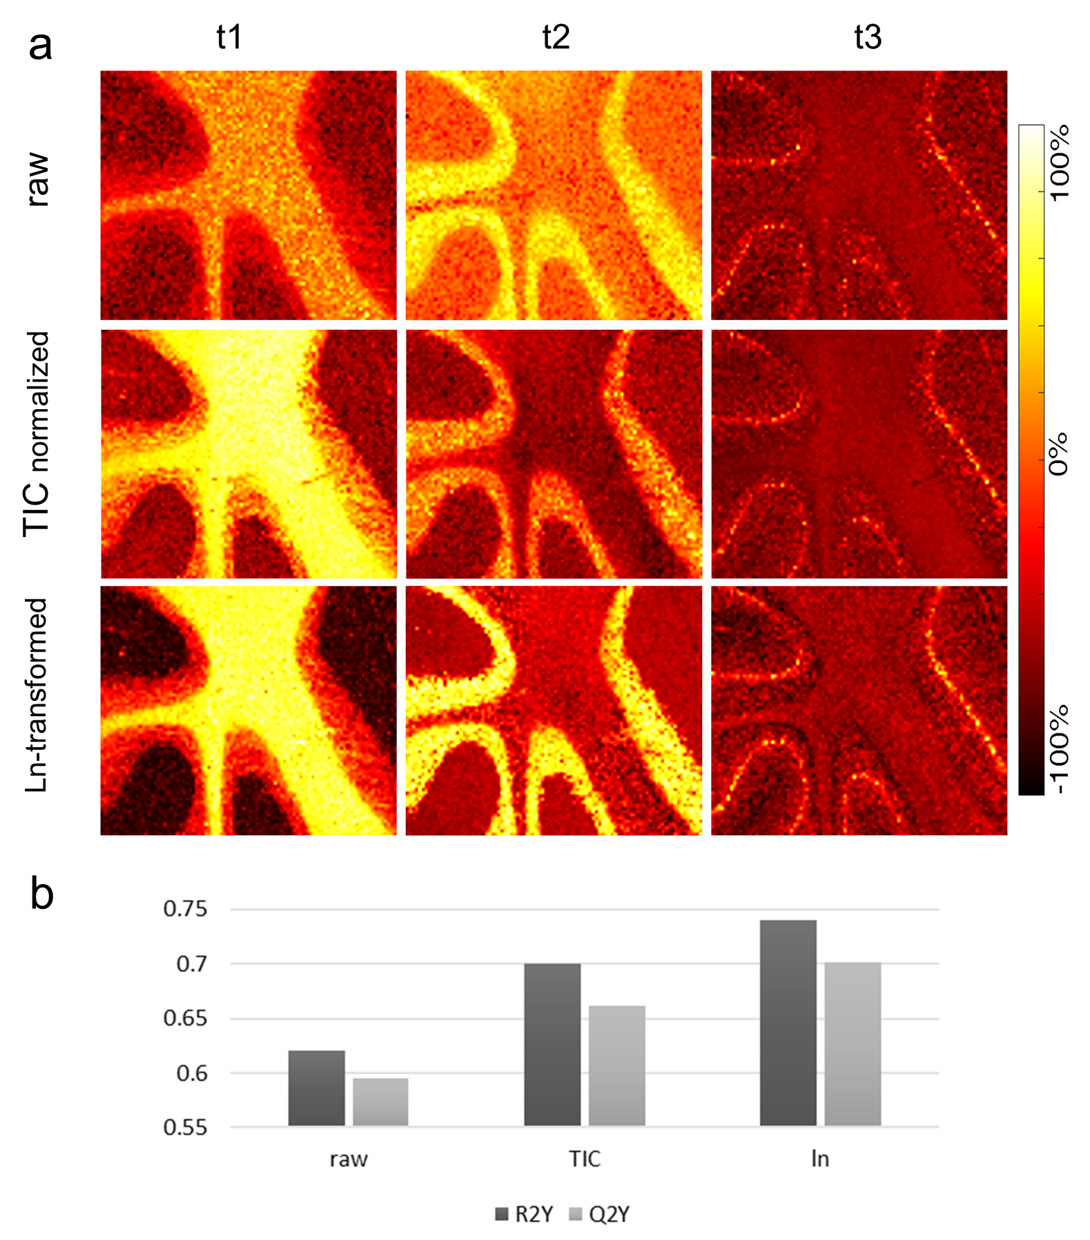
Figure S-6. OPLS-DA modelling results from differentially processed data for dataset 3. (a) OPLS-DA scores images; (b) OPLS-DA model quality metrics, R²Y and Q²Y, signifying the cumulative explained, respectively, predicted fraction of variation in the Y-block.

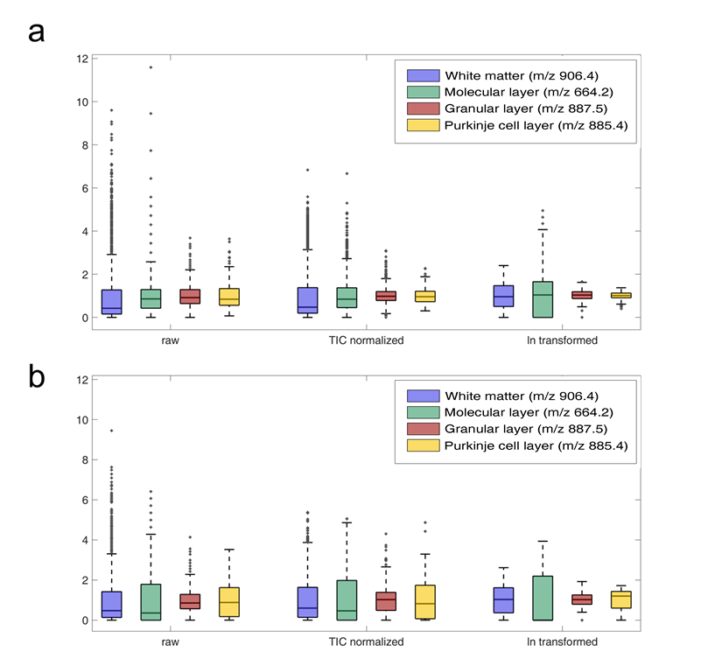
Figure S-7. Box plots of mean centered intensities of ions localizing to the ROI before and after data processing. (a) dataset 2, (b) dataset 3.

