Density and population structure of the jaguar (Panthera onca) in a protected area of Los Llanos, Venezuela from one year of camera trap monitoring
Jędrzejewski W., Puerto M. F., Goldberg J. F., Hebblewhite M., Abarca M., Gamarra G., Calderón L. E., Romero J. F., Viloria Á. L., Carreño R., Robinson H. S., Lampo M., Boede E. O., Biganzoli A., Stachowicz I., Velásquez G., Schmidt K.

Supplementary materials, Appendix A
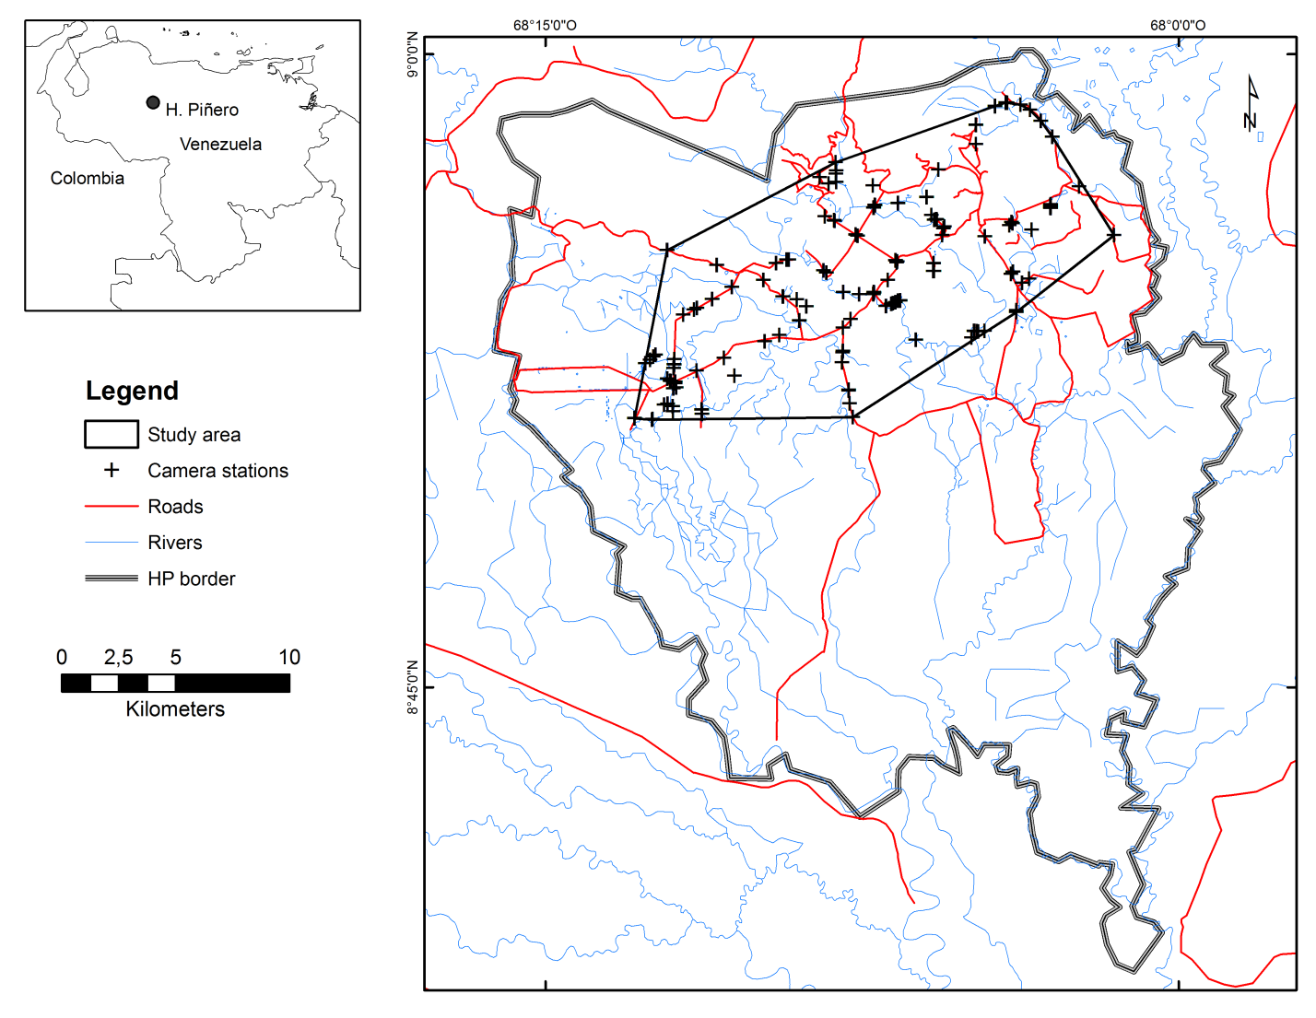
Fig. A1. Location of the study area and distribution of camera traps for jaguars inside the Hato Piñero ranch, Venezuela from July 2013 through July 2014.

