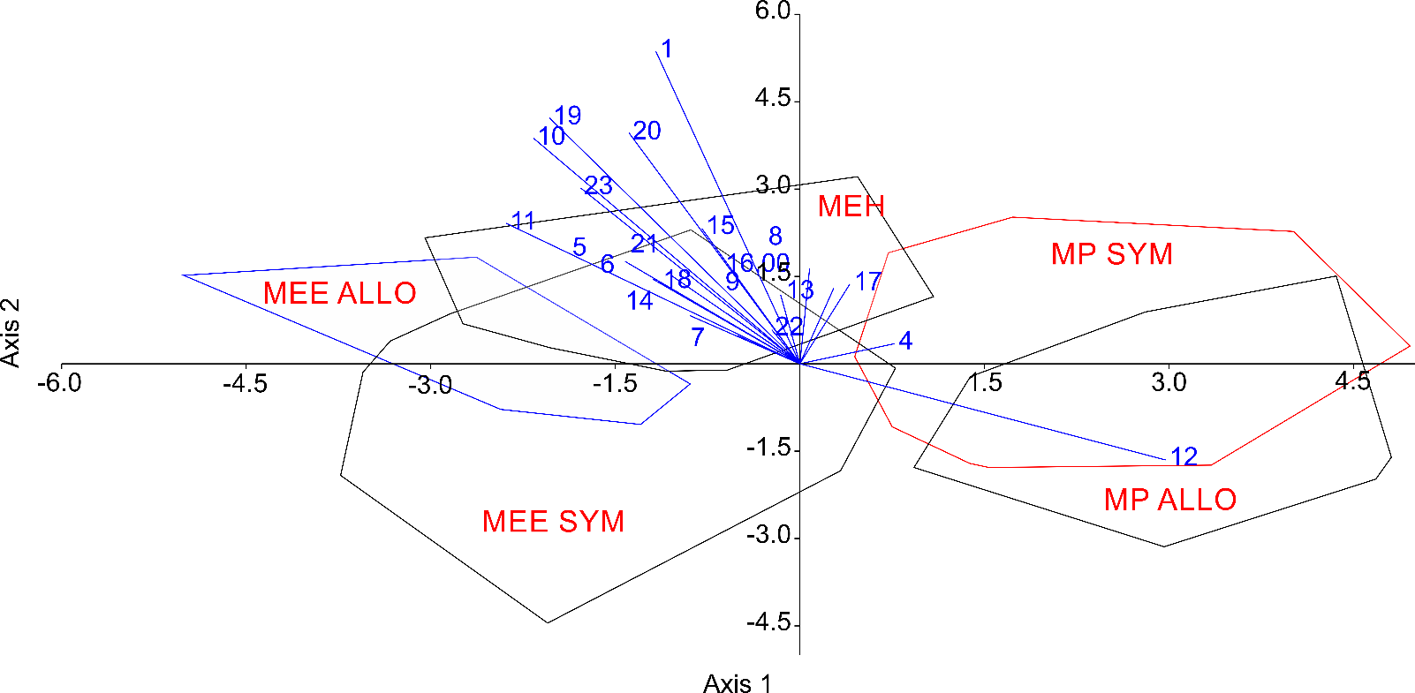
Figure S2, Supplementary figure: Projection of analysed specimens of mustelids in the morphological space as described along the first two axes of a linear discriminant analysis. Convex hulls show the dispersion of specimens within each group; for abbreviation see Tab. 1. Character vectors show relative contribution of the most important linear measurements.

