Supplementary material 1. Porcupine road–kill locations within each regional Province.

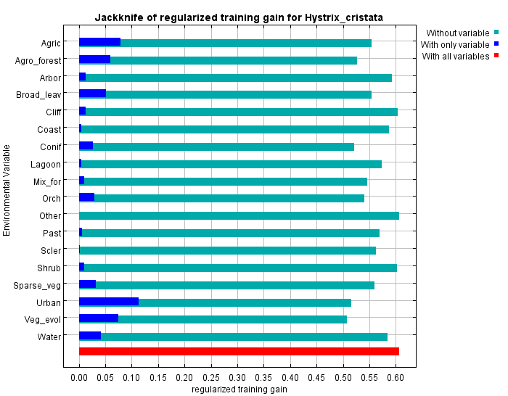
Supplementary material 2. Jackknife test of variable contribution. The plot shows the contribution of each environmental covariate to the model performance. Each bar depicts the gain (i.e., goodness–of–fit) of the model considering all the covariates, except the one shown in the y–axis (light blue bar), or with only that environmental variable (blue bar). The red bar depicts the gain of the model including all the covariates. Labels on the y–axis are listed: Agric = percentage of agricultural areas; Agro_forest = percentage share of agroforestry areas; Arbor = percentage share of arboriculture; Broad_leav = percentage share of broad–leaved forests; Cliff = percentage share of cliff areas; Coast = percentage share of coastal areas; Conif = percentage share of coniferous forests; Lagoon = percentage share of lagoons and swamps; Mix_for = percentage share of mixed forests; Orch = percentage share of orchards, vineyards, and olive groves; Other = percentage share of other categories; Past = percentage share of open pastures and grasslands; Scler = percentage share of sclerophyllous vegetation; Shrub = percentage share of areas moors and shrublands; Sparse_veg = percentage share of areas with sparse vegetation; Urban = percentage share of urban areas; Veg_evol = percentage share of areas with woody and shrubby vegetation in evolution; Water = percentage share of water bodies.

