- Small mammal species common names, scientific names, and four-letter abbreviations
Hispid pocket mouse (Chaetodipus hispidus) CHHI
Ord’s kangaroo rat (Dipodomys ordii) DIOR
Longtailed vole (Microtus longicaudus) MILO
Prairie vole (Microtus ochrogaster) MIOC
Meadow vole (Microtus pennsylvanicus) MIPE
House mouse (Mus musculus) MUMU
Northern grasshopper mouse (Onychomys leucogaster) ONLE
Olivebacked pocket mouse (Perognathus fasciatus) PEFA
Silky pocket mouse (Perognathus flavus) PEFL
Plains pocket mouse (Perognathus flavescens) PEFV
North American deer mouse (Peromyscus maniculatus) PEMA
Western harvest mouse (Reithrodontomys megalotis) REME
Plains harvest mouse (Reithrodontomys montanus) REMO

- Trapping effort graph
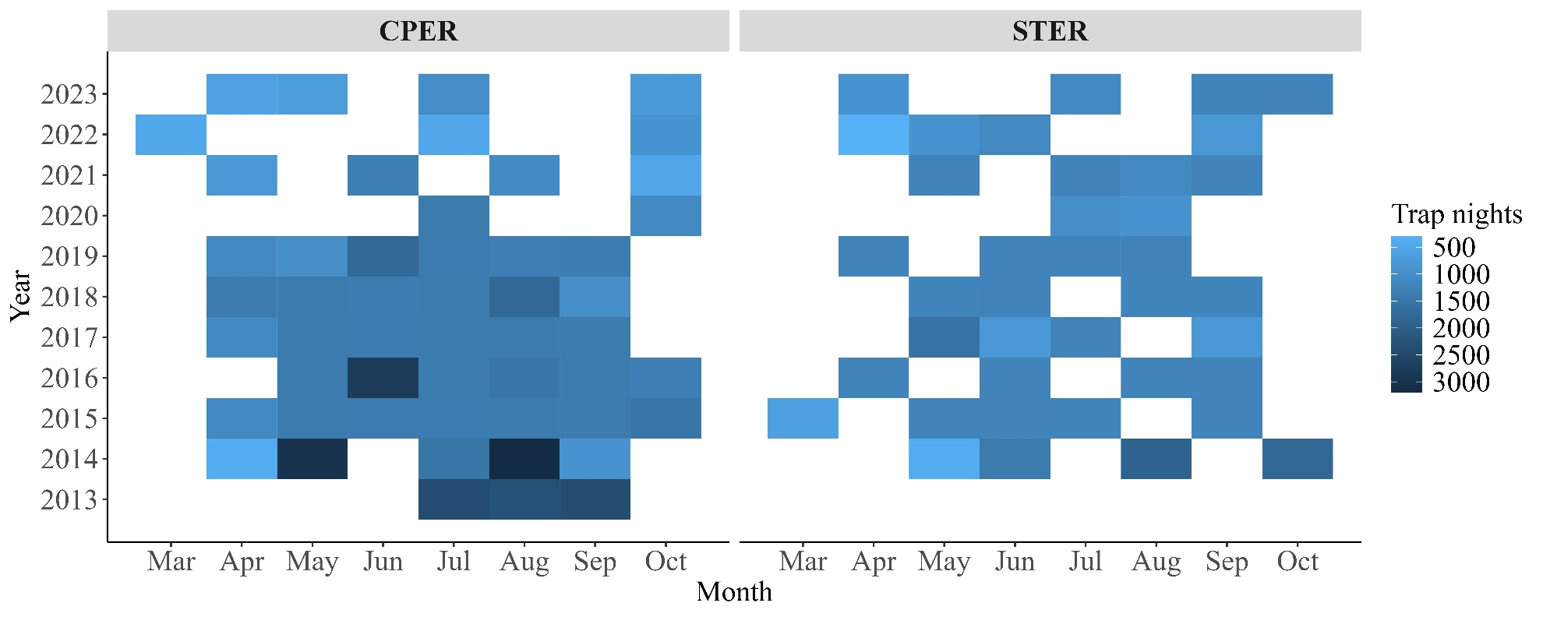
Fig. S1 Tile graph showing trap night efforts during each bout of trapping from 2013-2023 from two National Ecological Observatory Network (NEON) sites in Colorado, United States. CPER is a native shortgrass prairie site whereas is an active agricultural site.

- Temporal autocorrelation analysis
Table S1. Generalized linear model results on year or month in relation to capture rates and diversity indices. Regression estimate reported as the first value, p value reported as the second value. Significant temporal autocorrelations are highlighted in bold. Site CPER (the native shortgrass prairie site) was used as the reference level in the regression for site comparison.
 | CHHI | DIOR | MIOC | MIPE | ONLE | PEFL | PEFV | PEMA | REME | REMO | Total | Richness | Shannon | Simpson
Year | 0.023 | 0.331 | -0.441 | -0.352 | -0.082 | 0.133 | 0.719 | -0.136 | -0.234 | -0.332 | -0.059 | -0.023 | -0.005 | 0.002
Year | 0.606 | <0.001 | 0.032 | 0.196 | 0.124 | 0.034 | 0.157 | 0.041 | 0.005 | <0.001 | 0.087 | 0.158 | 0.707 | 0.678
Month | 0.158 | -0.095 | 0.141 | 0.149 | 0.043 | -0.089 | 0.216 | -0.144 | 0.082 | -0.024 | 0.007 | 0.016 | 0.017 | 0.008
Month | 0.026 | 0.451 | 0.499 | 0.629 | 0.603 | 0.397 | 0.586 | 0.148 | 0.451 | 0.841 | 0.900 | 0.512 | 0.396 | 0.357
Site | 1.774 | -1.864 | -0.478 | -1.142 | 3.009 | -3.995 | -1.404 | 3.087 | -1.030 | -1.265 | 0.926 | -0.131 | -0.180 | -0.031
Site | <0.001 | <0.001 | 0.592 | 0.432 | <0.001 | <0.001 | 0.480 | <0.001 | 0.031 | 0.030 | <0.001 | 0.176 | 0.026 | 0.341

- NMDS stressplot

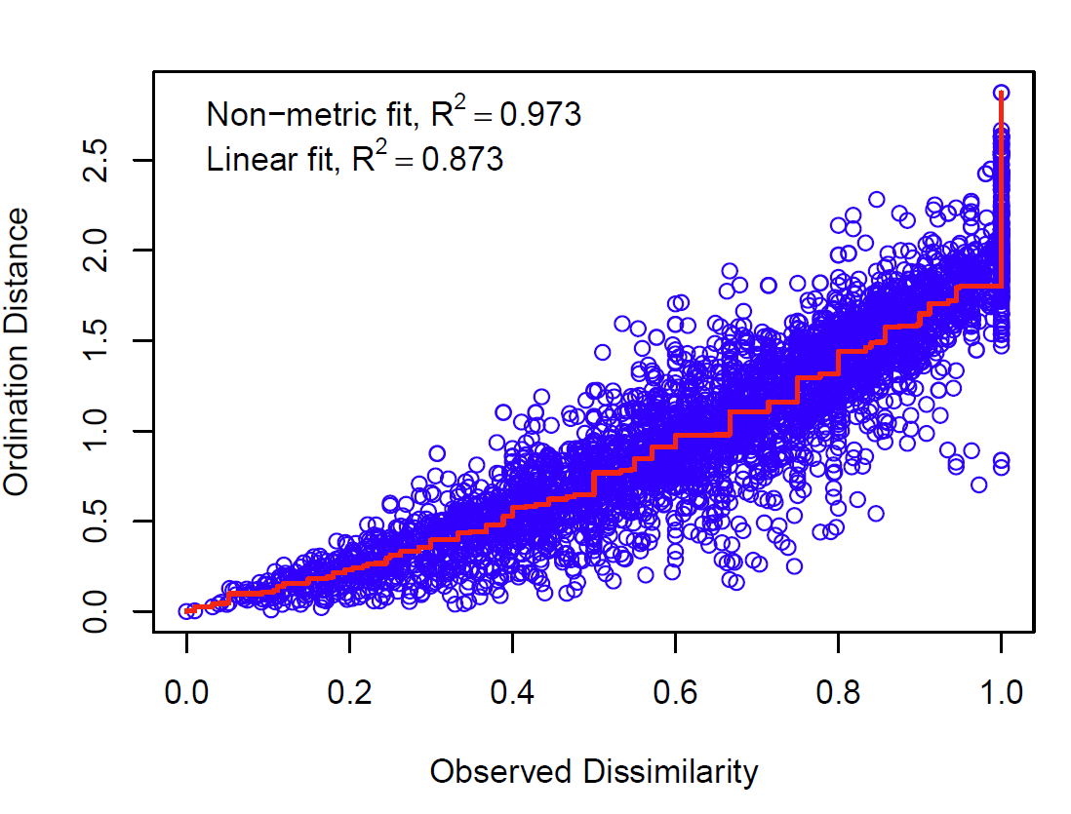
Fig. S2. NMDS stressplot to evaluate ordination quality. NMDS had a stress value of 0.164 and was plotted as Fig 1 in the manuscript.

- NMDS ordination graph for season
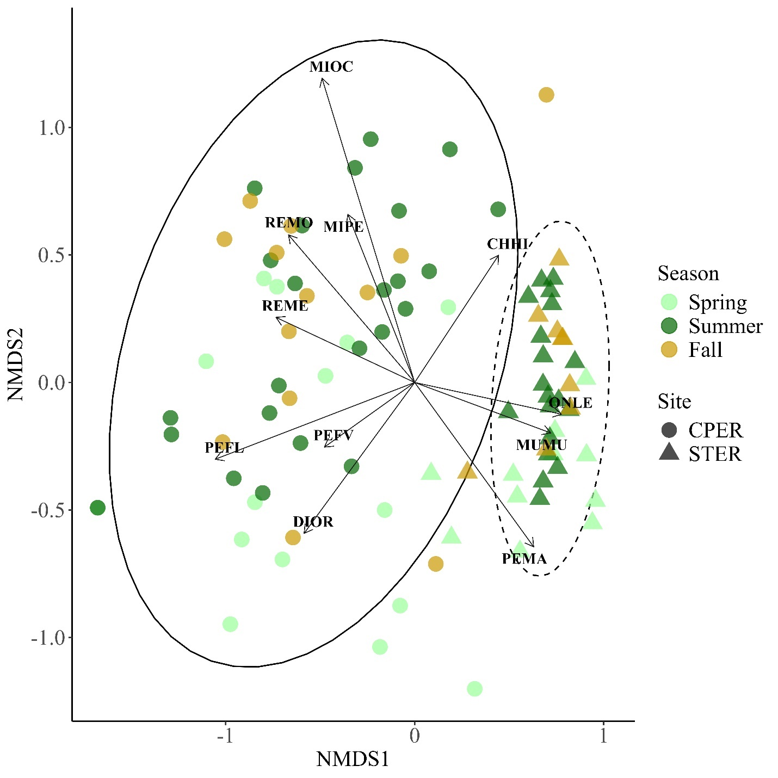
Fig S3. The two-dimensional non-metric multidimensional scaling (NMDS) ordination plot showing two sites in Colorado, United States, with small mammal community compositional differences (NMDS stress = 0.164, using Bray-Curtis distance). Seasonal variation highlighted by color light green – spring, dark green – summer, and yellow – fall. Seasons are defined as spring – April and May, summer – June to August, fall - September and October. Sites indicated by plot shapes. CPER (circle) is a native shortgrass prairie site whereas STER (triangle) is an active agricultural site. Ovals represent confidence intervals within which 95% of communities would be expected to fall in the ordination.

