Supplementary Material - S2

Title: Mechanisms driving variation in American marten winter rest site use across the Western Great Lakes Region
Journal: Mammal Research

Corresponding Author: Taylor B. Velander, Natural Resources Research Institute, Forest and Land Research Group, Duluth, Minnesota, USA. Email: velan018@d.umn.edu
Ron A. Moen, Natural Resources Research Institute, Forest and Land Research Group, Duluth, Minnesota, USA & University of Minnesota-Duluth, Department of Biology, Duluth, MN, USA
Angela M Kujawa, Little River Band of Ottawa Indians, Natural Resources Department, Manistee, Michigan, USA
Robert L. Sanders, Little River Band of Ottawa Indians, Natural Resources Department, Manistee, Michigan, USA
Paul W. Keenlance, Grand Valley State University, Biology Department, Allendale, Michigan, USA
John Erb, Minnesota Department of Natural Resources, Forest Wildlife Populations and Research Group, Grand Rapids, Minnesota, USA
Michael J. Joyce, Natural Resources Research Institute, Forest and Land Research Group, Duluth, Minnesota, USA

Introduction/Methods
We used a linear mixed effect model to assess the relationship between average daily microsite temperature and ambient temperature and to test whether this relationship differed across ground and tree cavity microsites during periods of snowpack. Fixed effects included ambient temperature as a continuous covariate, microsite type (ground or tree cavity) as a categorical covariate, and their two-way interaction. The analysis was performed in R (R Core Team 2021; Version 4.1.1) using the package ‘nlme’ (Pinheiro et al. 2025). The model controlled for two types of correlation. First, temporal autocorrelation was controlled by fitting residuals continuous time AR(1) autocorrelation structure (corCAR1), which models the decay of correlation between measurements as a function of the time difference between them. Second, the model explicitly controlled for spatial dependency using nested random intercepts for each site and for sites within the same forest stand. This structure accounted for the variance associated with site heterogeneity and the spatial clustering caused by ground sites being within the same stands. Preliminary results showed a continuous autoregressive coefficient (Phi(Φ)) of 0.67, indicating high temporal autocorrelation. We performed a post-hoc pairwise comparison on the estimated marginal slopes and intercepts (the intercept when ambient temperature is zero) of the relationship between site type and ambient temperature across both study areas using the package ‘emmeans’ (Lenth and Piaskowski 2025). For this analysis, we combined data from both study areas for each microsite type. We assessed assumptions of normality and equal variance using normalized residuals and standard diagnostic plots (quantile-quantile plots, plots of residuals versus predictor variables, and scale location plots).

Results
There were significant main effects of ambient temperature (β = 0.75, t = 159.9, df = 8272, P < 0.001; Table S2-1 and S2-2) and a significant interaction between microsite type and ambient temperature (β = -0.60, t = -92.1, df = 8272, P < 0.001) (Table S2-1). When ambient temperature was 0 C, ground microsites were significantly warmer than tree cavities (β = 1.3, t = 5.4, df = 46, P < 0.001). Average daily tree cavity and ground-level temperatures were similar when ambient temperatures were around 0℃ (x = 1.1℃ in Fig. 2). As ambient temperature increased above or decreased below ~0℃, the relative difference between ground-level microsites and tree-cavities increased, where ground-level microsites were warmer when ambient temperatures were below 0℃, and tree cavities were warmer when ambient temperatures were above 0℃ (Fig. S2-1).

Table S2-1 Model output of a linear mixed effect model that modeled microsite temperature as a function of ambient temperature, microsite type (ground or tree cavity), and their two-way interaction. The model accounted for temporal autocorrelation and used nested random intercepts for each site where microsite temperatures were measured and for sites that were located within the same forest stand.
Predictor | Estimate (β) | DF | t-value | p-value
(Intercept) | -1.1 | 8272 | -8.5 | < .0001
Microsite Type (Ground) | 1.3 | 46 | 5.5 | < .0001
Ambient Temperature | 0.8 | 8272 | 159.9 | < .0001
Microsite Type*Ambient  Temperature | -0.6 | 8272 | -92.1 | < .0001

Table S2-2 Summary of random effect variance and temporal autocorrelation for a linear mixed effect model (LMM). The LMM modeled daily mean microsite temperature as a function of daily mean ambient temperature, microsite type (ground or tree cavity), and their two-way interaction. Temperatures were collected at ground and tree cavity microsites in the Superior National Forest, Minnesota USA and the Huron-Manistee National Forest, Michigan USA. The model accounted for temporal autocorrelation and used nested random intercepts for each site where microsite temperatures were measured (SiteID) and for sites that were located within the same forest stand (StandGroup). Values represent the standard deviation (StdDev) of the random intercepts at the stand and site levels, along with the within-site residual. The Phi coefficient indicates the strength of the day-to-day correlation between temperature observations within individual sites.

Component | Level | Parameter | Value
Random Effect | StandGroup | StdDev | 0.7
Random Effect | SiteID | StdDev | 0.3
Residual | Within-site | StdDev | 1.5
Correlation | Time (Day) | Phi (Φ) | 0.7

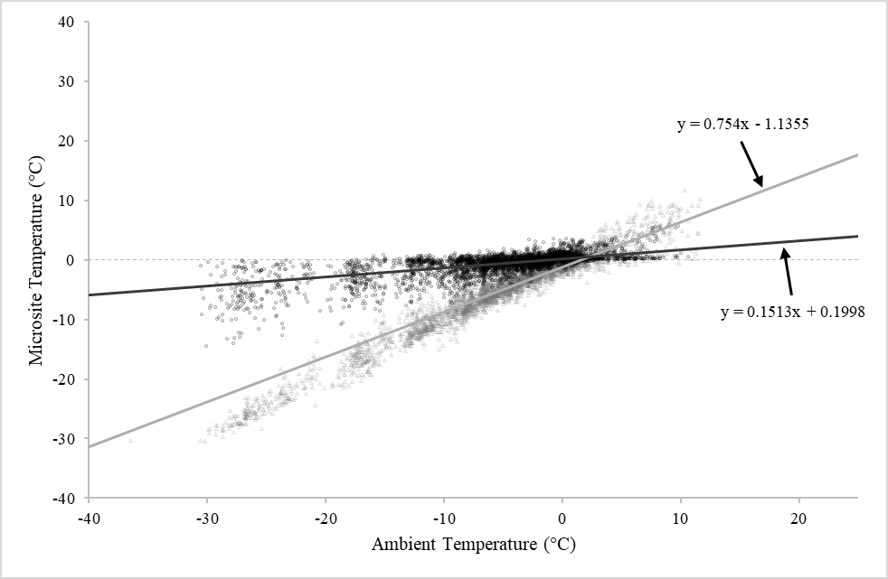
Fig. S2-1 Relationship between average daily ambient temperature and average daily microsite temperature in tree cavities (gray open triangles), and in ground-level microsites (black open circles). The solid gray and black lines represent the estimated marginal slopes for their respective microsite types. The gray dashed line represents 0 °C in microsites across ambient temperature. Data were collected in the Superior National Forest, Minnesota USA, and the Huron-Manistee National Forest, Michigan USA. Temperatures were measured during the winter from 2020-2021.

Literature Cited

Lenth R, Piaskowski J (2025). emmeans: Estimated Marginal Means, aka Least-Squares Means. R package version 2.0.1, https://rvlenth.github.io/emmeans/.
Pinheiro J, Bates D, R Core Team (2025). nlme: Linear and Nonlinear Mixed Effects Models. doi:10.32614/CRAN.package.nlme, R package version 3.1-168, https://CRAN.R- project.org/package=nlme.
R Core Team (2021) R: A language and environment for statistical computing. R Foundation for Statistical Computing, Vienna, Austria. https://www.R-project.org/

