Supplementary Materials.
Supplementary Table 1: HAM/TSP donor PBMCs.
Sample# | Donor ID# | Cells/ml | date | Gender
1 | NIC0071 | 3.0E+07 | 8/11/2015 | Male
2 | NC0560 | 2.0E+07 | 10/9/2014 | Female
3 | NIC0667 | 4.0E+07 | 5/31/2019 | Female
4 | NIC0745 | 5.0E+07 | 2/23/2009 | Male
5 | NIC1022 | 2.5E+07 | 7/17/2019 | Female
6 | NIC1026 | 5.0E+07 | 3/9/2012 | Female
7 | NIC1284 | 2.0E+07 | 1/23/2014 | Female
8 | NIC1306 | 5.5E+07 | 4/24/2014 | Male
9 | NIC2883 | 2.0E+07 | 7/12/2018 | Female
10 | NIC3024 | 4.0E+07 | 12/13/2019 | Male

Supplementary Table 2: CRISPR gRNAs targeting HTLV-1 NIC0071 isolate sequence.
#guideId | targetSeq | mitSpecScore | cfdSpecScore | offtargetCount
312rev | AGACCGCCACCGGTACCGCTCGG | 100 | 99 | 7
791rev | ATGGGGGTATTTGACGCGCGAGG | 99 | 99 | 9
1993rev | GCGGCAGAACGCGACTCAACCGG | 99 | 100 | 9
2034rev | CTAGACGGCGGACGCAGTTCAGG | 99 | 98 | 8
789rev | GGGGGTATTTGACGCGCGAGGGG | 98 | 99 | 20
790rev | TGGGGGTATTTGACGCGCGAGGG | 98 | 99 | 23
1984rev | CGCGACTCAACCGGCGTGGATGG | 98 | 99 | 7
1988rev | AGAACGCGACTCAACCGGCGTGG | 98 | 99 | 8
150rev | GGGCTGGAAGCGCTAACGATGGG | 97 | 99 | 26
323forw | CCGCTCCCGCCGAGCGGTACCGG | 97 | 99 | 22

Supplementary Table 3: Nominated off-target sites for HTLV-1 gRNAs env-312rev and 3’LTR-2034rev.
Off-target site name | offtargetSeq | mismatchPos | Mismatch# | chrom  location | strand | locusDesc
312rev-OFF1-Chr1 | AGACCACCACAGGTAAAGCTAGG | .....*....*....**... | 4 | chr1:  62410291-62410313 | + | intergenic:KANK4-USP1
312rev-OFF2-Chr5 | AGAGCGCCACTGGTGCCTCTAGG | ...*......*...*..*.. | 4 | chr5:  51173198-51173220 | + | intergenic:RNU6-1296P-CTD-2314G24.2
312rev-OFF3-Chr6 | GGACCCCAACCGGTACCCCTCGG | *....*.*.........*.. | 4 | chr6:  52237137-  52237159 | - | exon:IL17F
312rev-OFF4-Chr7 | AGACCACCACCAGTTCTGCTAGG | .....*.....*..*.*... | 4 | chr7:  43873767-43873789 | + | intergenic:MRPS24-URGCP
312rev-OFF5-Chr16a | AGGCCGCCGCGGGTGCCGCTGGG | ..*.....*.*...*..... | 4 | chr16:  25257609-25257631 | + | exon:ZKSCAN2
312rev-OFF6-Chr16b | AGACCGACACTGGTAGCCCTGGG | ......*...*....*.*.. | 4 | chr16:  23792032-23792054 | - | intergenic:CHP2-PRKCB
312rev-OFF7-Chr17 | ACACCGCCACCGAGACCGGTAGG | .*..........**....*. | 4 | chr17:  16535650-16535672 | + | intergenic:LRRC75A-ZNF287
2034rev-OFF1-Chr1 | CTAGAAGGCTGCCCCAGTTCAGG | .....*...*.*.*...... | 4 | chr1:  9347845-9347867 | + | intron:SPSB1
2034rev-OFF2-Chr2 | CTAAACGGAGAACACAGTTCTGG | ...*....*.*..*...... | 4 | chr2:  46096341-46096363 | + | intron:PRKCE
2034rev-OFF3-Chr6 | CTGGAAGGATGACGCAGTTCTGG | ..*..*..**.......... | 4 | chr6:  158543296-158543318 | + | intron:TMEM181
2034rev-OFF4-Chr10 | CTGGACCGCGGAGGCAGTGCAGG | ..*...*.....*.....*. | 4 | chr10:  97914641-97914663 | + | intron:CRTAC1
2034rev-OFF5-Chr11 | GTAGACGGCGGCAGCAGCTCCGG | *..........**....*.. | 4 | chr11:  73264540-73264562 | - | exon:P2RY6
2034rev-OFF6-Chr18 | CCAGAAGGCGGAAGCAGCTCAGG | .*...*......*....*.. | 4 | chr18:  8967036-8967058 | + | intergenic:MTCL1-NDUFV2/RP11-21J18.1
2034rev-OFF7-Chr20 | TCAGACGGAGGACGCAGCTCAGG | **......*........*.. | 4 | chr20:  63785722-  63785744 | + | intron:ZBTB46
2034rev-OFF8-ChrX | CAAGATGGCTGAGGCAGTTCTGG | .*...*...*..*....... | 4 | chrX:  27866672-27866694 | + | intergenic:MAGEB10-DCAF8L1

Supplementary Table 4: gRNAs and primers.
Name | Sequence 5’-3’
gRNAs:
HTLV-1 env-312rev | AGACCGCCACCGGTACCGCTCGG
HTLV-1 env-791rev | ATGGGGGTATTTGACGCGCGAGG
HTLV-1 3’LTR-1993rev | GCGGCAGAACGCGACTCAACCGG
HTLV-1 3’LTR-2034rev | CTAGACGGCGGACGCAGTTCAGG
mouse SLC22a17-218forw (non-targeting control gRNA) | GCCCGTGCTTTTCGTGGCGCTGG
On-target PCR primers
env-Forward-set1 | ATGACCATGAGCCCCAAA
3’LTR-Reverse-set-1 | GATCAAGGCCTCGTCTGTTC
env-Forward-set2 | GAGCCCTCTATACCATGGAAATC
3’LTR-Reverse-set-2 | TAACGGCGCAGAACAGAAA
env-Forward-set3 | CACTTGGCACGTCCTATACTC
qPCR TaqMan primers/probe
tax-Forward | CGGATACCCAGTCTACGTGTT
tax-Reverse | CAGTAGGGCGTGACGATGTA
tax-probe-FAM | CTGTGTACAAGGCGACTGGTGCC
hTert-Forward | TGGAGCAAGTTGCAAAGCAT
hTert-Reverse | CAGAGCCTTGCACAGAATCC
hTert-probe-HEX | CCGGCCTCAGCATGCGCCTG
Off-target PCR primers
312rev-OFF1-Forward* | CCCAAGAAGTTGATGGTGACA
312rev-OFF1-Reverse** | TCTTCAAGCCAAGGGCAAA
312rev-OFF2-Forward* | CCACCAGCTATGCCTTTCA
312rev-OFF2-Reverse** | TCGCATTGACCTTCTTTAGGAT
312rev-OFF3-Forward* | ACCTTCTCCAACTGGAAAGAAA
312rev-OFF3-Reverse** | TGAACACTCAGTGCTGTGG
312rev-OFF4-Forward* | CAGGATAGGTTTATGGCCAAATTA
312rev-OFF4-Reverse** | CATGTCAGATCAGGATTCATCTTT
312rev-OFF5-Forward* | GGGTGTGTCCGCTACTC
312rev-OFF5-Reverse** | TCCGGGCGGAACAGTTT
312rev-OFF6-Forward* | TGACAGTTAGCTGCCCAAATC
312rev-OFF6-Reverse** | TTCTTGTGCCCTCTGAGGTA
312rev-OFF7-Forward* | TTATTGCCAGTGTGTGGGT
312rev-OFF7-Reverse** | CGCAGTGTTCTTGGGAAATG
2034rev-OFF1-Forward* | CCAGCATCTTCATCCTCATGT
2034rev-OFF1-Reverse** | CGTCAGAGCGAGATTCTGTTTA
2034rev-OFF2-Forward* | TTCTCAGTGTTCCATGGGAATTA
2034rev-OFF2-Reverse** | CCCTATCTCCAAATGCCATC
2034rev-OFF3-Forward* | CCTGGCCTCAGAGTATGTTTATT
2034rev-OFF3-Reverse** | CGATACATCCCTGTTGCTTGA
2034rev-OFF4-Forward* | GGCTGTAATGCACAGGGTAG
2034rev-OFF4-Reverse** | CTTGAAGCCGGGACAGTG
2034rev-OFF5-Forward* | CAGCCTCTTCCAGACATCAC
2034rev-OFF5-Reverse** | AGGCCTCCCTGTATCCC
2034rev-OFF6-Forward* | GAAACGGTATGGCAATTCCTTAAA
2034rev-OFF6-Reverse** | ACTATGTTGTAACCTGTGTCTGAA
2034rev-OFF7-Forward* | GGGCCTTTGCTTCTATAAATGG
2034rev-OFF7-Reverse** | TTCCGAGTTGCTAAGATGAGG
2034rev-OFF8-Forward* | AACACAACTCAAACTGAACTGA
2034rev-OFF8-Reverse** | GTGGACAAGTGACATAAATGGA
Partial Illumina Adapter Sequences were added to the 5’-end of all off-target primers:
*For the forward sequencing read: 5’-ACACTCTTTCCCTACACGACGCTCTTCCGATCT-3’
**For the reverse sequencing read: 5’-GACTGGAGTTCAGACGTGTGCTCTTCCGATCT-3’

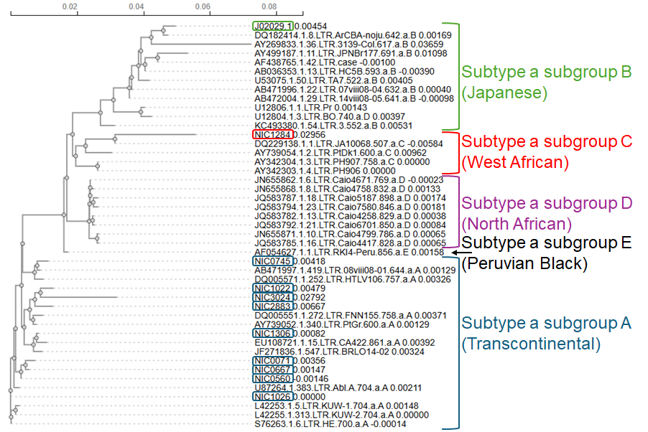
Supplementary Figure 1. HTLV-1 3’LTR sequences from our HAM/TSP cohort cluster with HTLV-1a-TC (subtype a (cosmopolitan) subgroup A (Transcontinental)) LTRs. A phylogenetic tree showing hierarchical clustering of HTLV-1 LTR sequences obtained from our cohort of ten HAM/TSP patients and LTR sequences extracted from the public HTLV-1 molecular epidemiology database (Araujo 2012). All LTR sequences in the database derive from subtype a (cosmopolitan). Ten of LTR sequences from each: subgroup A (Transcontinental, dark blue), B (Japanese, green) and D (North African, violet) were randomly selected for sequence alignment together with all available sequences for subgroup C (West African, 4 LTR sequences, red) and subgroup E (Peruvian, 1 LTR sequence, black).

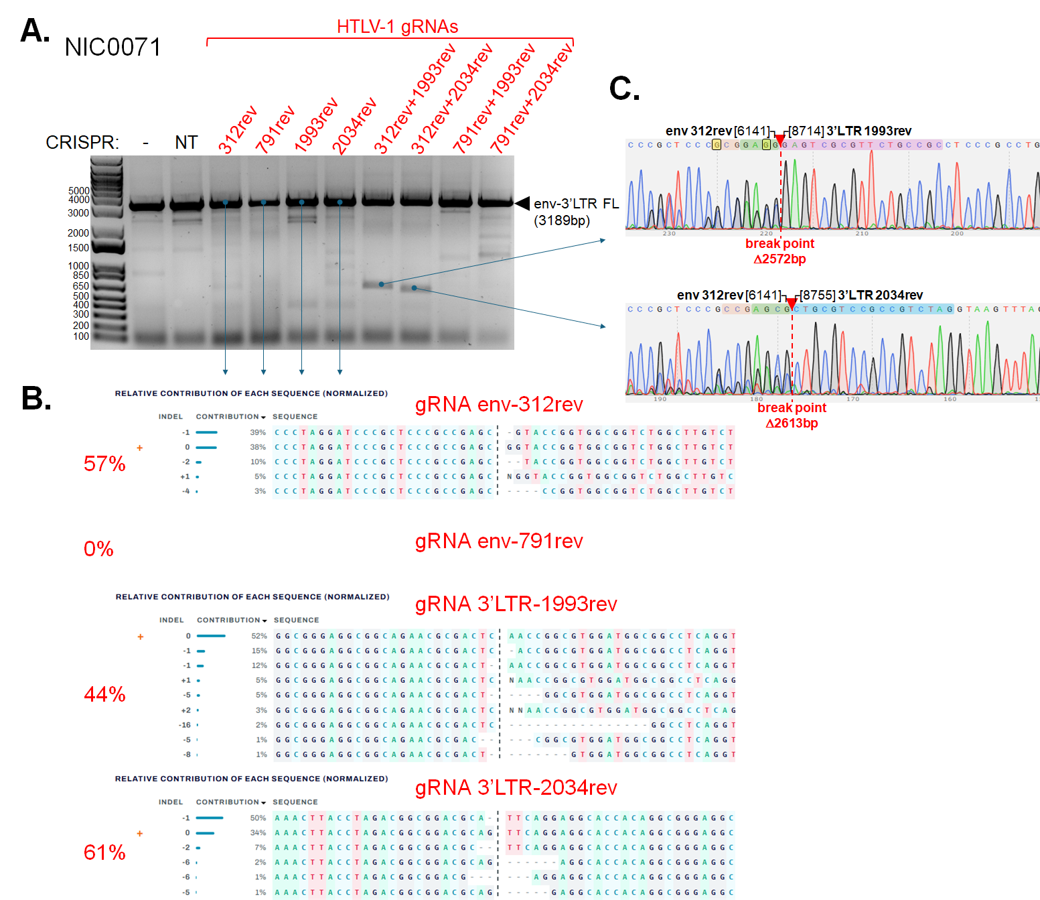
Supplementary Figure 2. CRISPR-mediated editing of env-3’LTR region of HTLV-1 genome in PBMCs from HAM/TSP donor NIC0071 (HTLV-1a-TC). A) Agarose gel picture of PCR genotyping of HTLV-1 env-3’LTR region from PBMCs of HAM/TSP donor NIC0071 2 days after treatment with non-targeting (NT) or HTLV-1 env and/or 3’LTR targeting (HTLV) Cas9/gRNA complexes. Black arrow points to 3189bp full-length env-3’LTR amplicon (Suppl.Table 4., PCR primer set 1). Blue arrows mark amplicons that were sent for Sanger sequencing verification. B) Sequence alignments obtained from ICE (inference of CRISPR edits) analysis of Sanger sequences of full-length amplicons from A). The sequences and frequencies of different InDel mutations detected at the gRNA target sites are shown. The total number of InDel mutations detected for each gRNA is shown on the left. C) Sanger sequencing chromatograms of truncated amplicons from A). gRNA env-312rev target site is highlighted in green, 3’LTR-1993rev target site in pink, 3’LTR-2034rev target site in blue, PAM sequences in red, and ambiguous/mismatched nucleotides in yellow. The site of CRISPR-excision “scars”, i.e., end-joined env-to-3’LTR sequences, are depicted by red arrows and a dashed red line (break point).
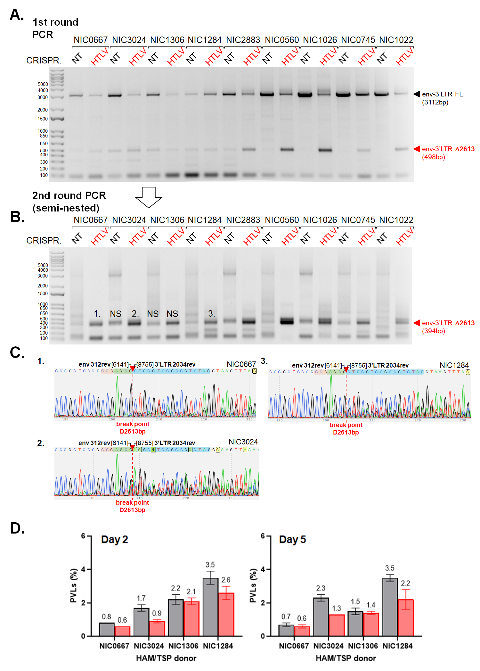
Supplementary Figure 3. CRISPR-mediated excision of env-3’LTR region of HTLV-1 genome in PBMCs from HAM/TSP patients with low PVLs. A) Agarose gel picture of PCR genotyping of HTLV-1 env-3’LTR region from five HAM/TSP patient PBMCs 2 days after treatment with non-targeting (NT) or HTLV-1-env+3’LTR targeting (HTLV) Cas9/gRNA complexes. Black arrow points to 3112bp full-length env-3’LTR amplicon (Suppl.Table 4., PCR primer set 2). Red arrow points to truncated 498bp amplicon resulting from CRISPR-mediated excision of 2613bp segment of HTLV-1 genome. B) Agarose gel picture of semi-nested PCR performed using as a template 3ul of PCR reactions shown in A) (Suppl.Table 4., env-Forward-set3 + 3’LTR-Reverse-set2). C) Sanger sequencing chromatograms of truncated amplicons from B) (6-8). gRNA env-312rev target site is highlighted in green, 3’LTR-2034rev target site in blue, PAM sequences in red, and ambiguous/mismatched nucleotides in yellow. The site of CRISPR-excision “scars”, i.e., end-joined env-to-3’LTR sequences, are depicted by red arrows and a dashed red line (break point). NS denotes non-specific, uninterpretable sequences (PCR artefact). D) qPCR quantification of proviral loads (PVLs) on day 2 (left) and 5 (right) post-CRISPR treatment. Grey bars represent cells treated with Cas9/gRNA complexes containing non-targeting gRNA (NT), and red bars represent cells treated with HTLV-1-env+3’LTR specific gRNAs (HTLV).
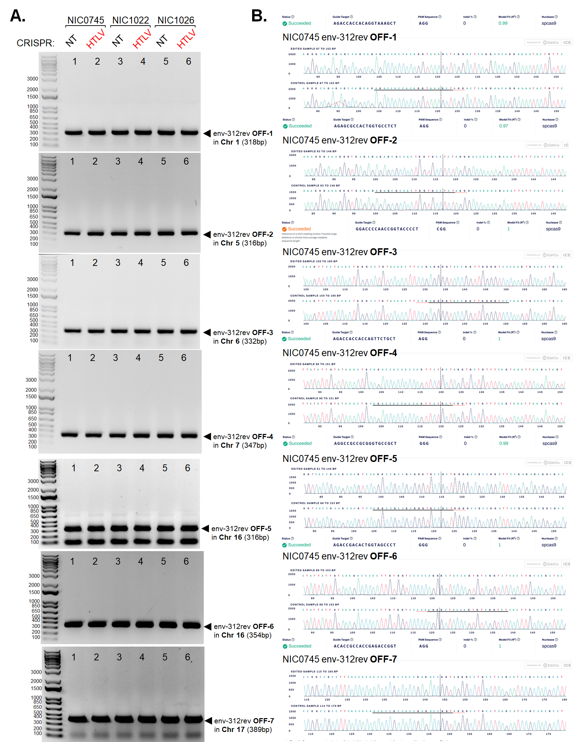

Supplementary Figure 4. Off-target analysis for HTLV-1 gRNA env-312rev. A) Agarose gel pictures of PCR genotyping of nominated off-target sites in the human genome for gRNA env-312rev. Genomic DNAs collected from three HAM/TSP patient PBMCs (NIC0745, lines 1-2, NIC1022, lines 3-4, and NIC1026, lines 5-6) 2 days after treatment with non-targeting (NT) or HTLV-1-env+3’LTR targeting (HTLV) Cas9/gRNA complexes were used as a template (same as used in Figure 1 and Figure 2). B) Example of Sanger sequencing chromatogram alignments obtained from ICE (inference of CRISPR edits) analysis of Sanger sequences of amplicons from A) for HAM/TSP donor NIC0745. No InDel mutations were detected in any of the three donors.
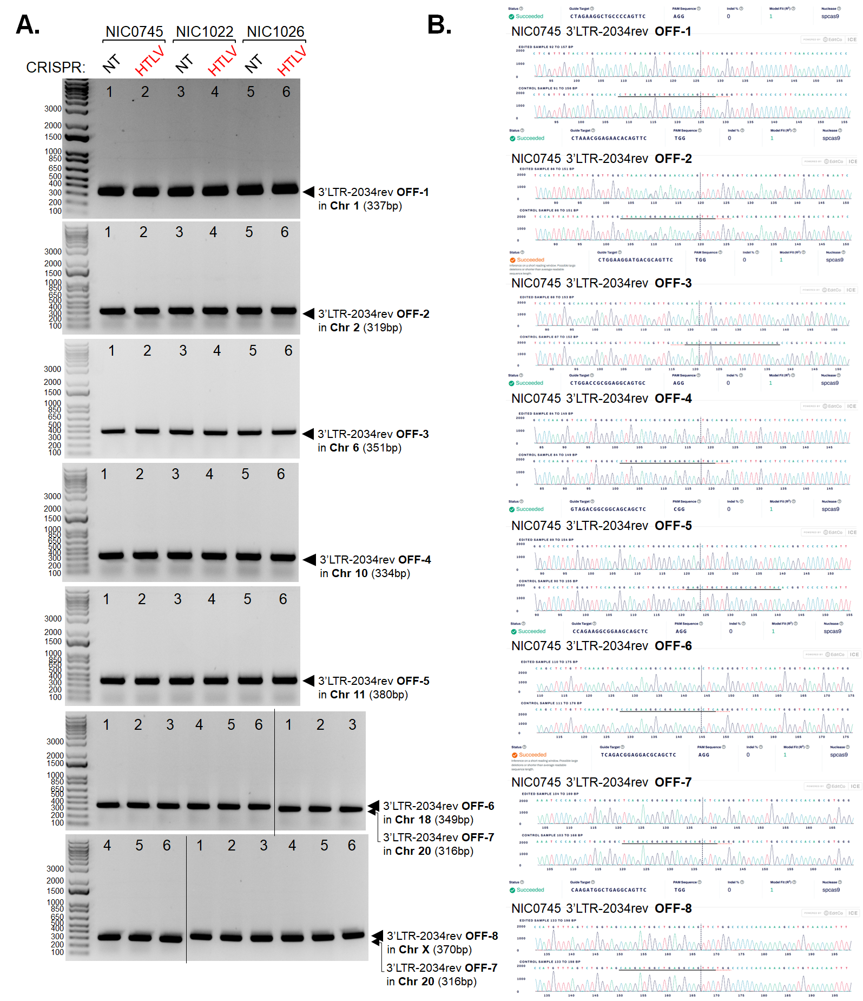

Supplementary Figure 5. Off-target analysis for HTLV-1 gRNA 3’LTR-2034rev. A) Agarose gel pictures of PCR genotyping of nominated off-target sites in the human genome for gRNA 3’LTR-2034rev. Genomic DNAs collected from three HAM/TSP patient PBMCs (NIC0745, lines 1-2, NIC1022, lines 3-4, and NIC1026, lines 5-6) 2 days after treatment with non-targeting (NT) or HTLV-1-env+3’LTR targeting (HTLV) Cas9/gRNA complexes were used as a template (same as used in Figure 1 and Figure 2). B) Example of Sanger sequencing chromatogram alignments obtained from ICE (inference of CRISPR edits) analysis of Sanger sequences of amplicons from A) for HAM/TSP donor NIC0745. No InDel mutations were detected in any of the three donors.

