Supplementary data

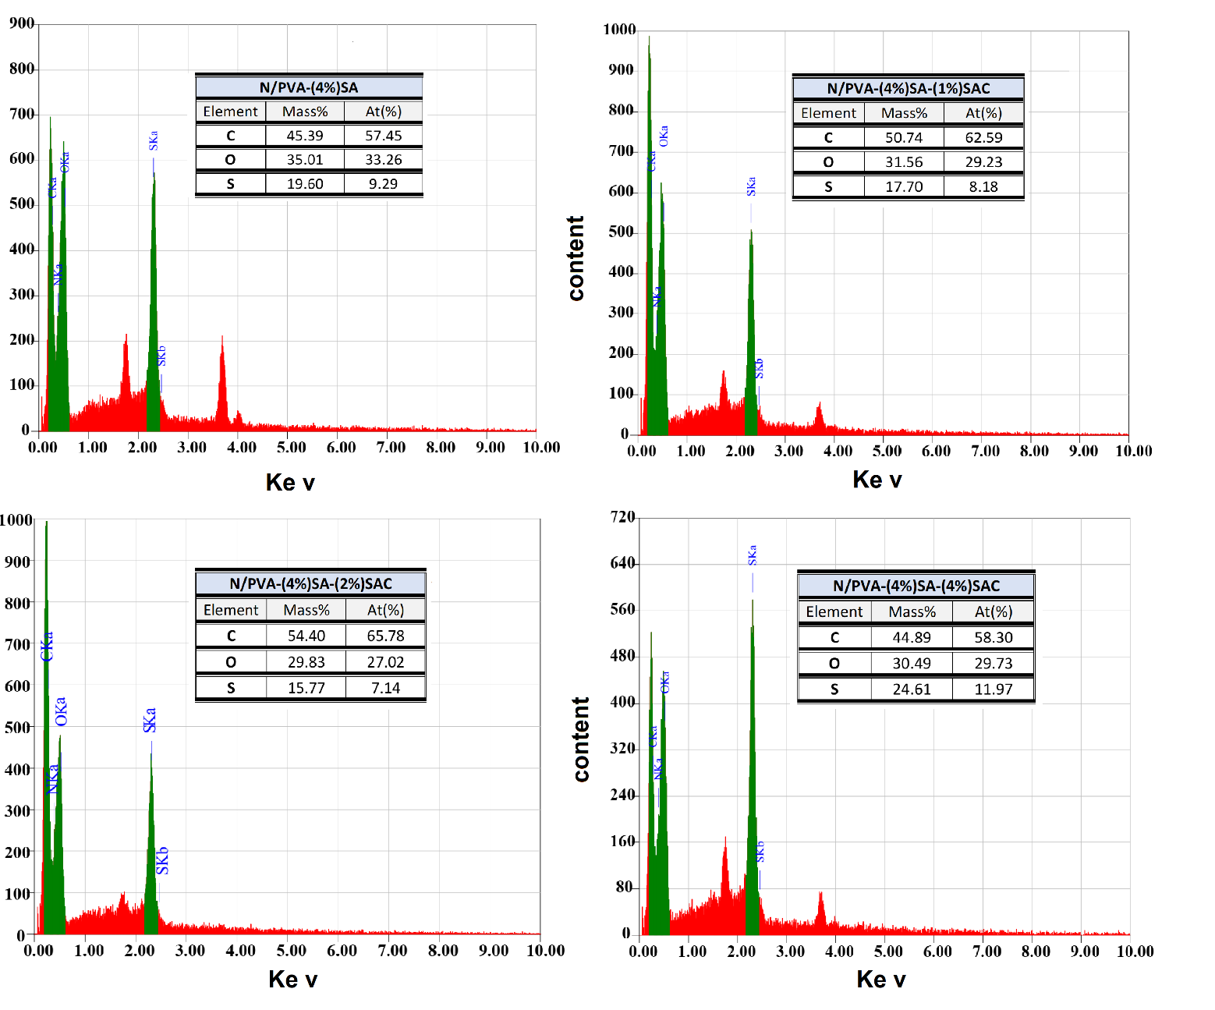
a
b
c
d

Supplementary 1 Energy dispersive X-ray (EDX) of N/PVA-SA-SAC based polyelectrolytic membranes with different SAC concentration (0 (a), 1 (b), 2 (c), and 4% (d)).

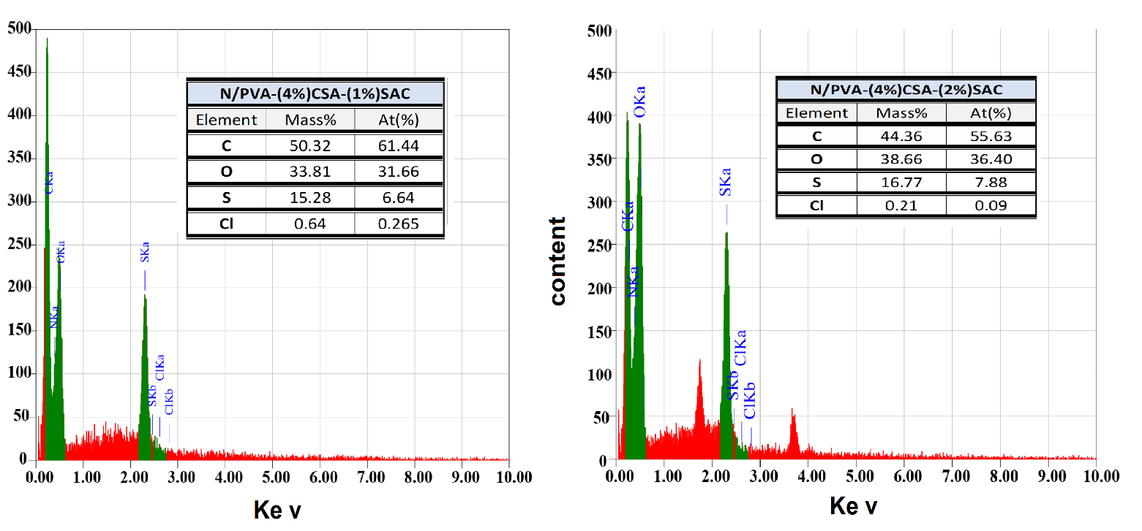
a
b

Supplementary 2 Energy dispersive X-ray (EDX) of N/PVA-(4%) CSA-SAC based polyelectrolytic membranes with different SAC concentration (1 (a) and 2% (b)).

