Table S1 . Antibacterial activity of ligand and their metal complexes

No. | Compound | Inhibition %
No. | Compound | S. pyogenes |  | E.coli
No. | Compound | 1µg/ml | 5µg/ml | 1µg/ml | 5µg/ml
 | B | 75.32 | 91.24 | 48.76 | 56.23
 | A | 74.40 | 95.32 | 52.11 | 66.76
B₁ | Cu(H₂L)I | 57.66 | 88.3 | 86.44 | 92.13
A₁ | Cu(H₂L)I | 88.41 | 94.31 | 82.8 | 86.50
B₂ | Cu(H₂L)₂(ClO₄)₂ | 64.5 | 96.16 | 70.55 | 54.92
A₂ | Cu(H₂L)₂(ClO₄)₂ | 90.34 | 94.82 | 97.63 | 89.34
B₃ | [Zn (H₂L)₂(H₂O)]SO₄ | 81.16 | 96.16 | 82.16 | 87.3
A₃ | [Zn (H₂L)₂(H₂O)]SO₄ | 91.42 | 93.23 | 92.6 | 96.83
B₄ | [Cd (H₂L)Cl]Cl | 48.23 | 58.31 | 43.66 | 32.8
A₄ | [Cd (H₂L)Cl]Cl | 74.42 | 65.03 | 56.63 | 46.43

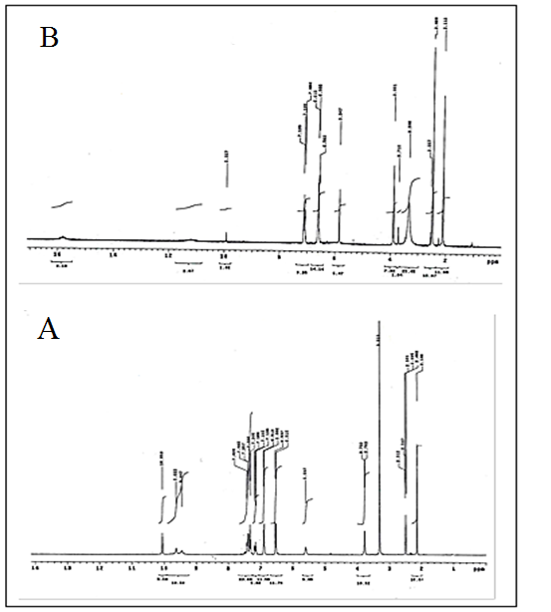
Fig . S₁. ¹H NMR spectra of ligands (B) before and after irradiation (A) in DMSO-d₆ solution

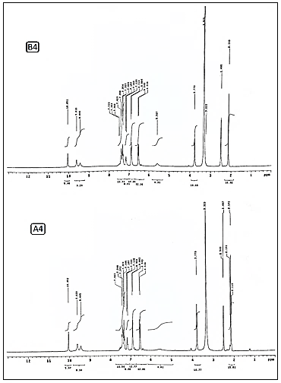
Fig .S2. ¹H NMR spectra of cadium complex (B₄) before and after irradiation (A₄) in DMSO-d₆ solution

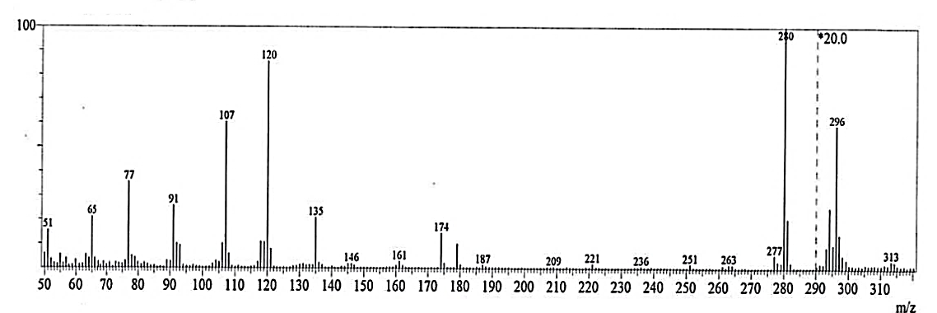
Fig.S3. Mass spectrum of ligand (B)
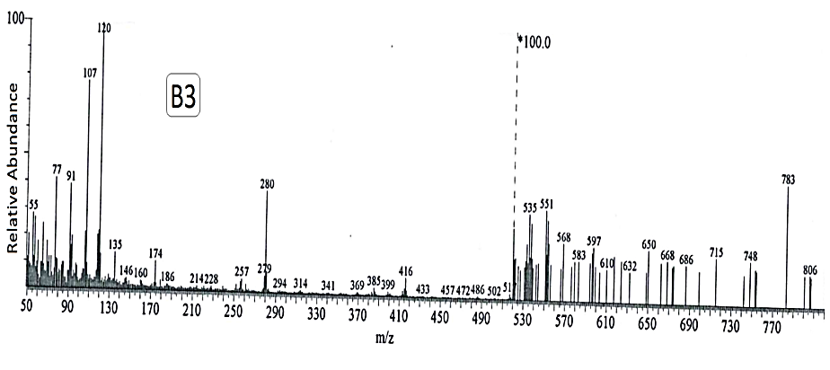
Fig.S4. Mass spectrum of zinc complex (B₃)

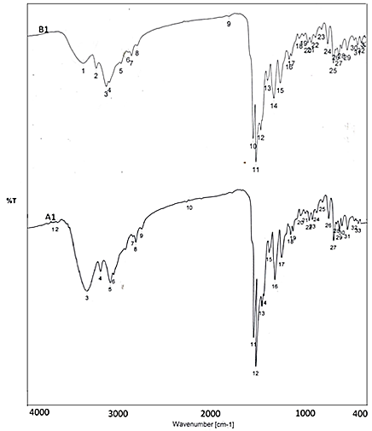
Fig. S5. IR spectra of copper(I) complexes before irradiation (B₁) and after irradiation (A₁)

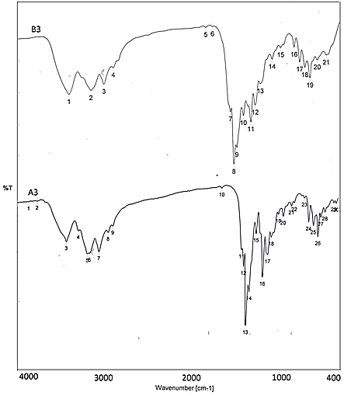
Fig.S6. IR spectra of zinc complexes before irradiation (B₃) and after irradiation (A₃)

Fig. S7. UV- spectra of copper complexes before and after irradiation(B₁ and A₁)
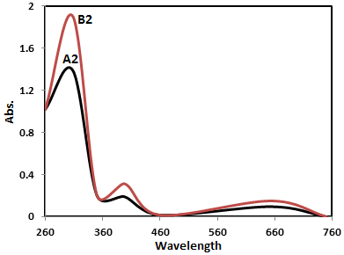
Fig. S8. UV- spectra of copper complexes before and after irradiation (B2and A2)

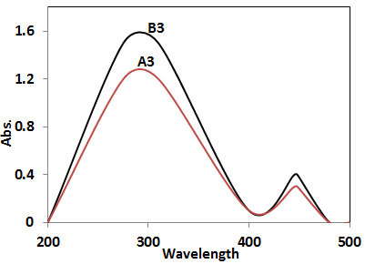
Fig.S9. UV- spectra of zinc(II) complexes before and after irradiation(B₃and A₃)

Fig.S10. UV- spectra of Cd(II) complexes before and after irradiation(B4 and A4)

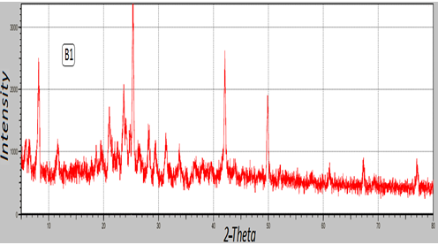

Fig . S11. XRD spectra of copper(I) complex before irradiation (B₁)

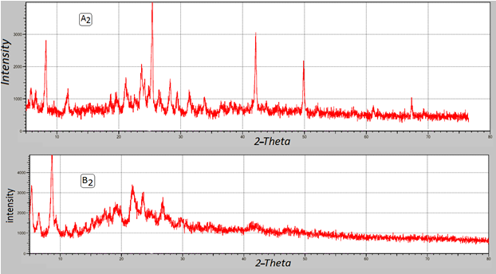
Figure S12. XRD spectra of copper(II) complexes before and after irradiation(B2 and A2)
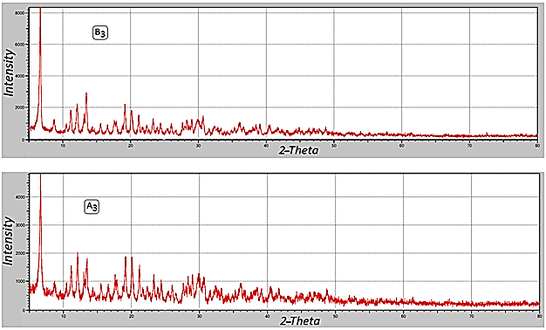
Figure S13. XRD spectra of zinc(II) complexes before and after irradiation(B3 and A3)

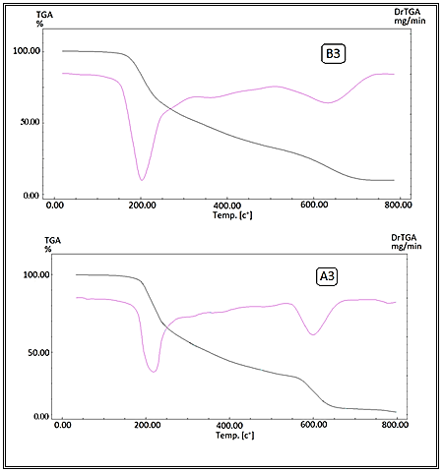
Fig.S14. TG/ DTG curves of complexes (B3) before irradiation, after irradiation (A3)

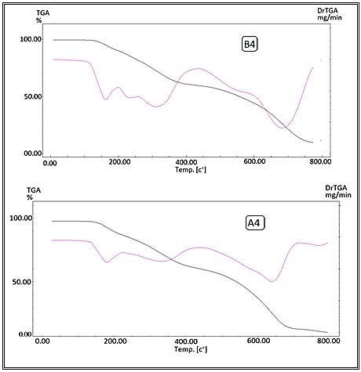
Fig. S15. TG/ DTG curves of complexes (B₄) before irradiation, after irradiation (A₄)

