Supporting Information

Decolorization of Congo Red and Reactive Black 5 dyes with horseradish peroxidase-immobilized cross-linked polymeric microbeads

Altynay Zhumabekovaª, Samir Abbas Ali Nomaª, Elif Tümay Özerª, Bilgen Osman^{a*}

ªBursa Uludag University, Department of Chemistry, Faculty of Arts and Science, Bursa, Turkey

1. Determination of parameters effecting enzyme activity
1.1. Effect of pH and temperature
To find the optimum pH of free HRP and PEDMT-HRP, the substrate was dissolved in different buffer solutions (pH 2.0-10.0), then activities were measured. Three types of buffers were used: 50 mM acetate buffer (pH 2.0-5.0), 50 mM phosphate buffer (pH 6.0–7.0), and 50 mM Tris-HCl buffer (pH 8.0-10.0). The pH with the highest enzyme activity was defined as the optimum pH of the enzyme.
The effect of temperature on free HRP and PEDMT-HRP activity was examined at different temperatures between 25 and 70 °C. The enzymes were incubated at different temperatures for 30 min, and then their activities were assayed by using a substrate solution with the optimum pH value. The temperature with the highest enzyme activity was determined as the optimum temperature of the enzyme.
1.2 Effect of H₂O₂ concentration
To determine the optimum H₂O₂ concentration, enzyme activities were measured at various H₂O₂ concentrations (1-5%, v/v). Enzyme activity measurements were completed as previously described: free HRP and PEDMT-HRP were incubated with o-dianisidine (6 mM, 2 mL) and 75 µL of H₂O₂ (1-5%, v/v) at optimum pH and temperature. The reactions were stopped by adding NaOH solution (1.5 M, 75 µL) to the reaction medium. Results were given as relative activity, assuming the highest activity as 100%.
1.3. Thermal and storage stability
The thermal stability was determined for the free HRP and PEDMT-HRP by incubating both in a water bath at 50 °C for 180 min. Aliquots were taken at different intervals (0-180 min), and the enzyme activities were measured at optimum conditions. The remainder of free HRP and PEDMT-HRP were then compared with the initial activities, which were considered to be 100% activity.
To determine the storage stability of free HRP and PEDMT-HRP, both enzyme samples were stored at room temperature (~25 °C) for 4 weeks. And the activity of both enzyme samples was measured every week according to the enzyme activity method specified. The first enzyme activity was considered 100 %, and subsequent activities were calculated relatively.
1.4. Metal ions and solvent effect
Free HRP and PEDMT-HRP were incubated in different metal ion solutions (5 mM, 1 mL) (Ag⁺, Ca²⁺, Co²⁺, Cu²⁺, Mg²⁺, Ni²⁺, Sc³⁺, Zn²⁺, Pb²⁺, and Fe³⁺) at room temperature for 24 h, and then their activities were measured under optimum conditions. Organic solvents such as dichloromethane (DCM), toluene, ethanol, diethyl ether, chloroform, benzene and dimethylsulfoxide (DMSO) were used to determine solvent effects on the enzyme activity. Free HRP and PEDMT-HRP were incubated with organic solvents (%5 v/v, 1 mL) at room temperature for 24 h, and their activities were measured. The activity in the absence of these compounds (metal ion solution and organic solvent) was assumed to be 100%.
2. Parameters effecting decolorization
2.1. Effect of pH
The impact of pH on dye decolorization was examined with free HRP and PEDMT-HRP. The maximum absorption wavelength of the dye solutions can change with the pH of the medium; thus, UV spectra were prepared between 200 nm to 800 nm for CR and RB5 solutions. It was observed that the maximum absorption wavelength of CR solution was changed between 487-560 nm depending on the pH, while RB5 solution has only one maximum absorption wavelength at 598 nm for all pHs. CR and RB5 solutions in the concentration of 20 mg/L were prepared with different buffers: acetate buffer (50 mM, pH 3.0-5.0), phosphate buffer (50 mM, pH 6.0-7.0), and Tris-HCl buffer (50 mM, pH 8.0-10.0). The reaction mixture consisted of 10 mL dye solution, 75 μL of H₂O₂ solution in the concentration of 3 % v/v (22.05 µmol H₂O₂), and 5 mg PEDMT-HRP or an equal amount of free HRP. The enzyme amount was 300 ng. The final concentration of H₂O₂ was 2.2x10 ⁻³ M. The molar ratio of H₂O₂/dye (CR and RB5) was 76 and 109.2 for CR and RB5, respectively. Decolorization was assessed by incubating the enzymes with the dye solutions at 25 °C for 2 h and measuring the absorbance by UV-visible spectrophotometer at the specific λmax values of CR and RB5 solutions. The highest decrease in the dye absorbance was accepted as optimum.
2.2. Effect of dye concentration
The effect of dye concentration was studied using dye solutions in the 5-100 mg/L concentration range. The reaction mixture included 10 mL of dye solution with a constant H₂O₂ concentration (3%,v/v) and a constant amount of both enzymes at room temperature (25 ºC). The experiments were performed at the optimum pH value, which was determined before. The dye concentration, which had a maximum decolorization ratio, was considered optimum.
2.3. Effect of enzyme amount
The experiment was conducted at optimum pH and dye concentration concentration of 20 mg/L for CR and RB5 solutions, room temperature, and H₂O₂ concentration (3%,v/v) with different amounts of HRP-immobilized microbeads and volumes of free HRP solution. The amount of free HRP solution and HRP-immobilized microbeads with the highest decolorization efficiency was accepted as optimum.
2.4. Effect of H₂O₂ concentration
The optimum H₂O₂ concentration was investigated for dye decolorization. Different H₂O₂ concentrations (75 μL, 1-5%,v/v) were used. H₂O₂ was added to the reaction mixtures containing 20 mg/L of CR and RB5 solutions at optimum pH and a fixed amount of free and HRP-immobilized microbeads. The highest decolorization ratio was accepted as optimum.
2.5. Effect of contact time
To investigate the effect of time on dye decolorization, the reaction mixture was incubated at different intervals (30-180 min), and the decolorization rates were determined at the end of the same specified periods. Experiments were held at optimum pH, constant free HRP solution and HRP-immobilized microbeads amount, and fixed H₂O₂ and dye concentration (20 mg/L for CR and RB5 at pH 6.0).

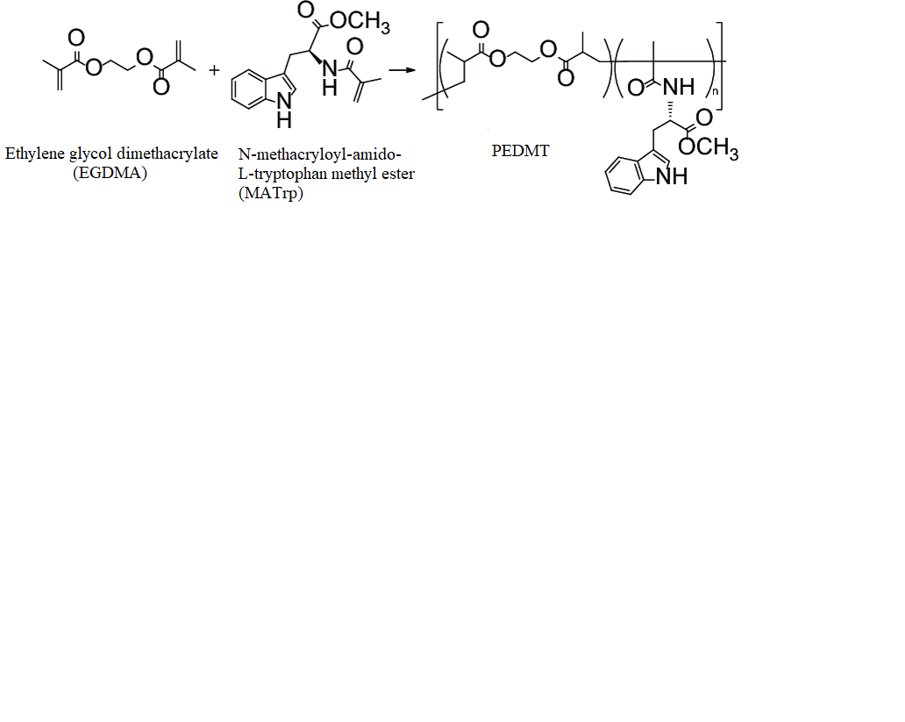
Fig. SI1 Synthesis reaction of PEDMT microbeads.

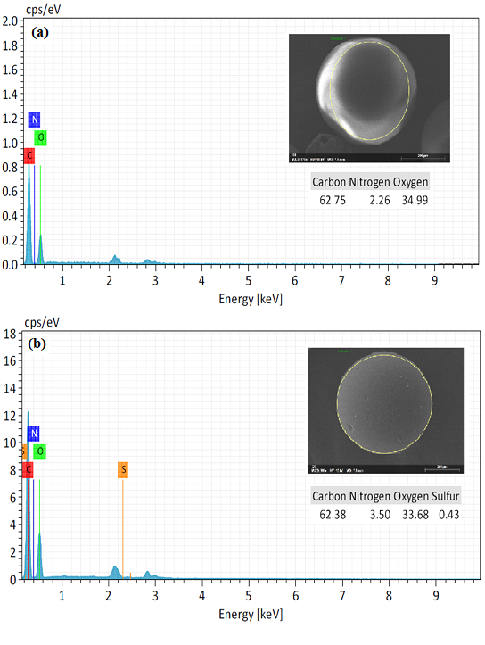
Fig. SI2 SEM-EDX spectra of (a) PEDMT and (b) HRP-immobilized PEDMT microbeads

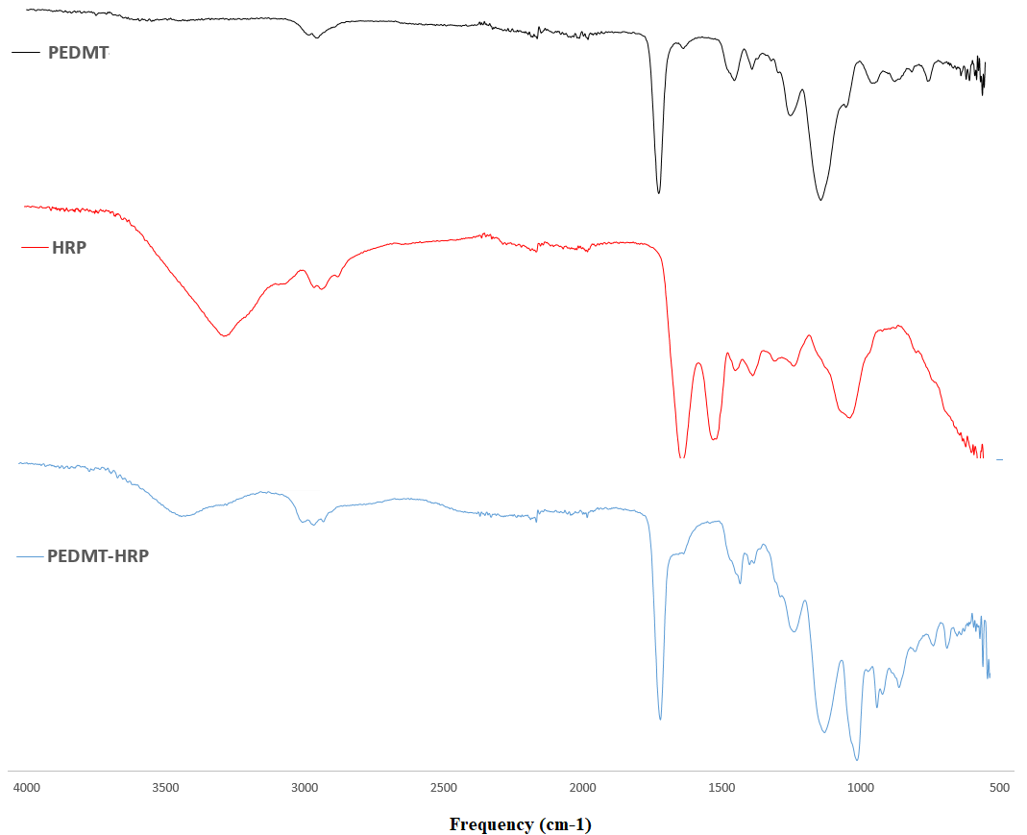

Fig. SI3 FTIR spectra of free HRP, PEDMT and PEDMT-HRP microbeads.

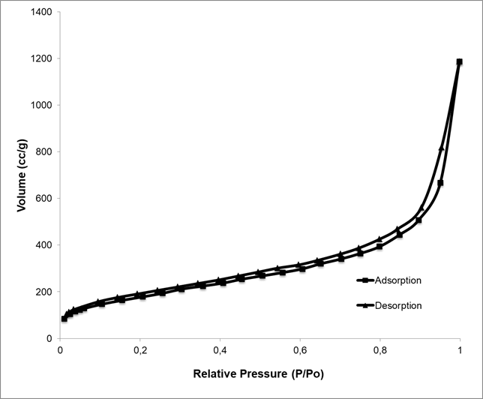
(a)
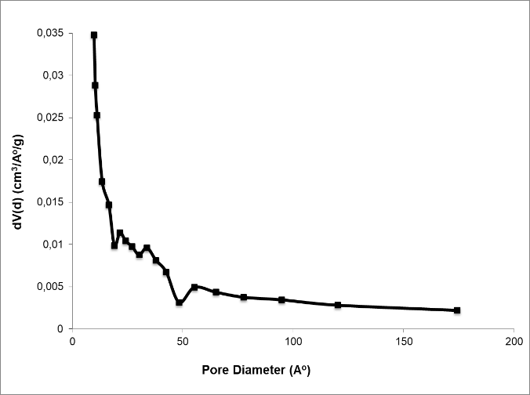
(b)

Fig. SI4 Adsorption/desorption isotherms of nitrogen at 77.40 K (a) and pore size distribution (b) obtained by Dv(d) according to average pore diameter for the PEDMT microbeads.

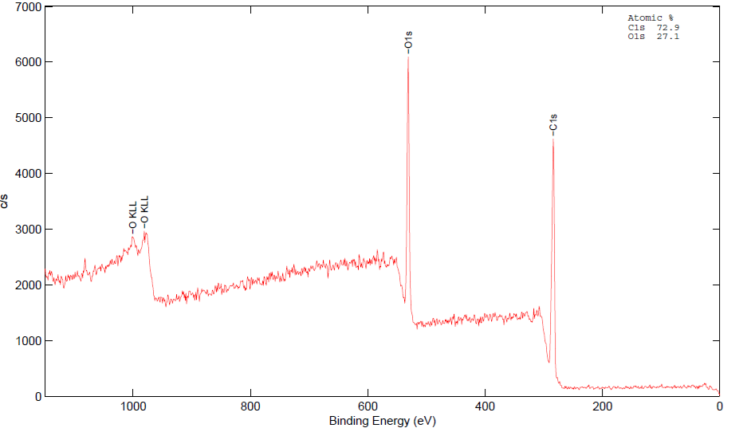
(a)
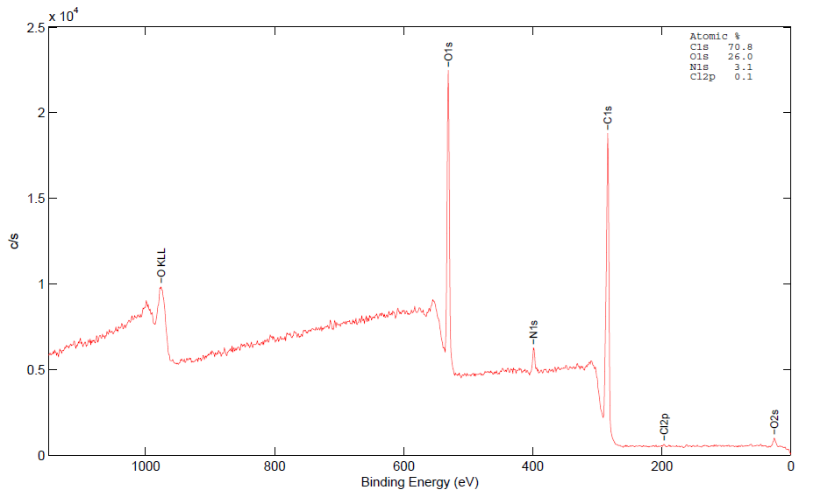
(b)
Fig. SI5 The full XPS spectra of (a) PEDMT and (b) HRP-immobilized PEDMT microbeads

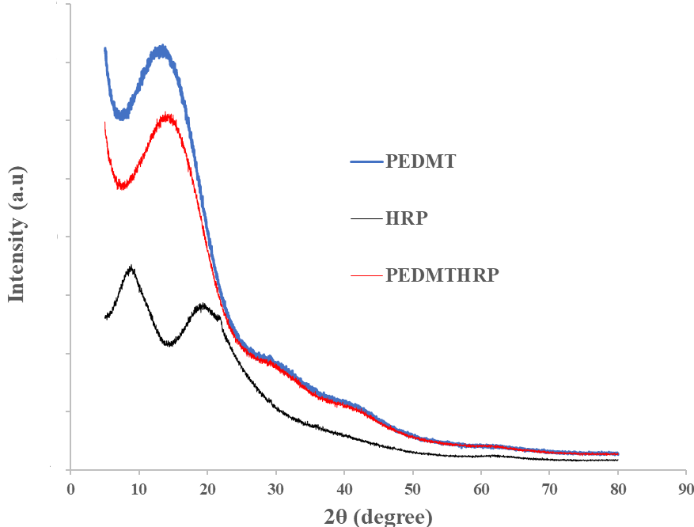
Fig SI6. The XRD spectra of PEDMT microbeads and PEDMT-HRP and HRP enzymes

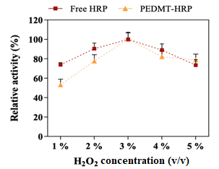

Fig. SI7 Optimum H₂O₂ concentration of free HRP and PEDMT-HRP.

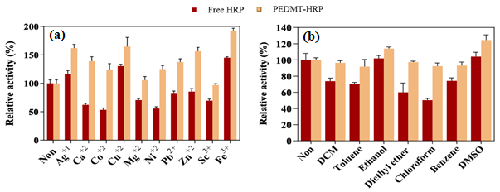
Fig. SI8 The effect of (a) metal ions and (b) organic solvents on free HRP and PEDMT-HRP activity.

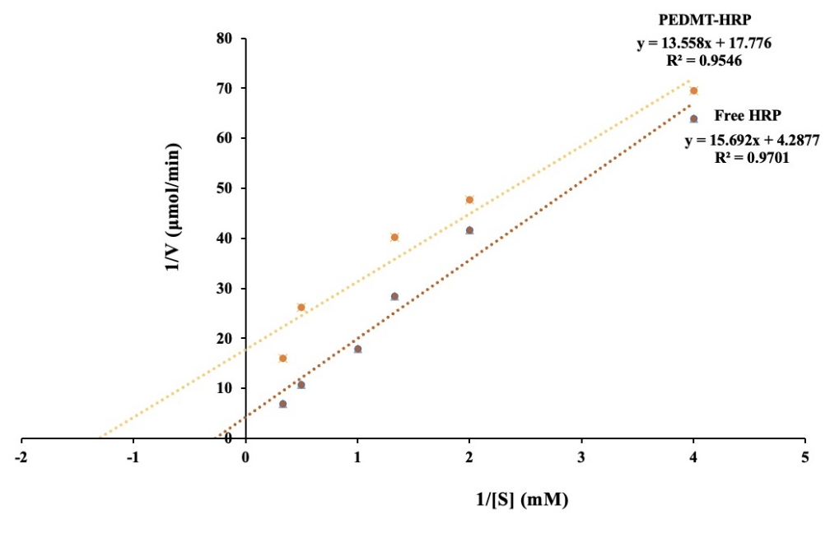
Fig. SI9 The Lineweaver–Burk plots of free HRP and PEDMT-HRP.

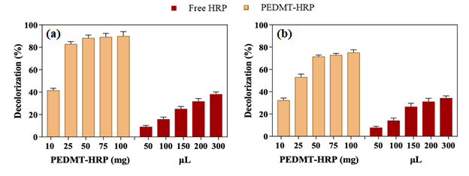
Fig. SI10 Effect of HRP-immobilized microbeads and enzyme amount on decolorization of (a) CR and (b) RB5 solutions (pH: 6.0, CR and RB5 concentration: 20 mg/L, temperature: 25 ºC, time: 2 h, H₂O₂ concentration: 3%, v/v).

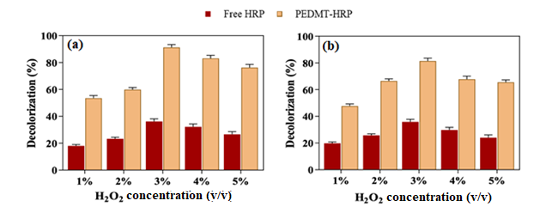
Fig. SI11 Effect of H₂O₂ concentration on dye decolorization of (a) CR and (b) RB5 solutions (pH 6.0, CR and RB5 concentration: 20 mg/L, PEDMT-HRP amount: 50 mg, HRP solution volume: 150 µL, temperature: 25 ºC, time: 2 h).
.

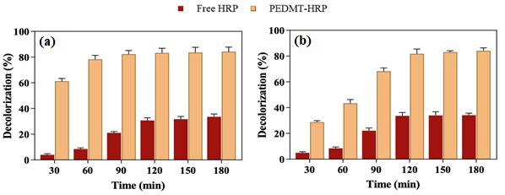

Fig. SI12 Effect of contact time on decolorization of (a) CR and (b) RB5 solutions (pH: 6.0, CR and RB5 concentration: 20 mg/L, PEDMT-HRP amount: 50 mg, HRP solution volume: 150 µL, temperature: 25 ºC, H₂O₂ concentration: 3%, v/v).

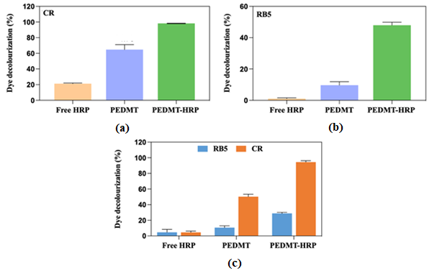
Fig. SI13 Decolorization efficiency of free HRP, PEDMT microbeads and PEDMT-HRP for (a) CR, (b) RB5 and (c) CR and RB5 mixture under optimum conditions.

