Supplementary Material
School: Reg1 | Grade: Year 3 | Teacher: Val | Tour time: 03.45min
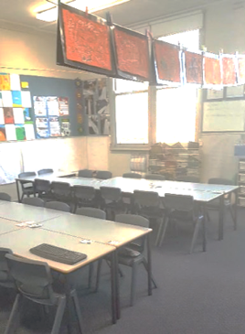 | (00.01)  Alright. So, this is my current year three classroom. I’ll take you through what’s on our walls.
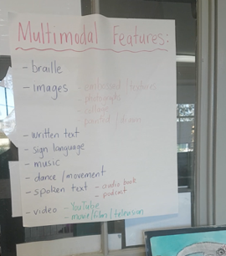 | (00.08)  So, we’ve got some analysis of features that we’ve been looking at of some texts we’ve been looking at as part of our current English unit.
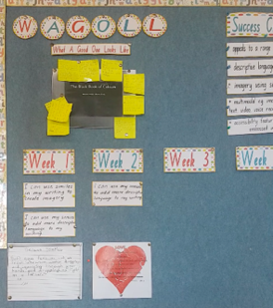 | (00.19)  As we keep going along, we’ve got a writing wall. So then, on this writing wall we have a mentor text that we’re showing the students what a good piece of writing looks like, and the students have analysed that piece of writing and that’s what the post-it notes (yellow) are at the top.
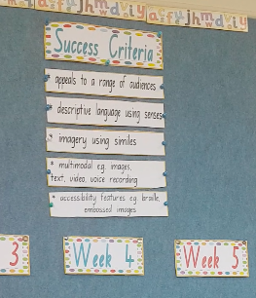 | (00.36)  Then as a class we have collaborated to work out, well, what are some of the success criteria that would make our own text a bit stronger if we were going to be trying to do something similar. Then we are breaking it down week by week on some of the things they are going to focus on, so that over time they can build on some of those features from the success criteria in their own writing.
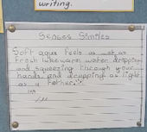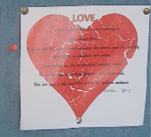 | (00.56)  Down the bottom I have examples of student work. So, there is the success criteria for that particular week and then I have an example of a student who has demonstrated that in their piece of writing so the students have examples of what that also looks like.
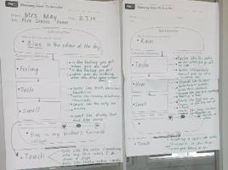 | (01.12)  As we go along, I just put records of any writing planning we do as a whole class. So, this is something that I did with them before they did their own poems.
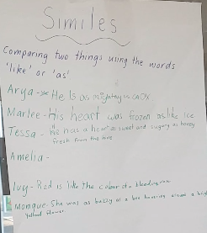 | (01.24)  And then here is some work the students have done. We have some charts up so the students can add to as we’re going through our unit.
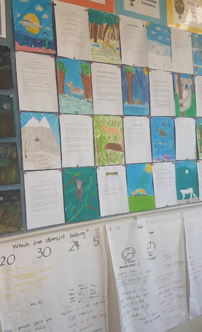 | (01.33)  On the back wall is Maths problem solving. But we also have texts from last term that the students wrote. Last term students were studying as part of our integrated unit endangered animals. The students did research and then the purpose of this text was not just to inform their audience about that animal but also to persuade them to do something to protect it. The students created, researched, drafted, and wrote their text. Then they created some nice illustrations to go with their text. This then formed a class book. They published it and the students regularly read each other’s writing. So that was quite a good little project.
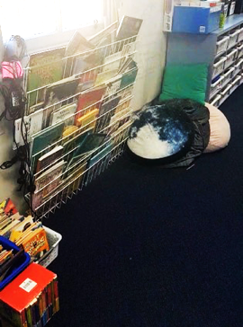 | (02.27)  Over here we have just our reading corner. The students also have books in their tub that they have chosen from the library that they like to get out to read. So, yes there is quite an array of material for the students to read.
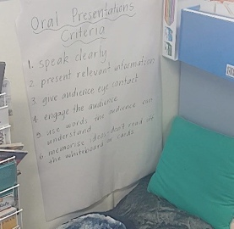 | (02.42)  Down here we’ve got our oral presentations criteria. Again, this is something the students have come up with. They’ve co-constructed it with peers and come back as a whole group and picked out the things they think make up a good oral presentation. In every unit we do for English, the students have to do an oral presentation so this criteria helps them reflect on their work and come up with their own goal that they want to focus on for next time.
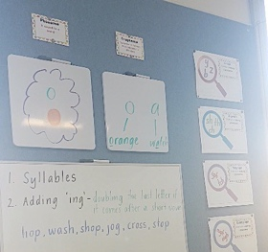 | (03.18)  Up here we’ve got just a spelling wall. So, we have what our focus phoneme is and the graphemes that are used to represent that phoneme. And then I have some spelling activities that the students work on independently after they’ve done some work with me.
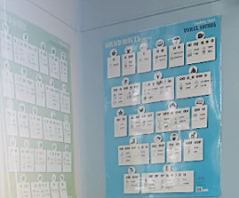 | (03.35)  And then over here I just have some more charts that the students like, to assist them with their spelling and that’s pretty much it. Thank you.

