Supplementary Figure 1
Matrix showing the mapping of routines by NQS element
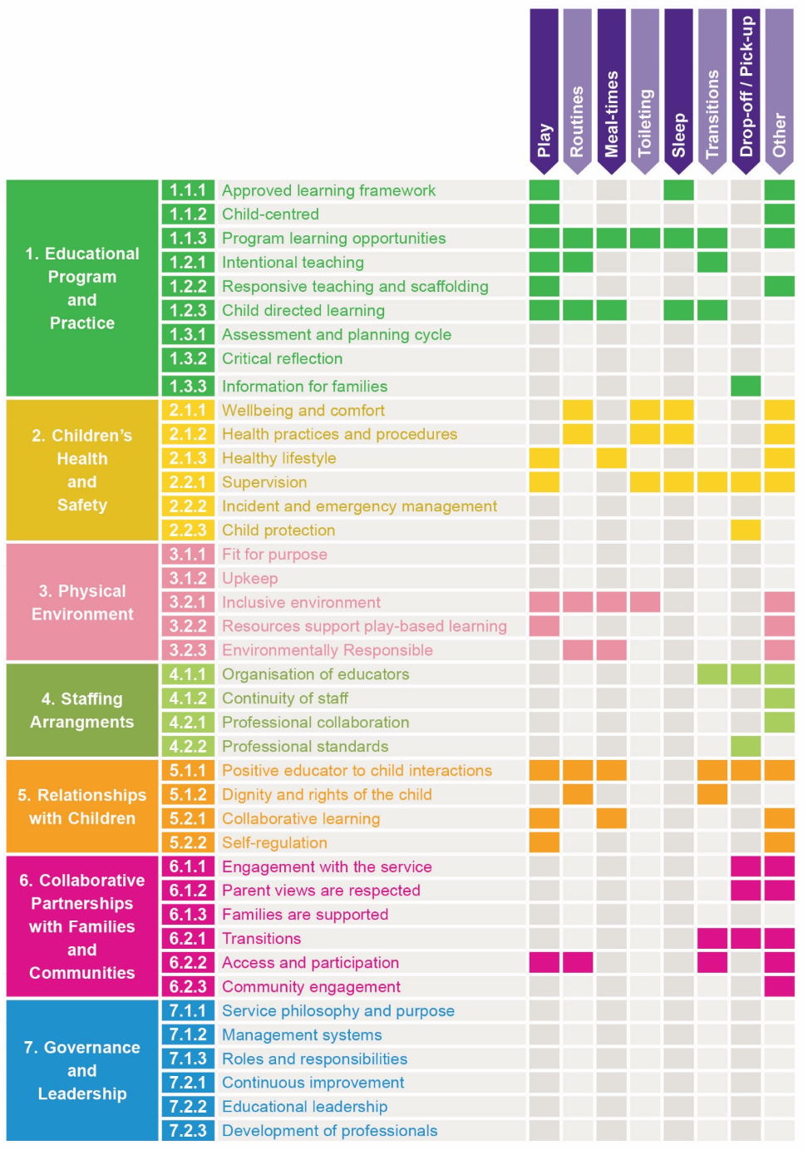
Note. From BLINDED FOR REVIEW.

