Teachers' knowledge of adapting tasks for inclusive mathematics instruction

Electronic supplementary material

Appendix 1: Final coding guide
Main category | Subcategory |  | Definition of |  | Anchor examples
Reduction | Reduction of the number range via the number of tiles  RU 1 | The teacher suggests reducing the number of tiles or reducing the number range. |  | 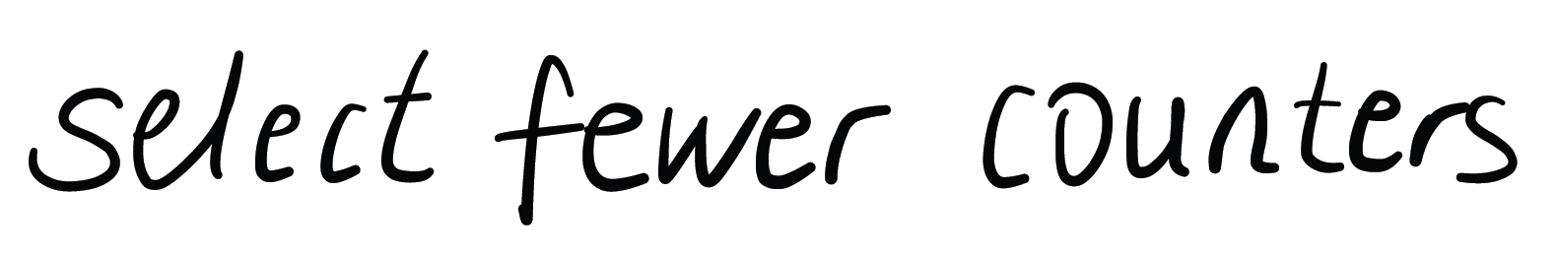  (ElJo28Me)    (BaRe20Mü)
Reduction | Reduction of the number range via dot field  RU 2 | The teacher suggests reducing the size of the field (e.g. field of 5). |  | 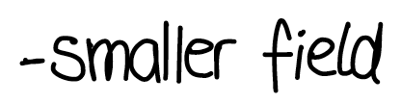  (GaSi05Sc)    (MaTa27Lo)
Reduction | Sample template  RU 3 | The teacher suggests working with a sample template (in original size)/several fields as a documentation aid.  A sample template (in original size) is provided by the teacher. |  | 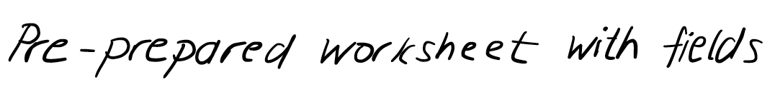  (GaSi05Sc)  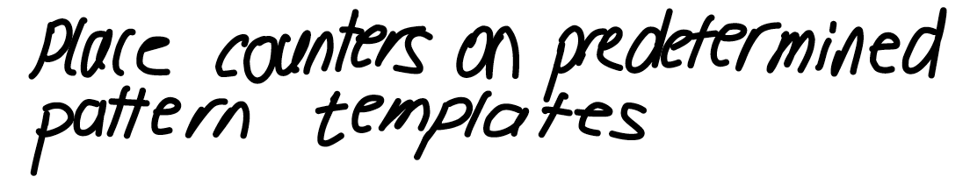  (EvNo20Ti)  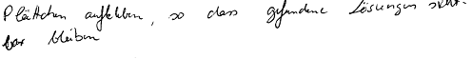  (BaRe20Mü)  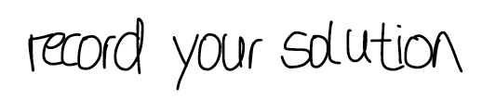  (ElHo02Mu)
Reduction | Trace and colour in given patterns  RU 4 | The teacher suggests that the given pattern is to be copied or coloured in (template is visible). |  |   (ElBe13Wi)
Reduction | Continue specified patterns  RU 5 | The teacher suggests giving an initial pattern of some (but not necessarily all seven) tiles for the learners to complete. |  | 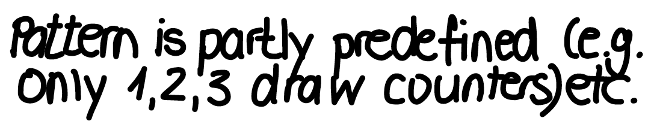  (ClMi12Ha)  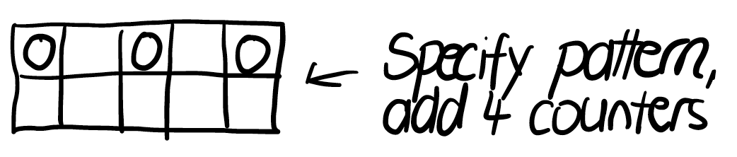  (ChFr21Bi)  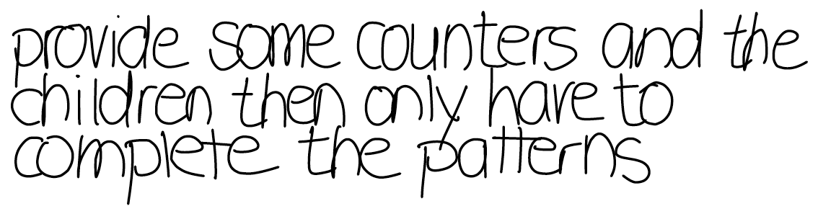  (AnJo13He)
Reduction | Sort predefined patterns  RU 6 | The teacher suggests sorting given patterns. |  |   (ElBe13Wi)  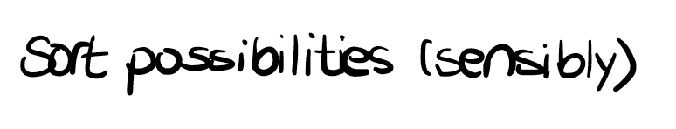  (ElJo28Me)
Reduction | Simplify the task  RU 7 | The teacher suggests simplifying the task (unspecific) - this also includes explaining terms.  instead of demanding a different, concrete number of options (e.g. three) |  | 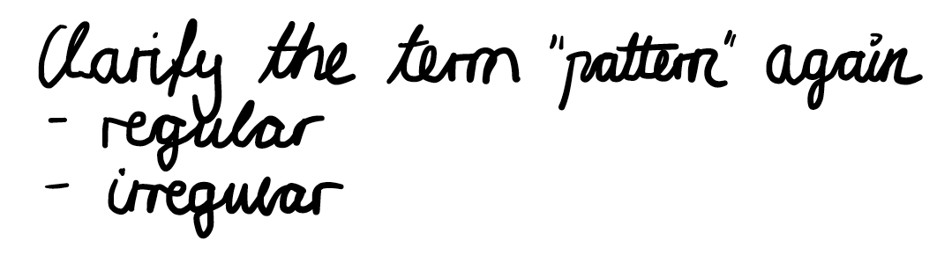  (JoJo29Hi)  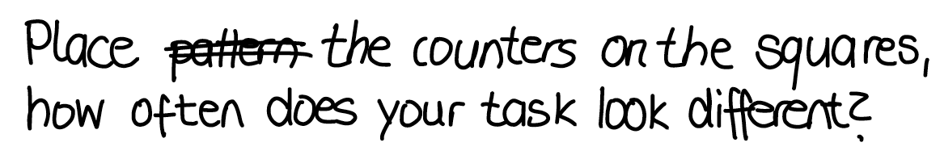  (GeKa12PI)
Reduction | Specify sample solutions  RU 8 | The teacher suggests having a given solution checked for correctness. |  |   (SuFr26Do)  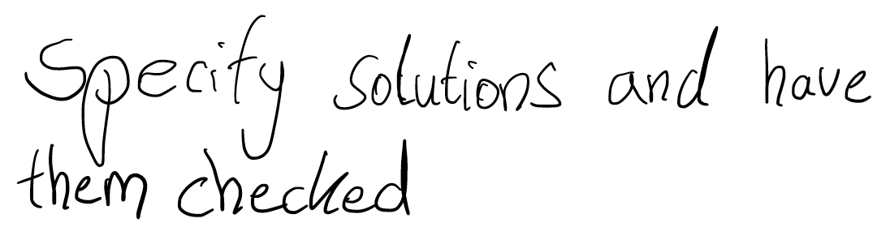  (EvNo20Ti)
Reduction | Use specialised language  RU 9 | The teacher suggests giving examples for orientation. |  |   (JuWo05Hi)
Reduction | Give examples  RU 10 | The teacher suggests giving examples for orientation. |  | (SuFr26Do)
Extension | Extend number range  EU 1 | The teacher suggests extending the number range (without specifically mentioning the number of dots or tiles). |  | 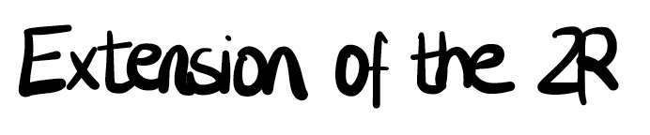  (ClMi12Ha)
Extension | Extend number range via number of tiles  EU 2 | The teacher suggests increasing the number of tiles or increasing the number range. |  | 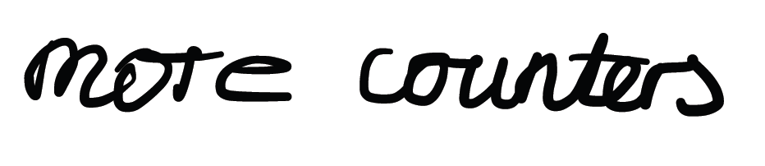  (EvNo20Ti)  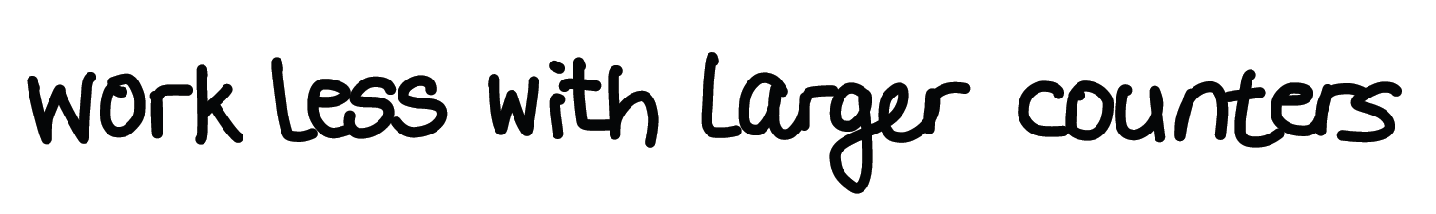  (UrRo25Bi)
Extension | Extending the number range using a dot matrix  EU 3 | The teacher suggests enlarging the field (e.g. field of 20). |  | 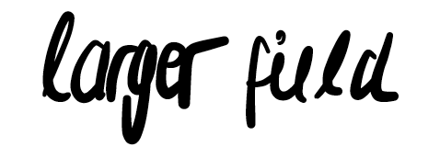  (GaSi05Sc)    (ElBe13Wi)
Extension | Determine the number of possibilities (combinatorial question)  EU 4 | The teacher suggests determining the number of possibilities. |  |   (ElHo02Mu)    (UrRo25Bi)
Extension | find many/all possibilities (combinatorial question)  EU 5 | The teacher encourages students to find as many or all possibilities as possible. |  |   (BaRe20Mü)    (EvNo20Ti)
Extension | Process-related competence requirement  EU 6 | The teacher suggests that the procedure/strategy should be described. |  |   (GaSi05Sc)    (EvAl25Ma)
Extension | Use the two colours of the tiles  EU 7 | The teacher suggests that two colours are used for the tiles - create two-coloured patterns (use red and blue tiles). |  | 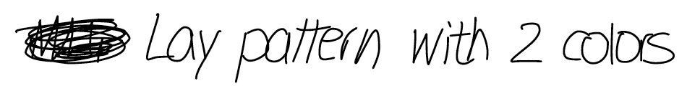  (ElHo02Mu)  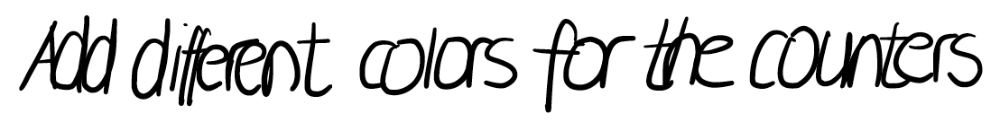  (GeKa12PI)
Extension | Link two-colour patterns with combinatorial questions  EU 8 | The teacher gives specific instructions for laying two-coloured patterns, e.g. "3 of the 7 tiles should be red. How many different patterns can you find?" |  | 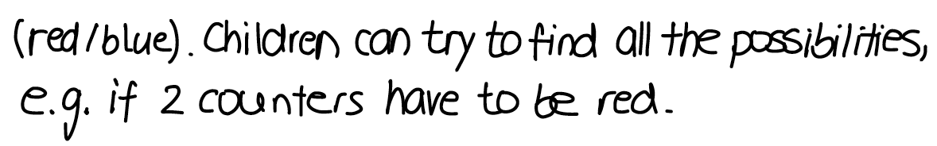  VeWi17Mü
Extension | Combinatorial question with linked condition  EU 9 | The teacher suggests to find some/all possibilities under fulfilment of a certain condition. |  |   (ChFr21Bi)
Extension | Sort your own solutions  EU 10 | The teacher suggests that the pupils sort the solutions they have found. |  | 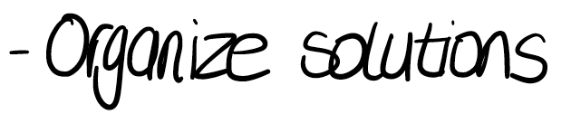  (BaRe20Mü)
Extension | Stimulate a change of presentation  EU 11 | The teacher explicitly suggests adding a change of presentation to the task. |  | 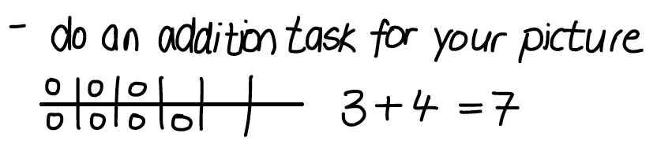  (DoHe09Bo)  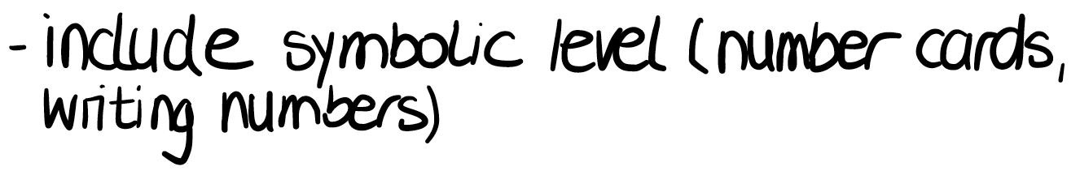  (CAN)
Non-content | Offer material  NI 1 | The teacher suggests (unspecifically) to offer material (general, no reference to the task). |  |   (BaRe20Mü)  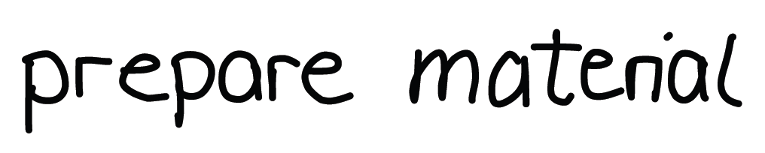  (JoJo29Hi)
Non-content | Group work  NI 2 | The teacher encourages the use of group work as a social form. |  | 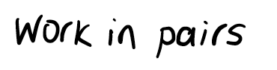  (JoJo29Hi)  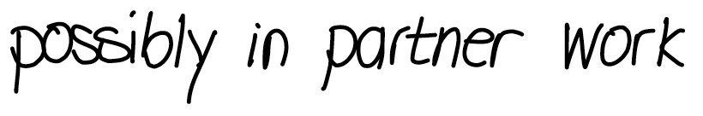  (SiEr27Dü)
Non-content | Tip cards  NI 3 | The teacher suggests using tip cards to support the learners in completing the task. |  |   (HaTu12Lü)    (Can)
Non-content | See  NI 4 | The teacher suggests offering support in the area of "vision". |  | No anchor example
Non-content | Musculoskeletal system  NI 5 | The teacher suggests offering support for the musculoskeletal system |  | No anchor example
Non-content | Motor skills support: Laying turning stones  NI 6 | The teacher suggests using "turning stones" and underlays instead of turning tiles to lay the patterns. |  |   (JoJo29Hi)    (EvAl25Ma)
Non-content | Motor skills support: Stamp documentation  NI 7 | The teacher suggests using stamps (e.g. circles made of foam rubber) to document the patterns. |  |   (HaTu12Lü)  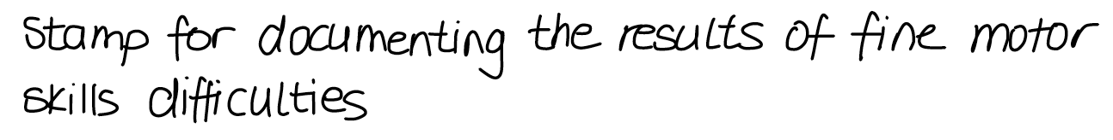  (HaTu12Lü)

Appendix 2: Overview of relevant coding of the subcategories of the main category Non-content
group B Sep 18 / Feb 19 (N=49)
Subcategories | Start_BL_{B} | End_BL_{B} | Difference
Offer material | 10/49 (20,4 %) | 11/49 (22,4 %) | + 2 %
Group work | 17/49 (34,7 %) | 15/49 (30,6 %) | - 4,1 %
Tip cards | 5/49 (10,2 %) | 4/49 (8,2 %) | - 2 %
Turning stones | 4/49 (8,2 %) | 2/49 (4,1 %) | - 4,1 %

Appendix 3: Overview of relevant coding of the subcategories of the main category Non-content of groups A (n = 38) & B (n = 49) before and after the blended learning programme (percentages in brackets)
 | Start_BL_{A} /  Start_ BL_{B} | End_BL_{A} /  End_ BL_{B} | Difference
Offer material | A 13/38 (34,2 %) | A 9/38 (23,7 %) | - 4 (10,5 %)
Offer material | B 11/49 (22,4 %) | B 11/49 (22,4 %) | 0 (0 %)
Group work | A 16/38 (42,1 %) | A 9/38 (23,7 %) | - 7 (18,4 %)
Group work | B 15/49 (30,6 %) | B 15/49 (30,6 %) | 0 (0 %)
Tip cards | A 4/38 (10,5 %) | 2/38 (5,3 %) | - 2 (5,3 %)
Tip cards | B 4/49 (8,2 %) | B 0/49 (0 %) | - 4 (8,2 %)
Turning stones | A 3/38 (7,9 %) | 7/38 (18,4 %) | +4 (10,5 %)
Turning stones | B 2/49 (4,1 %) | 6/49 (12,2 %) | +4 (8,1 %)
Stamp | A 0/38 (0 %) | 3/38 (7,9 %) | +3 (7,9 %)
Stamp | B 0/38 (0 %) | B 0/38 (0 %) | 0 (0 %)

