Suplementary material

Production of volatile fatty acids FROM SLAUGHTERHOUSE BLOOD BY mixed-CULTURE fermentation

Jersson Plácido^{1,2}*, Yue Zhang
1 Water and Environmental Engineering Group, Faculty of Engineering and the Environment, University of Southampton, Southampton, United Kingdom
2 Centre for Cytochrome P450 Biodiversity, Institute of Life Science, Medical School, Swansea University, Swansea SA2 8PP, Wales, UK

.
Preliminary experiments on blood loading, methanogens inhibitor using iodoform and enzymatic hydrolysis using trypsin
- Experimental methods used in the preliminary experiments
- Figure 1. VFA profiles at different blood loadings in the absence of iodoform
- Figure 2. VFA profiles at different blood loadings in the presence of iodoform
- Figure 3. VFA profiles with or without enzymatic hydrolysis pretreatment
- VFA yield calculations
- Table 1. VFA yields at different blood loadings with or without iodoform
.
Experimental methodology
Two sets of preliminary batch experiments were conducted to investigate the effect of blood loading, methanogen inhibition and enzymatic pretreatment on the rate and extent of VFA production. The blood loading was calculated by dividing the volume of blood solution added by the total working volume of the reactor including the volume contributed by the inoculum. Seven blood loading levels, 1, 5, 15, 25, 50, 75, and 90%, were tested in the presence or absence of iodoform; this was also to investigate if and to what degree a methanogen inhibitor could facilitate VFA production in batch mode. The working volume was made up by deionised water for the first six loadings. The Second experiment, run at a blood loading of 90%, was to evaluate the effect of enzymatic hydrolysis on VFA production by running pre-hydrolysed blood solution in parallel with that without enzymatic hydrolysis. All three sets of the above mentioned experiments were conducted using 250-mL Erlenmeyer flasks with a working volume of 150 mL, and were inoculated with 15 mL of un-acclimated Millbrook digestate in each flask. This gave a volumetric inoculum loading of 10%. To maintain anaerobic conditions, the headspace of each flask was purged with nitrogen gas when starting the experiments, and when taking liquid samples (for VFA and protein analyses) and/or adding iodoform. Each flask was sealed with a rubber bung through which a stainless-steel metal tube was installed to collect the gas produced to a gas sampling bag during the fermentation process. The flasks were placed in an orbital incubator at a temperature of 37 ºC and an orbiting speed of 150 rpm throughout the experiments. The first two experiments were performed for 41 days, and the experiment on the effect of enzymatic hydrolysis was run for 31 days.

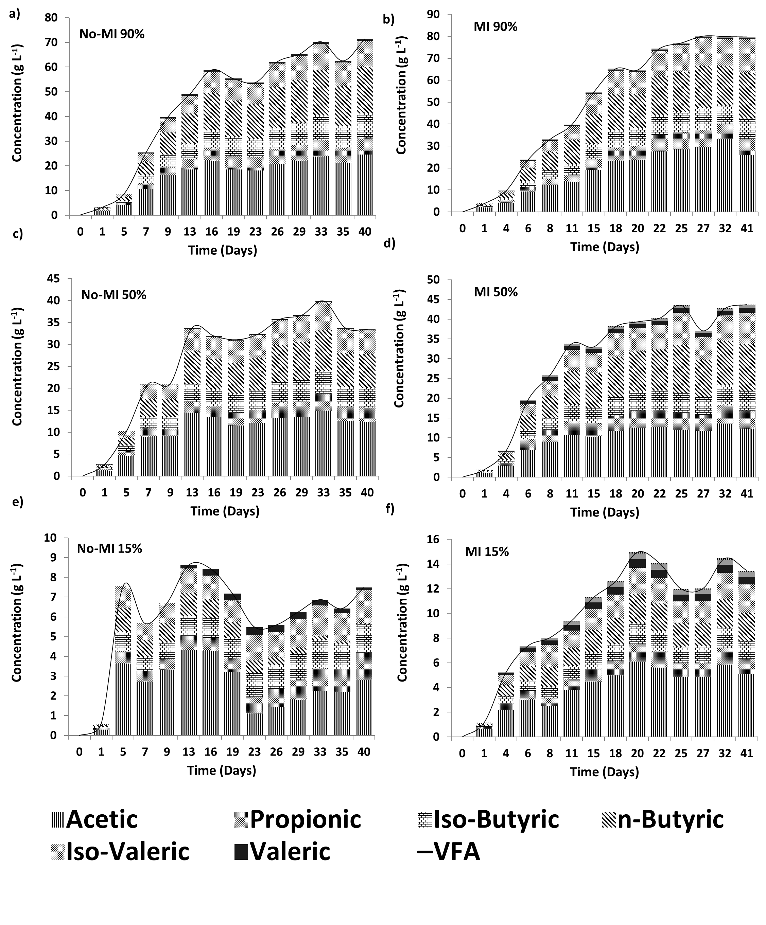
Figure 1. VFA profiles at different blood loadings in the absence of iodoform

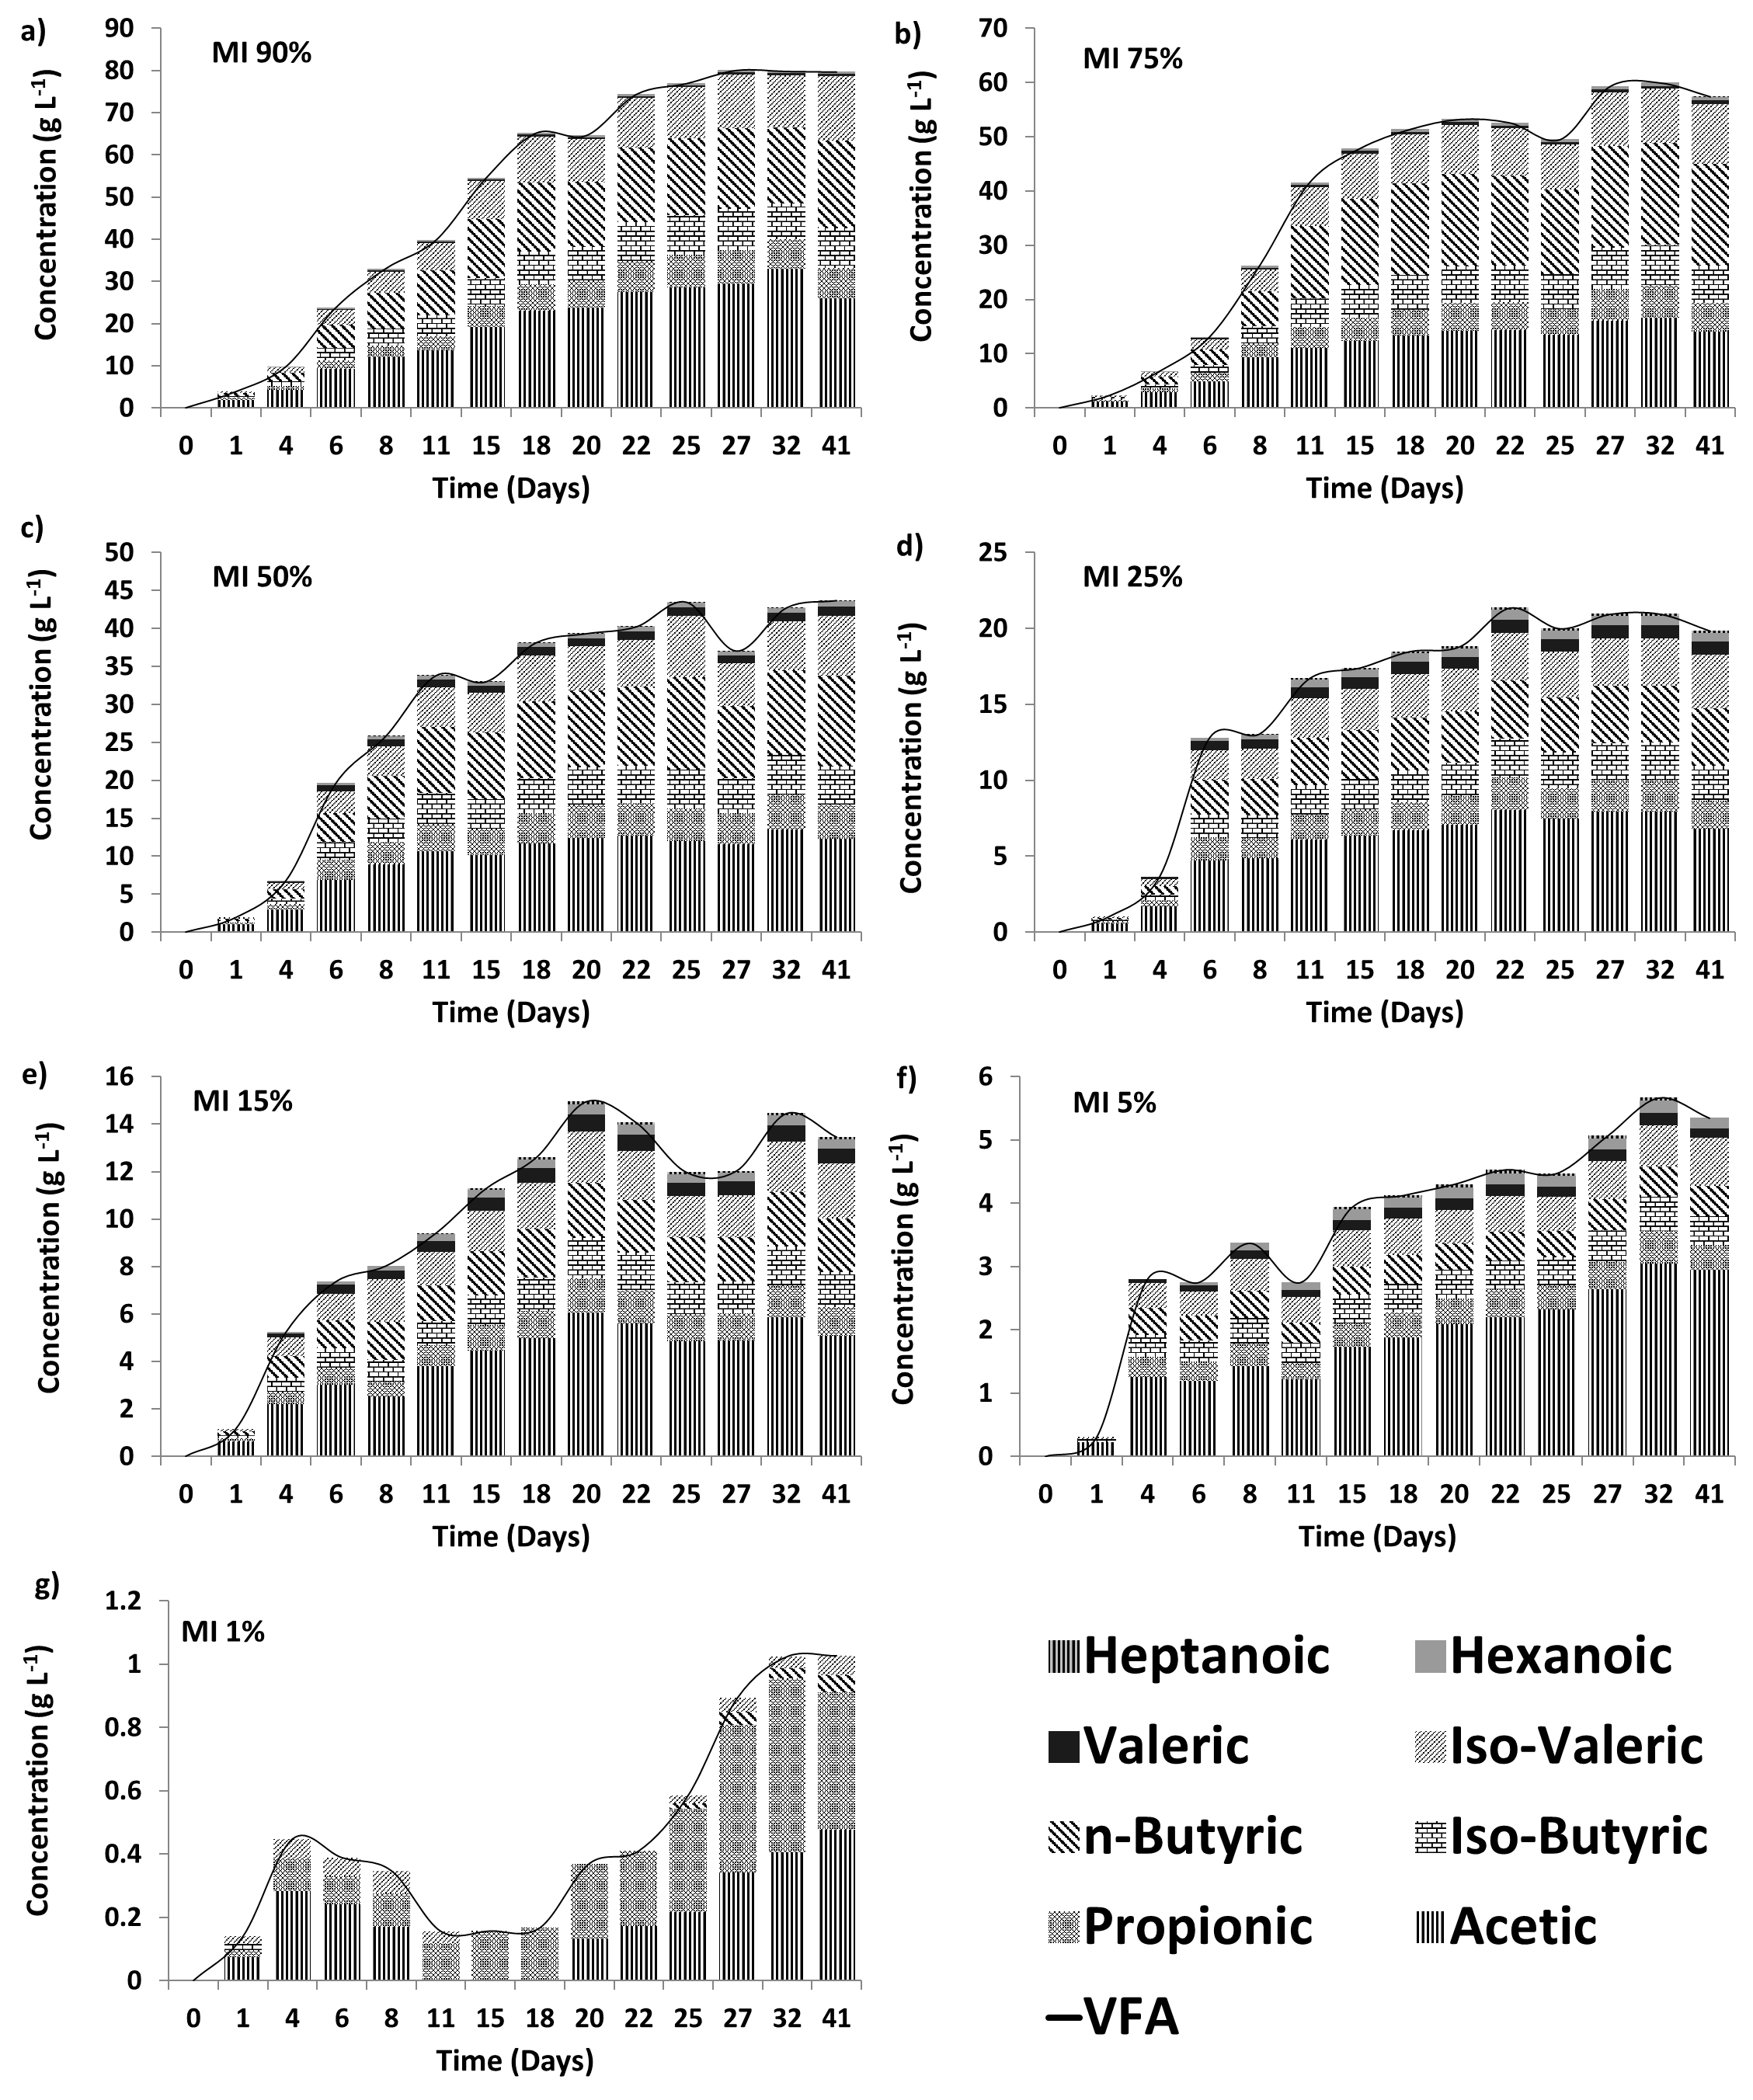
Figure 2. VFA profiles at different blood loadings in the presence of iodoform.
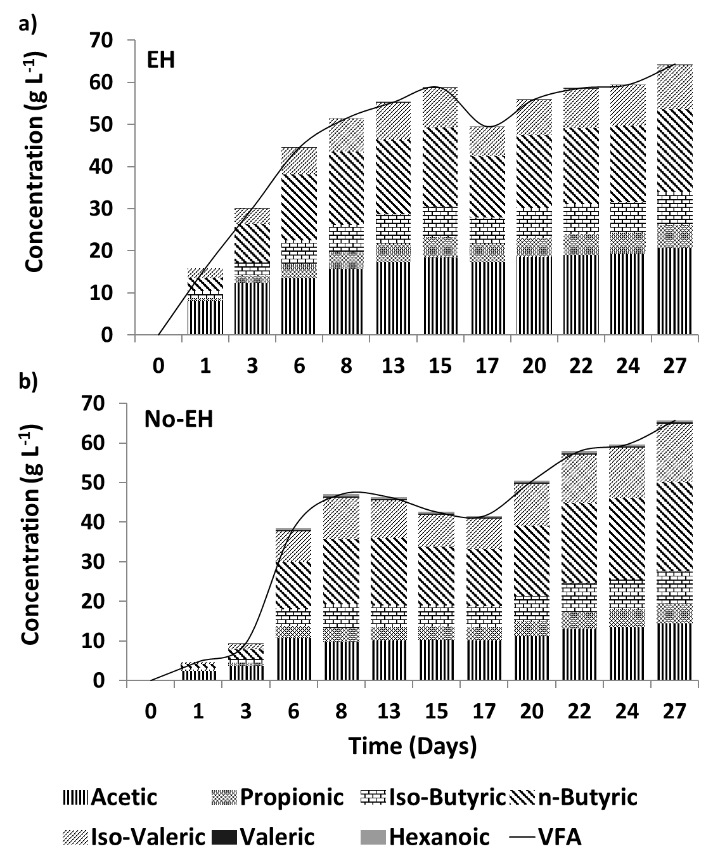
Figure 3. VFA profiles with or without enzymatic hydrolysis pretreatment.

3.1.1. Effect of blood loading and methanogen inhibitor
The VFA production profiles at different blood loadings without and with iodoform addition are shown in Figure 1 and 2, respectively. As expected the higher total acids concentration was achieved from the higher blood loading, with the maximum reached in the reactors with blood loading of 90%: 71 and 80 g L⁻¹ in reactors without and with iodoform, respectively. The difference in VFA concentration due to methanogenesis inhibition by iodoform was observed in all the blood concentrations, and this was more evident in the lower blood concentration. A blood loading of 1% or 5% could not inhibit the methanogenic activity and the VFA accumulated at the beginning the test was consumed by day 7 and 20, respectively. At higher loadings a continuous accumulation of VFA was observed for both sets of experiment until it reached a plateau: at loading of 15-50%, VFA increased until day seven, whereas the VFA accumulation extended to day 13 for loading 75 and 90%. It is noted that the initial VFA accumulation rate in a reactor without iodoform addition was usually lower than that of its counterpart with iodoform but at the same loading, probably due to the simultaneous VFA consumption by methanogens when the ammonia and/or VFA concentration was still low. This is the reason which caused the lower final concentrations when iodoform was not present.

All the tests without iodoform evidenced the presence of six types of VFA, acetic, propionic, iso-butyric, n-butyric, iso-valeric, and valeric acid. For example, the concentration profile for the highest loading was 24.5, 6.9, 9.7, 18.7, 10.6, and 0.8 g L⁻¹ for the above mentioned VFA species, respectively. Acetic acid was always the dominant acid, while the proportion of other acids was different at different blood loadings. N-butyric acid was the second dominant specie for loading 50-90%; but no fixed pattern can be identified for lower blood loadings. Eight types of VFA species were produced in the set of experiment with iodoform addition: acetic, propionic, iso-butyric, n-butyric, iso-valeric, valeric, hexanoic, and heptanoic acid, alought heptanoic acid was not found in the lowest and highest blood loadings (1 and 90%). The concentration profile for the highest loading was 25.9, 7.3, 9.3, 20.9, 15.2, 0.5, 0.55 and 0 g L⁻¹ for the above mentioned VFA species, respectively. Iso-valeric acid showed the greatest increase (42%) when compared to the profile without iodoform addition. Similar to the experiment without iodoform, acetic acid had the largest concentration at almost all blood loadings, except 75% where n-butyric acid had the largest concentration.

Table 1a summaries the VFA yield at different blood loadings. At higher loadings, the total VFA yields were around 0.5~0.6 when iodoform was absent; or 0.6~0.7 when it was added. The yield reached the highest (0.7~0.8) at lower loadings of 1 and 5% when iodoform was absent, probably due to the lack of product-induced feedback inhibition at lower loadings and therefore the conversion was more complete. Although highest yield was achieved, these low loadings in practice were not favoured due to the low final VFA concentration and associated recovery issue.

3.1.2. Enzymatic pretreatment
Figure 3 shows the production of VFA with enzymatic hydrolysis (EH) and without enzymatic hydrolysis (No-EH) on blood. The presence of enzymatic hydrolysis did not alter the final concentration of VFA. The initial VFA production rate, however, was improved considerably. The VFA production in EH reactor was 3 times greater than that of No-EH reactor during the initial 3 days, which was primarily contributed by the accumulation of acetic, n-butyric and iso-butyric acids. During these days, the EH pretreatment achieved more than 60% of final acetic acid quantity and 40% of final n-butyric and iso-butyric acid quantity. Although the No-EH experiment just achieved 15% of the total acid production, its VFA content increased rapidly between day 3 and 8, and it achieved the same total VFA production as the EH pretreatment at day 22.

The VFA profiles were different in those reactors, although the total VFA concentrations were at the same level and the same types of acids were present. In the reactor with EH pretreatment, acetic and n-butyric acids were dominant, and accounted for 32% and 30% of total VFA production on a mass basis, respectively. The share of iso-valeric (16%) and iso-butyric (12%) acid was followed up in this reactor. In contrast, n-butyric acid out-competed acetic acid in No-EH reactor and account for 34% of total VFA production. Acetic acid had the same percentage (22%) as iso-valeric acid (22%) in No-EH reactor, with n-butyric acid was the fourth species (12%). The ratio of iso-valeric and iso-butyric acid had same percentage.

The gas produced from both reactors composed primarily carbon dioxide (CO₂), with a content up to 90% on a volume basis, and less than 10% of hydrogen (H₂), and methane (CH₄). Hydrogen was the second component produced from No-EH reactor, whereas methane (CH₄) was the second one from EH reactor.

VFA yield calculations
VFA yield was expressed as a percentage of blood VS in this study, as shown in Eq. 1 and Eq.2 below.
In batch experiment:
$VFA yield \left(\%\right)=\frac{{VFA}_{f}}{{VS}_{blood} ∙ {loading}_{blood}}∙100\%$ Equation (1)
In semi-continuous experiment:
$VFA yield \left(\%\right)= \frac{{VFA}_{f} ∙ V-{VFA}_{i} ∙ \left(V-v\right)}{{VS}_{blood} ∙ v}∙100\%$ Equation (2)
where
VFA_{f}, VFA concentration at the end of a feeding cycle, g L⁻¹;
V, reactor working volume, L;
VS_{blood}, VS of blood solution as substrate, g L⁻¹;
Loading_{blood}, volumetric blood loading, %.
where
VFA_{i}, VFA concentration at the beginning of the same feeding cycle, which equalled its concentration at the end of the previous feeding cycle, g L⁻¹;
v, the volume of blood solution added at the beginning of a feeding cycle, L

Table 1. VFA yields at different blood loadings with or without iodoform.
Blood concentration | 1% |  | 5% |  | 15 % |  | 25% |  | 50% |  | 75% |  | 90%
Inhibitor (CHI₃) | Yes | No | Yes | No | Yes | No | Yes | No | Yes | No | Yes | No | Yes | No
Acetic Acid yield | 0.35 | 0.03 | 0.44 | 0.08 | 0.25 | 0.14 | 0.20 | 0.19 | 0.18 | 0.18 | 0.14 | 0.14 | 0.21 | 0.20
Propionic acid yield | 0.32 | 0.01 | 0.06 | 0.04 | 0.06 | 0.07 | 0.05 | 0.04 | 0.07 | 0.05 | 0.05 | 0.06 | 0.06 | 0.06
Iso-butyric acid yield | 0.00 | 0.01 | 0.07 | 0.05 | 0.07 | 0.07 | 0.07 | 0.06 | 0.08 | 0.07 | 0.07 | 0.06 | 0.08 | 0.08
n-Butyric acid yield | 0.04 | 0.03 | 0.07 | 0.03 | 0.11 | 0.00 | 0.11 | 0.08 | 0.18 | 0.11 | 0.19 | 0.12 | 0.17 | 0.15
Iso-Valeric acid yield | 0.05 | 0.03 | 0.11 | 0.07 | 0.11 | 0.08 | 0.11 | 0.08 | 0.12 | 0.08 | 0.11 | 0.07 | 0.12 | 0.09
Valeric acid yield | 0.00 | 0.00 | 0.02 | 0.01 | 0.03 | 0.01 | 0.02 | 0.00 | 0.02 | 0.00 | 0.01 | 0.00 | 0.00 | 0.01
Hexanoic acid yield | 0.00 | 0.00 | 0.02 | 0.00 | 0.02 | 0.00 | 0.02 | 0.00 | 0.01 | 0.00 | 0.01 | 0.00 | 0.00 | 0.00
Heptanoic acid yield | 0.00 | 0.00 | 0.01 | 0.00 | 0.00 | 0.00 | 0.00 | 0.00 | 0.00 | 0.00 | 0.00 | 0.00 | 0.00 | 0.00
VFA yield | 0.76 | 0.11 | 0.80 | 0.27 | 0.66 | 0.37 | 0.59 | 0.45 | 0.65 | 0.50 | 0.57 | 0.44 | 0.66 | 0.59

*Corresponding author. Tel.: +44 (0)7809158696; E-mail address: j.e.placidoescobar@swansea.ac.uk
Iodoform (CHI₃) (Sigma-Aldrich) was employed as methanogen inhibitor to identify if an external inhibitor was necessary when using blood as substrate. When it was in use, a solution of 20 g CHI₃ L⁻¹ ethanol was added every other day at a strength of 200 µL L⁻¹ fermenter working volume throughout the fermentation processes in test

