Supporting Information for
Real-Time Biomass Feedstock Particle Quality Detection Using Image Analysis and Machine Vision
Chandrakanth Gudavalli†, Elizabeth Bose†, Bryon S. Donohoe, David A. Sievers*

National Renewable Energy Laboratory: National Bioenergy Center, 15013 Denver West Parkway, Golden, CO 80403, USA

*Corresponding author: david.sievers@nrel.gov (303-384-7748)
†Equally-contributing authors
Table S1. Reasons and number of images removed from data set before analyzing the percent surface area coverage of biomass per image and the textural features of each image. The above reasons would interfere with the image threshold used to calculate the biomass coverage
Reason | Qty. of Images
Air hose | 338
Operator hand | 3
Excessive dust | 259
Excessive blur | 277
Extensive shadow | 1
Total | 878

Table S2. Summary statistic of each baseline and of all four averaged
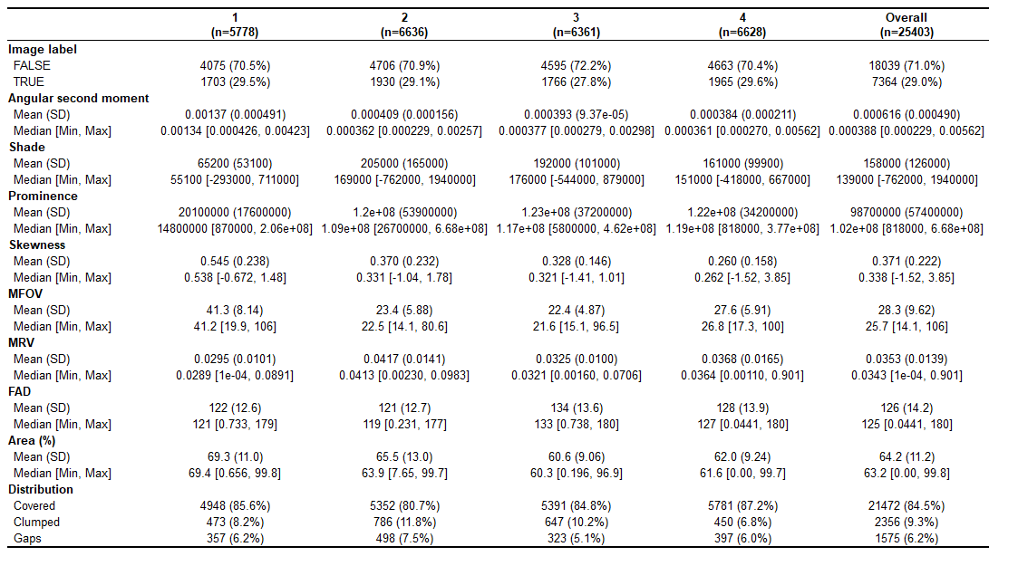
Table S3. Chi-squared test indicates that the relationship between TRUE/FALSE label and the distribution pattern of biomass on the conveyor belt is significant
Distribution  pattern | y |  | Total
Distribution  pattern | FALSE | TRUE | Total
Covered | 15,500 | 5,972 | 21,472
Clumps | 1,360 | 996 | 2,356
Gaps | 1,179 | 396 | 1,575
Total | 18,039 | 7,364 | 25,403
χ² = 227.772, df = 2, Cramer's V = 0.095, p = 0.000

Table S4. Chi-squared test indicates that the relationship between TRUE/FALSE label and the baseline run is marginally significant
Baseline | y |  | Total
Baseline | FALSE | TRUE | Total
1 | 4,075 | 1,703 | 5,778
2 | 4,706 | 1,930 | 6,636
3 | 4,595 | 1,766 | 6,361
4 | 4,663 | 1,965 | 6,628
Total | 18,039 | 7,364 | 25,403
χ² = 6.7278, df = 3, Cramer's V = 0.095, p = 0.081

Table S5. Results of the Wald chi-squared test indicate that all variables except time are significant predictors of the TRUE/FALSE labels
Variable | Df | Chisq | Pr(>Chisq)
Time | 1 | 2.52952 | 0.111734
Distribution | 2 | 292.5417 | 2.99E−64
Baseline | 3 | 161.8593 | 7.28E−35
Angular second moment | 1 | 36.16583 | 1.81E−09
Prominence | 1 | 20.00172 | 7.74E−06
Shade | 1 | 62.67184 | 2.44E−15
Skewness | 1 | 100.0519 | 1.48E−23
Rc | 1 | 74.30299 | 6.70E−18
MFOV | 1 | 100.6003 | 1.13E−23
FAD | 1 | 31.58168 | 1.91E−08
MRV | 1 | 207.0687 | 5.99E−47
Area covered (%) | 1 | 416.951 | 1.12E−92

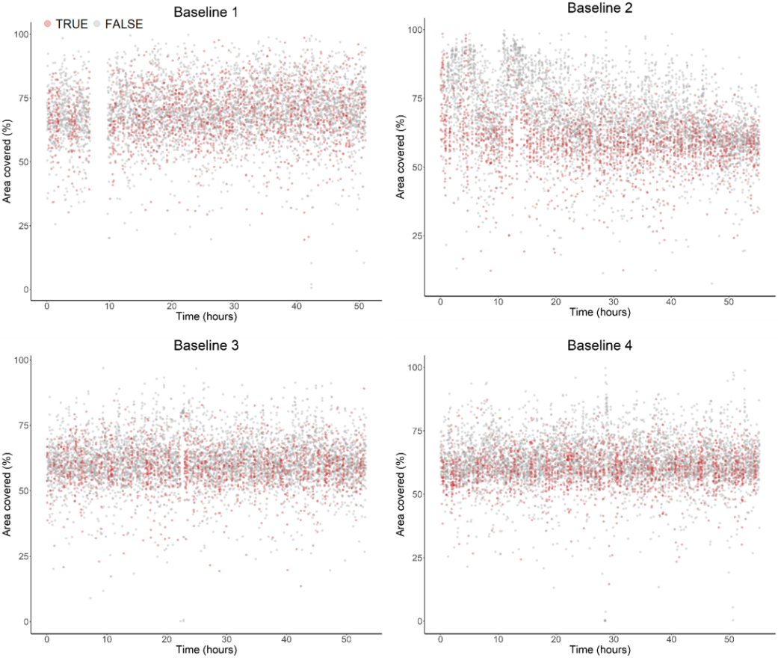
Figure S1. Area covered versus time for each baseline.

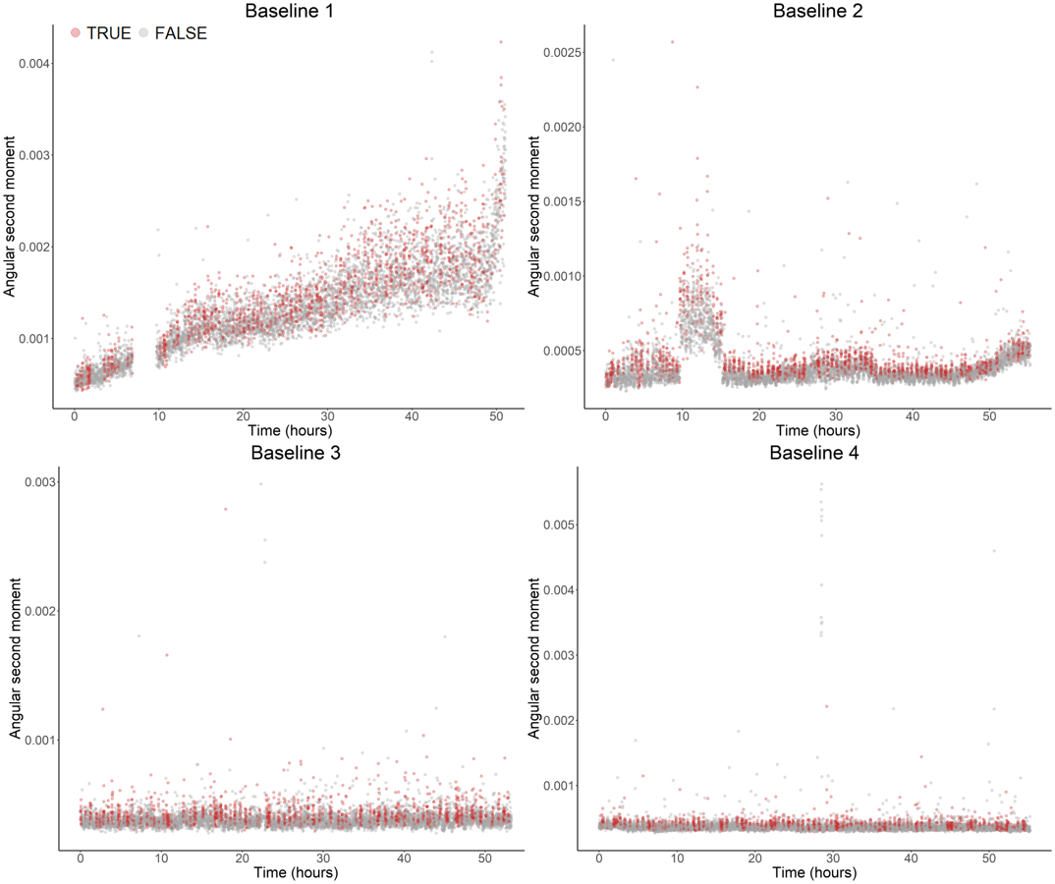
Figure S2. Angular second moment versus time for each baseline.

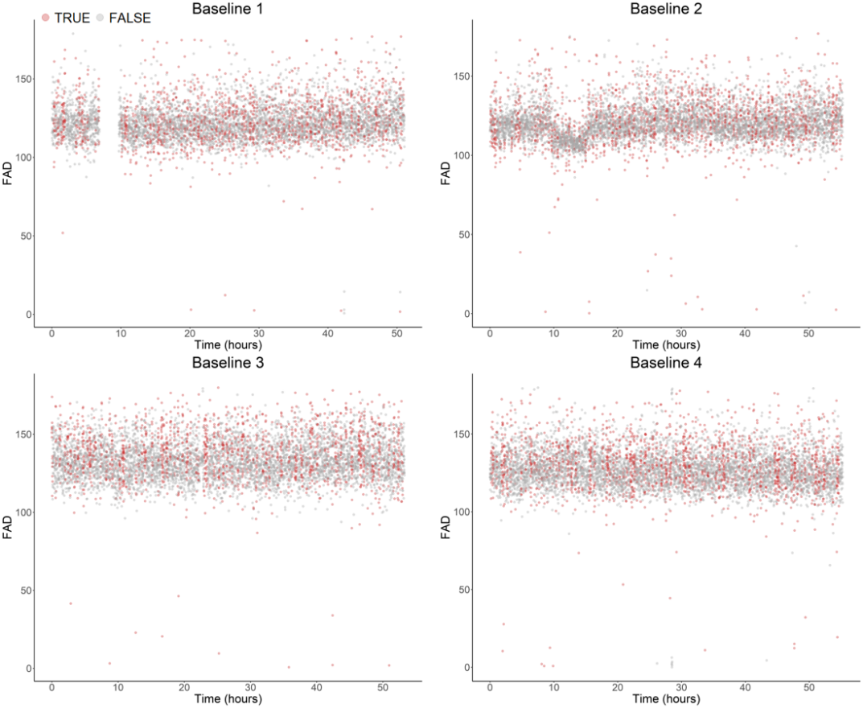
Figure S3. FAD versus time for each baseline.

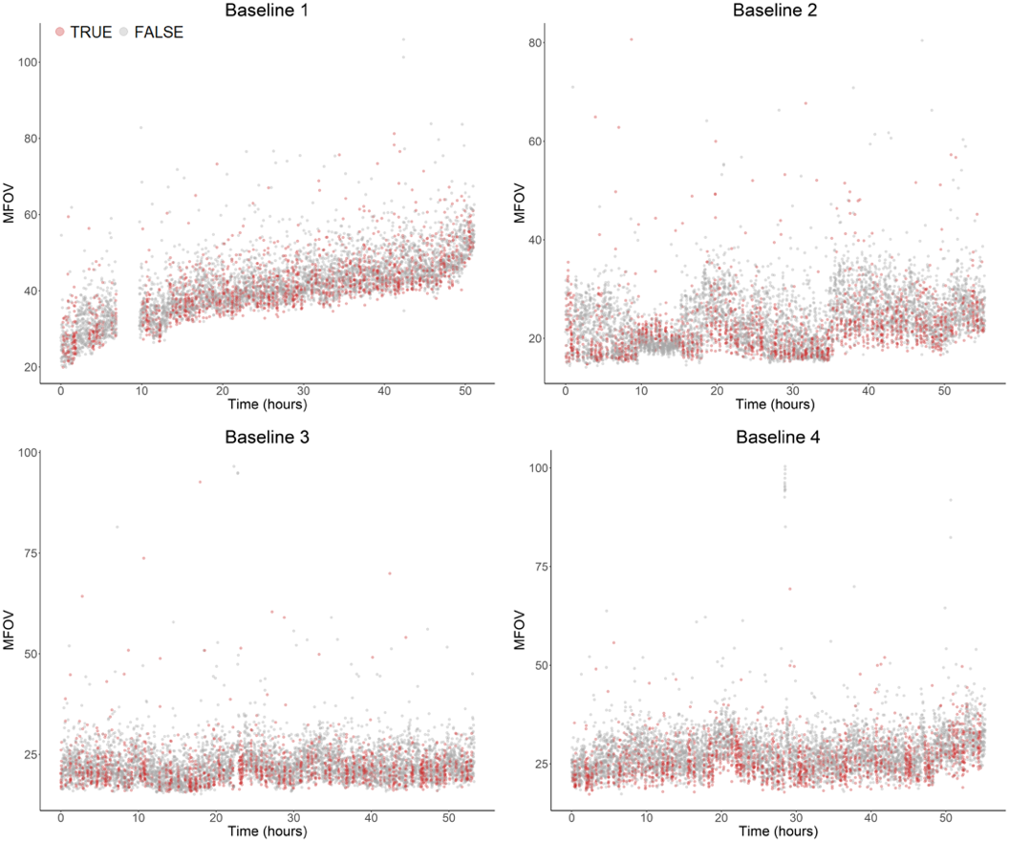
Figure S4. MFOV versus time for each baseline.

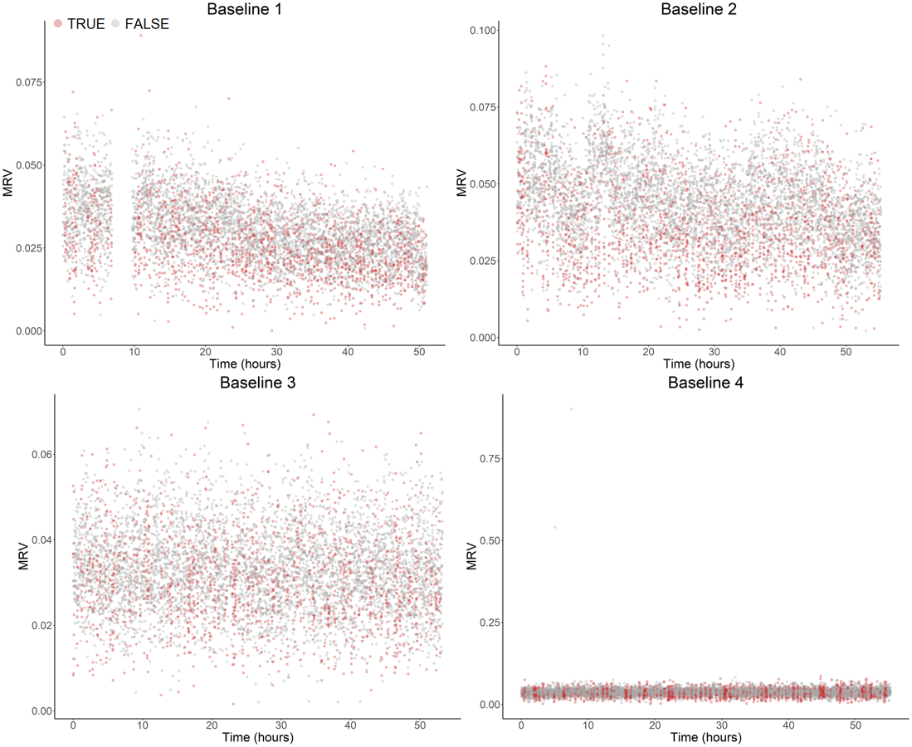
Figure S5. MRV versus time for each baseline.

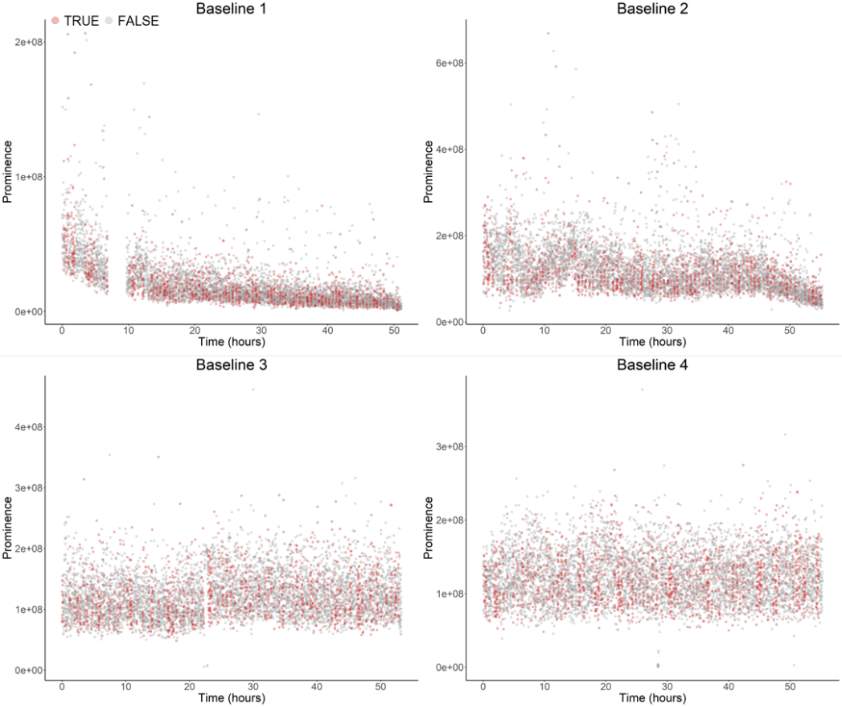
Figure S6. Prominence versus time for each baseline.

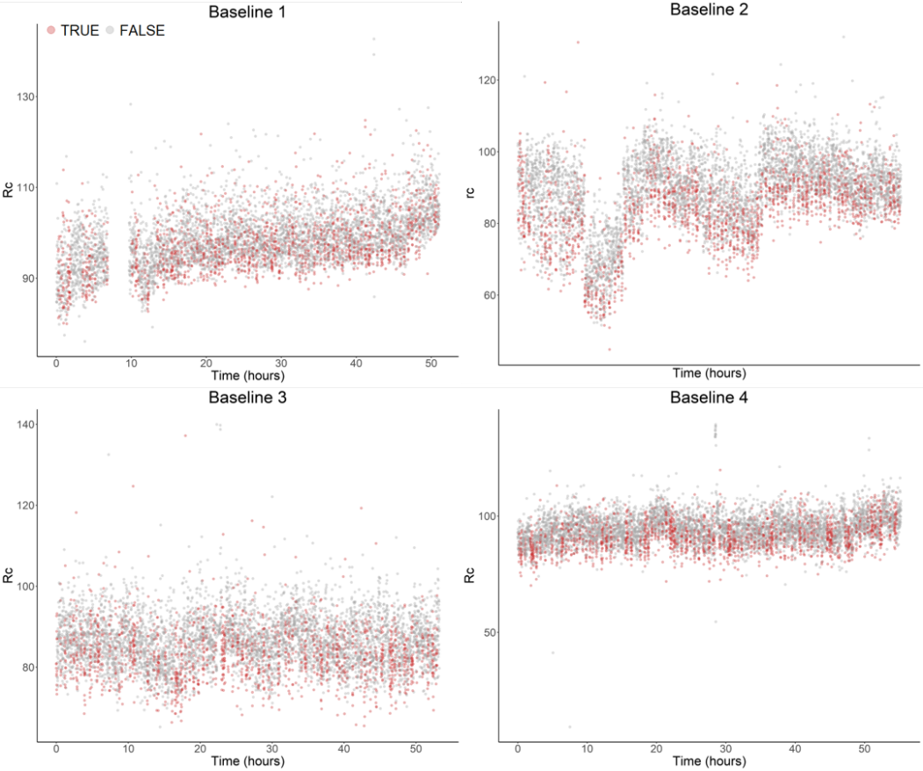
Figure S7. Rc versus time for each baseline.

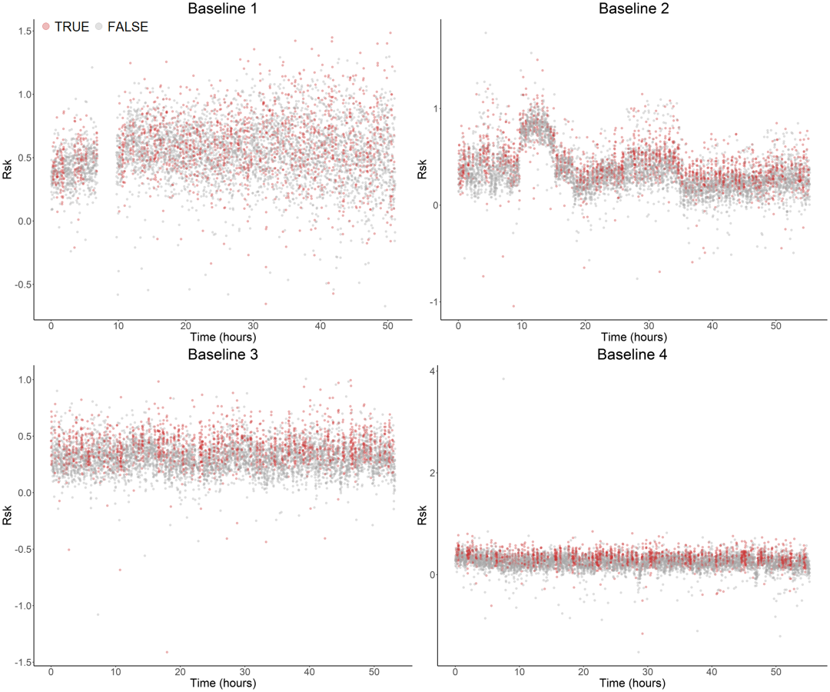
Figure S8. Rsk versus time for each baseline.

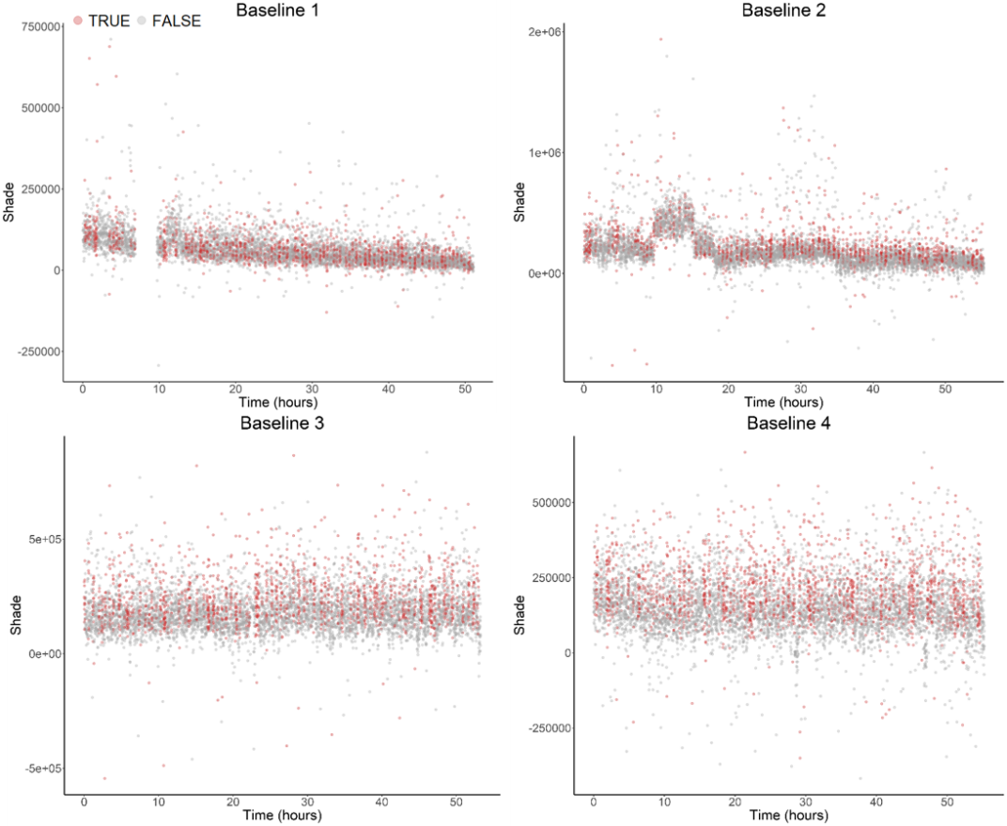
Figure S9. Shade versus time for each baseline.

