Energy-efficient bioethanol recovery process

using deep eutectic solvent as entrainer

Seong Chan Lee, Hyeon Woo Oh, Hee Chul Woo*, and Young Han Kim*
Department of Chemical Engineering, Pukyong National University

Supplementary Materials

Table S1. Measurements of liquid-liquid equilibrium in a system of water(1)/ethanol(2)/2-methyl pentanol(3). Units are in mole fraction.

Number | Organic phase |  |  | Aqueous phase
 | x_{1,1} | x_{2,1} | x_{3,1} | x_{1,2} | x_{2,2} | x_{3,2}
1-1 | 0.1259 | 0.0386 | 0.8355 | 0.9955 | 0.0038 | 0.0008
1-2 | 0.1302 | 0.0345 | 0.8352 | 0.9942 | 0.0055 | 0.0003
1-3 | 0.1346 | 0.0400 | 0.8320 | 0.9949 | 0.0039 | 0.0011
2-1 | 0.1638 | 0.1772 | 0.6591 | 0.9624 | 0.0351 | 0.0025
2-2 | 0.1702 | 0.1758 | 0.6540 | 0.9687 | 0.0288 | 0.0025
2-3 | 0.1735 | 0.1723 | 0.6543 | 0.9718 | 0.0278 | 0.0004
3-1 | 0.1869 | 0.3250 | 0.4881 | 0.9386 | 0.0602 | 0.0013
3-2 | 0.1834 | 0.3253 | 0.4913 | 0.9469 | 0.0514 | 0.0016
3-3 | 0.1775 | 0.3272 | 0.4954 | 0.9477 | 0.0504 | 0.0020
4-1 | 0.2607 | 0.4798 | 0.2595 | 0.8529 | 0.1403 | 0.0068
4-2 | 0.2556 | 0.4813 | 0.2631 | 0.8565 | 0.1383 | 0.0052
4-3 | 0.2439 | 0.4894 | 0.2667 | 0.8506 | 0.1440 | 0.0054

Table S2. Calculated compositions of liquid-liquid equilibrium in a system of water(1)/ethanol(2)/2-methyl pentanol(3) using molecular simulation and NRTL prediction. Units are in mole fraction.

Procedure |  | Organic phase |  |  |  | Aqueous phase
 | x_{1,1} |  | x_{2,1} | x_{3,1} | x_{1,2} |  | x_{2,2} | x_{3,2}
Molecular simulation
 | 0.0924 |  | 0.0346 | 0.8730 | 1.0000 |  | 0.0000 | 0.0000
 | 0.1249 |  | 0.1327 | 0.7425 | 0.9903 |  | 0.0088 | 0.0009
 | 0.1160 |  | 0.2544 | 0.6296 | 0.9699 |  | 0.0301 | 0.0000
 | 0.1525 |  | 0.3688 | 0.4787 | 0.9340 |  | 0.0608 | 0.0052
 | 0.2128 |  | 0.4546 | 0.3327 | 0.8688 |  | 0.1312 | 0.0000
 | 0.2674 |  | 0.5101 | 0.2224 | 0.8173 |  | 0.1819 | 0.0008
 | 0.3047 |  | 0.5298 | 0.1654 | 0.7717 |  | 0.2178 | 0.0105
NRTL
 | 0.1083 |  | 0.0162 | 0.8755 | 0.9978 |  | 0.0021 | 0.0001
 | 0.1222 |  | 0.1383 | 0.7395 | 0.9701 |  | 0.0299 | 0.0000
 | 0.1465 |  | 0.2419 | 0.6116 | 0.9425 |  | 0.0574 | 0.0001
 | 0.1774 |  | 0.3404 | 0.4822 | 0.9102 |  | 0.0896 | 0.0002
 | 0.2281 |  | 0.4421 | 0.3298 | 0.8686 |  | 0.1309 | 0.0005
 | 0.2994 |  | 0.5055 | 0.1951 | 0.8172 |  | 0.1816 | 0.0012
 | 0.3306 |  | 0.5141 | 0.1553 | 0.8015 |  | 0.1969 | 0.0016

Table S3. Calculated compositions of vapor-liquid equilibrium in a system of ethanol(1) and 2-methyl pentanol(2) using molecular simulation and NRTL prediction. Units are in mole fraction.

Procedure |  | Molecular simulation |  |  |  |  |  |  | NRTL
T, K | x₁ |  | x₂ | y₁ | y₂ | x₁ |  | x₂ |  | y₁ | y₂
417.50 | 0.0164 |  | 0.9836 | 0.1206 | 0.8794 | 0.0095 |  | 0.9905 |  | 0.1226 | 0.8774
410.50 | 0.0589 |  | 0.9411 | 0.3010 | 0.6990 | 0.0294 |  | 0.9706 |  | 0.3119 | 0.6881
404.75 | 0.0802 |  | 0.9198 | 0.4309 | 0.5691 | 0.0500 |  | 0.9500 |  | 0.4458 | 0.5542
396.25 | 0.1246 |  | 0.8754 | 0.5910 | 0.4090 | 0.0890 |  | 0.9110 |  | 0.6052 | 0.3948
383.75 | 0.2033 |  | 0.7967 | 0.7711 | 0.2289 | 0.1788 |  | 0.8212 |  | 0.7765 | 0.2235
374.00 | 0.3158 |  | 0.6842 | 0.8637 | 0.1363 | 0.3000 |  | 0.7000 |  | 0.8691 | 0.1309
368.75 | 0.4235 |  | 0.5765 | 0.8893 | 0.1107 | 0.3993 |  | 0.6007 |  | 0.9075 | 0.0925
364.75 | 0.5023 |  | 0.4977 | 0.9209 | 0.0791 | 0.4990 |  | 0.5010 |  | 0.9327 | 0.0673
361.50 | 0.5895 |  | 0.4105 | 0.9501 | 0.0499 | 0.5990 |  | 0.4010 |  | 0.9511 | 0.0489
358.75 | 0.6974 |  | 0.3026 | 0.9568 | 0.0432 | 0.6965 |  | 0.3035 |  | 0.9653 | 0.0347
356.25 | 0.7869 |  | 0.2131 | 0.9808 | 0.0192 | 0.7950 |  | 0.2050 |  | 0.9777 | 0.0223
354.00 | 0.8937 |  | 0.1063 | 0.9897 | 0.0103 | 0.8893 |  | 0.1107 |  | 0.9883 | 0.0117

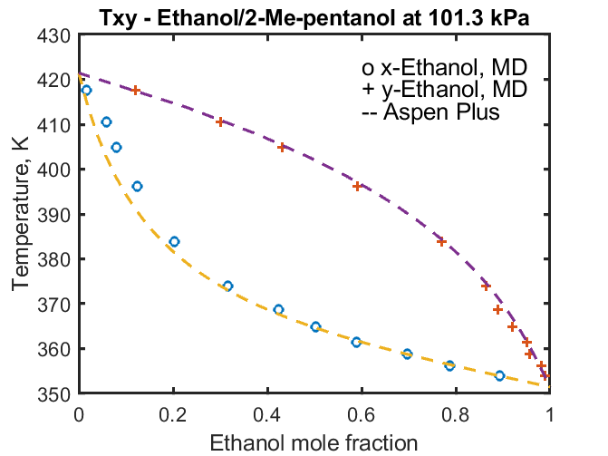

Fig. S1. Txy diagram of the ethanol/2-methyl pentanol binary system. The circles represent the molecular simulation computed ethanol composition in the liquid and plus (+) symbols represent ethanol in the vapor phase. The curves are the Aspen Plus computed compositions.

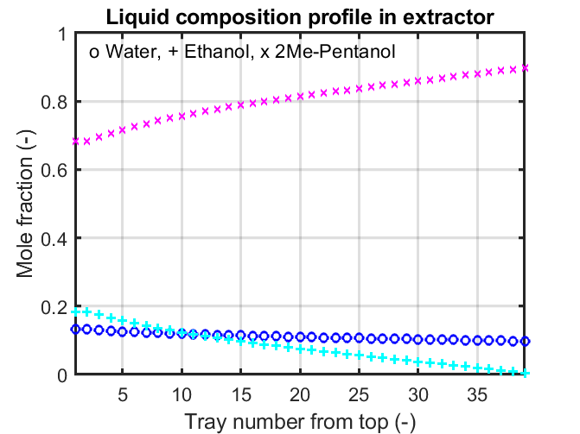

Fig. S2. Liquid composition profile of the organic phase and extractor tray numbers counted from the top.
File S1. List of input file in RASPA simulation

SimulationType MonteCarlo
NumberOfCycles 15000
NumberOfInitializationCycles 3000
PrintEvery 1000
PrintPropertiesEvery 1000
PrintForceToOutput no
PrintPseudoAtomsToOutput no
PrintMoleculeDefinitionToOutput no

Forcefield CastilloVlugtCalero2009

Box 0
BoxLengths 24 24 24
BoxAngles 90 90 90
ExternalTemperature 298.15
ExternalPressure 1.013e5

Box 1
BoxLengths 41 41 41
BoxAngles 90 90 90
ExternalTemperature 298.15
ExternalPressure 1.013e5

GibbsVolumeChangeProbability 0.0

Component 0 MoleculeName water
MoleculeDefinition CastilloVlugtCalero2009
TranslationProbability 1.0
RotationProbability 1.0
ReinsertionProbability 0.2
GibbsSwapProbability 0.05
CreateNumberOfMolecules 404 17

Component 1 MoleculeName ethanol
MoleculeDefinition CastilloVlugtCalero2009
TranslationProbability 1.0
RotationProbability 1.0
ReinsertionProbability 0.2
GibbsSwapProbability 0.05
CreateNumberOfMolecules 20 103

Component 2 MoleculeName 2methyl1pentanol
MoleculeDefinition CastilloVlugtCalero2009
TranslationProbability 1.0
RotationProbability 1.0
ReinsertionProbability 0.2
GibbsSwapProbability 0.05
CreateNumberOfMolecules 1 275

