Table S1 Porous properties of the produced activated carbons at the various ZnCl₂:OP mass ratios
V_{T} (cm³g⁻¹)^{b} | S_{BET} (m²g⁻¹)ª | ZnCl₂:OP mass ratio
0.642 | 700 | 1:1 | 1
0.8 | 906 | 2:1 | 2
1.29 | 1067 | 3:1 | 3
0.74 | 825 | 4:1 | 4

ª BET specific surface area, and ^{b} total pore volume

Table S2: Porous properties comparison of OPAC with other agricultural waste-derived ACs reported in literature

Biomass precursor | Activator | Conditions | S_{BET} (m²g⁻¹)ª | V_{T} (cm³g⁻¹) ^{b} | V_{mic} (cm³g⁻¹) ^{c} | V_{meso} (cm³g⁻¹) ^{d} | V_{meso}/V_{T}, % ^{e} | Ref.
Corn stigmata fibers | ZnCl₂ | 400 °C , 60 min | 389.00 | 0.18 | 0.170 | 0.01 | 5.60 | [1]
Rice husk | ZnCl₂ | 500 °C, 120 min,  500 °C, 60 min | 138.00 | 0.11 | -- | 0.11 | 100.00 | [2]
Coffee husk | ZnCl₂ | 500 °C, 120 min,  500 °C, 60 min | 613.00 | 0.29 | 0.170 | 0.12 | 41.39 | [2]
Coconut shells | ZnCl₂ | 500 °C, 60 min | 935.46 | 0.41 | 0.260 | 0.155 | 37.80 | [3]
Pine-fruit residue | ZnCl₂ | 500 °C, 120 min | 774.20 | 0.44 | 0.305 | 0.135 | 30.68 | [4]
Sesame seed | ZnCl₂ | 700 °C | 490.00 | -- | -- | -- | -- | [5]
Pomegranate seeds | ZnCl₂ | 600 °C, 60 min | 978.80 | 0.56 | 0.283 | 0.280 | 50.00 | [6]
Pomegranate seeds | ZnCl₂ | 800 °C, 60 min | 823.70 | 0.35 | 0.071 | 0.279 | 79.71 | [6]
Wild chestnut shell | ZnCl₂ | 700 °C, 60 min | 932.14 | 0.50 | 0.302 | 0.2 | 40.00 | [7]
Cocoa shell | ZnCl₂ | 500 °C, 40 min | 642.00 | 0.48 | -- | -- | -- | [8]
Siriguela seed | ZnCl₂ | 500 °C, 40 min, | 956.00 | 0.95 | -- | -- | -- | [8]
Corncob | ZnCl₂ | 500 °C, 120 min | 763.18 | 0.41 | 0.350 | 0.06 | 14.63 | [9]
Acorn shell | ZnCl₂ | 600 °C, 30 min | 1289.00 | -- | 0.210 | -- | -- | [10]
Oil palm shell | ZnCl₂ | 500 °C, 120 min | 1118 | 0.51 | 0.42 | 0.09 | 17.65 | [11]
Tea industry waste | ZnCl₂ | 700 °C, 240 min | 1066 | 0.580 | 0.337 | 0.243 | 41.89 | [12]
Potato peels | ZnCl₂ | 450 °C, 60 min | 1027.00 | 1.34 | 0.130 | 1.21 | 90.29 | [13]
Sugar cane bahasse | ZnCl₂ | 500 °C, 60 min | 1145.00 | 1.30 | 0.150 | 1.15 | 88.46 | [14]
Baobab fruit Shell | ZnCl₂ | 500 °C, 60 min | 559.54 | 0.58 | 0.11 | 0.47 | 81.03 | [15]
Tomato waste | ZnCl₂ | 600 °C, 60 min | 1093 | 1.569 | 0.129 | 1.440 | 91.78 | [16]
Waste potato residue | ZnCl₂ | 600 °C, 60 min | 1357 | 1.065 | 0.083 | 0.982 | 92.2 | [17]
Orange peels | ZnCl₂ | 500 °C, 60 min | 1096 | 1.29 | 0.160 | 1.13 | 87.59 | This study
ª BET specific surface area, ^{b} total pore volume, ^{c} micropore volume, ^{d} Mesopore volume, ^{e} mesopore fraction

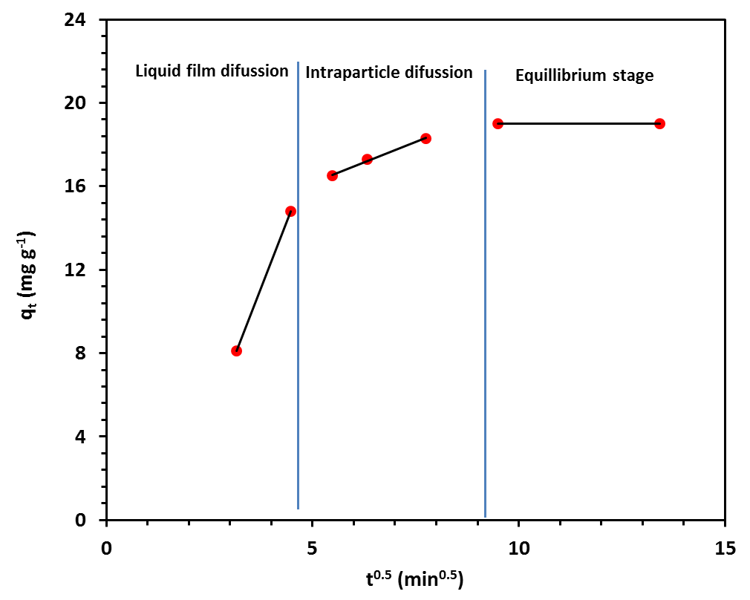
Fig. S1. Application of the Webber-Morris intraparticle diffusion model for the APAP adsorption using OPAC.
References
[1] Mbarki, F., Selmi, T., Kesraoui, A. and Seffen, M., 2022. Low-cost activated carbon preparation from Corn stigmata fibers chemically activated using H3PO4, ZnCl2 and KOH: Study of methylene blue adsorption, stochastic isotherm and fractal kinetic. Industrial Crops and Products, 178, p.114546.
[2] Paredes-Laverde, M., Salamanca, M., Diaz-Corrales, J., Flórez, E., Silva-Agredo, J. and Torres-Palma, R., 2021. Understanding the removal of an anionic dye in textile wastewaters by adsorption on ZnCl2 activated carbons from rice and coffee husk wastes: A combined experimental and theoretical study. Journal of Environmental Chemical Engineering, 9(4), p.105685.
[3] Yağmur, H. and Kaya, İ., 2021. Synthesis and characterization of magnetic ZnCl2-activated carbon produced from coconut shell for the adsorption of methylene blue. Journal of Molecular Structure, 1232, p.130071.
[4] Madankar, C., Bhagwat, S. and Meshram, P., 2021. Cd2+ removal from synthetic waters by ZnCl2-activated carbon. Materials Today: Proceedings, 45, pp.4684-4688.
[5] Kırbıyık, Ç., Pütün, A. and Pütün, E., 2017. Equilibrium, kinetic, and thermodynamic studies of the adsorption of Fe(III) metal ions and 2,4-dichlorophenoxyacetic acid onto biomass-based activated carbon by ZnCl 2 activation. Surfaces and Interfaces, 8, pp.182-192.
[6] Uçar, S., Erdem, M., Tay, T. and Karagöz, S., 2009. Preparation and characterization of activated carbon produced from pomegranate seeds by ZnCl2 activation. Applied Surface Science, 255(21), pp.8890-8896.
[7] Altintig, E. and Kirkil, S., 2016. Preparation and properties of Ag-coated activated carbon nanocomposites produced from wild chestnut shell by ZnCl2 activation. Journal of the Taiwan Institute of Chemical Engineers, 63, pp.180-188..
[8] Pereira, R., Veloso, C., da Silva, N., de Sousa, L., Bonomo, R., de Souza, A., Souza, M. and Fontan, R., 2014. Preparation of activated carbons from cocoa shells and siriguela seeds using H3PO4 and ZnCL2 as activating agents for BSA and α-lactalbumin adsorption. Fuel Processing Technology, 126, pp.476-486.
[9] Lu, Q., Wang, Z., Dong, C., Zhang, Z., Zhang, Y., Yang, Y. and Zhu, X., 2011. Selective fast pyrolysis of biomass impregnated with ZnCl2: Furfural production together with acetic acid and activated carbon as by-products. Journal of Analytical and Applied Pyrolysis, 91(1), pp.273-279.
[10] Saka, C., 2012. BET, TG–DTG, FT-IR, SEM, iodine number analysis and preparation of activated carbon from acorn shell by chemical activation with ZnCl2. Journal of Analytical and Applied Pyrolysis, 95, pp.21-24.
[11] Arami-Niya, A., Daud, W. and Mjalli, F., 2011. Comparative study of the textural characteristics of oil palm shell activated carbon produced by chemical and physical activation for methane adsorption. Chemical Engineering Research and Design, 89(6), pp.657-664.
[12] 10.1021/je300597u | J. Chem. Eng. Data 2012, 57, 2733−2743
[13] Hussein, M., Abo El Naga, A., El Saied, M., AbuBaker, M., Shaban, S. and El Kady, F., 2021. Potato peel waste-derived carbon-based solid acid for the esterification of oleic acid to biodiesel. Environmental Technology & Innovation, 21, p.101355.
[14] Abo El Naga, A., El Saied, M., Shaban, S. and El Kady, F., 2019. Fast removal of diclofenac sodium from aqueous solution using sugar cane bagasse-derived activated carbon. Journal of Molecular Liquids, 285, pp.9-19.
[15] Nedjai, R., Kabbashi, N. A., Alam, M. Z., & Al-Khatib, M. F. R. (2021, December). Production and Characterization of Activated Carbon from Baobab Fruit Shells by Chemical Activation Using ZnCl2, H3PO4 and KOH. In Journal of Physics: Conference Series (Vol. 2129, No. 1, p. 012009). IOP Publishing.
[16] Sayğılı, H. and Güzel, F., 2016. High surface area mesoporous activated carbon from tomato processing solid waste by zinc chloride activation: process optimization, characterization and dyes adsorption. Journal of Cleaner Production, 113, pp.995-1004.
[17] Zhang, Z., Luo, X., Liu, Y., Zhou, P., Ma, G., Lei, Z. and Lei, L., 2015. A low cost and highly efficient adsorbent (activated carbon) prepared from waste potato residue. Journal of the Taiwan Institute of Chemical Engineers, 49, pp.206-211.

