Supplementary Information file
Eco-friendly synthesis of Salmalia Malabarica gum stabilized palladium nanoparticles: Antibacterial and catalytic properties.
Kondaiah Sekuª, Babu Pejjai^{b}, Ahmed I. Osman^{c}, Syed Sulaiman Hussainiª, Mohammed Al-Abri^{d,e}, Nadavala Siva Kumar^{f}, N. Satya Vijaya Kumar^{g}, S. Shravan Kumar Reddy^{h}, Kishor Kumar Sadasivuni^{i}, Ahmed Al-Fatish^{f}, Bhagavanth Reddy G^{j*}

ªDepartment of Engineering, Civil Section, University of Technology and Applied Sciences-Shinas, Sultanate of Oman.
^{b}Department of Physics, Sri Venkateshwara College of Engineering, Karakambadi Road, Tirupati, 517507, India.
^{c}Department of Chemical Engineering, King Saud University, P.O. Box 800, Riyadh 11421,
Saudi Arabia.
^{d}School of Chemistry and Chemical Engineering, Queen’s University Belfast, Belfast BT9 5AG, Northern Ireland, UK.
^{e}Nanotechnology Research Center, Sultan Qaboos University, Muscat, Oman
^{f}Department of Petroleum and Chemical Engineering, College of Engineering, Sultan Qaboos University, Muscat, Oman.
^{g}Centre of excellence, Vignan's Foundation for Science, Technology & Research (Deemed to be University), Vadlamudi, Guntur – 522213, Andhra Pradesh, India.
^{h}Department of Physics, Chaitanya Bharathi Institute of Technology, Gandipet, Hyderabad, India -500 075.
^{i}Centre for Advanced Materials, Qatar University, Doha, Qatar
^{j}Department of Chemistry, Palamuru University PG center, Wanaparthi, India.

*Corresponding authors: kondareddyseku@gmail.com (Kondaiah Seku) bhagavanth.g@gmail.com (Bhagavanth Reddy G)

1. Materials and Methods
2.0. PdNPs catalyze the reduction of 4 -NP
We examined the catalytic activity of PdNPs for the reduction of 4-nitrophenol in the presence of NaBH4. A quartz cell was used to study the reaction with 0.2 mM 4-nitrophenol and 0.015 mM NaBH4. When p-nitrophenolate ions form in the reaction mixture, the yellow colour changes to a deep yellow. Afterwards, 5 mg of PdNPs [24] were added to the reaction mixture, and UV-visible spectra were recorded over a period of time.
2.5. Reduction of MO and RhB dyes catalytically
PdNP was used as catalyst towards the reduction of MO and Rh-B dyes in the presence of NaBH₄. A mixture of 2 mL of MO solution and 10 mL of 10 mM NaBH4 was stirred for five minutes with 8 mL of DD water. A 3 mL reaction mixture was added to a cuvette with 5 mg of PdNPs, and the UV-Visible spectrum was recorded over time. Rh-B was reduced using the same method.
2.6. Antibacterial properties of PdNPs
Using the zone inhibition method, PdNPs were tested for antibacterial properties against Gram-negative bacteria like E coli and Pseudomonas aeruginosa and Gram-positive bacteria like Bacillus subtilis and Bacillus cereus (Gram-positive). A pure strain of bacteria was inoculated into 100 mL of Luria broth in conical flasks to produce active cultures. Overnight, these flasks were incubated at 37ºC. Spread plate techniques were used to seed overnight active cultures into nutrient agar medium. A sterilized metallic borer was later used to make cavities in the nutrient agar plates. Different concentrations (0, 60, 80, and100 µg) of colloidal PdNPs suspension were then loaded into these cavities, and the plates were incubated at 37ºC for overnight. The inhibition zone formed around the wells was measured after incubation.
2.7. Characterization Techniques
Various physicochemical techniques have been employed to characterize the formation of PdNPs. The dye reduction studies and identification of PdNPs were performed using the Lab India UV-3200. Shimadzu's IR Affinity-1 was used to perform FTIR spectral studies. An XRD analysis of the synthesized PdNPs was carried out using the Rigaku Miniflex. The size and shape of PdNPs were investigated using TEM (JEOL2000; ZEISS EVO instrument). X-ray photoelectron spectroscopy (XPS) analysis of the samples was studied with a Thermo Fisher Scientific K Alpha + spectrometer (Waltham, MA, USA). Energy dispersive X-ray spectroscopy (EDX -EDAX -EDS-SSD, EDAX lnc., USA) was used to study the elemental analysis.

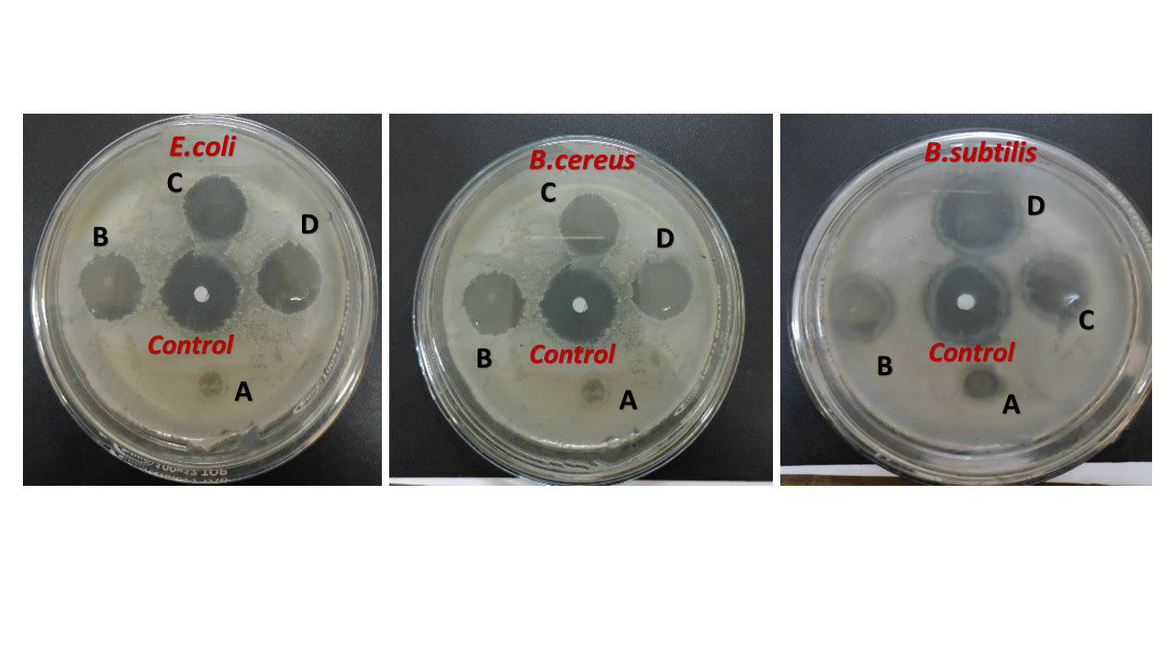
Fig. S1. Antibacterial activity of PdNPs using (a) Escherichia coli; (b) Bacillus subtilis; (c) B. Subtilis and Amoxicillin as a standard (1mg/ml solution: disks containing (i) = 0 µg/µL of PdNPs; (ii) = 60 µg/µL of PdNPs; (iii) = 80 µg/µL of PdNPs; (iv) = 100 µg/µL of PdNPs and Amoxicillin standard).

