Performance evaluation of microbial fuel cell fabricated using green nano-graphene oxide as coating anode material
Afaf Abdel Razik Mohamedª, Ali El-Dissouky Aliª, Mohamed Salah El-Din Hassouna^{b},
Amel F. Elhusseinyª, Abd El-Hady B. Kashyout^{c}, Zhen He^{d}, Hanan Moustafa^{b}*

ª Chemistry Department, Faculty of Science, Alexandria University, 2 Bagdad Street, PO Box 2-Moharrem Beck, Alexandria, 21321, Egypt.
^{b} Institute of Graduate Studies and Research, Alexandria University, Alexandria 21526, Egypt.
^{c} Electronic Materials Department, City of Scientific Research and Technological Applications (SRTA-City), Egypt.
^{d} Department of Energy, Environmental and Chemical Engineering, Washington University in St. Louis, St. Louis, MO 63130, USA

Corresponding author
E- mail: Hanan.abdallah@alexu.edu.eg

Data availability
Data will be available upon special request from corresponding author

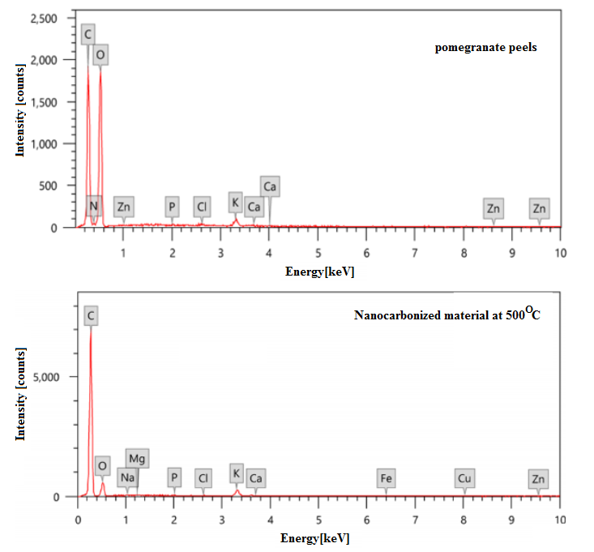
Supplementary figure S1. The EDX of pomegranate peels and nanocarbonized material prepared at 500 °C.

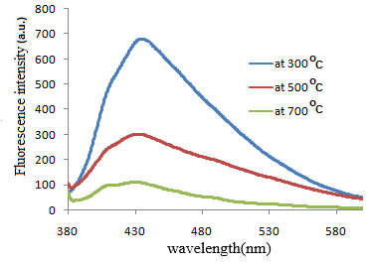
Supplementary figure S2. Fluorescence spectra of nanocarbonized materials at different temperatures.
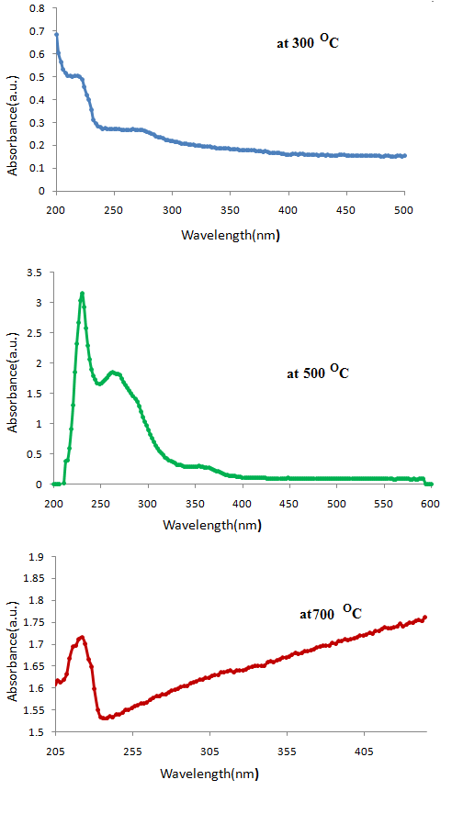
Supplementary figure S3. UV-visible spectra of nanocarbonized materials at different temperatures.

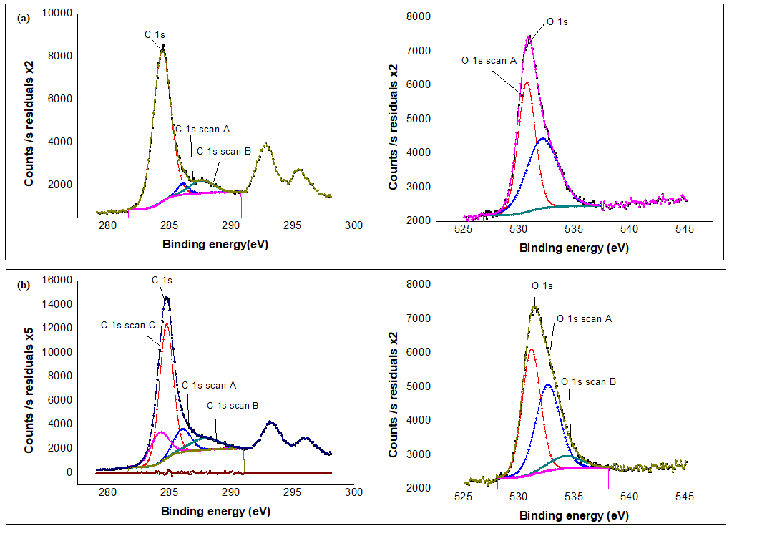 Supplementary figure S4. Core level C1s and O1s high-resolution XPS spectra of GO (a) and rGO (b) obtained by hydrothermal reduction using pomegranate peels. blue solid line represents the experimental data, yellow lines are the deconvoluted components.

Supplementary figure S5. Voltage versus time of the different trials of testing MFC.
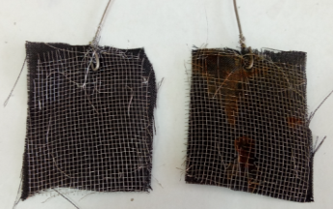
Supplementary figure S6. Carbon cloth supported on stainless steel mesh was used as electrode; cathode (left) , anode after microbial corrosion (right).

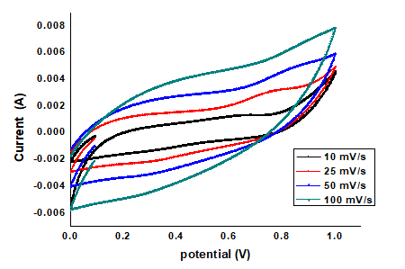
Supplementary figure S7. Cyclic Voltammogram at different scanning rates using free graphite plate anode.

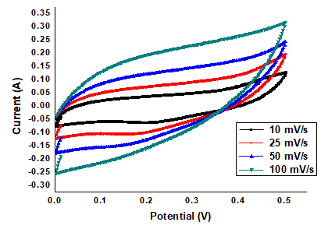
Supplementary figure S8. Cyclic voltammogram at different scanning rates using MFC with graphite plate coated with GO as anode.

Supplementary table 1. Chemical composition of pomegranate peel powder and nanocarbonized material at 500 °C.
Analysis wt. % | Pomegranate peels powder | Nanocarbonized material at temperature= 500°C
C | 42.11 | 76.32
O | 55.86 | 21.33
K | 0.95 | 1.77
N | 0.58 | ND
Zn | 0.19 | ND
Fe | ND | 0.13
ND= not detected

Supplementary table 2.Trails using different current collector and electrodes.
Trial | Anode | Cathode | Current collector | Anolyte | Catholyte
I | Graphite plates (7x1x0.5 cm) |  | Copper wire (1mm diameter) | a synthetic solution containing (per liter): 1 g acetate; H₄Cl, 0.15 g; NaCl,0.5 g; MgSO₄, 0.015 g; CaCl₂, 0.02 g; NaHCO₃, 0.5 g; and trace element, 1 mL (120mL) was used | 100 mM potassium dichromate dissolved in 0.25 M sulfuric acid (120mL) was used
II |  |  | Copper wire was connected to the anode, while titanium wire (1mm diameter) was connected to the cathode.
III | Carbon cloth supported on stain less steel mesh (5cmx5cm) |  | Titanium wire (1mm diameter)
IV | Graphite plates (7x1x0.5cm) | Carbon cloth supported on stainless steel mesh  (5 cmx5cm) | Titanium wire (1mm diameter)

