Sustainability assessment of orange peel waste valorization pathways from juice industries
Pantelis Manakasª, Athanasios T. Balafoutis^{b}, Constantina Kottaridi^{c}, Anestis Vlysidisª
ªSchool of Chemical Engineering, National Technical University, Iroon Polytechneiou 9, Zografou 157 80, Athens, Greece (anestisvlysidis@chemeng.ntua.gr)
^{b}Institute of Bio-Economy & Agro-Technology, Centre of Research & Technology Hellas, Dimarchou Georgiadou 118, Volos, 38333, Greece (a.balafoutis@certh.gr)
^{c}University of Piraeus, Department of Economics, 80, M. Karaoli and A. Dimitriou Street, Piraeus, PC: 18534, Greece (kottarid@unipi.gr)

Supplementary Information

- Query string pathway for OPW characterization:
TITLE-ABS-KEY ( orange AND peel AND characterization ) OR ( citrus AND waste AND characterization ) OR ( orange AND waste AND characterization ) OR ( citrus AND peel AND characterization ) OR ( citrus AND residues AND characterization ) AND ( LIMIT-TO ( DOCTYPE , "ar" ) OR LIMIT-TO ( DOCTYPE , "re" ) OR LIMIT-TO ( DOCTYPE , "ch" ) ) AND ( LIMIT-TO ( PUBYEAR , 2022 ) OR LIMIT-TO ( PUBYEAR , 2021 ) OR LIMIT-TO ( PUBYEAR , 2020 ) OR LIMIT-TO ( PUBYEAR , 2019 ) OR LIMIT-TO ( PUBYEAR , 2018 ) OR LIMIT-TO ( PUBYEAR , 2017 ) OR LIMIT-TO ( PUBYEAR , 2016 ) OR LIMIT-TO ( PUBYEAR , 2015 ) OR LIMIT-TO ( PUBYEAR , 2014 ) OR LIMIT-TO ( PUBYEAR , 2013 ) OR LIMIT-TO ( PUBYEAR , 2012 ) OR LIMIT-TO ( PUBYEAR , 2011 ) OR LIMIT-TO ( PUBYEAR , 2010 ) )

- Query string pathway for OPW valorization:
TITLE-ABS-KEY ( orange AND peel AND management ) OR ( citrus AND waste AND management ) OR ( orange AND waste AND management ) OR ( citrus AND peel AND management ) OR ( citrus AND residues AND management ) ( orange AND peel AND valorization ) OR ( citrus AND waste AND valorization ) OR ( orange AND waste AND valorization ) OR ( citrus AND peel AND valorization ) OR ( citrus AND residues AND valorization ) ( orange AND peel AND treatment ) OR ( citrus AND waste AND treatment ) OR ( orange AND waste AND treatment ) OR ( citrus AND peel AND treatment ) OR ( citrus AND residues AND treatment ) AND ( LIMIT-TO ( DOCTYPE , "ar" ) OR LIMIT-TO ( DOCTYPE , "re" ) OR LIMIT-TO ( DOCTYPE , "ch" ) ) AND ( LIMIT-TO ( PUBYEAR , 2022 ) OR LIMIT-TO ( PUBYEAR , 2021 ) OR LIMIT-TO ( PUBYEAR , 2020 ) OR LIMIT-TO ( PUBYEAR , 2019 ) OR LIMIT-TO ( PUBYEAR , 2018 ) OR LIMIT-TO ( PUBYEAR , 2017 ) OR LIMIT-TO ( PUBYEAR , 2016 ) OR LIMIT-TO ( PUBYEAR , 2015 ) OR LIMIT-TO ( PUBYEAR , 2014 ) OR LIMIT-TO ( PUBYEAR , 2013 ) OR LIMIT-TO ( PUBYEAR , 2012 ) OR LIMIT-TO ( PUBYEAR , 2011 ) OR LIMIT-TO ( PUBYEAR , 2010 ) )

- Query string pathway for sustainability assessment of OPW management scenarios:
TITLE-ABS-KEY ( sustainability AND assessment ) OR ( life AND cycle AND assessment OR lca ) OR ( techno-economic AND assessment ) AND ( orange AND peel AND management ) OR ( citrus AND waste AND management ) OR ( orange AND waste AND management ) OR ( citrus AND peel AND management ) OR ( citrus AND residues AND management ) ( orange AND peel AND valorization ) OR ( citrus AND waste AND valorization ) OR ( orange AND waste AND valorization ) OR ( citrus AND peel AND valorization ) OR ( citrus AND residues AND valorization ) ( orange AND peel AND treatment ) OR ( citrus AND waste AND treatment ) OR ( orange AND waste AND treatment ) OR ( citrus AND peel AND treatment ) OR ( citrus AND residues AND treatment ) AND ( LIMIT-TO ( DOCTYPE , "ar" ) OR LIMIT-TO ( DOCTYPE , "re" ) OR LIMIT-TO ( DOCTYPE , "ch" ) ) AND ( LIMIT-TO ( PUBYEAR , 2022 ) OR LIMIT-TO ( PUBYEAR , 2021 ) OR LIMIT-TO ( PUBYEAR , 2020 ) OR LIMIT-TO ( PUBYEAR , 2019 ) OR LIMIT-TO ( PUBYEAR , 2018 ) OR LIMIT-TO ( PUBYEAR , 2017 ) OR LIMIT-TO ( PUBYEAR , 2016 ) OR LIMIT-TO ( PUBYEAR , 2015 ) OR LIMIT-TO ( PUBYEAR , 2014 ) OR LIMIT-TO ( PUBYEAR , 2013 ) OR LIMIT-TO ( PUBYEAR , 2012 ) OR LIMIT-TO ( PUBYEAR , 2011 ) OR LIMIT-TO ( PUBYEAR , 2010 ) )

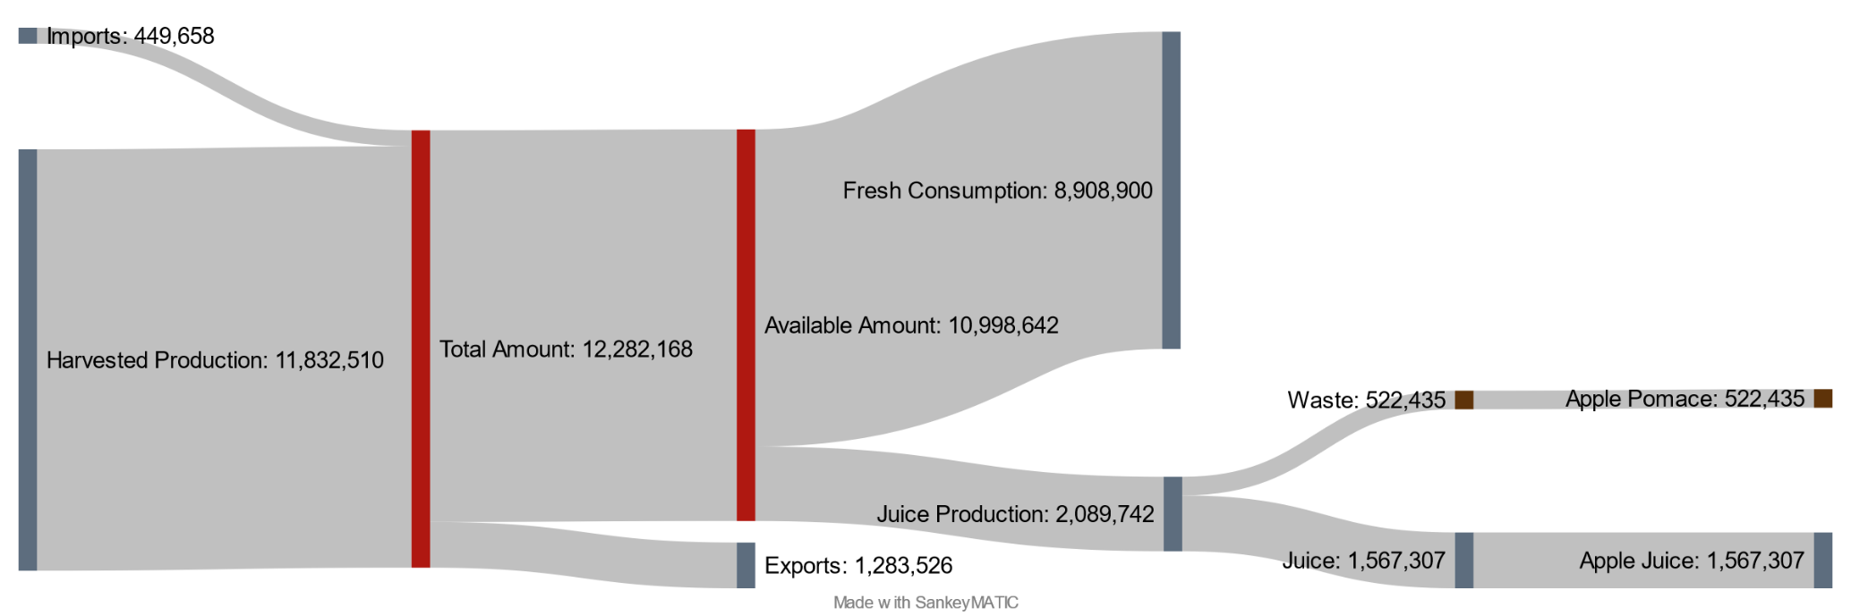
Figure S1. Mass flow of apple cultivation to waste generation through juice extraction (t). The values are in tons and refer to the EU region for the year 2020
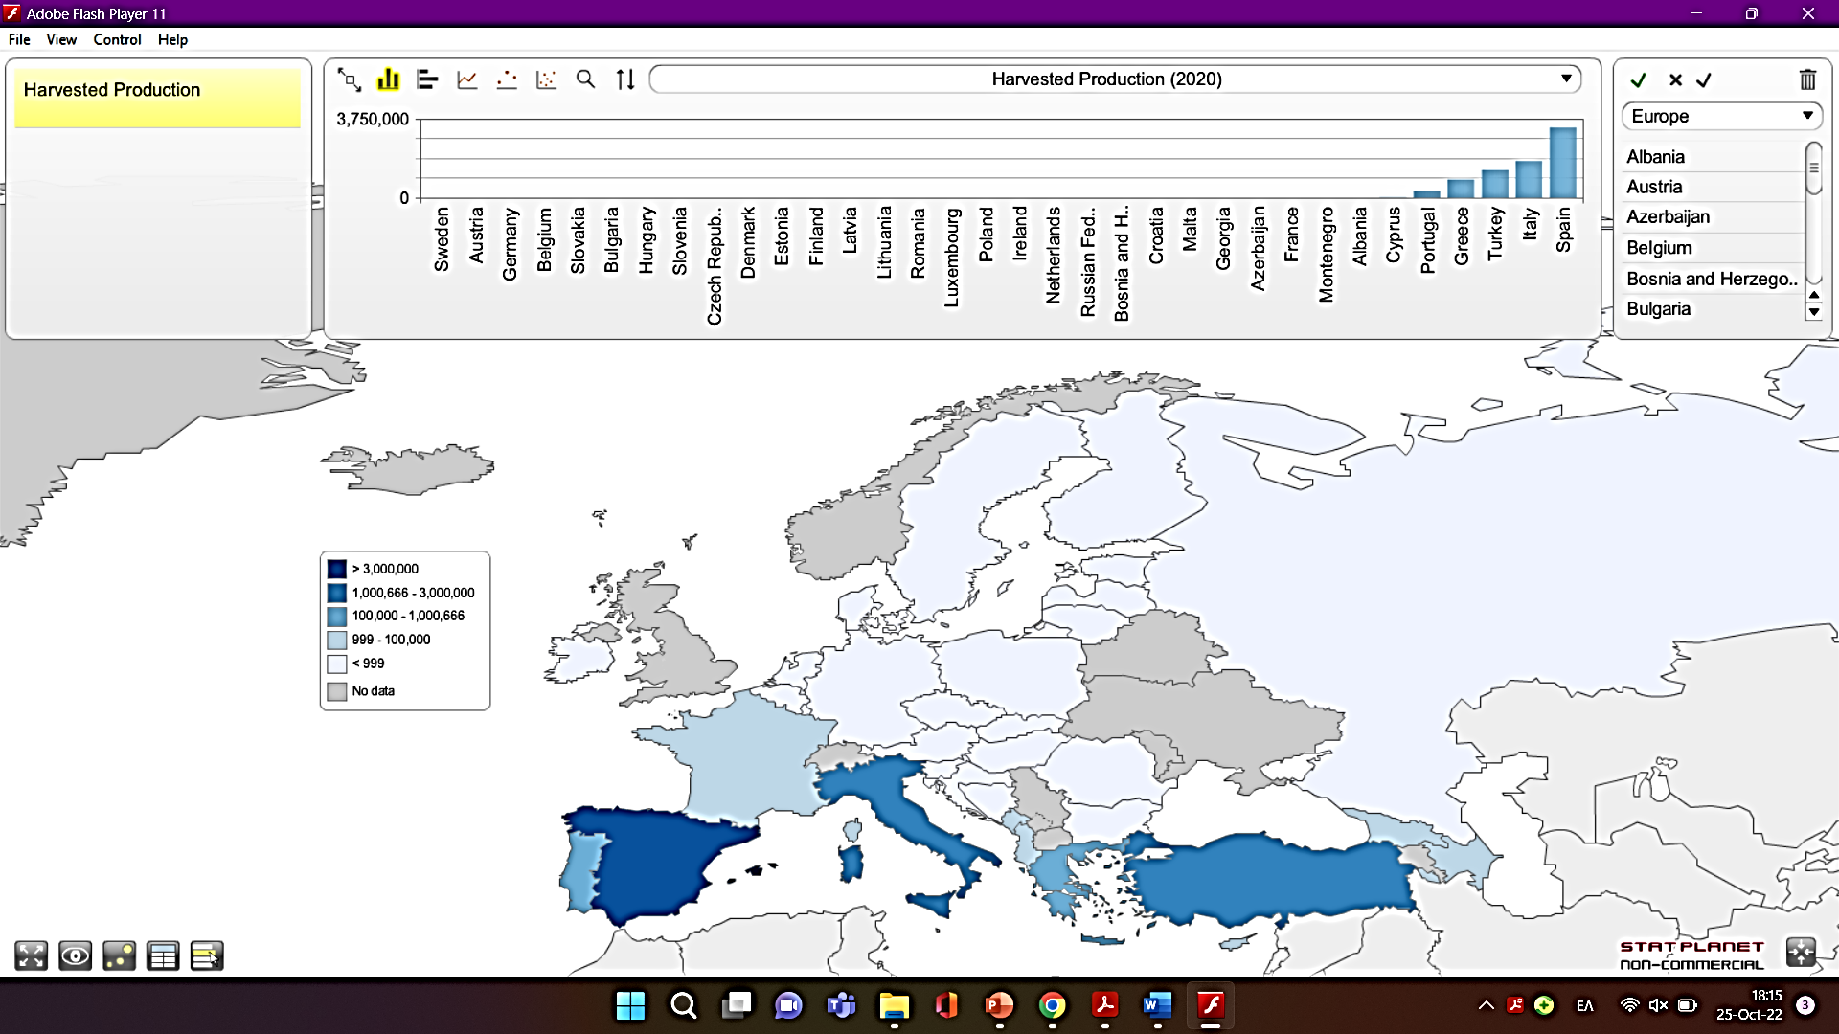
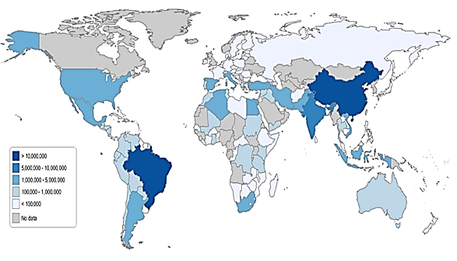
b)
a)

Figure S2 Geographical distribution of oranges production harvested in EU (2a) and globally (2b) in tons.

Figure S3 Frequency of environmental indicators in the selected studies derived from the LR. CC: climate change, POF: photochemical ozone formation, OD: ozone depletion, EUF: freshwater eutrophication, HT: human toxicity (cancer/non cancer effects), TA: terrestrial acidification, FD: fossil depletion, EUM: marine eutrophication, FE: freshwater ecotoxicity, WD: water depletion, TE: terrestrial ecotoxicity, LU: land use, IR: ionizing radiation, AC: acidification, ME: marine ecotoxicity, EUT: terrestrial eutrophication, PM: particulate matter, MD: mineral depletion

a
Conv. EO extr.

Joglekar et al., 2019

b

Joglekar et al., 2019

c

Joglekar et al., 2019

Figure S4 Comparison of Ozone Depletion (a), Terrestrial Acidification (b) and Freshwater Eutrophication (c) performance of different OPW valorization scenarios per f.u... L/Coal Inc.: Landfill/Coal Incineration OPW Inc: orange peel waste incineration, B/D: Biogas/Digestate, B/Fer: Biogas/Fertilizer, Pyr: Pyrolysis, Inc: Incineration, B/D/Lim: Biogas/Digestate/Limonene, CD: Co-digestion, CD+UP: Co-digestion/Methane Upgrade, COMP: Compost, FEED: Animal Feeding, SD: Steam distillation, E.O.: Essential Oil, MAE: Microwave-assisted Extraction, Conv: Conventional, PHC: Phenolic Content, UAE: Ultrasound -assisted Extraction, FU: Functional Unit, OPW: Orange Peel Waste

a

b

Figure S5 Trade-off between Photochemical Ozone Formation and Freshwater Eutrophication (a) and between Photochemical Ozone Formation and Terrestrial Acidification (b). All values are normalized per f.u..

b
a
Figure S6 Negative correlation between Production Cost and Climate Change (a) and between Energy Consumption and Climate Change (b). All values are normalized per f.u..

