Adsorptive Removal of Hazardous Rhodamine B Dye from Aqueous Solutions by St. John’s Wort (Hypericum perforatum)

Birol Isik*

Department of Chemistry, Faculty of Arts & Sciences, Yildiz Technical University, Esenler, Istanbul, 34220, Turkey

*Corresponding author: Birol Isik
Tel.: +902123834136
E-mail: 19birol91@gmail.com

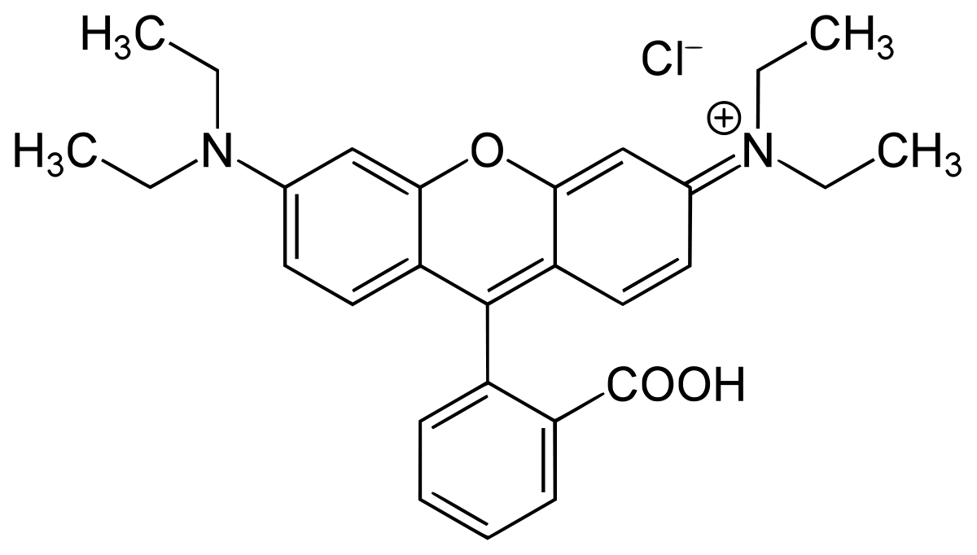
Figure S1. The chemical structure of RhB dye (C₂₈H₃₁ClN₂O₃, λ_{max}: 554 nm, pK_{a} = 3.7)

$$Adsorption \%=100×\left(\frac{C_{o}-C_{e}}{C_{o}}\right) (S1)$$
$$q_{e} \left({mg}/g\right)=\left(C_{o}-C_{e}\right)×\frac{V}{m} (S2)$$
Where $C_{o}$ is the initial RhB concentration (mg/L), $C_{e}$ is the equilibrium RhB concentration (mg/L), $q_{e}$ is the RhB dye adsorbed efficiency at equilibrium (mg/g), $V$ is the volume of RhB dye solution (L), and $m$ is the mass of adsorbent (g).

$$Sum of square error \left(SSE\right)=\sum_{i=1}^{n}{{\left(q_{e,exp}-q_{e,cal}\right)}^{2}} (S16)$$
$$Average relative error \left(ARE\right)=\frac{100}{n}\sum_{i=1}^{n}{\left|\frac{q_{e,exp}-q_{e,cal}}{q_{e,exp}}\right|} (S17)$$
$$Root mean square error \left(RMSE\right)=\sqrt{\frac{1}{n-2}\sum_{i=1}^{n}{{\left(q_{e,exp}-q_{e,cal}\right)}^{2}}} (S18)$$
$$Chi-square \left(χ^{2}\right)=\sum_{i=1}^{n}{\frac{{\left(q_{e,exp}-q_{e,cal}\right)}^{2}}{q_{e,cal}}} (S19)$$
$$Sum of Absolute Errors \left(EABS\right)=\sum_{i=1}^{n}{\left|q_{e,cal}-q_{e,exp}\right|} (S20)$$

