Supplementary table (1): Multiple regression analysis of Plackett-Burman design
Examined variable | Keratinase activity analysis
 | Coefficient | Standard error | t-statistics | p-value
Intercept | 173.2176
Feather concentration  (%) | -11.065 | 3.278939 | -3.37457 | 0.00972
Wheat bran  (%) | -6.7275 | 1.63947 | -4.10346 | 0.003421
Initial pH | 0.402778 | 1.09298 | 0.368514 | 0.722051
Incubation period  (days) | -17.9508 | 1.63947 | -10.9492 | 4.3E-06
Inoculum size  (%) | -0.52125 | 0.819735 | -0.63588 | 0.542616
Concentration of K₂HPO₄  (%) | 71.64583 | 40.98674 | 1.748025 | 0.118589
Concentration of KH₂PO₄  (%) | -201.75 | 163.947 | -1.23058 | 0.253432
Summary of the model
Multiple R | 0.974874
R² | 0.950379
Adjusted R² | 0.90696
Standard Error | 6.557878

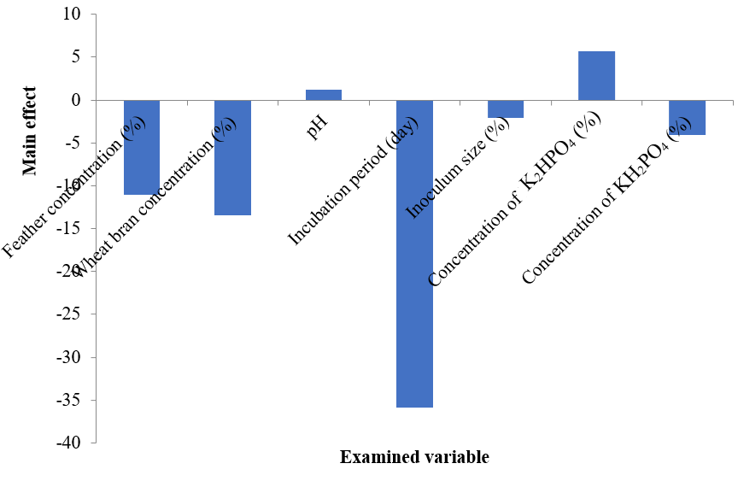

Supplementary figure (1): Main effect of the examined variables in Plackett-Burman design.

Supplementary table (2): Analysis of Box-Behnken Design
Source | Sum of Squares | Df | Mean Square | F-value | p-value
Model | 18969.93 | 9 | 2107.77 | 6.1 | 0.0132 | Significant
X₁ | 2286.9 | 1 | 2286.9 | 6.62 | 0.0369
X₂ | 2040.73 | 1 | 2040.73 | 5.91 | 0.0454
X₃ | 3463.44 | 1 | 3463.44 | 10.02 | 0.0158
X₁X₂ | 1399.56 | 1 | 1399.56 | 4.05 | 0.084
X₁X₃ | 4209.37 | 1 | 4209.37 | 12.18 | 0.0101
X₂X₃ | 275.82 | 1 | 275.82 | 0.7983 | 0.4013
X₁² | 5024.95 | 1 | 5024.95 | 14.54 | 0.0066
X₂² | 160.07 | 1 | 160.07 | 0.4633 | 0.518
X₃² | 20.37 | 1 | 20.37 | 0.059 | 0.8151
Residual | 2418.62 | 7 | 345.52
Lack of Fit | 1061.82 | 3 | 353.94 | 1.04 | 0.4643 | Non-significant
Pure Error | 1356.8 | 4 | 339.2
Cor Total | 21388.56 | 16

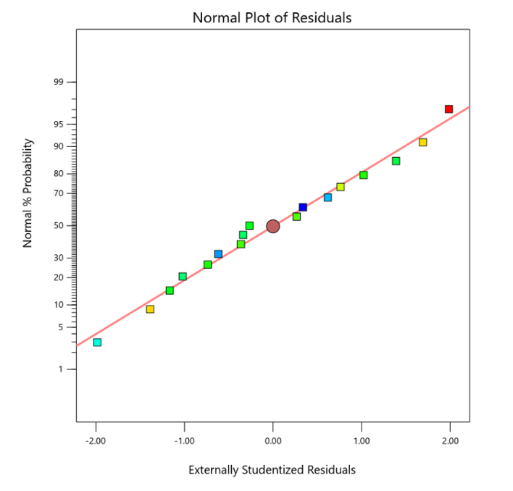
Supplementary figure (2): Normal plot of residuals for the keratinase activity.

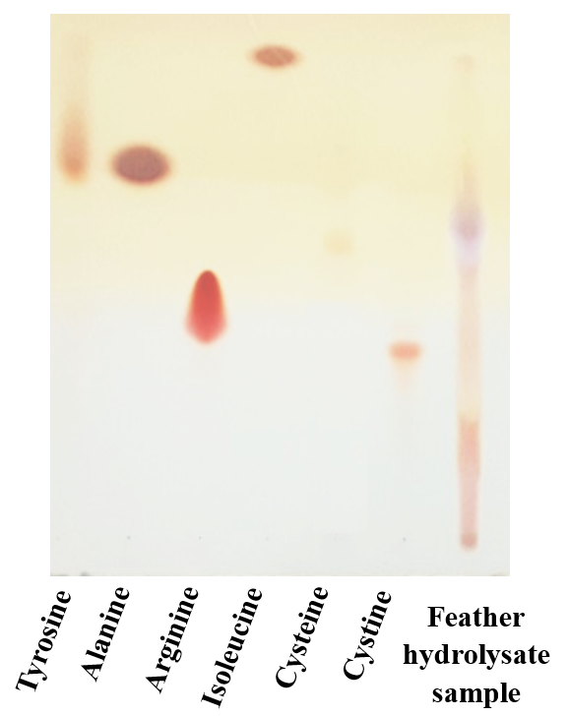
Supplementary figure (3): TLC analysis of feather hydrolysate sample.

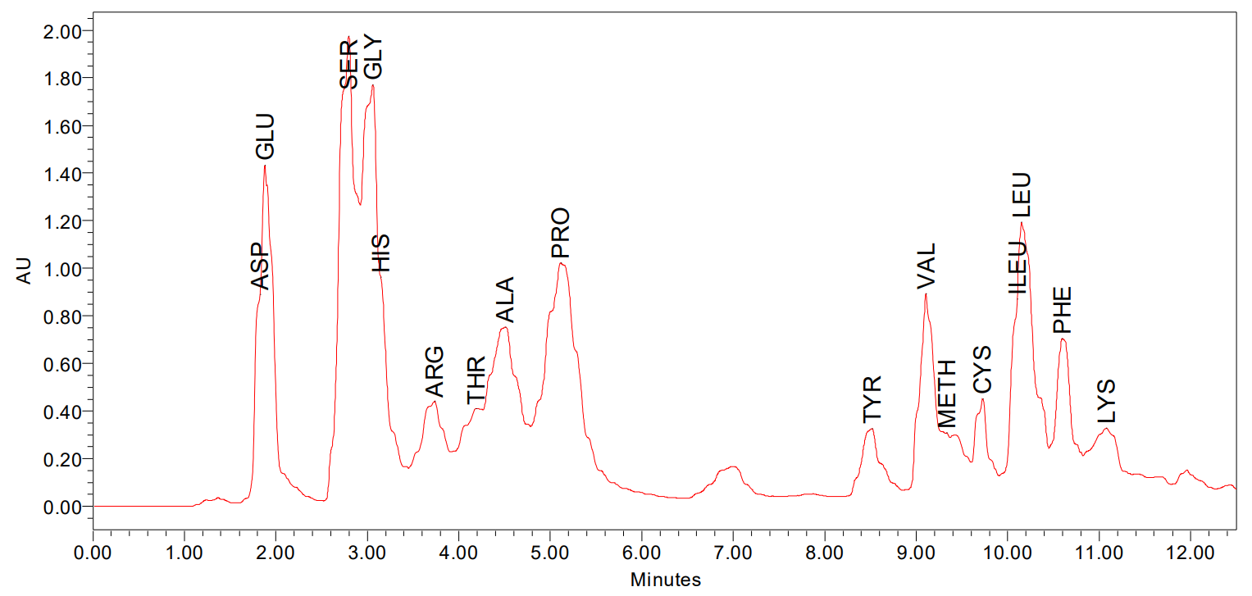
Feather sample
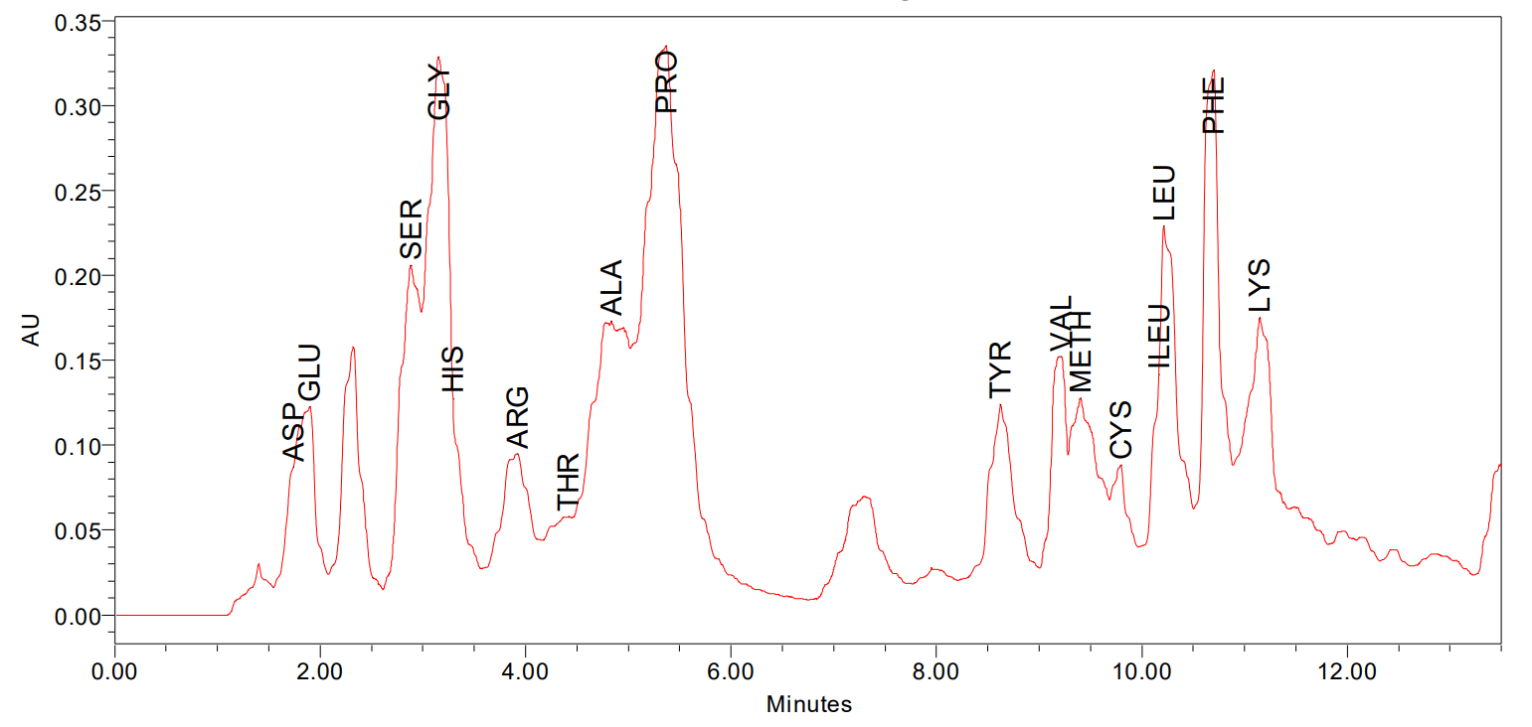
Feather hydrolysate sample
Supplementary figure (4): Amino acid analysis profile of feather before and after hydrolysis.

