Nanoporous Carbons from Hydrothermally Pre-treated Avocado Waste: Experimental Design, Hydrogen Storage Behavior, and Energy Distribution Analysis
Lehlohonolo Mohaleª, Jibril Abdulsalam^{a,} and Jean Mulopoª

Supplementary Material

Table S1. Proximate, ultimate, and total sulfur analysis of Hydrochars samples.

Analysis |  | HC₁₈₀ |  | HC₂₀₀ | HC₂₂₀
Proximate Analysis (wt.%)
Moisture Content |  | 4.71 |  | 4.20 | 3.85
Volatile Matter |  | 72.04 |  | 70.20 | 63.67
Fixed Carbon |  | 21.38 |  | 24.08 | 31.54
Ash |  | 1.87 |  | 1.52 | 0.95
Ultimate Analysis (wt. %)
Carbon |  | 65.11 |  | 65.26 | 65.13
Hydrogen |  | 5.41 |  | 5.35 | 5.3
Nitrogen |  | 1.39 |  | 1.44 | 1.42
Oxygen |  | 28.09 |  | 27.95 | 28.15
Sulfur |  | 0.00 |  | 0.00 | 0.00

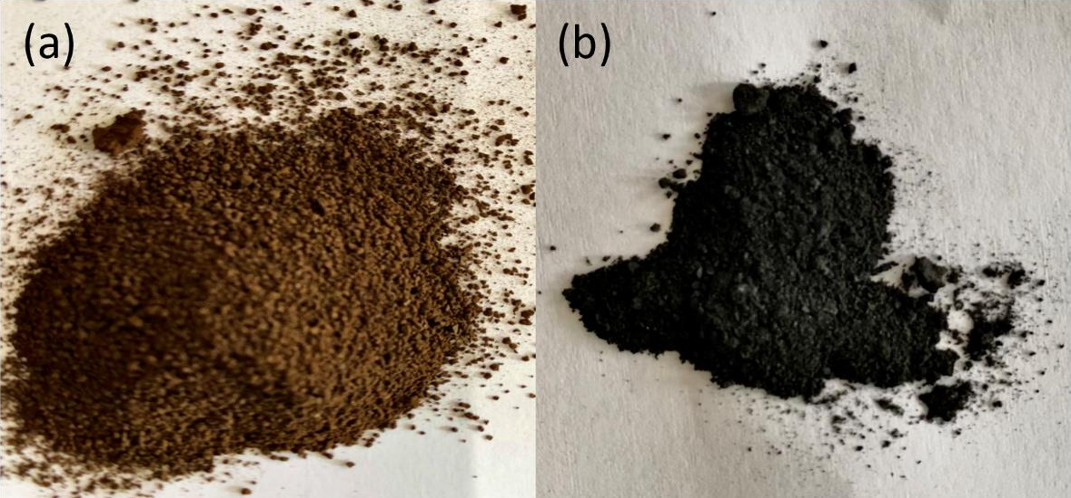

Fig. S1. Image of (a) hydrochar HC₂₀₀, and (b) activated carbon AC₂₀₀
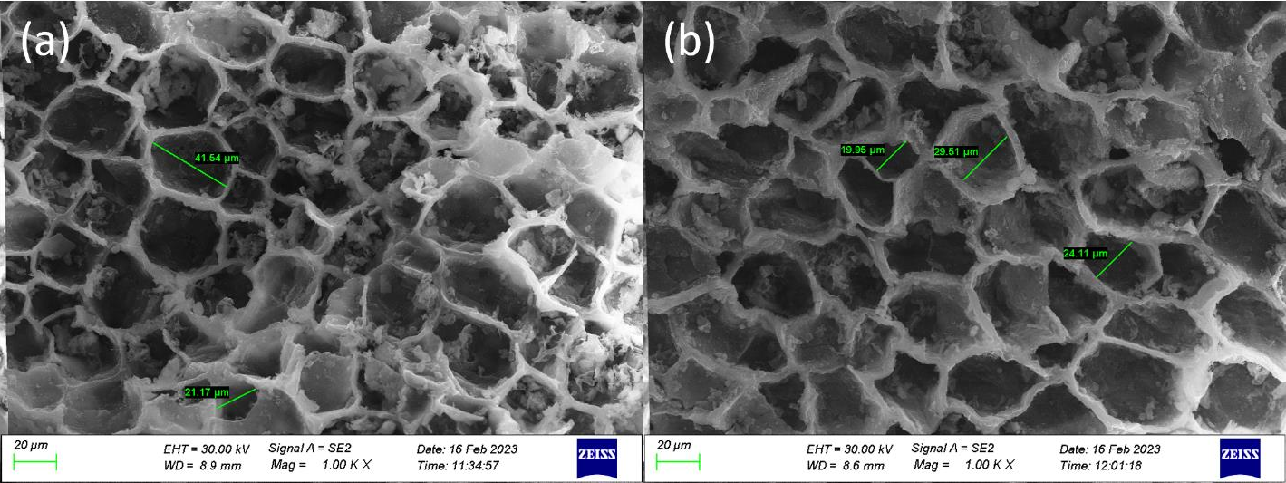
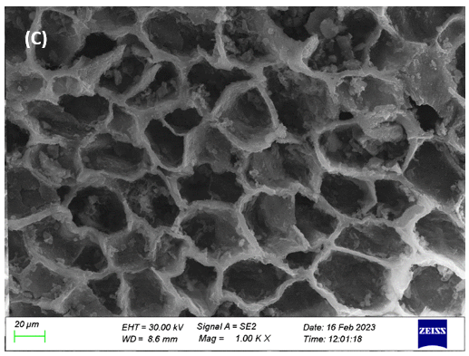
Fig. S2. SEM images of (a) HC₁₈₀, (b) HC₂₀₀, (c) HC₂₂₀

Table S2. Yield of Synthesised Activated Carbons

Sample | Process Conditions |  | Precursor mass (g) | KOH mass (g) | Total mass (g) | Mass of activated sample (g) | Yield (%)
Sample | Temperature (ºC) | KOH Weight ratio
At different Temperatures
AC₇₀₀ | 700 | 1:3 | 4 | 12 | 16 | 5.38 | 33.6
AC₈₀₀ | 800 | 1:3 | 4 | 12 | 16 | 4.56 | 28.5
AC₉₀₀ | 900 | 1:3 | 4 | 12 | 16 | 2.56 | 16
At different KOH weight ratio
AC1:1 | 800 | 1:1 | 4 | 4 | 8 | 1.99 | 24.9
AC1:2 | 800 | 1:2 | 4 | 8 | 12 | 2.87 | 23.9
AC1:3 | 800 | 1:3 | 4 | 12 | 16 | 3.58 | 22.4
At different hydrothermal pre-treatment temperature
AC₁₈₀ | 800 | 1:3 | 4 | 12 | 16 | 4.57 | 28.6
AC₂₀₀ | 800 | 1:3 | 4 | 12 | 16 | 4.56 | 28.5
AC₂₂₀ | 800 | 1:3 | 4 | 12 | 16 | 3.97 | 24.8

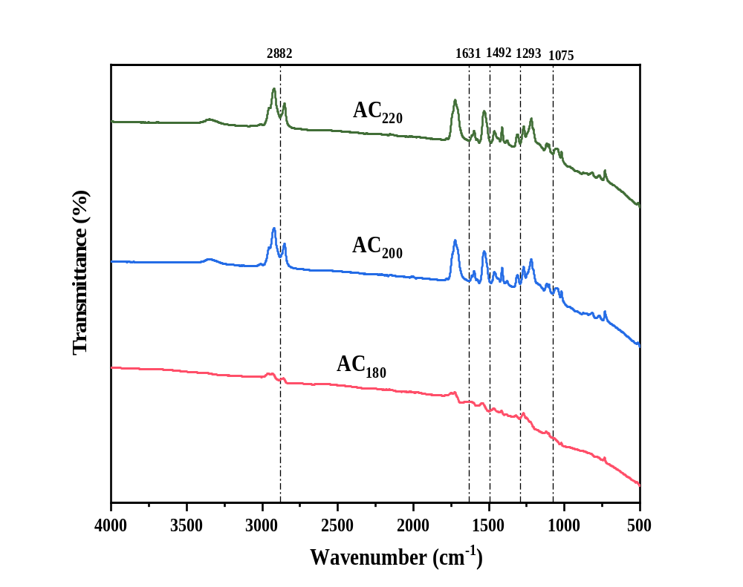
Fig. S3. FTIR spectra of the optimized activated carbons

Table S3. H₂ uptake of different activated carbons at 77 K
S/N | Source | Surface area (m²/g) | Pore volume (cm³/g) | Uptake pressure (bar) | H₂ uptake  (wt. %) | Reference
1 | AC₁₈₀ | 2178.1 | 1.26 | 1 | 2.44 | This study
2 | AC₂₀₀ | 2529.8 | 1.45 | 1 | 3.07 | This study
3 | AC₂₂₀ | 1838.4 | 1.09 | 1 | 1.90 | This study
4 | Sawdust | 1486.2 | 0.767 | 1 | 3.03 | [1]
5 | Pine Cones | 1173 | 0.383 | 1 | 1.6 | [2]
 | Pine Cones | 1173 | 0.383 | 80 | 5.5 | [2]
6 | Food waste | 2885 | 1.93 | 23 | 6.15 | [3]
7 | Bark | 2849 | 1.08 | 1 | 3.01 | [4]
8 | Onion peel | 3150 | 1.64 | 1 | 3.67 | [5]
9 | Cigarette butt | 4310 | 2.09 | 1 | 4 | [6]
 | Cigarette butt | 4113 | 1.87 | 1 | 3
 | Cigarette butt | 2803 | 1.23 | 1 | 3.2
 | Cigarette butt | 2515 | 1.20 | 1 | 2.7
 | Cigarette butt | 2393 | 1.09 | 1 | 3
 | Cigarette butt | 1970 | 0.86 | 1 | 2
10 | Sucrose | 2842 | 1.35 | 1 | 2.21 | [7]
11 | Chicken Feathers | 314 | - | 80 | 3.5 | [8]
12 | Pig skin | 2799 | 1.91 | 1.13 | 2.49 | [9]
13 | Oil palm shell | 3508 | 1.10 | 40 | 2.86 | [10]
14 | Bamboo | 3208 | 1.01 | 1 | 2.74 | [11]
 | Bamboo | 3208 | 1.01 | 40 | 6.6 | [11]
15 | Carbon precursor | 2386 | 1.16 | 1 | 2.94 | [12]
16 | Sword bean shell | 2838 | 1.54 | 1 | 2.63 | [13]
 | Sword bean shell | 2838 | 1.54 | 40 | 5.74 | [13]

References
[1] Liang Y, Wang Y, Ding N, Liang L, Zhao S, Yin D, et al. Preparation and hydrogen storage performance of poplar sawdust biochar with high specific surface area. Ind Crops Prod. 2023;200:116788.
[2] Stelitano S, Conte G, Policicchio A, Aloise A, Desiderio G, Agostino RG. Pinecone-derived activated carbons as an effective medium for hydrogen storage. Energies. 2020;13(9):2237.
[3] Saha N, Reza MT. Upcycling simulated food wastes into superactivated hydrochar for remarkable hydrogen storage. J Anal Appl Pyrolysis. 2021;159:105322.
[4] Hu W, Li Y, Zheng M, Xiao Y, Dong H, Liang Y, et al. Degradation of biomass components to prepare porous carbon for exceptional hydrogen storage capacity. Int J Hydrogen Energy. 2021;46(7):5418-26.
[5] Musyoka NM, Mutuma BK, Manyala N. Onion-derived activated carbons with enhanced surface area for improved hydrogen storage and electrochemical energy application. RSC advances. 2020;10(45):26928-36.
[6] ScottáBlankenship L. Correction: Cigarette butt-derived carbons have ultra-high surface area and unprecedented hydrogen storage capacity. Energy Environ Sci. 2021;14(6):3633-.
[7] Nazir G, Rehman A, Hussain S, Afzal AM, Dastgeer G, Rehman MA, et al. Heteroatoms-doped hierarchical porous carbons: Multifunctional materials for effective methylene blue removal and cryogenic hydrogen storage. Colloids Surf, A. 2021;630:127554.
[8] Madathil AP, Achar SK, Moses V, Meda US, Chetan N, Vidya C, et al. Use of Keratin Present in Chicken Feather as a Hydrogen Storage Material: A Review. International Journal of Engineering Materials and Manufacture. 2020;5(4):148-55.
[9] Gao A, Guo N, Yan M, Li M, Wang F, Yang R. Hierarchical porous carbon activated by CaCO₃ from pigskin collagen for CO₂ and H₂ adsorption. Microporous Mesoporous Mater. 2018;260:172-9.
[10] Zhao W, Luo L, Chen T, Li Z, Zhang Z, Fan M, editors. Activated carbons from oil palm shell for hydrogen storage. IOP Conference Series: Materials Science and Engineering; 2018: IOP Publishing.
[11] Zhao W, Luo L, Wang H, Fan M. Synthesis of bamboo-based activated carbons with super-high specific surface area for hydrogen storage. BioResources. 2017;12(1):1246-62.
[12] Sethia G, Sayari A. Activated carbon with optimum pore size distribution for hydrogen storage. Carbon. 2016;99:289-94.
[13] Chen T, Zhou Y, Luo L, Wu X, Li Z, Fan M, et al. Preparation and characterization of heteroatom self-doped activated biocarbons as hydrogen storage and supercapacitor electrode materials. Electrochim Acta. 2019;325:134941.

