Table S1: ANOVA for a quadratic model representing the reducing sugar response
Source | Sum of Squares | df | Mean Square | F-value | p-value
Model | 12204.88 | 9 | 1356.10 | 44.43 | < 0.0001 | significant
A-H₂SO₄ | 2980.11 | 1 | 2980.11 | 97.65 | < 0.0001
B-Autoclave time | 10.29 | 1 | 10.29 | 0.3370 | 0.5798
C-Molasses loading | 7201.44 | 1 | 7201.44 | 235.97 | < 0.0001
AB | 0.2678 | 1 | 0.2678 | 0.0088 | 0.9280
AC | 398.60 | 1 | 398.60 | 13.06 | 0.0086
BC | 18.52 | 1 | 18.52 | 0.6067 | 0.4615
A² | 1572.34 | 1 | 1572.34 | 51.52 | 0.0002
B² | 13.74 | 1 | 13.74 | 0.4503 | 0.5237
C² | 42.66 | 1 | 42.66 | 1.40 | 0.2757
Residual | 213.63 | 7 | 30.52
Pure Error | 1.90 | 4 | 0.4746
Cor Total | 12418.51 | 16

Table S2: Optimum conditions for sugarcane molasses pre-treatment
Input variables |  | Predicted optimum levels
Sulphuric acid % (v/v) |  | 0.75
Autoclave time (min) |  | 5
Molasses loading % (w/v) |  | 20
Response | Predicted values |  | Observed values
Reducing sugar | 92.592 g/L |  | 98.14 g/L

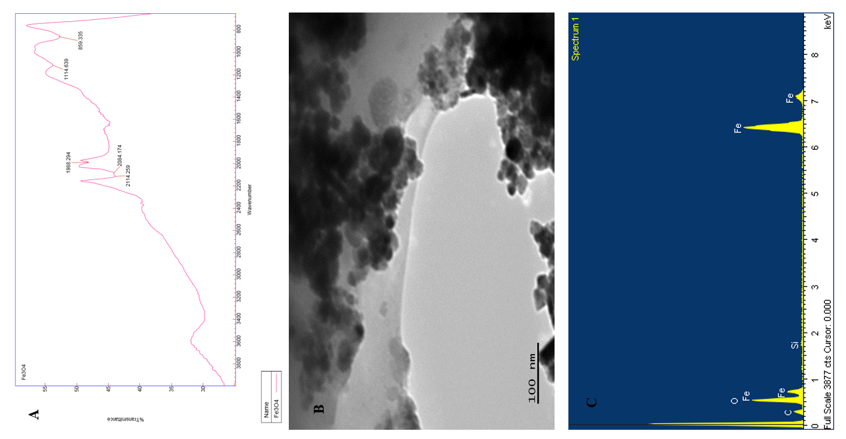
Fig. S1: A: FTIR spectrum of Fe₃O₄ NP, B: TEM image of Fe₃O₄ NP, C: SEM-EDX image of Fe₃O₄ NP

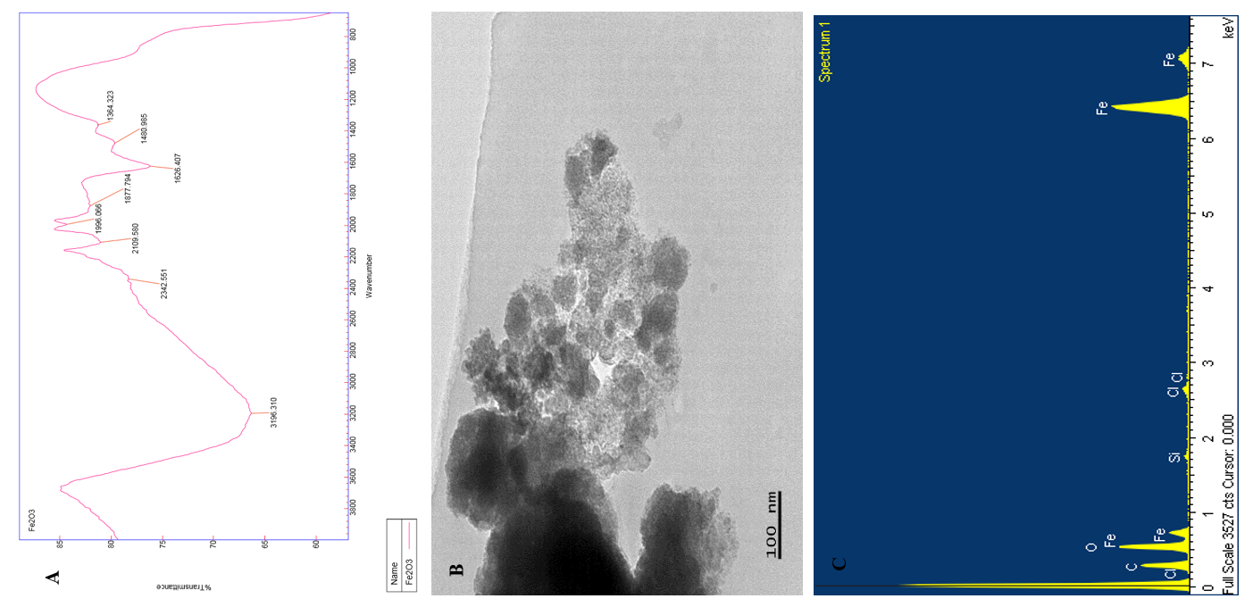
Fig. S2: A: FTIR spectrum of Fe₂O₃ NP, B: TEM image of Fe₂O₃ NP, C: SEM-EDX image of Fe₂O₃ NP

Fig. S3: FTIR spectrum of TSC-Fe₃O₄ NP, FTIR spectrum of PEG-Fe₃O₄ NP, FTIR spectrum of C-Fe₃O₄ NP, FTIR spectrum of K-Carrageenan-Fe₃O₄ NP and FTIR spectrum of Fe₃O₄ NP.

