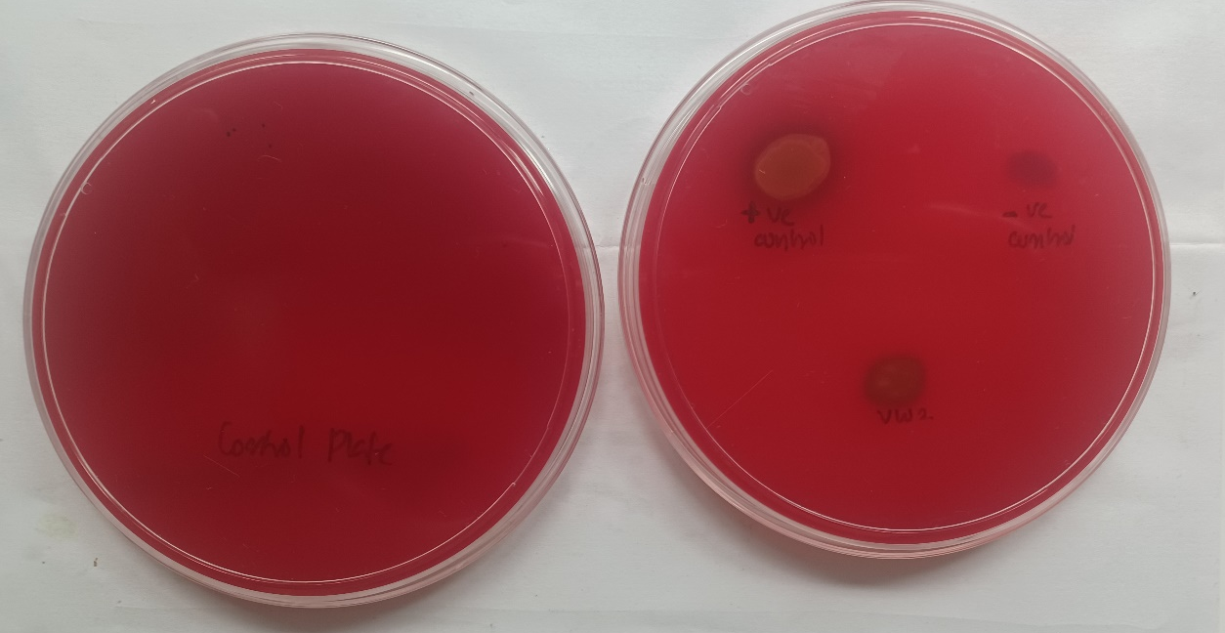
A
B
i
iii
ii

Fig. 1. Haemolytic assay of B. cenocepasia VW2 in blood agar. A- Control plate, B- Test: i- Staphylococcus aureus (+ control), ii. Bacillus cereus (- control), iii. B. cenocepasia VW2

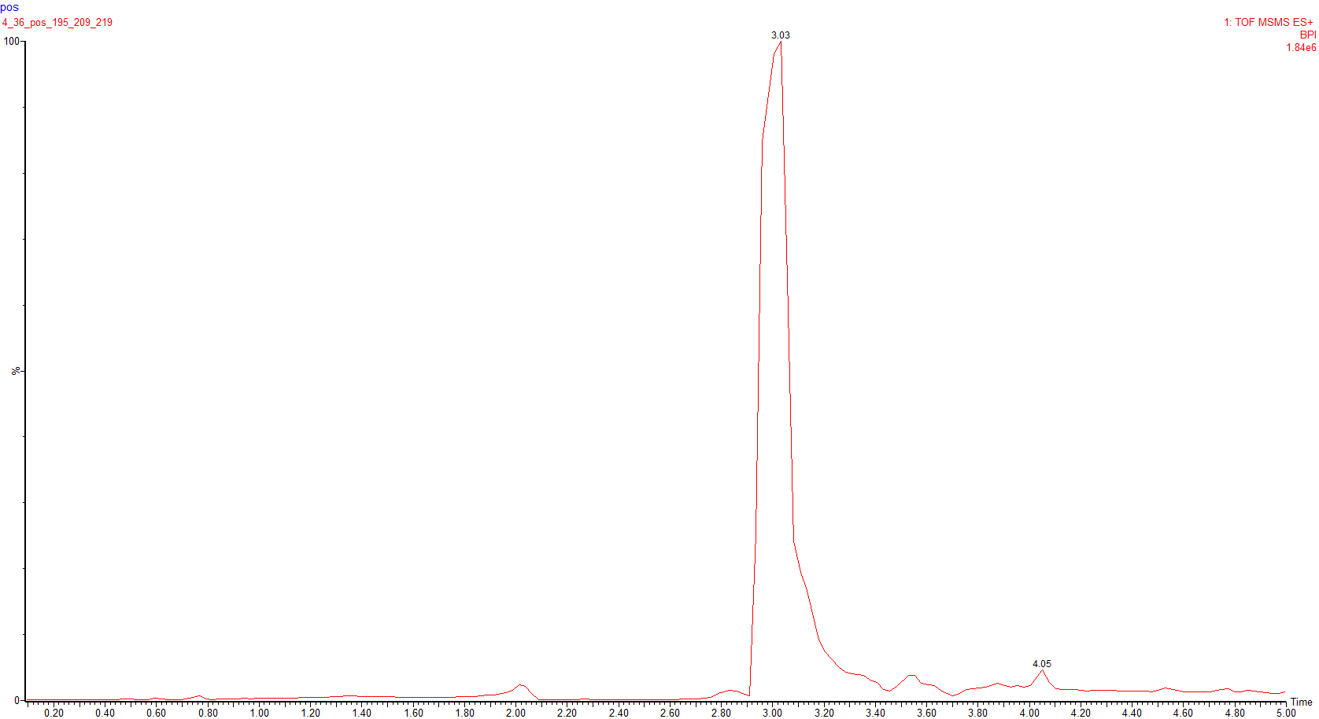

Fig: 2. UPLC-Q-TOF MS/MS chromatogram of the methanolic extract of MSFM.

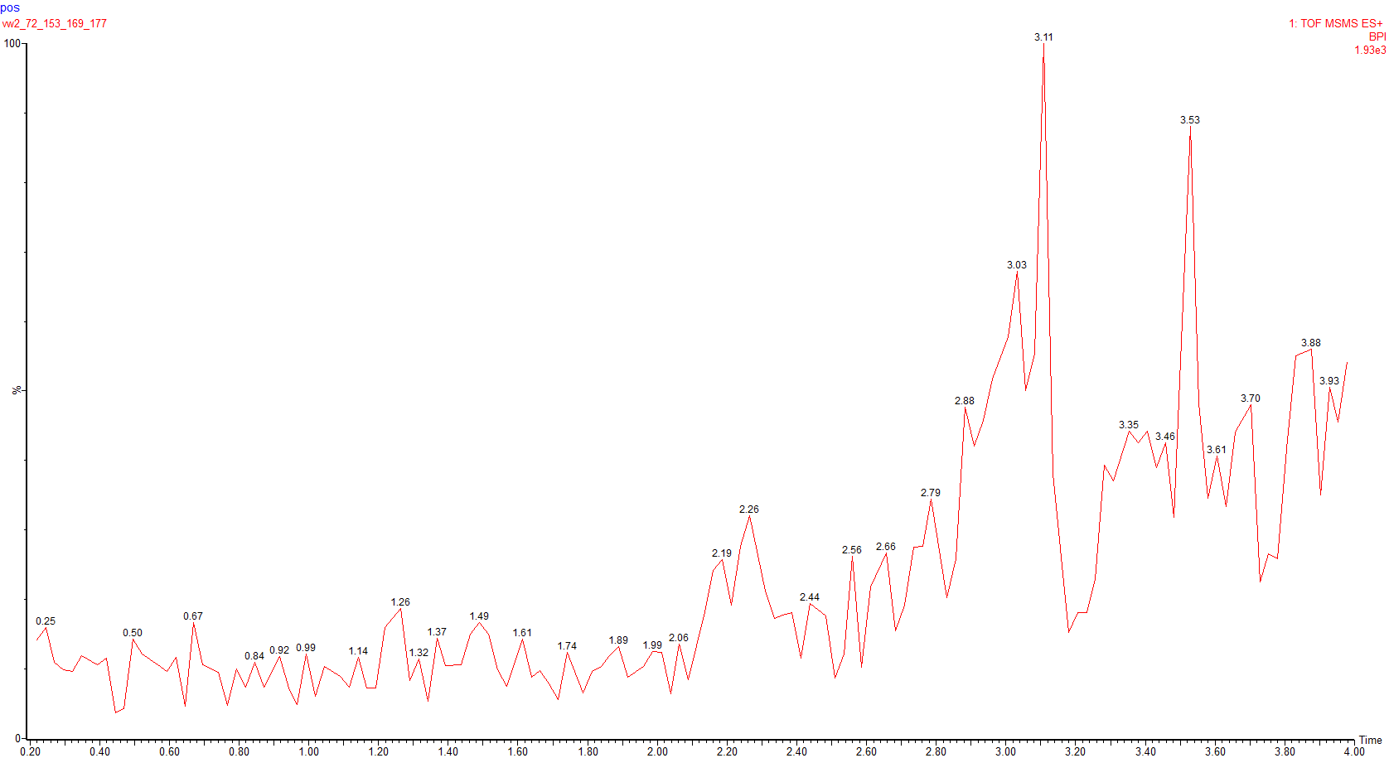

Fig: 3. UPLC-Q-TOF MS/MS chromatogram of the methanolic extract of MSFM after treatment with the selected isolate B. cenocepasia VW2 for 72 hours

