Supplementary materials
Slow-Pyrolysis of Municipal Sewage Sludge: Biochar Characteristics and Advanced Thermodynamics
Naeimeh Vali^{a*}, Samyar Zabihiª, Shahin Shamimª, Abas Mohsenzadehª and Anita Pettersson^{a*}
ª: Swedish Centre for Resource Recovery (SCRR), University of Borås, 501 90 Borås, Sweden
* Corresponding author, E-mail: naeimeh.vali@hb.se, https://orcid.org/0000-0001-9443-5547

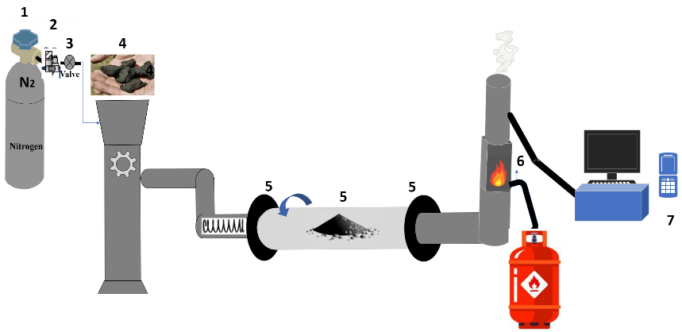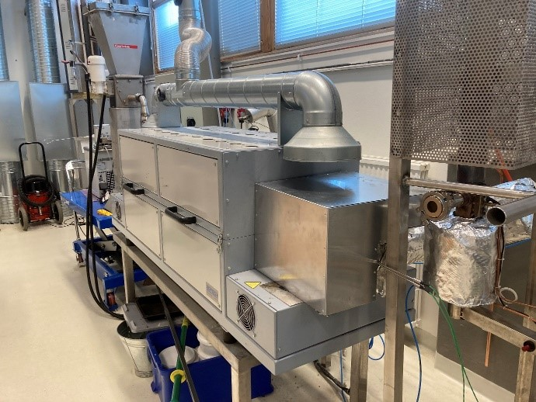
Figure S1.Lab scale rotating pyrolysis unit and its schematic drawing: 1) Nitrogen, 2) Valve, 3) pressure gage, 4) feeding system, 5) thermocouple, 6) gas burner, 7) gas analyzer.

Table S 1. Utilizing the database Sources as a reference, the elements, solid solutions, and compounds in the thermodynamic equilibrium calculations.
Databases | Comments
Elements | H, C, N, O, Na, Mg, Al, Si, P, K, Ca, Fe, Cr, Pb, Ni, Cu, Mn, Zn, Cd, S, Cl
FactPS | pure stoichiometric gas and solid phases
FToxid | pure stoichiometric solid phases  Slag A: (liquid oxide melt): K₂O, SiO₂, CaO, MgO, P₂O₅  SPINA: (AB₂O₄-type cubic spinel solution containing Al-Co-Cr-Fe-Mg-Ni-Zn-O)
Mull: Mullite (Al, Fe)₂(Al, Si, B, Fe) O₅
CORU: (Corundum-Al₂O₃-Cr₂O₃-Fe₂O₃-Mn₂O₃)
Feld: NaAlSi₃O₈ - KAlSi₃O₈ - CaAl₂Si₂O₈ - SrAl₂Si₂O₈ - BaAl₂Si₂O₈ - NaFeSi₃O₈
CMPc: K₂Al₂Si₄O₁₂-K₂MgSi₅O₁₂
M2Pa: (Mg,Ca)₂P₂O₇
 | C3Pb: medium-T solid solution (Ca,Mg)₃P₂O₈
 | C3Pa: low-T solid solution (Ca,Mg)₃P2O₈
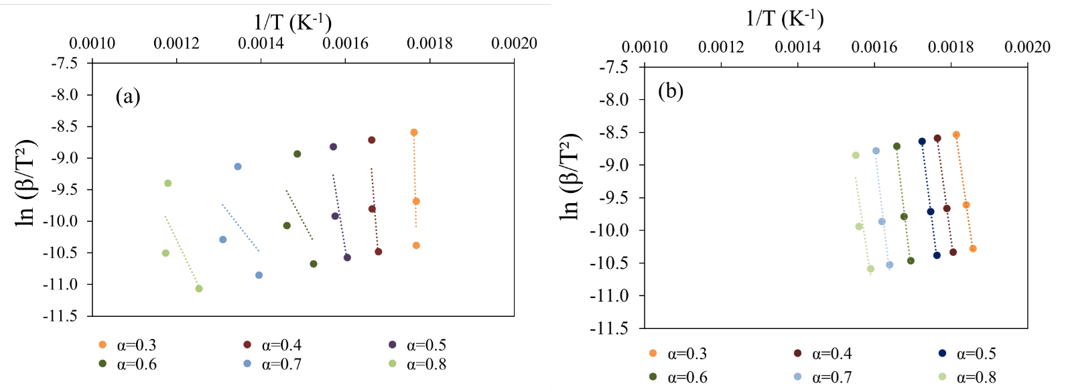
Figure S2.Results of the Kissinger-Akahira-Sunose method for various conversions during sewage sludge pyrolysis at different temperatures for a) BSS and b) LSS.

Table S 2. Elemental composition and H/C ratio of biochars at various pyrolysis temperatures.
Biochar | Results
 |  | Total-C (wt.%) | Total-H (wt.%) | Total-N (wt.%) | H/C Ratio
BSSC 500 ˚C |  | 40.4 | 7.42 | 1.30 | 0.18
BSSC 700 ˚C |  | 44.4 | 7.33 | 1.43 | 0.16
BSSC 900 ˚C* |  | 23.2 | 5.60 | 3.65 | 0.24
LSSC 500 ˚C |  | 43.6 | 6.53 | 1.66 | 0.15
LSSC 700 ˚C |  | 42.4 | 5.10 | 1.23 | 0.12
LSSC 900 ˚C |  | 30.8 | 4.90 | 1.20 | 0.16
* Results taken from an external lab.
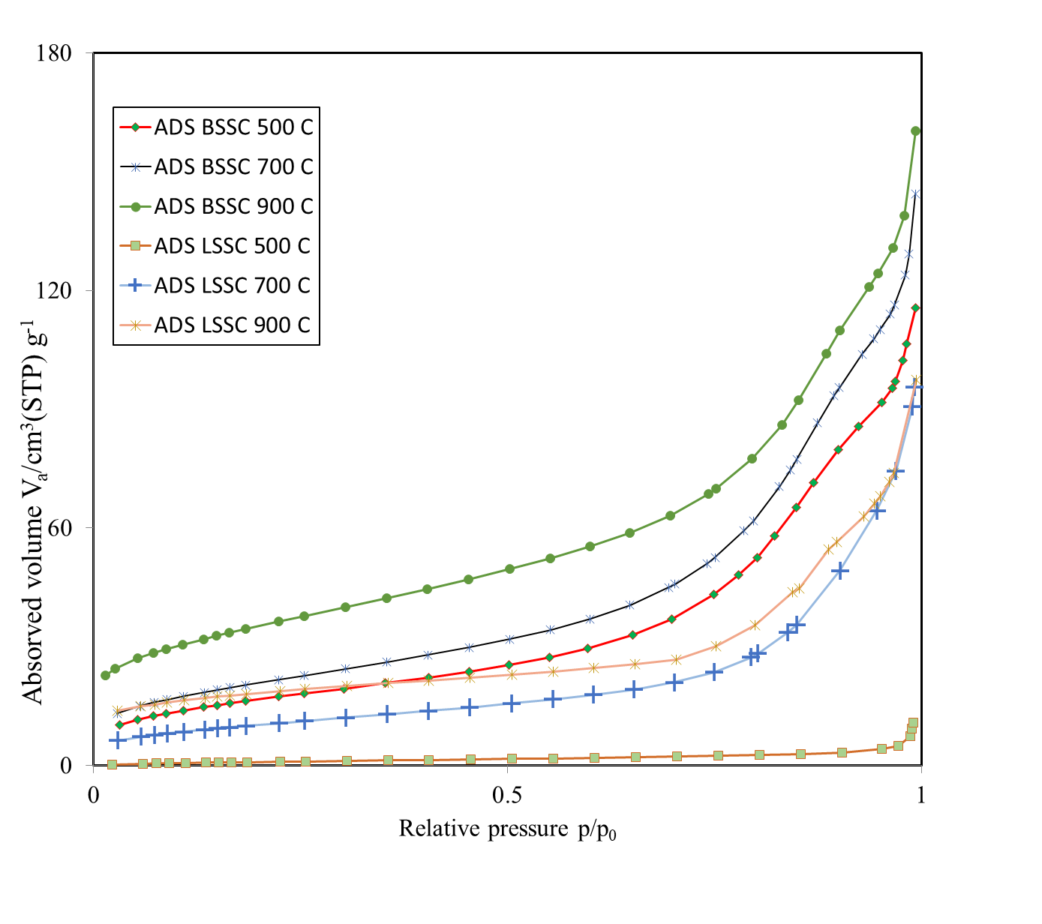
Figure S 3. Nitrogen isothermal adsorption analysis (ADS).

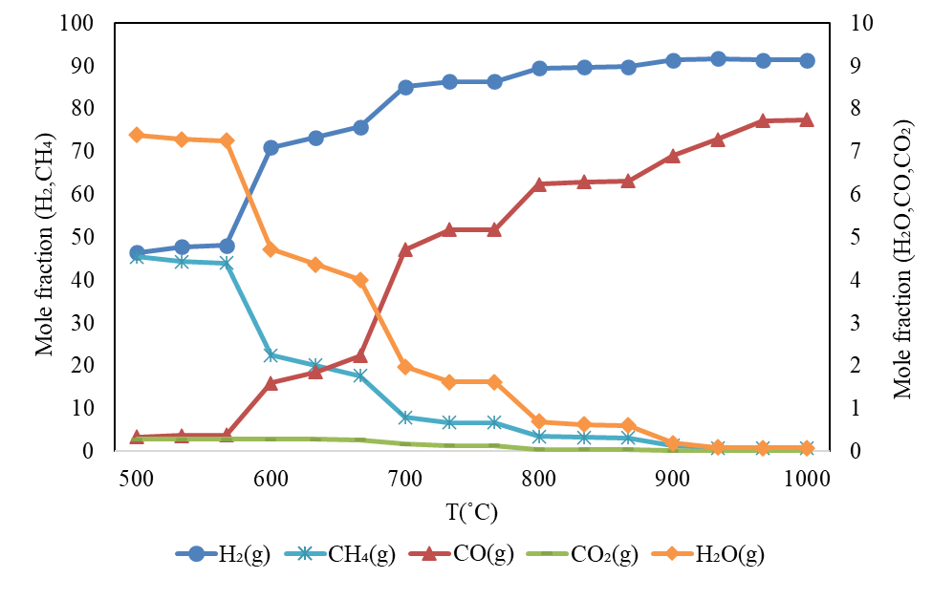
Figure S 4. The results of TECs showing the main gaseous products during pyrolysis at various temperatures.

