Supplementary File

Development and Characterization of Activated Charcoal Adsorbent Derived from Oak for Efficient Removal of Methylene Blue: Functionality vs Surface Area
Ali Bülbülª, Ali Delibaş^{b}*, and Ramazan Coşkun^{b}
ª İstanbul Water and Sewerage Administration (İSKİ), İstanbul, Türkiye
^{b} Department of Chemistry, Faculty of Arts and Sciences, Yozgat Bozok University, Yozgat, Türkiye
*Corresponding author, E-mail address: ali.delibas@bozok.edu.tr
Table S1. Effect of pH on MB adsorption onto MK
pH | Ci (ppm) | DF | Abs | Ct  (ppm) | Ct*DF  (ppm) | DR  (%)
2 | 100 | 20 | 0,911 | 5,39 | 107,81 | -
3 | 100 | 20 | 0,855 | 5,05 | 101,14 | -
4 | 100 | 20 | 0,843 | 4,98 | 99,71 | 0.29
5 | 100 | 20 | 0,831 | 4,91 | 98,28 | 1.72
6 | 100 | 30 | 0,564 | 3,32 | 99,75 | 0.25
7 | 100 | 20 | 0,826 | 4,88 | 97,69 | 2.31
8 | 100 | 20 | 0,809 | 4,78 | 95,67 | 4.33
9 | 100 | 20 | 0,836 | 4,94 | 98,88 | 1.12
*DF=Dilation factor, Abs=Absorbance, DR=Dye removal

S.Figure 1. Langmuir adsorption isotherm for MM adsorption on SMK

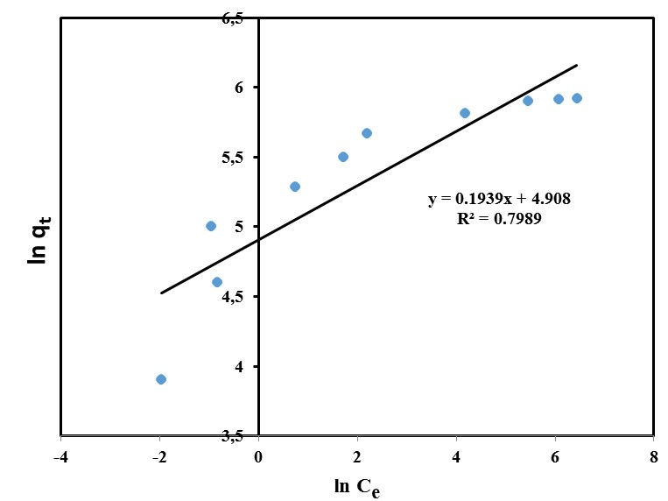
S.Figure 2. Freundlich adsorption isotherm for MM adsorption on SMK

S.Figure 3. Temkin adsorption isotherm for MM adsorption on SMK

S.Figure 4. Pseudo-1st order kinetic model for 100 and 200 ppm MM on SMK

S.Figure 5. Pseudo second order kinetic model for 100 and 200 ppm MM on SMK

S.Figure 6. Intra-particle diffusion model for 100 and 200 ppm MM on SMK

