Supplementary material
Valorization of rice straw through FeCl₃ pretreatment: Experiments- Modelling and Optimization

Dinabandhu Manna¹ Ranjana Chowdhury^{1†} Suvi Kuittinen² Ari Pappinen²
Jouko Vepsäläinen³ Md. Kamrul Hassan^{2*}
¹Chemical Engineering Department, Jadavpur University, Kolkata – 700 032, West Bengal, India
² School of Forest Sciences, University of Eastern Finland, P.O. Box 111, FI80101 Joensuu, Finland
³School of Pharmacy, University of Eastern Finland, P.O. Box 1627, FI70211 Kuopio, Finland
†Research supervisor, Email id: ranjana.juchem@gmail.com
Contact no. +91-9830359430, Telephone/FAX: +91-33-2414 6378
*Corresponding author, Email id: kamrul.hassan@uef.fi
Contact no. +358-504422346

Combined severity Page No. S3

List of Tables
Table | Page No.
Table S1 Coded levels of independent variables for degradation of carbohydrates | S4
Table S2 Coded levels of variables used for the optimization of yields of xylose, glucose and furfural (g/kg of RS) | S5
Table S3 ANOVA Table for optimization xylan degradation | S6
Table S4 ANOVA Table for optimization cellulose degradation | S7
Table S5 ANOVA Table for optimization of $Y_{G,EH}$ | S8
Table S6 ANOVA Table for optimization of $Y_{G,C}$ | S9

List of Figures
Figure | Page No.
Fig. S1 Plot of the natural logarithm of each rate constant, $\ln\left(k_{i}\right)$ against $\frac{1}{T}$ (Rate constants involved in the xylan conversion) | S10
Fig. S2 Plot of the natural logarithm of each rate constant, $\ln\left(k_{i}\right)$against $\frac{1}{T}$ (Rate constants involved in the cellulose conversion) | S11
Fig. S3 Glucose yield after enzymatic hydrolysis of untreated and pretreated rice straw | S12

Calculation of lignin degradation S13

Combined severity
The $R_{0} and ω,$the hydrolysis kinetics of hemicellulose and cellulose can be written as,
$-\frac{1}{C_{Xy}}\frac{{dC}_{Xy}}{dt}= k_{Xy}$ (S1)
As there is no hydrolysis during the heating up and cooling down period,
$-\frac{1}{C_{Xy}}\frac{{dC}_{Xy}}{dt}=k_{Xy0}\exp\left(-\frac{E_{Xy}}{RT}\right)$ (S2)
Or$-\ln\left(\frac{1}{C_{Xy}}\frac{{dC}_{Xy}}{dt}\right)=k_{Xy0}-\frac{E_{Xy}}{RT}$ (S3)
Through Taylor series expansion, neglecting higher terms, around reference temperature $T_{R}$,
$-\ln\left(\frac{1}{C_{Xy}}\frac{{dC}_{Xy}}{dt}\right)=lnk_{Xy0}-\frac{E_{Xy}}{RT_{R}}+\frac{E_{Xy}}{R{T_{R}}^{2}T_{R}}\left(T-T_{R}\right)$ (S4)
$or, \frac{1}{C_{Xy}}\frac{{dC}_{Xy}}{dt}=k_{Xy0}\exp\left(-\frac{E_{Xy}}{RT_{R}}\right)exp$($\frac{E_{Xy}}{R{T_{R}}^{2}}\left(T-T_{R}\right))=k_{XyR}exp\left(\frac{\left(T-T_{R}\right)}{ω_{Xy}}\right)$ (S5)
$\frac{R{T_{R}}^{2}}{E_{Xy}}=ω_{Xy}$; $k_{Xy0}\exp\left(-\frac{E_{Xy}}{RT_{R}}\right)=k_{XyR}$ (S6)
Or, $\int_{C_{Xy0}}^{C_{Xy}}{\frac{{dC}_{Xy}}{C_{Xy}}}=\int_{0}^{t}{k_{XyR}exp\left(\frac{\left(T-T_{R}\right)}{ω_{Xy}}\right)dt}=k_{XyR}texp\left(\frac{\left(T-T_{R}\right)}{ω_{Xy}}\right)=k_{XyR}R_{0Xy,iso}$ (S7)
Where,
$R_{0Xy,iso}=texp\left(\frac{\left(T-T_{R}\right)}{ω_{Xy}}\right)=severity factor for xylose degradation under isothermal condition$ (S8)
Similarly, for hydrolysis of cellulose,
$\int_{C_{Cellu0}}^{C_{Cellu}}{\frac{{dC}_{Cellu}}{C_{Cellu}}}=\int_{0}^{t}{k_{CellR}exp\left(\frac{\left(T-T_{R}\right)}{ω_{Cellu}}\right)dt}=k_{CellR}texp\left(\frac{\left(T-T_{R}\right)}{ω_{Cellu}}\right)=k_{CellR}R_{0Cellu,iso}$ (S9)
$R_{0Cellu,iso}=texp\left(\frac{\left(T-T_{R}\right)}{ω_{Cellu}}\right)= severity factor for Cellulose degradation under isothermal condition$ (S10)

Table S1 Coded levels of independent variables for degradation of carbohydrates
Input variables | Unit | Coded variable level |  |  | Model Response
Input variables | Unit | -1 | 0 | 1 | Model Response
Pretreatment temperature | °C | 150 | 170 | 190 | (i) Xylan degradation (%)  (ii) Cellulose degradation (%)
Pretreatment time | min | 5 | 10 | 15 | (i) Xylan degradation (%)  (ii) Cellulose degradation (%)

Table S2 Coded levels of variables used for the optimization of yields of xylose, glucose and furfural (g/kg of RS)
Input variables | Unit | Coded variable level |  |  | Model Response
Input variables | Unit | -1 | 0 | 1 | Model Response
Pretreatment temperature | °C | 150 | 170 | 190 | (i) Xylose yield (g/ kg of RS)  (ii) Glucose yield (g/ kg of RS)  (iii) Furfural yield (g/ kg of RS)
Pretreatment time | min | 5 | 10 | 15

Table S3 ANOVA Table for optimization xylan degradation
Source | Sum of Squares | df | Mean Square | F-value | p-value
Model | 4472.93 | 5 | 894.59 | 75.49 | < 0.0001 | significant
A-Temperature | 2651.91 | 1 | 2651.91 | 223.79 | < 0.0001
B-Time | 321.10 | 1 | 321.10 | 27.10 | 0.0012
AB | 187.69 | 1 | 187.69 | 15.84 | 0.0053
A² | 1305.67 | 1 | 1305.67 | 110.18 | < 0.0001
B² | 52.61 | 1 | 52.61 | 4.44 | 0.0731
Residual | 82.95 | 7 | 11.85
Lack of Fit | 82.95 | 3 | 27.65
Pure Error | 0.0000 | 4 | 0.0000
Cor Total | 4555.88 | 12
(R²: 0.9818; adjusted R²: 0.9688; Predicted R²: 0.9259)

Table S4 ANOVA Table for optimization cellulose degradation
Source | Sum of Squares | df | Mean Square | F-value | p-value
Model | 3050.65 | 5 | 610.13 | 586.83 | < 0.0001 | significant
A-Temperature | 2232.44 | 1 | 2232.44 | 2147.21 | < 0.0001
B-Time | 293.32 | 1 | 293.32 | 282.12 | < 0.0001
AB | 110.25 | 1 | 110.25 | 106.04 | < 0.0001
A² | 374.53 | 1 | 374.53 | 360.23 | < 0.0001
B² | 77.49 | 1 | 77.49 | 74.53 | < 0.0001
Residual | 7.28 | 7 | 1.04
Lack of Fit | 7.28 | 3 | 2.43
Pure Error | 0.0000 | 4 | 0.0000
Cor Total | 3057.93 | 12
(R²: 0.9976; adjusted R²: 0.9959; Predicted R²: 0.9831)

Table S5 ANOVA Table for optimization of $Y_{G,EH}$
Source | Sum of Squares | df | Mean Square | F-value | p-value
Model | 36.54 | 5 | 7.31 | 44.94 | < 0.0001 | significant
A-CS | 13.04 | 1 | 13.04 | 80.23 | < 0.0001
B-Enzyme loading | 11.68 | 1 | 11.68 | 71.86 | < 0.0001
AB | 3.39 | 1 | 3.39 | 20.82 | 0.0026
A² | 0.0095 | 1 | 0.0095 | 0.0582 | 0.8163
B² | 8.20 | 1 | 8.20 | 50.43 | 0.0002
Residual | 1.14 | 7 | 0.1626
Lack of Fit | 1.14 | 3 | 0.3794
Pure Error | 0.0000 | 4 | 0.0000
Cor Total | 37.68 | 12
(R²: 0.9763; adjusted R²: 0.9642; Predicted R²: 0.9471)

Table S6 ANOVA Table for optimization of $Y_{G,C}$
Source | Sum of Squares | df | Mean Square | F-value | p-value
Model | 670.27 | 5 | 134.05 | 30.51 | 0.0001 | significant
A-CS | 411.54 | 1 | 411.54 | 93.68 | < 0.0001
B-EH | 66.94 | 1 | 66.94 | 15.24 | 0.0059
AB | 20.25 | 1 | 20.25 | 4.61 | 0.0689
A² | 139.15 | 1 | 139.15 | 31.67 | 0.0008
B² | 51.56 | 1 | 51.56 | 11.74 | 0.0110
Residual | 30.75 | 7 | 4.39
Lack of Fit | 30.75 | 3 | 10.25
Pure Error | 0.0000 | 4 | 0.0000
Cor Total | 701.02 | 12
(R²: 0.9652; adjusted R²: 0.9431; Predicted R²: 0.9132)

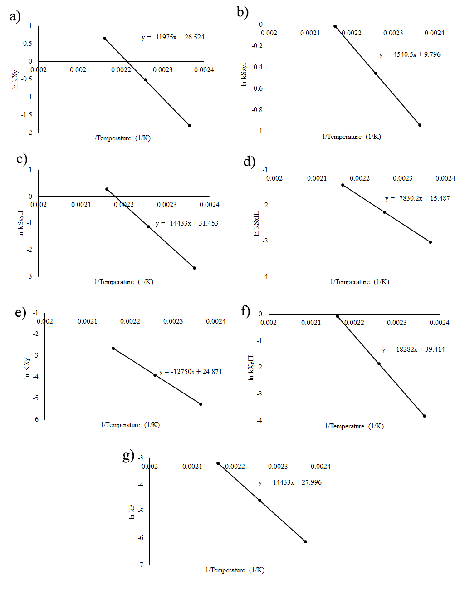
Fig. S1 Plot of the natural logarithm of each rate constant, $\ln\left(k_{i}\right)$against $\frac{1}{T}$ (Rate constants involved in the xylan conversion)
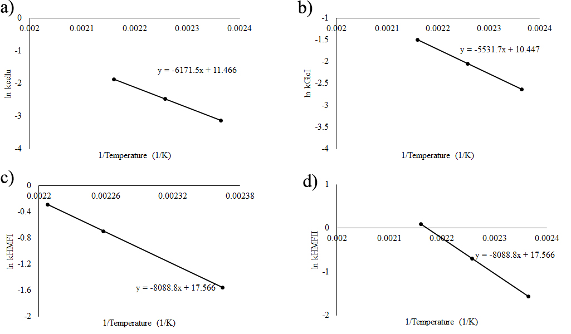
Fig. S2 Plot of the natural logarithm of each rate constant, $\ln\left(k_{i}\right)$against $\frac{1}{T}$ (Rate constants involved in the cellulose conversion)

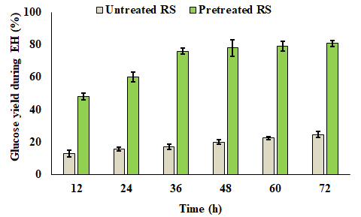
Fig. S3 Glucose yield after enzymatic hydrolysis of untreated and pretreated rice straw

Calculation of lignin degradation
The % degradation of carbohydrate polymer (cellulose, hemicelluloses and lignin) has been calculated based on rice straw fed using the following equation (provided in the manuscript):
$Degradation of Carbohydrate polymer \left(\%\right)= \frac{Mass of Carbohydrate polymer in feed rice straw-Residual Mass of Carbohydrate polymer }{Mass of rice straw fed to the reactor} ×100$ (20)
At 190°C with 15 minutes pretreatment time and 0.2 M FeCl₃, the degradation of lignin (%)
$= \frac{Mass of lignin in feed rice straw-Residual Mass oflignin }{Mass of rice straw fed to the reactor} ×100$
$=\frac{1.68-1.435}{1.68}×100=14.58$

