Supplementary information
A new green heterogeneous solid catalyst from corn cob agricultural residue for biodiesel production
J.L. Aleman-Ramirez*, Claudia P. Villamizar C., Martin Barragán-Trinidad,
P.J. Sebastian**
¹ Instituto de Energías Renovables (UNAM), Privada Xochicalco s/n, Temixco, Morelos, C.P.62580, México
*Corresponding Authors:
J.L. Aleman-Ramirez*: alemanluis20@outlook.com
P.J. Sebastian**: sjp@ier.unam.mx

Table S1. Pairwise comparison p-values of BD yield at different catalyst loadings using Tukey's HSD test.
Treatments to compare | p-value
2 – 1 % | 0.088
3 – 1 % | 4.92 x10⁻⁵
4 – 1 % | 0.009
5 – 1 % | 0.930
3 – 2 % | 1.45 x 10⁻⁴
4 – 2 % | 0.183
5 – 2 % | 0.042
4 – 3 % | 4.03 x 10⁻⁴
5 – 3 % | 4.04 x 10⁻⁵
5 – 4 % | 0.005

Table S2. Pairwise comparison p-values of BD yield at different molar ratios of methanol/sunflower oil using Tukey's HSD test.
Treatments to compare | p-value
15:1 – 12:1 | 0.002
6:1 – 12: 1 | 0.071
9:1 – 12: 1 | 0.001
6:1 – 15:1 | 7.03 x 10⁻⁴
9:1 – 15:1 | 1.28 x 10⁻⁴
9:1 – 6:1 | 0.004

Table S3. Pairwise comparison p-values of BD yield at different temperatures using Tukey's HSD test.
Treatments to compare | p-value
55 °C – 50 °C | 0.023
60 °C – 50 °C | 2.32 x 10⁻⁴
65 °C – 50 °C | 3.38 x 10⁻⁵
60 °C – 55 °C | 8.88 x 10⁻⁴
65 °C – 55 °C | 7.24 x 10⁻⁵
65 °C – 60 °C | 6.90 x 10⁻⁴

Table S4. Pairwise comparison p-values of BD yield at different reaction times using Tukey's HSD test.
Treatments to compare | p-value
150 min – 120 min | 8.83 x 10⁻⁴
30 min – 120 min | 0
90 min – 120 min | 2.80 x 10⁻⁴
30 min – 150 min | 0
90 min – 150 min | 0.045
90 min – 30 min | 0

Table S5. Pairwise comparison p-values of BD yield across different reuse cycles using Tukey's HSD test.
Treatments to compare | p-value
C2 – C1 | 1.000
C3 – C1 | 0.743
C4 – C1 | 0.018
C5 – C1 | 9.59 x 10⁻⁴
C6 – C1 | 1.57 x 10⁻⁴
C7 – C1 | 4.10 x 10⁻⁶

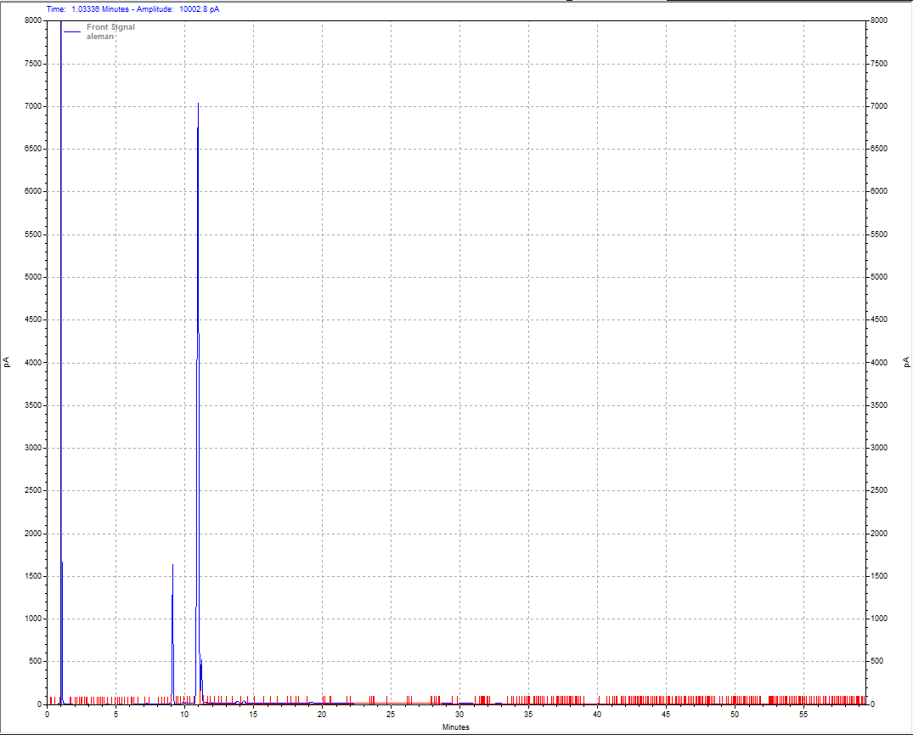
Solvent
FAMES
Figure S1. Chromatogram obtained for sunflower oil BD. The transesterification reaction was carried out under optimal conditions.

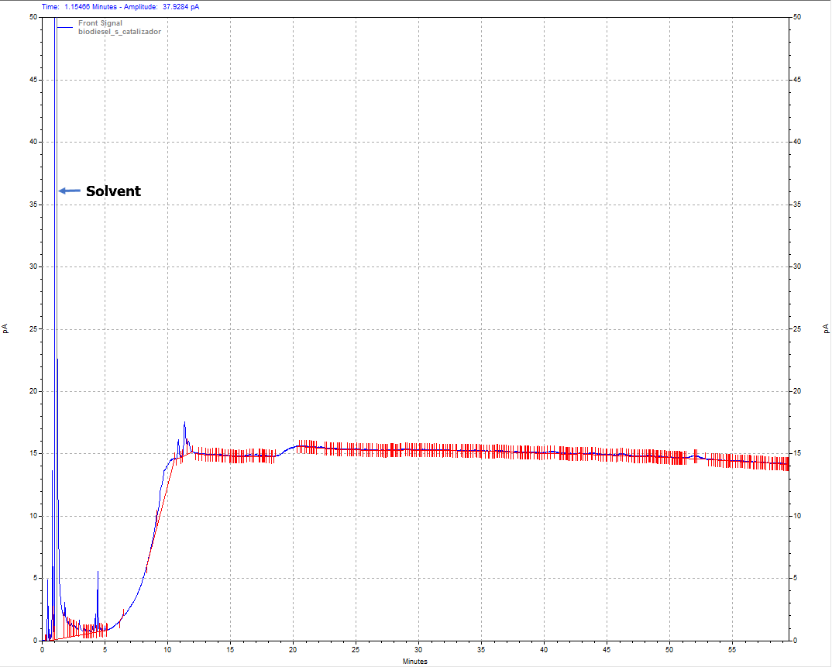
Figure S2. Chromatogram of the blank assay (in the absence of catalyst) under optimal test conditions.

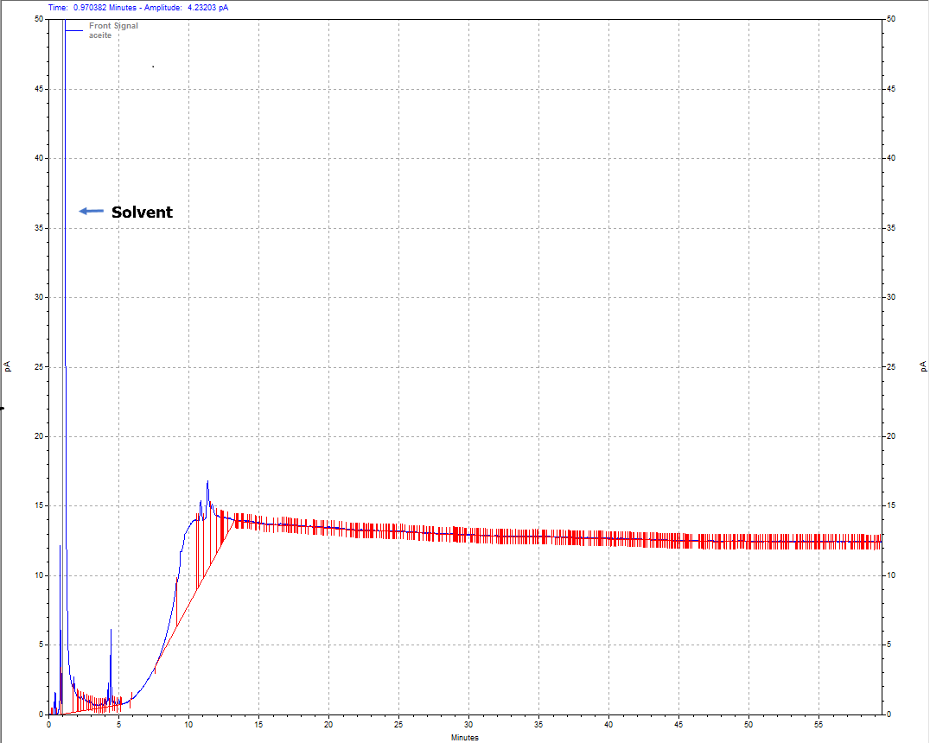
Figure S3. Chromatogram of commercial sunflower oil.

