Waste-based Pichia stipitis inoculum development for co-fermentation of nanoparticle-detoxified pretreated potato peel hydrolysate

Adeniyi P. Adebule¹, Isaac A. Sanusi¹, E.B. Gueguim Kana¹
¹University of KwaZulu-Natal, School of Life Sciences, Pietermaritzburg Campus, South Africa

Table S1: Analysis of variance (ANOVA) for the PSID model
Source | Sum  of squares | df | Mean  square | F-value | p-value
Model | 1.662E+13 | 9 | 1.846E+12 | 12.46 | 0.0016 | significant
A- Incubation time | 4.867E+12 | 1 | 4.867E+12 | 32.85 | 0.0007
B- Temperature | 2.421E+12 | 1 | 2.421E+12 | 16.34 | 0.0049
C- Waste Lub. Oil | 1.725E+12 | 1 | 1.725E+12 | 11.64 | 0.0113
AB | 1.282E+11 | 1 | 1.282E+11 | 0.8650 | 0.3833
AC | 6.178E+11 | 1 | 6.178E+11 | 4.17 | 0.0805
BC | 2.327E+12 | 1 | 2.327E+12 | 15.71 | 0.0054
A² | 7.200E+11 | 1 | 7.200E+11 | 4.86 | 0.0633
B² | 6.882E+11 | 1 | 6.882E+11 | 4.64 | 0.0681
C² | 2.710E+12 | 1 | 2.710E+12 | 18.29 | 0.0037
Residual error | 1.037E+12 | 7 | 1.482E+11
Pure Error | 1.045E+09 | 4 | 2.612E+08
df= Degree of freedom, PSID= Pichia stipitis inoculum development

Table S2: Analysis of variance (ANOVA) of the developed ethanol yield model.
Source | Sum of Squares | df | Mean Square | F-value | p-value
Model | 0.0864 | 9 | 0.0096 | 76.92 | < 0.0001 | significant
A-Solid loading | 0.0606 | 1 | 0.0606 | 486.01 | < 0.0001
B-Co-inoculation time | 0.0084 | 1 | 0.0084 | 66.98 | < 0.0001
C-Inoculation ratio | 0.0060 | 1 | 0.0060 | 48.37 | 0.0002
AB | 0.0009 | 1 | 0.0009 | 7.06 | 0.0326
AC | 0.0008 | 1 | 0.0008 | 6.25 | 0.0410
BC | 0.0046 | 1 | 0.0046 | 36.70 | 0.0005
A² | 0.0001 | 1 | 0.0001 | 0.4196 | 0.5378
B² | 0.0042 | 1 | 0.0042 | 33.96 | 0.0006
C² | 0.0007 | 1 | 0.0007 | 5.36 | 0.0538
Residual | 0.0009 | 7 | 0.0001
Pure Error | 3.829E-07 | 4 | 9.573E-08
Cor Total | 0.0872 | 16

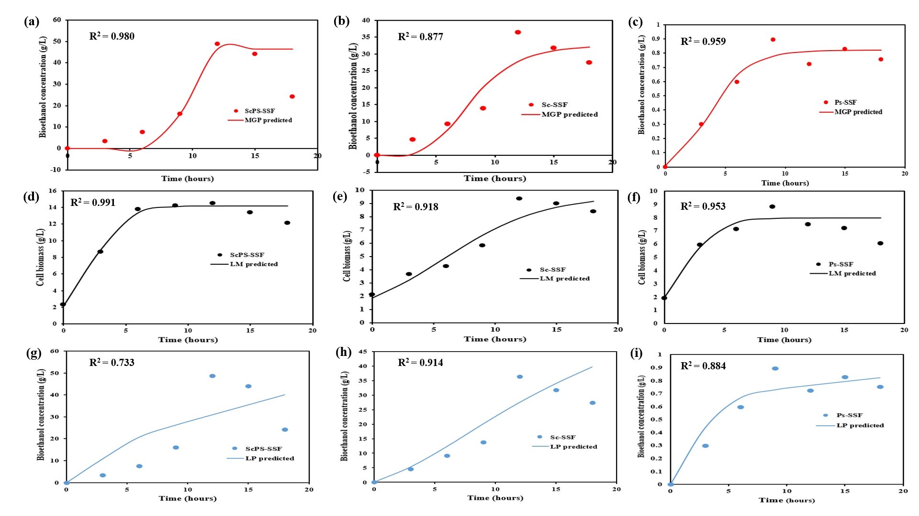
Fig. S1: Modified Gompert model graph for bioethanol formation (a, b and c), logistic model graph of cell biomass (d, e and f), and Luederking-piret model (g, h and i) for product formation by ScPs-SSF, Sc-SSF and Ps-SSF, respectively

