Cellulose-based functional materials from Posidonia oceanica: a sustainable valorization approach
Alice Cappitti,^{a*} Stefano Fabbri,ª Samuele Visi,ª Edoardo Zonta,^{b,c} Benedetto Pizzo,^{d} Paola Mazzanti,^{e} Donatella Giomi,^{a,f} Antonella Salvini,^{a,f*}
ª Department of Chemistry “Ugo Schiff”, University of Florence, Via della Lastruccia 3-13, 50019 Sesto Fiorentino, Italy
^{b} Department of Industrial Engineering, University of Trento, Via Sommarive 9, 38123 Trento, Italy
^{c} National Interuniversity Consortium of Materials Science and Technology (INSTM), Florence, Italy
^{d} CNR-IBE, Istituto per la BioEconomia (Institute of BioEconomy), via Madonna del Piano, 10, Sesto Fiorentino, Italy
^{e} Department of Agricultural, Food, Environmental and Forestry Sciences and Technologies (DAGRI), University of Florence, Piazzale delle Cascine, 18, 50144 Florence, Italy
^{f} Laboratorio congiunto VALORE”, via della Lastruccia 3-13, 50019 Sesto Fiorentino, Italy
*alice.cappitti@unifi.it
*antonella.salvini@unifi.it

Details on spectroscopic analysis
The ¹H spectra were recorded with a Varian Mercury plus 400 spectrophotometer or with a Varian INOVA spectrophotometer both operating at a frequency of 339.921 MHz. The chemical shifts are reported in ppm and referred to TMS as internal standard. Spectra elaboration was performed with the software MestReNova.
ATR spectra were recorded with a Shimadzu model 227-38001-01 QATR-10 single bounce - extended range with monolithic diamond tip, connected to a computer with the lab Solution IR v. 2.16 software, for data processing. All FT-IR analyses were set with the following parameters: spectral resolution of 4 cm⁻¹; 32 scans for each spectrum and Scan Range between 4000 and 400 cm⁻¹.
Details on the panels production
PP1. Untreated Posidonia fibers (1.9 g) were placed in a Petri dish.
PP2. Washed and manually separated Posidonia fibers (1.9 g) were arranged at the bottom of a Petri dish and covered with 15 mL of deionized water. A solution of ball-milled Posidonia (400 mg) in 8 mL of 8% DMSO/LiCl was poured onto the fiber bed. The supernatant was removed, and the panel was rinsed with water to eliminate any residual solvent. The resulting panel was then subjected to a load of 140 g for 24 h, followed by drying in an oven at 30–35 °C.
PP3. Washed and manually separated Posidonia fibers (1.9 g) were arranged at the bottom of a Petri dish. A solution containing ball-milled Posidonia (800 mg) and EASAQUA™ (400 mg) in 16 mL of 8% DMSO/LiCl was then poured onto the fiber bed. The resulting panel was crosslinked in an oven at 30–35 °C under a 140 g load for 24 h and subsequently left to rest for one week. Finally, the panel was washed seven times with deionized water to remove residual solvent and dried in an oven at 30–35 °C.
PP4. Washed and manually separated Posidonia fibers (1.9 g) were arranged at the bottom of a Petri dish and covered with 15 mL of deionized water. A solution of ball-milled Posidonia (800 mg) in 16 mL of 8% DMSO/LiCl was poured onto the fiber bed. The supernatant was removed, and the panel was rinsed with water to eliminate any residual solvent. The resulting panel was then subjected to a load of 140 g for 24 h, followed by drying in an oven at 30–35 °C.
PP5. Washed and manually separated Posidonia fibers (12 g) were arranged at the bottom of a Petri dish and covered with 100 mL of deionized water. A solution of ball-milled Posidonia (2.5 g) in 50 mL of 8% DMSO/LiCl was poured onto the fiber bed. The supernatant was removed, and the panel was rinsed with water to eliminate any residual solvent. The resulting panel was then subjected to a load of 560 g for 24 h, followed by drying in an oven at 30–35 °C.
Details on the films production
FC. A solution of microcrystalline cellulose (150 mg) in 6 mL of 8% DMSO/LiCl was prepared. The upper part of a Büchner funnel fitted with a glass microfiber filter was immersed in a bath of deionized water (100 mL). The cellulose solution was evenly distributed over the filter using a pipette, and the excess water was removed by filtration. The resulting film was pressed under a load of approximately 144 g for 24 h and subsequently dried in an oven at 30–35 °C.
FP1. Posidonia oceanica powder (150 mg), previously subjected to ball milling and bleaching/delignification step, was dissolved in 3 mL of 8% DMSO/LiCl. The solution was distributed onto the glass microfiber filter of a Büchner funnel immersed in deionized water (100 mL). The excess water was removed by filtration, and the resulting film was pressed under a load of approximately 144 g for 24 h and subsequently dried in an oven at 30–35 °C.
FP2. A solution of Posidonia oceanica powder (150 mg, treated as in FP1) in 3 mL of 8% DMSO/LiCl was combined with a solution of microcrystalline cellulose (50 mg) in 2 mL of 8% DMSO/LiCl. The mixture was distributed onto the glass microfiber filter of a Büchner funnel immersed in deionized water (100 mL). The excess water was removed by filtration, and the resulting film was pressed under a load of approximately 144 g for 24 h and subsequently dried in an oven at 30–35 °C.
FP3. A solution of Posidonia oceanica powder (150 mg, treated as in FP1) in 3 mL of 8% DMSO/LiCl was prepared and distributed onto the filter of a Büchner funnel immersed in 100 mL of deionized water. The excess water was removed by filtration, and the wet film was treated with 0.300 mL of a 5% (w/w) aqueous glycerol solution to reach a final glycerol content of 10% (w/w) relative to Posidonia. The resulting film was pressed under a load of approximately 144 g for 24 h and subsequently dried in an oven at 30–35 °C.
FP4. A solution of Posidonia oceanica powder (150 mg, treated as in FP1) in 3 mL of 8% DMSO/LiCl was prepared and distributed onto the filter of a Büchner funnel immersed in 100 mL of deionized water. The excess water was removed by filtration, and the wet film was treated with 0.300 mL of a 5% (w/w) aqueous Klucel G® solution to reach a final Klucel G® content of 10% (w/w) relative to Posidonia. The resulting film was pressed under a load of approximately 144 g for 24 h and subsequently dried in an oven at 30–35 °C.
FP5. A solution of Posidonia oceanica powder (150 mg, treated as in FP1) in 3 mL of 8% DMSO/LiCl was prepared and distributed onto the filter of a Büchner funnel immersed in 100 mL of deionized water. The excess water was removed by filtration and the wet film was treated sequentially with 0.300 mL of a 5% (w/w) aqueous glycerol solution and 0.300 mL of a 5% (w/w) aqueous Klucel G® solution, each allowing absorption, to achieve final loadings of 10% (w/w) glycerol and 10% (w/w) Klucel G® relative to Posidonia. The resulting film was pressed under a load of approximately 144 g for 24 h and subsequently dried in an oven at 30–35 °C.
FP6. A solution of Posidonia oceanica powder (150 mg, treated as in FP1) in 3 mL of 8% DMSO/LiCl was prepared and distributed onto the filter of a Büchner funnel immersed in 100 mL of deionized water. The excess water was removed by filtration, and the wet film was treated with 0.300 mL of a nanocellulose dispersion, yielding a final CNC1 content of 5% (w/w, dry basis) relative to Posidonia. The resulting film was pressed under a load of approximately 144 g for 24 h and subsequently dried in an oven at 30–35 °C.
FP7. A solution of Posidonia oceanica powder (150 mg, treated as in FP1) in 3 mL of 8% DMSO/LiCl was prepared and distributed onto the filter of a Büchner funnel immersed in 100 mL of deionized water. The excess water was removed by filtration. The resulting film was pressed under a load of approximately 144 g for 24 h and dried in an oven at 30-35°C; thereby the dry film was treated with 1 mL of a 1.6 % beeswax solution in ethyl acetate, yielding a final CNC1 content of 10% (w/w, dry basis) relative to Posidonia. The final film was dried again in an oven at 30–35 °C.

Details on contact angle measurements
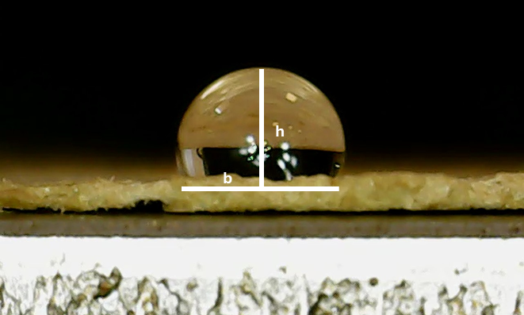
Fig. S1. Static contact angle measurement of selected Posidonia oceanica film

¹H-NMR spectra
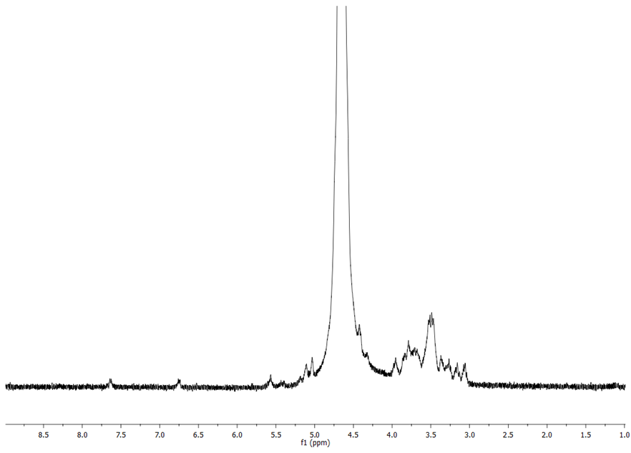
Fig. S2. ¹H-NMR spectrum of the water-soluble fraction obtained from Posidonia oceanica after HCl pretreatment, acquired in D₂O. Chemical shifts are reported in ppm.
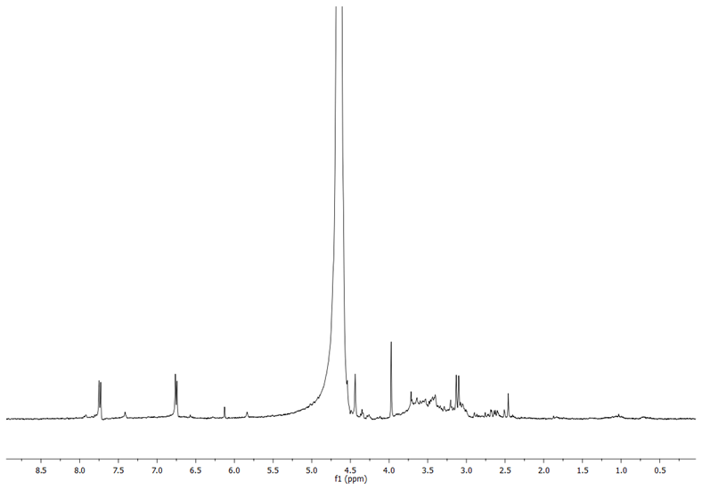
Fig. S3. ¹H-NMR NMR spectrum of the water-soluble fraction isolated from Posidonia oceanica after bleaching/delignification with H₂O₂/NaOH. Spectrum is acquired in D₂O. Chemical shifts are reported in ppm.

Details on cellulose solubilization
Table S1. Tests results on the solubilization and reprecipitation of cellulose and Posidonia oceanica under different conditions
Sample | Solvent | Pretreatment | Weight loss% | Yield (H2O) % | Yield (EtOH) %
Cellulose | DMAc/LiCl |  |  | 96.1 ± 3.9
Cellulose | DMAc/LiCl |  |  |  | 91.5 ± 3.1
Cellulose | DMSO/LiCl |  |  | 90.6 ± 0.8
Cellulose | DMSO/LiCl |  |  |  | 90.7 ± 3.1
Posidonia | DMSO/LiCl |  |  |  | 2.6 ± 0.2
Posidonia | DMAc/LiCl |  |  |  | 18.9 ± 0.8
Posidonia | DMAc/LiCl | HCl | 38 ± 4 |  | 11.4 ± 1.3
Posidonia | DMSO/LiCl | HCl | 44.5 ± 0.5 |  | 14.5 ± 0.3
Posidonia | DMAc/LiCl | HCl 5h | 42.5 ± 2.5 |  | 13
Posidonia | DMAc/LiCl | NaOH | 13.5 ± 1.5 |  | 8.4 ± 0.3
Posidonia | DMSO/LiCl | NaOH | 14.5 ± 1.5 |  | 3.9 ± 0.3
Posidonia | DMAc/LiCl | NaOH 60°C | 28 |  | 8.4
Posidonia | DMAc/LiCl | H₂O₂/NaOH | 24.4 ± 7.6 |  | 15.6
Posidonia | DMSO/LiCl | H₂O₂/NaOH | / |  | 17

Details on films morphology
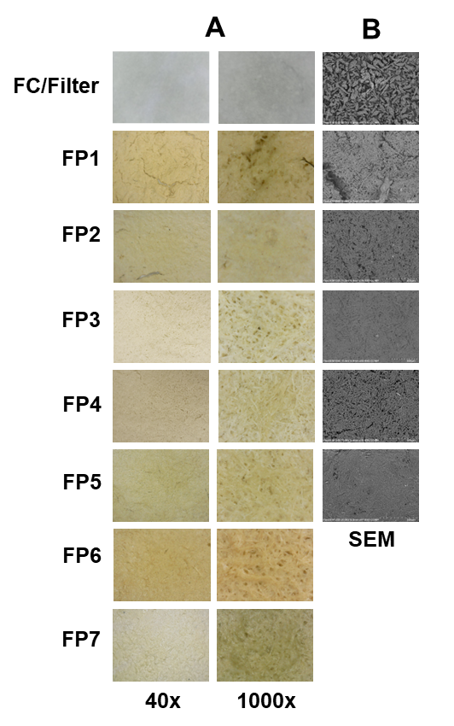
Fig. S4. A. Optical images of films at magnifications: 40x (0.7 cm) and 1000x (1 mm). B. SEM images (500 µm scale bar)

