Supplementary Materials
for
Enhancing methane production during anaerobic digestion of sewage sludge using enzymes produced by autochthonous microbial consortia

Magdalena Ćwiertniewicz-Wojciechowska¹, Anna Wolny², Sebastian Jurczyk³, Grzegorz Cema¹, Aleksandra Ziembińska-Buczyńska¹
¹ Department of Environmental Biotechnology, Silesian University of Technology, Akademicka 2A, Gliwice PL-44100, Poland
² Department of Chemical Organic Technology and Petrochemistry, Faculty of Chemistry, Silesian University of Technology, Krzywoustego 4, Gliwice PL-44100, Poland
³ Institute for Engineering of Polymer Materials and Dyes, Lukasiewicz Research Network, Sklodowskiej-Curie 55, Torun PL-87100, Poland
Corresponding author: magdalena.cwiertniewicz-wojciechowska@polsl.pl

- TGA analysis
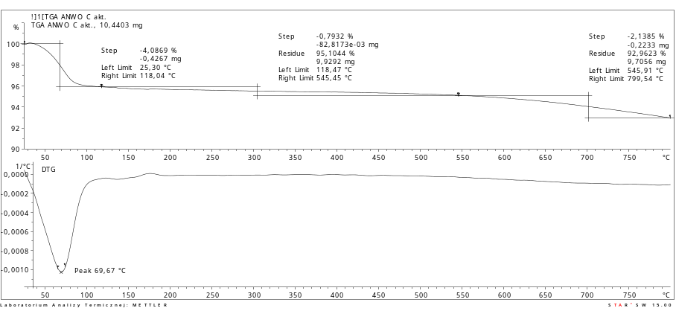
Fig S1. Thermogravimetric analysis (TGA) for an activated carbon as a carrier.
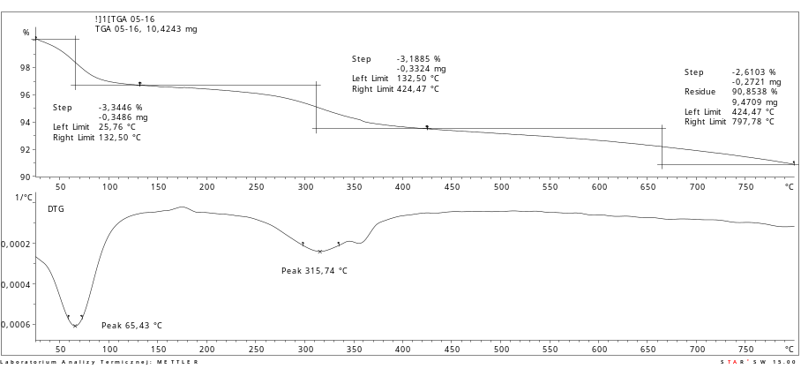
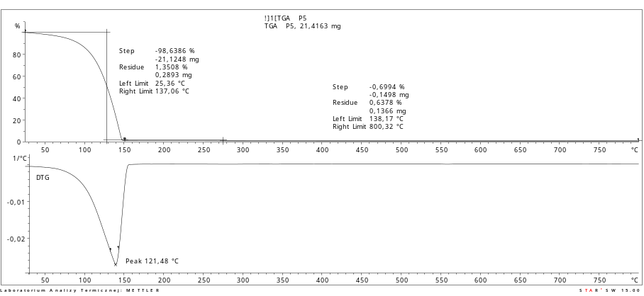
Fig S2. Mixture of an isolated enzymes without an addition of the Na-citric buffer.

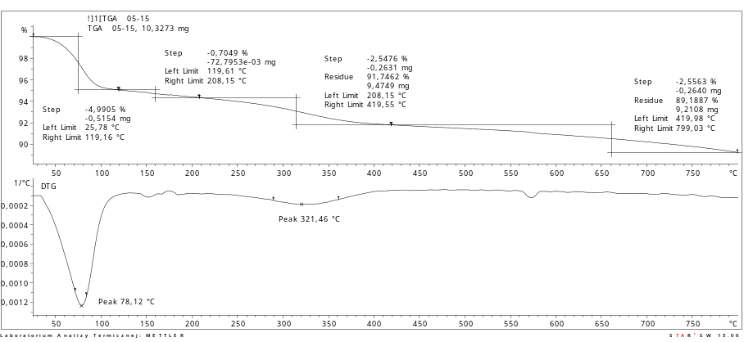
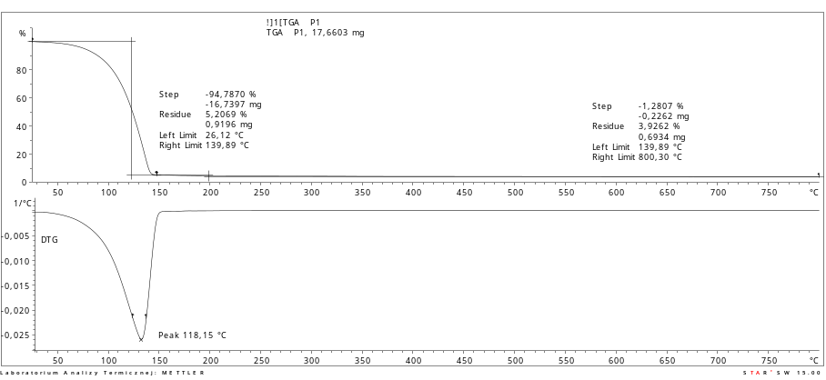
Fig S3. Mixture of an isolated enzymes in a ratio 2:1 with a Na-citric buffer.
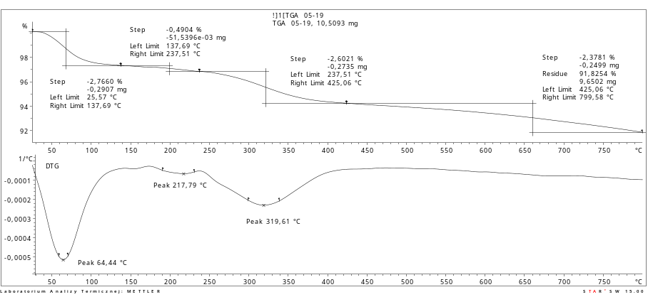
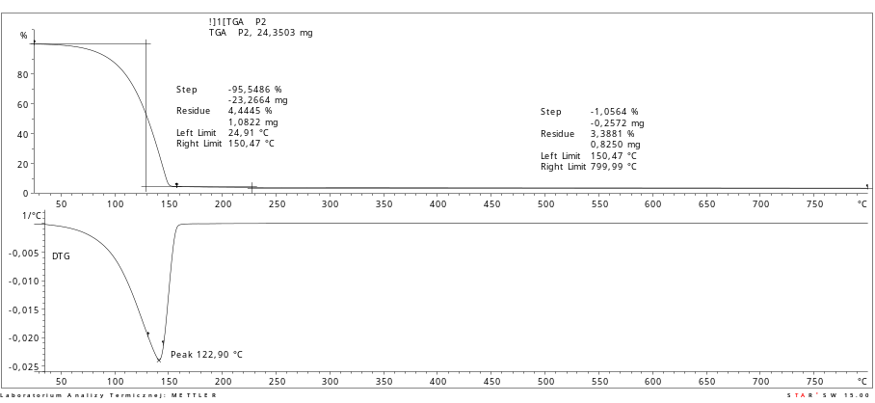

Fig S4. Mixture of an isolated enzymes in a ratio 3:1 with a Na-citric buffer.

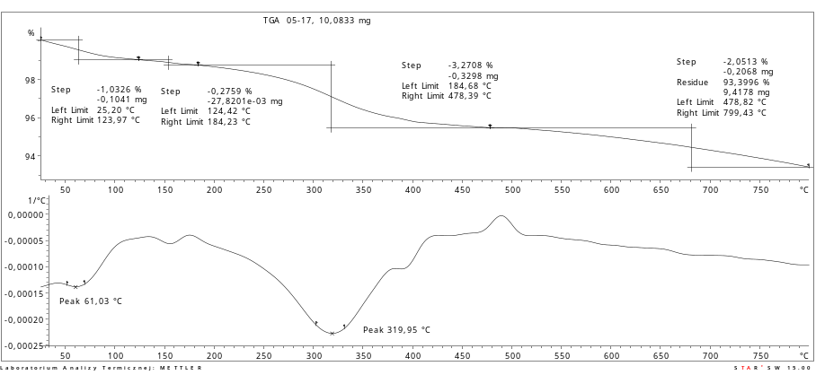
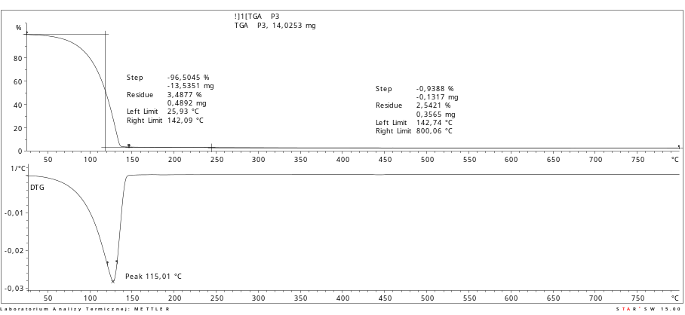
Fig S5. Mixture of an isolated enzymes in a ratio 4:1 with a Na-citric buffer.
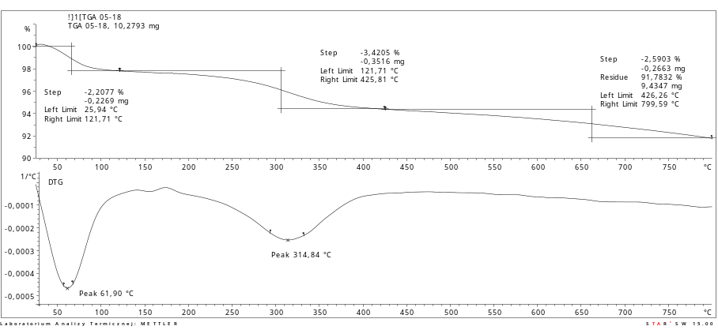
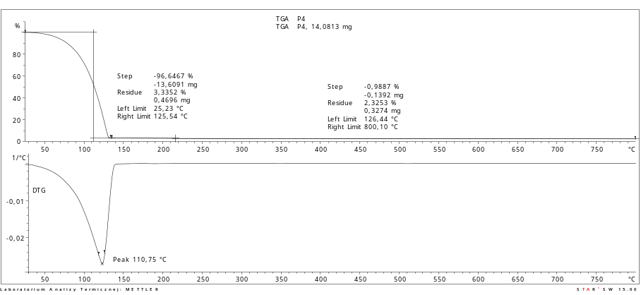
Fig S6. Mixture of an isolated enzymes in a ratio 5:1 with a Na-citric buffer.
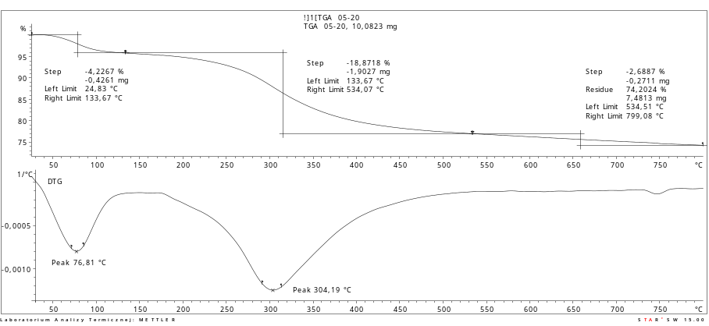
Fig S7. Mixture of a commercial enzyme (CelliC Tec2, Novozymes), immobilized on the activated carbon as a carrier.
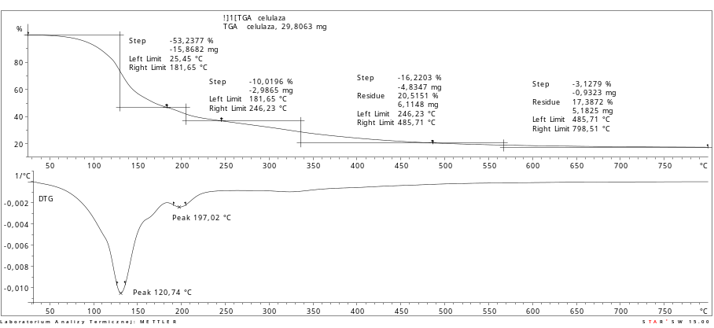
Fig 8S. Mixture of a commercial enzyme (CelliC Tec2, Novozymes) in a non-immobilized form.

