Supplementary information

Supplementary Table 1.
Primer sequences for real-time quantitative PCR on cDNA obtained from post-mortem Tpo-Cre/LSL-Braf^{V600E} mouse tumor tissues.
Gene | 5’ 3’ forward primer | 5’ 3’ reverse primer
Dio1 | GCT-GAA-GCG-GCT-TGT-GAT-ATT | GTT-GTC-AGG-GGC-GAA-TCG-G
Dio2 | AAT-TAT-GCC-TCG-GAG-AAG-ACC-G | GGC-AGT-TGC-CTA-GTG-AAA-GGT
Duox1 | AAA-ACA-CCA-GGA-ACG-GAT-TGT | AGA-AGA-CAT-TGG-GCT-GTA-GGG
Duox2 | AAG-TTC-AAG-CAG-TAC-AAG-CGA-T | TAG-GCA-CGG-TCT-GCA-AAC-AG
Foxe1 (Ttf2) | ATC-GCG-CTC-ATC-GCT-ATG-G | GGG-GTT-GTC-GCG-GTA-GAA-C
Glis3 | TGT-GGC-ATG-AAT-CTC-CAC-CG | AGG-TGA-AGA-CTG-TTA-GCA-AGA-CT
Nkx2-1 (Ttf1) | AGG-ACA-CCA-TGC-GGA-ACA-G | CCA-TGC-CGC-TCA-TAT-TCA-TGC
Pax8 | ATG-CCT-CAC-AAC-TCG-ATC-AGA | ACA-ATG-CGT-TGA-CGT-ACA-ACT-T
Slc26a4 | CAG-CGG-TAA-CGG-AAG-TGC-AT | TCT-GCC-AAG-TAC-CTC-ACT-ATG-A
Slc5a5 (NIS) | CGC-TAC-GGT-CTC-AAG-TTT-CTG | CGC-AGT-TCT-AGG-TAC-TGG-TAG-G
Slc5a8 | TTA-TGG-GCG-GTC-GCA-GTA-TG | CAA-AAC-GGT-AGA-CCT-CGG-CA
Tg | CTG-GTC-TTG-TGG-GTC-TCT-ACT | CAC-TGG-GGA-ACA-TAT-TCA-GCC
Thra | GGT-CAC-CAG-ATG-GAA-AGC-GAA | CCT-TGT-CCC-CAC-ACA-CGA-C
Thrb | ACA-CCA-GCA-ATT-ACC-AGA-GTG | GCA-GCT-CGA-AGG-GAC-ATG-A
Tpo | CTT-GGA-GCT-ATG-GCA-ATA-ATG-CT | GAG-CTG-GCT-CGT-TTC-CAC-A
Tshr | CAC-CAG-GAG-GAC-GAC-TTC-AGA | GGC-AGA-CTC-GAA-AAT-GCA-AGA
B2m (housekeeping gene) | TTC-TGG-TGC-TTG-TCT-CAC-TGA | CAG-TAT-CTT-CGG-CTT-CCC-ATT-C

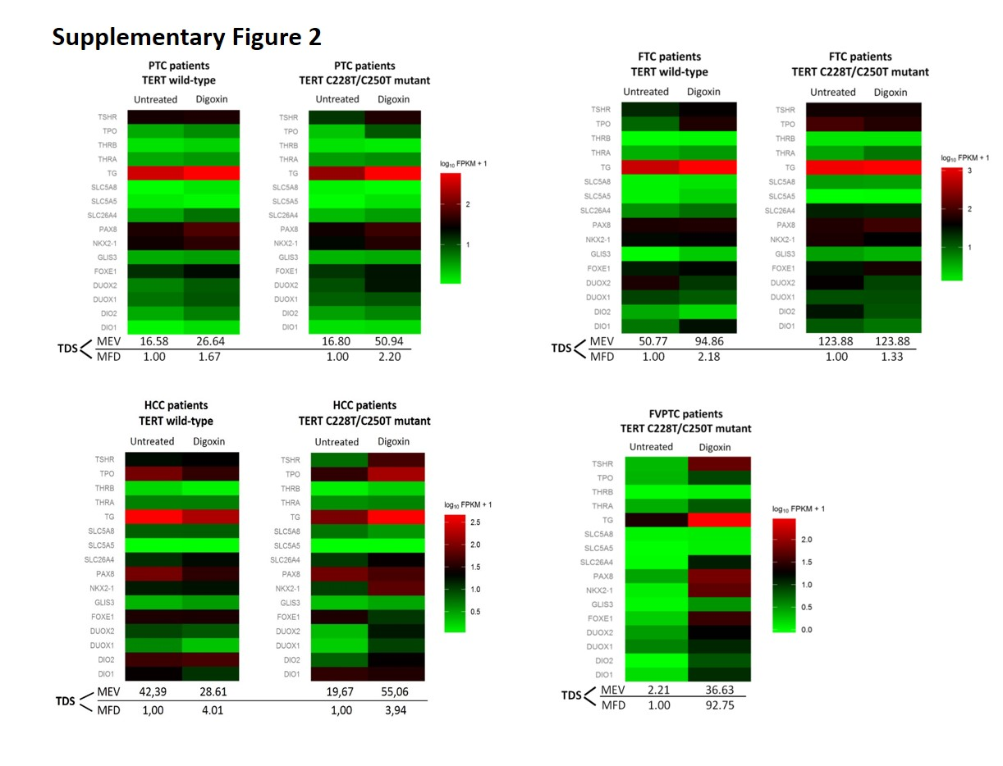
Supplementary Figure 1
Supplementary Fig 1 Heatmaps of thyroid-specific gene expression in NMTC tumor tissue after histological and genetic stratification. MEV: mean expression value of all 16 TDS genes; MFV: mean fold difference of all 16 TDS genes between untreated NMTC patients (reference value, 1.00 by default) and NMTC patients treated with digoxin. Subgroups represent:
(1) PTC patients with TERT wild-type tumor (digoxin treated, N=2; untreated matched control, N=2);
(2) PTC patients with TERT mutant tumor (digoxin treated, N=3; untreated matched control, N=4);
(3) FTC patients with TERT wild-type tumor (digoxin treated, N=1; untreated matched control, N=1); (4) FTC patients with TERT mutant tumor (digoxin treated, N=1; untreated matched control, N=1);
(5) HCC patients with TERT wild-type tumor (digoxin treated, N=2; untreated matched control, N=1);
(6) HCC patients with TERT mutant tumor (digoxin treated, N=1; untreated matched control, N=1);
(7) FVPTC patients with TERT mutant tumor (digoxin treated, N=1; untreated matched control, N=1). FTC: follicular thyroid cancer; FVPTC: follicular-variant papillary thyroid cancer; HCC: Hürthle cell carcinoma; MEV: Mean Expression Value; MFD: Mean Fold Difference; PTC: papillary thyroid cancer; TDS: Thyroid Differentiation Score.

