Title
EIF2B4 Promotes Hepatocellular Carcinoma Progression and Immune Evasion by Driving STAT3 Translation via a GEF-Dependent Mechanism
Journal
Cellular Oncology
Authors
Yirui He^{*,1}, Yunhe Li^{*,2}, Yayi Chen^{*,1}, Sha Liu³, Jia Liu¹, Rui Wei¹, Jiapeng Zhang^{#,1}
Affiliation
1. Department of Hematology, Department of Urology and Institute of Urology, Department of Pulmonary and Critical Care Medicine, West China Hospital, Sichuan University, Chengdu, China.
2. Department of Thoracic and Cardiac Surgery, Second Affiliated Hospital of Chongqing Medical University, Chongqing, China.
3. Department of Geriatrics, Sichuan Second Hospital of Traditional Chinese Medicine, Chengdu, China.

*These authors contributed equally to this work and should be considered co-first authors
# Corresponding author
Email: jp_zhang@scu.edu.cn

Supplementary material
Supplementary figure
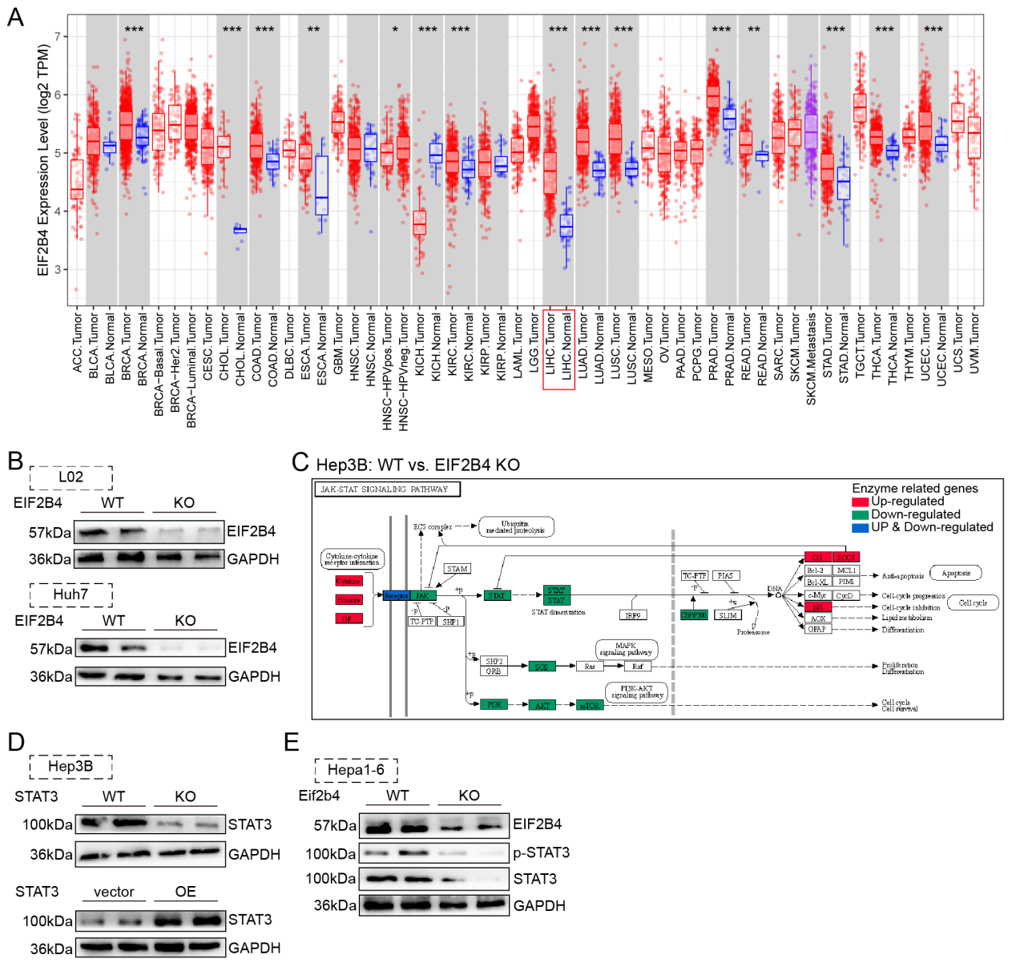
- Differential expression of EIF2B4 between tumor and adjacent normal tissues across various cancer types in the TCGA database.
- Representative immunoblot showing validation of EIF2B4 knockout in cell lines.
- Transcriptomic changes of key genes in the JAK-STAT signaling pathway before and after EIF2B4 knockout in Hep3B cells.
- Representative immunoblot showing validation of EIF2B4 overexpression in Hep3B.
- Representative immunoblot showing validation of EIF2B4 konckout in Hepa1-6.
Uncropped immunoblots
Figure5
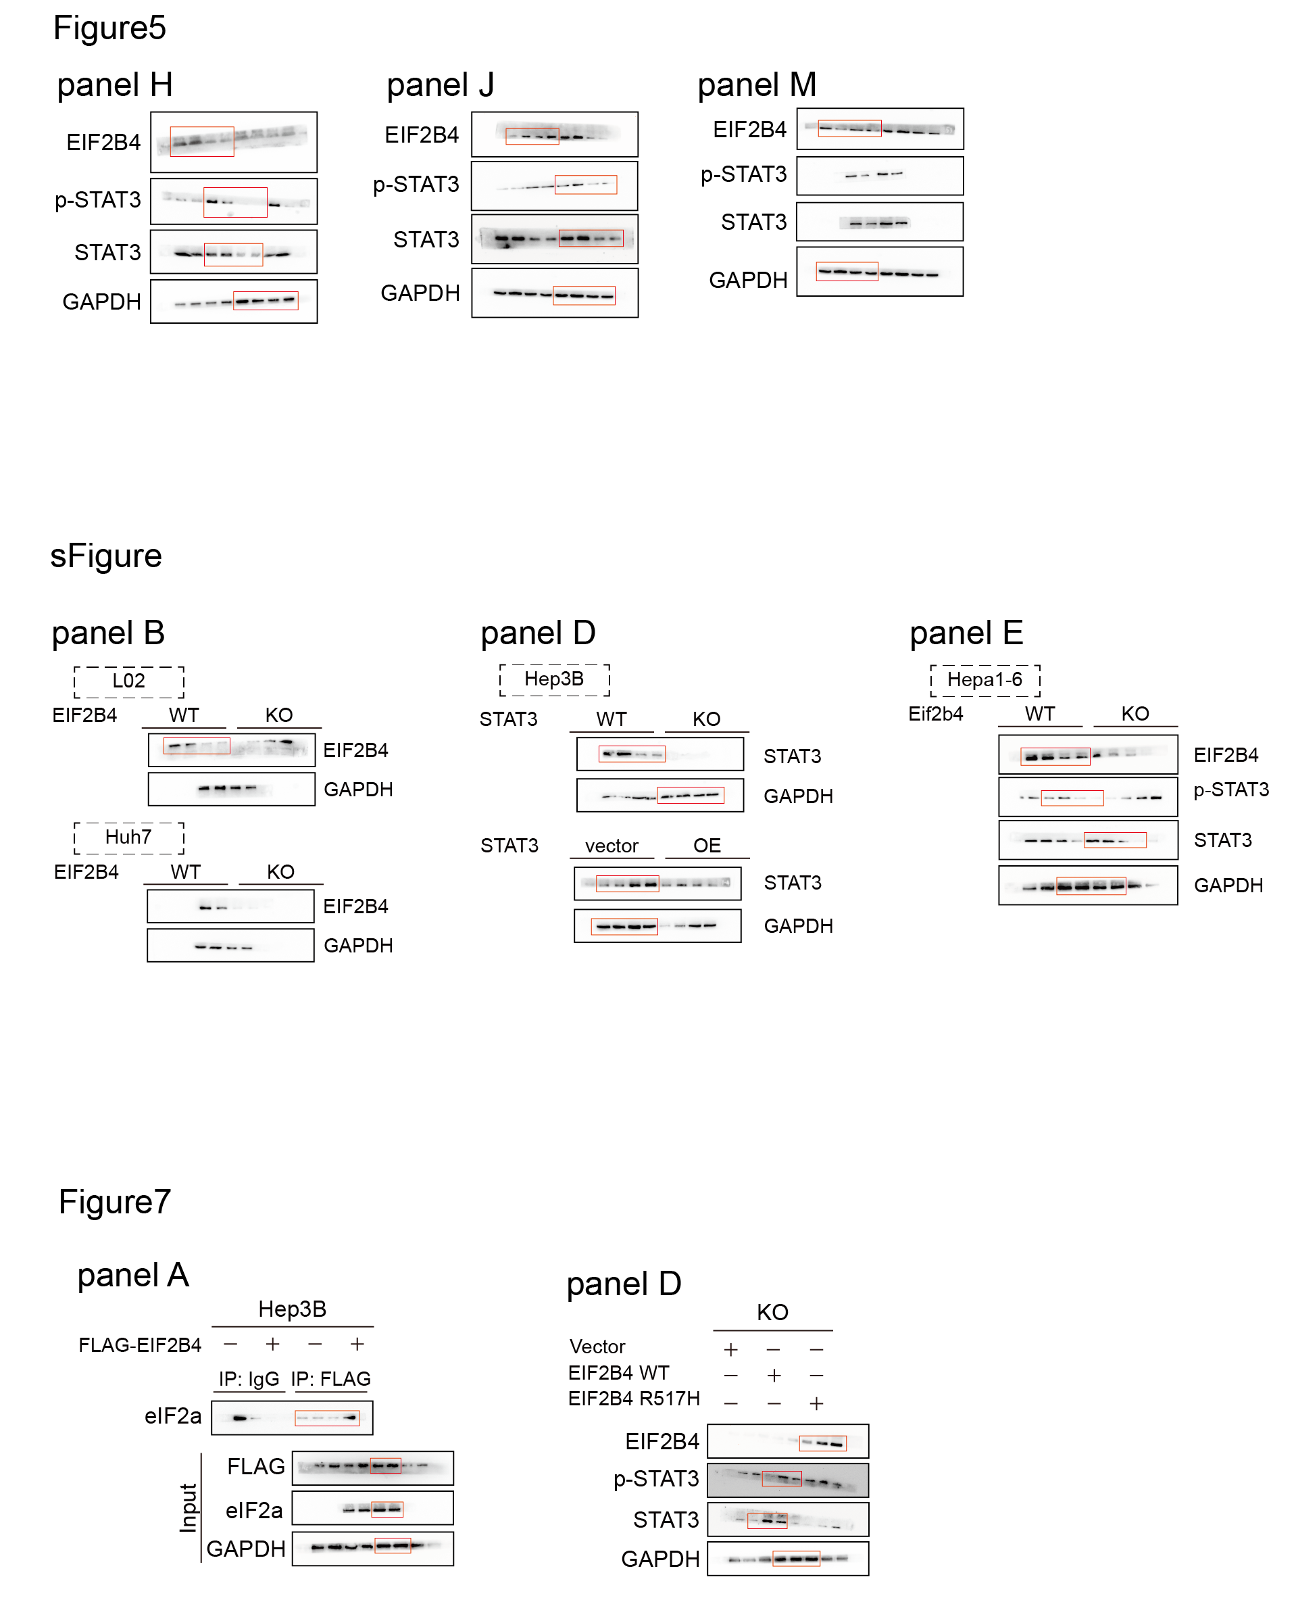
Figure7
Supplementary figure

