RAB3A-mediated BAG6 translocation promotes non-small cell lung cancer tumorigenesis and progression
Xiaoli Liu^{1,2}, Wen Wang¹, Wanwei Cao³, Zhanyu Li³, Hao Huang³, Fang Liu ⁴, Yang Wang ⁴, Zhijuan Zhong ⁴, Hongyu Zhang¹, Xiaofeng Pei¹, Hongtao Chen^{4,5}
¹Department of Oncology, The Fifth Affiliated Hospital of Sun Yat-sen University, Zhuhai 519000, China.
²Guangdong Provincial Engineering Research Center of Molecular Imaging, the Fifth Affiliated Hospital of Sun Yat-sen University, Zhuhai 519000, China
³Department of Pathology, The Fifth Affiliated Hospital of Sun Yat-sen University, Zhuhai 519000, China.
⁴Department of Laboratory, The Fifth Affiliated Hospital of Sun Yat-sen University, Zhuhai 519000, China.
⁵Department of Laboratory, Xinjiang Medical University Affiliated Second Hospital, Wulumuqi 830028, China.
Xiaoli Liu, Wen Wang, Wanwei Cao and Zhanyu Li contributed equally.
Email:
Xiaoli Liu:liuxli37@mail2.sysu.edu.cn
Wen Wang: wangw258@mail3.sysu.edu.cn
Wanwei Cao: caoww@mail.sysu.edu.cn
Zhanyu Li: lizhany@mail.sysu.edu.cn
Hao Huang: huangh227@outlook.com
Fang Liu: liufang17961051@outlook.com
Yang Wang: 13639908783@139.com
Zhijuan Zhong: 13570633297@139.com
Hongyu Zhang: zhhyu@mail.sysu.edu.cn
Xiaofeng Pei: peixf3@mail.sysu.edu.cn
Hongtao Chen: 13926925941@139.com
Corresponding author at:
Hongyu Zhang
Department of Oncology, The Fifth Affiliated Hospital of Sun Yat-sen University, Zhuhai 519000, China
Email: zhhyu@mail.sysu.edu.cn
Xiaofeng Pei
Department of Oncology, The Fifth Affiliated Hospital of Sun Yat-sen University, Zhuhai 519000, China
Email: peixf3@mail.sysu.edu.cn
Hongtao Chen
Department of Laboratory, Xinjiang Medical University Affiliated Second Hospital, Wulumuqi 830028, China
Email: 13926925941@139.com
Supplementary Materials
Supplementary materials contain 8 supplementary figures.
Supplementary Figures and Legends

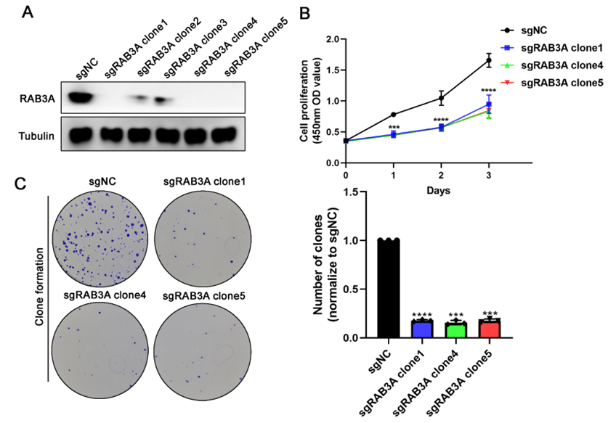
Fig. S1 Phenotypic validation with RAB3A-null monoclonal lines.
A Western blot validation of RAB3A-null clones. B CCK8 assay of cell viability in RAB3A-null clones. C Colony formation assay in RAB3A-null clones. Data are presented as the mean ± SD. *** p < 0.001, **** p < 0.0001.

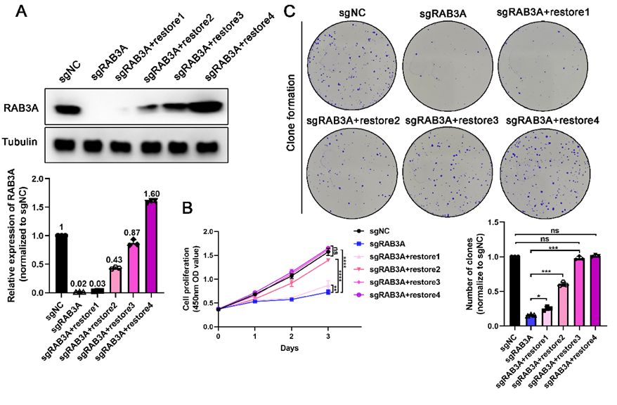
Fig. S2 Physiological RAB3A levels suffice for oncogenic function.
A Experimental design for RAB3A titration. Lane 1: sgNC; Lane 2: sgRAB3A; Lanes 3-6: Rescue with very low/low/medium/high viral titers. B Proliferation in reconstituted cells. C Colony formation in reconstituted cells. * p<0.05, ** p<0.01,*** p<0.001, **** p<0.0001. ns, nonsignificant difference

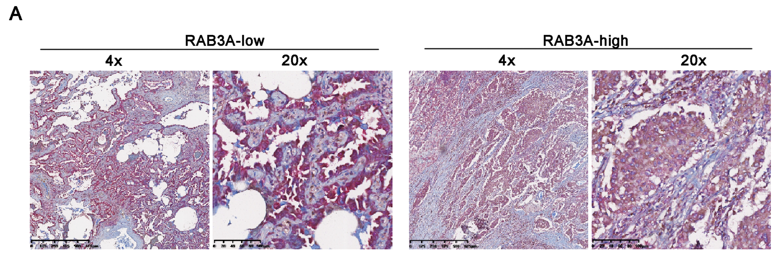
Fig. S3 RAB3A expression-dependent BAG6 cytoplasmic co-localization in NSCLC clinical specimens.
A Dual-IHC analysis of RAB3A (brown) and BAG6 (red) in RAB3A-low (left) and RAB3A-high (right) specimens . Scale bars: 625 μm (4×), 100 μm (20×).

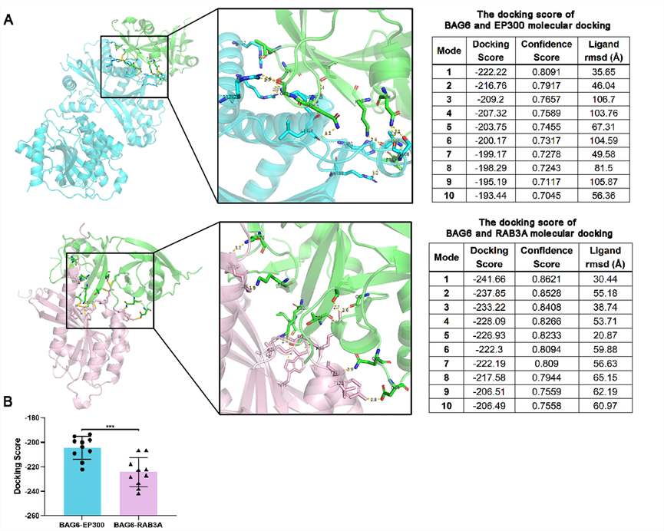
Fig. S4 Computational modeling of competitive binding between RAB3A and EP300 for BAG6 recruitment.
A Molecular docking of protein complexes using HDOCK server. B Statistical analysis of HDOCK docking scores for protein complexes. Lower scores indicate higher affinity. Error bars represent the mean ± SD. ***p < 0.001.
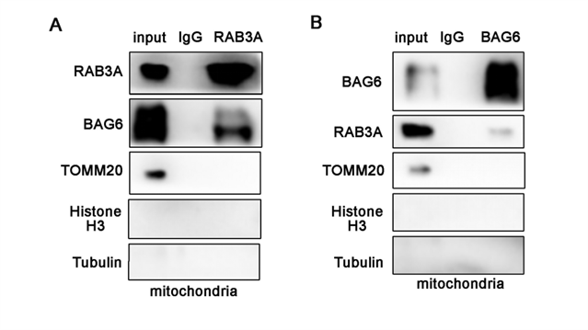
Fig. S5 Co-IP of RAB3A and BAG6 from purified mitochondrial lysates.

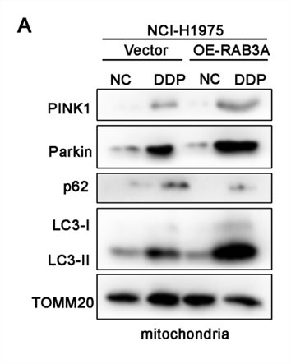
Fig. S6 RAB3A overexpression enhances mitophagy to confer oxidative stress tolerance.
A Western blot analysis of mitophagy markers in RAB3A overexpression cells treated with DDP (10 μM). DDP, cisplatin

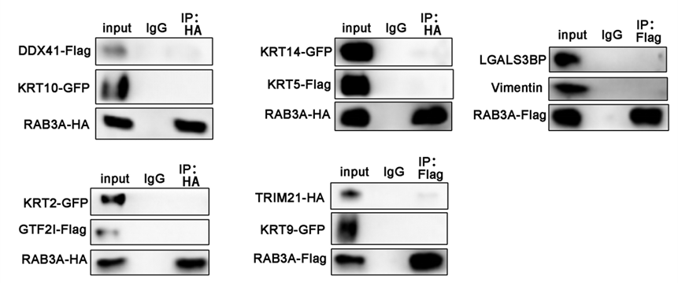
Fig. S7 Validation of top 10 MS candidates.

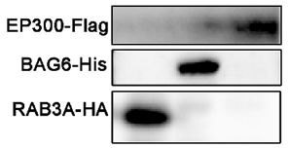
Fig. S8 Western blot analysis of purified proteins.

