Supplementary materials
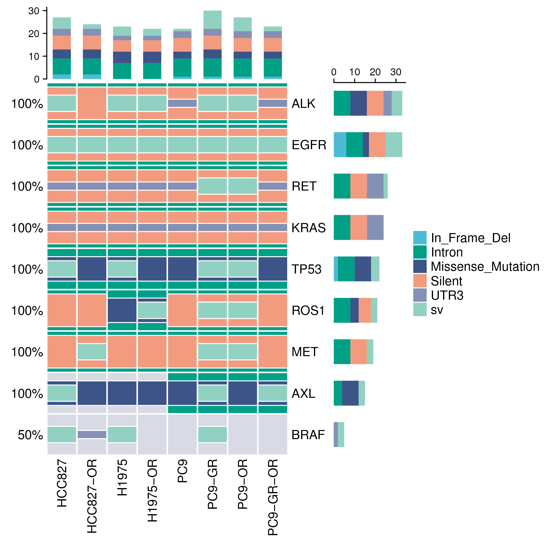
Supplementary Fig.1 WES of common osimertinib-resistant relevant mutations in cell lines. ( Note: PC9-GR is a PC9 cell line that is resistant to gefitinib. PC9-GR-OR is an osimertinib-resistant cell line established based on the PC9-GR resistant cell line. These two models were not used in this study, but were tested together.)

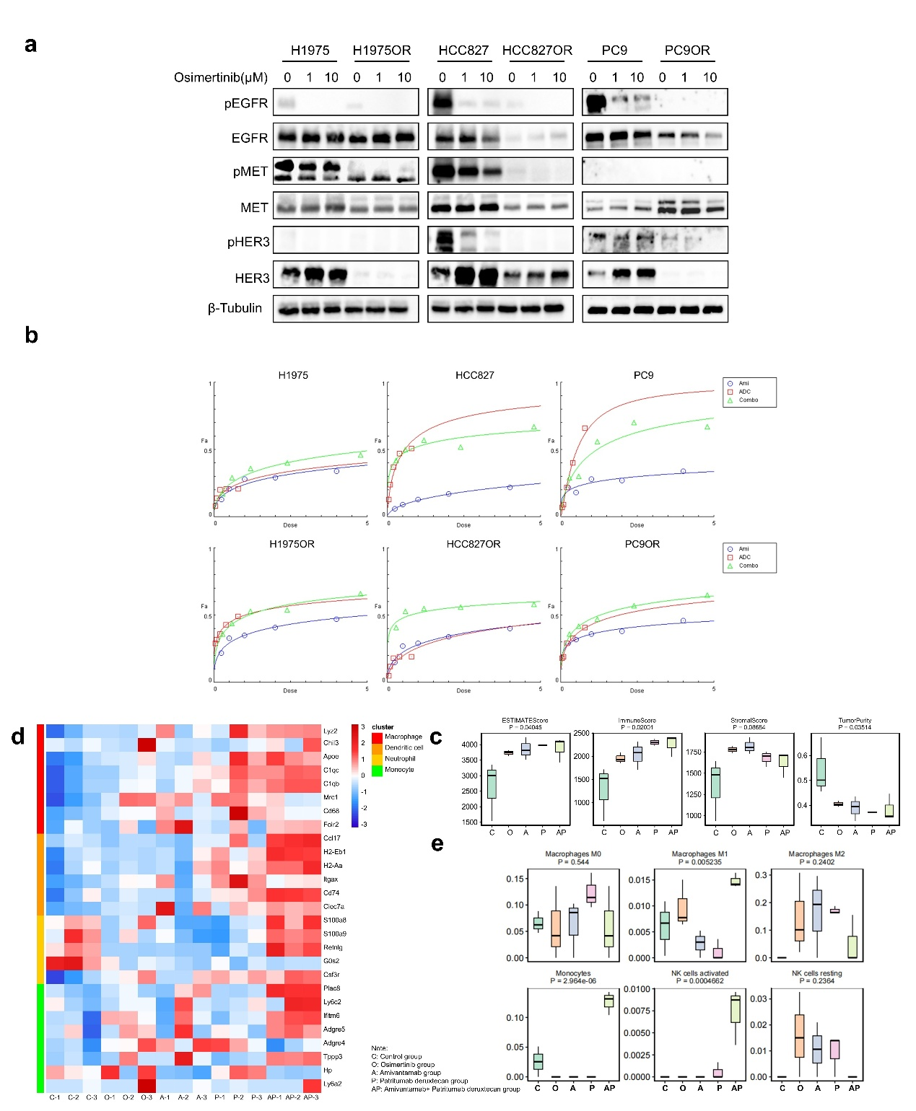
Supplementary Fig.2 (a) Following 8-hour in vitro exposure to gradient concentrations of osimertinib (0, 1, 10 μM), western blot analysis was employed to assess corresponding alterations in protein expression profiles across treated cell lines. (b) The Fraction affected (Fa)-Dose plots show the inhibition rate after Cells were treated with different concentrations of amivantamab and patritumab deruxtecan for 72 h. Ami, amivantamab; ADC, patritumab deruxtecan; Combo, amivantamab and patritumab deruxtecan combination. (c) Tumor microenvironment-related scores were calculated by the ESTIMATE algorithm. (d) Heatmap of genes representing different immune cells to reflect the composition of immune cells infiltrating. N=3. (e) The proportions and distributions of tumor-infiltrating immune cells were calculated by the CIBERSORT algorithm. N=3.
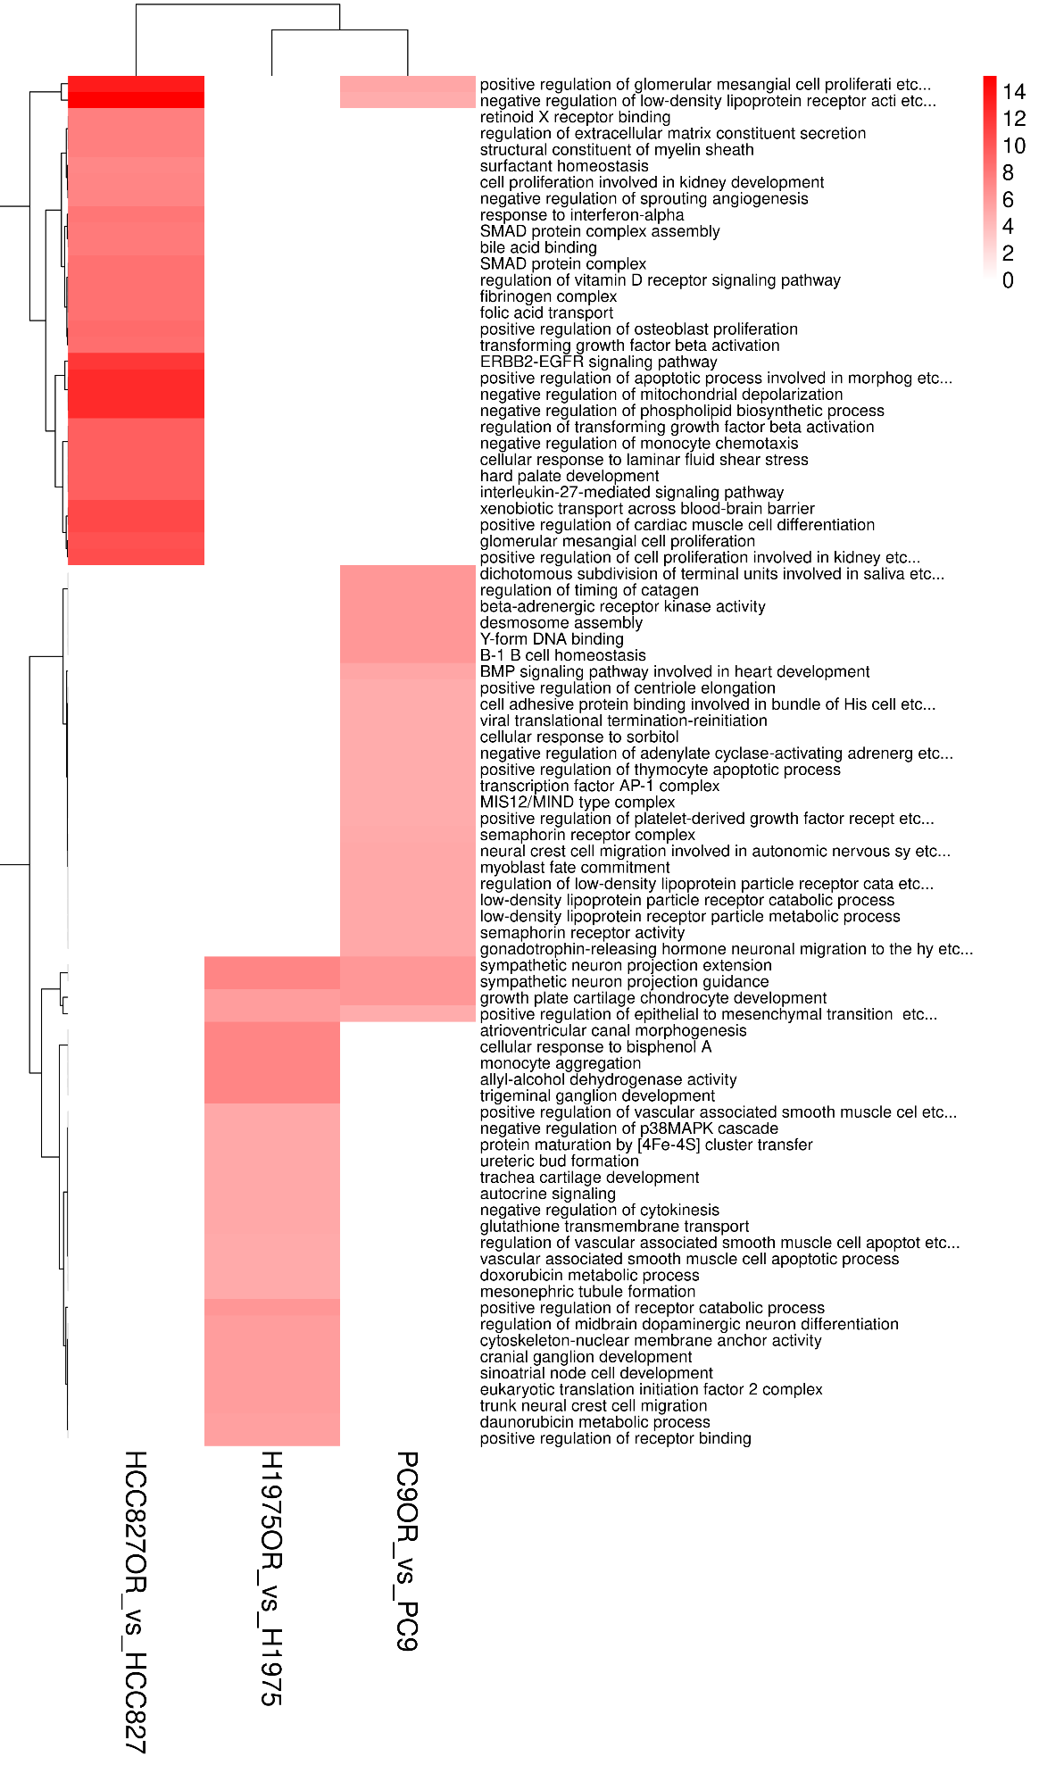
Supplementary Fig.3 GO enrichment heatmap depending the mRNA rich factor , N=3.

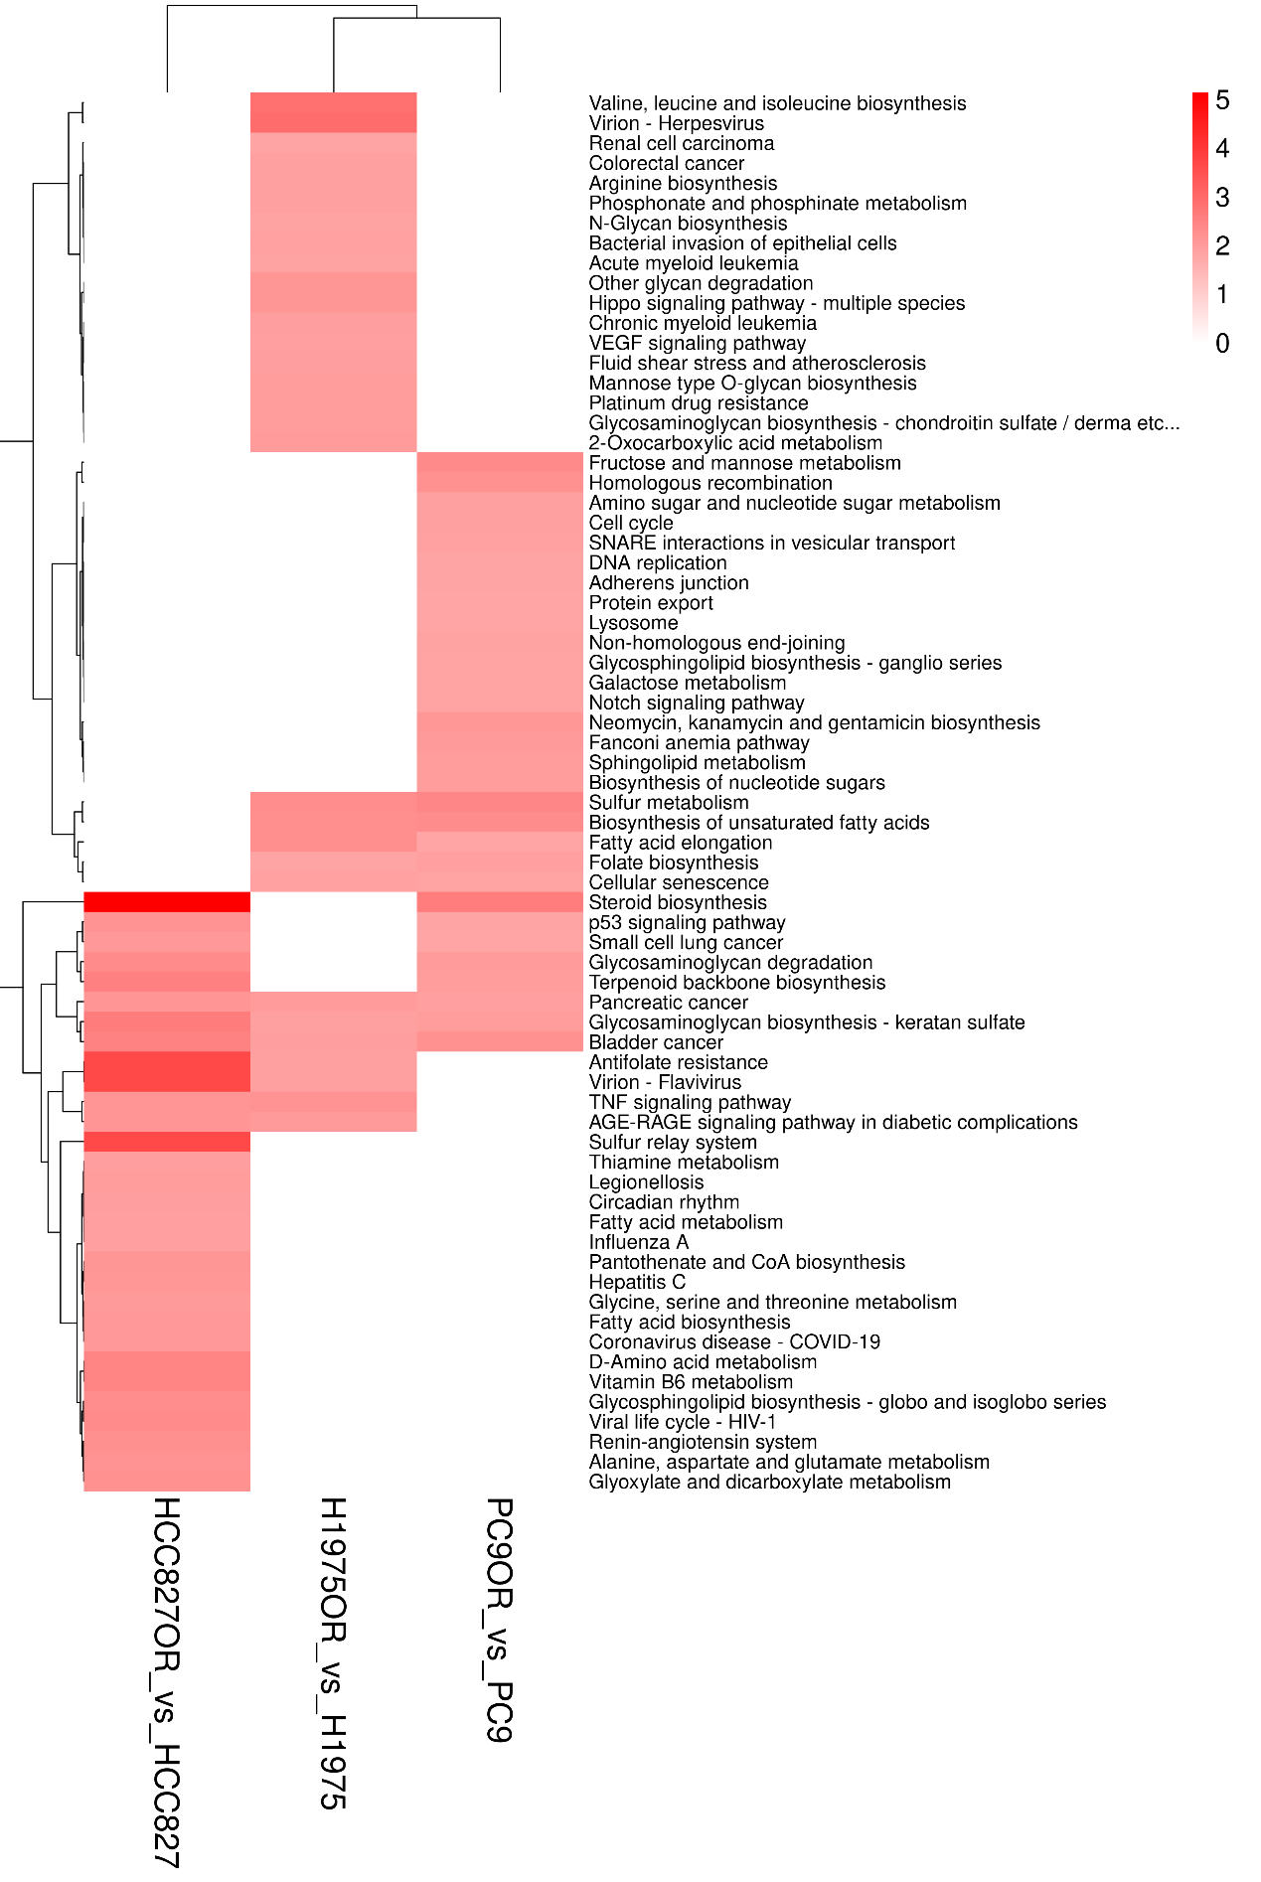
Supplementary Fig.4 KEGG enrichment heatmap depending the mRNA rich factor. N=3.

