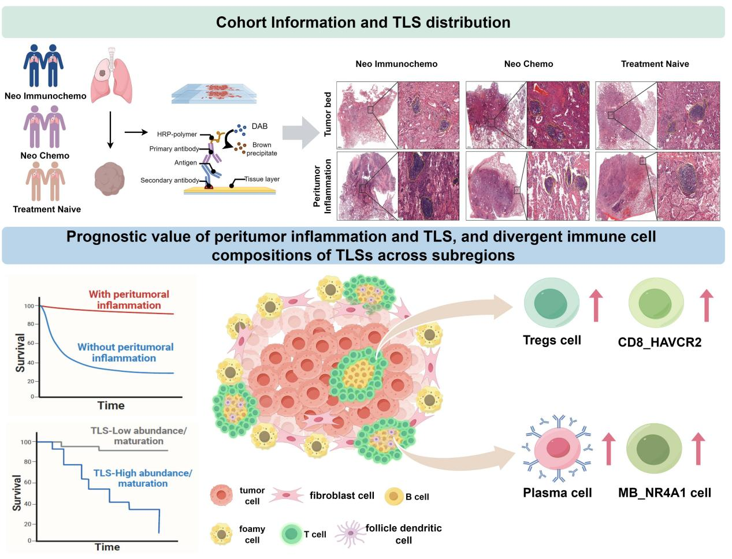

Through comprehensive analysis of postoperative tissue samples from three cohorts of patients with resectable NSCLC, we found that neoadjuvant immunochemotherapy was associated with a higher prevalence of peritumoral inflammation (PI) and greater abundance and maturation of tertiary lymphoid structures (TLS). Spatial transcriptomic analysis further revealed distinct cellular compositions between PI TLS and tumor-bed TLS, including greater plasma-cell abundance in PI TLS.

