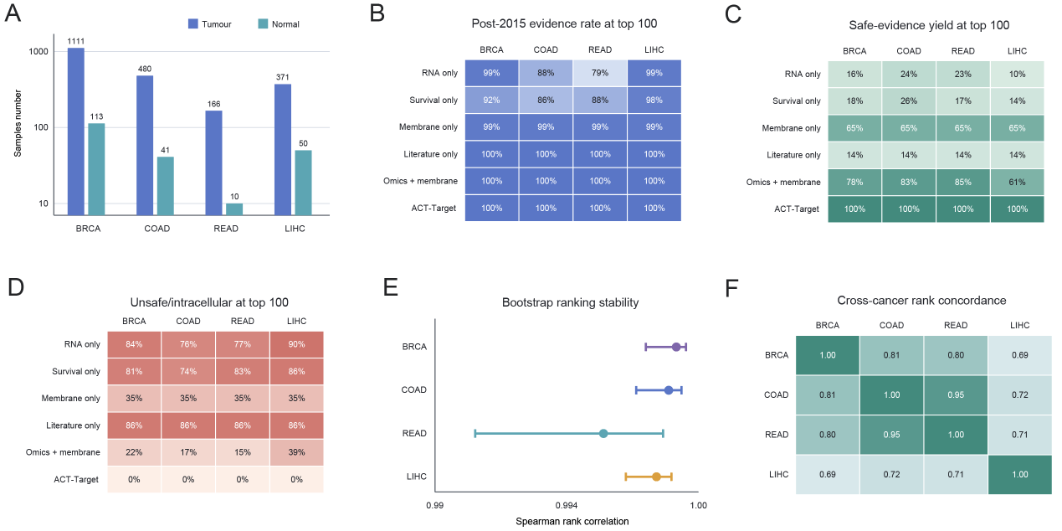
Figure S1. Cancer-stratified evaluation of ACT-Target across four TCGA cohorts.
(A) Numbers of tumor and normal samples included from TCGA breast invasive carcinoma (BRCA; 1,111 tumor and 113 normal samples), colon adenocarcinoma (COAD; 480 and 41), rectum adenocarcinoma (READ; 166 and 10), and liver hepatocellular carcinoma (LIHC; 371 and 50); the y-axis is shown on a logarithmic scale. (B) Proportion of the top 100 ranked candidates positive under the broad 2015-2026 ADC/CAR-T development-evidence index for ACT-Target and five comparator strategies: RNA-only differential-expression ranking, survival-only ranking, membrane-only filtering, literature-only ranking, and omics-plus-membrane integration. (C) Safe-evidence yield, defined as the proportion of the top 100 candidates that were both positive under the development-evidence index and not classified as unsafe or intracellular. (D) Proportion of the top 100 candidates flagged as unsafe or intracellular on the basis of intracellular localization, broad housekeeping expression, immune-cell or fratricide risk, or insufficient antibody-accessible surface localization. (E) Stability of the ACT-Target rankings under 1,000 cancer-stratified nonparametric bootstrap resamples, with tumor and normal samples resampled separately. Points indicate median Spearman rank correlations between the bootstrap-derived and full-cohort rankings, and horizontal bars indicate empirical 2.5th-97.5th percentile intervals. (F) Pairwise Spearman correlations between the cancer-specific complete-gene rankings. All cohorts were evaluated using the common candidate universe and a fixed scoring rule without cancer-specific weight refitting. These analyses assess internal transportability across TCGA cohorts and do not constitute independent external validation.

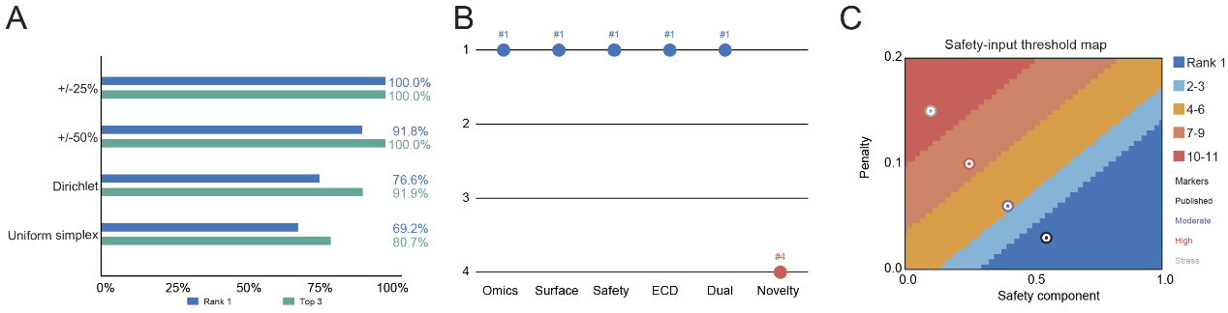
Figure S2. Sensitivity of ADAM17 prioritization to composite-score weights and safety inputs.
Sensitivity analyses were conducted among the 11 representative candidates with complete component scores displayed in Figure 2. The prespecified balanced discovery score comprised omics evidence (weight, 0.20), surface localization (0.15), safety (0.20), extracellular-domain accessibility (ECD; 0.15), dual-modality suitability (0.15), and novelty (0.15), followed by subtraction of a candidate-specific safety penalty. (A) Probability that ADAM17 ranked first or within the top three across 100,000 Monte Carlo samples per perturbation scenario. The +/-25% and +/-50% scenarios independently perturbed each component weight and the safety penalty within the indicated range; the centered-Dirichlet scenario sampled weights around the prespecified configuration; and the uniform-simplex scenario provided an agnostic stress test over the full weight simplex. Positive component weights were renormalized to sum to one in every simulation. (B) Leave-one-module-out analysis showing the ADAM17 rank after sequential omission of the omics, surface, safety, ECD-accessibility, dual-modality, or novelty component; the remaining positive weights were renormalized to sum to one. (C) Threshold map showing the ADAM17 rank as a joint function of its safety-component value and safety penalty, while all other component values and comparator inputs were held fixed. Markers denote the nominal/published setting (safety component 0.55; penalty 0.03) and moderate (0.40; 0.06), high-concern (0.25; 0.10), and stress-test (0.10; 0.15) scenarios. These scenarios evaluate ranking sensitivity and should not be interpreted as calibrated probabilities of clinical toxicity.

Figure S3. ADAM17 promotes tumor growth in vivo.
(A) Representative bioluminescence images (left) and quantification of average radiance (right) of AKT/NICD tumor-bearing mice, established via hydrodynamic injection. Data are presented as mean ± SEM. ****p < 0.0001; ***p < 0.001; **p < 0.01; *p < 0.05. ns, not significant. Significance was determined using Student's t-test (A).

Figure S4. Cross-reactivity of anti-ADAM17 monoclonal antibodies against mouse ADAM17 (mADAM17).
(A) Binding kinetics and affinities of the purified mAbs to mouse ADAM17 measured by Bio-Layer Interferometry (BLI).

Figure S5. Characterization of ADAM17-targeted antibody-drug conjugates (ADCs).
(A) Mass spectrometry analysis validating the Drug-to-Antibody Ratios (DAR) of the ADCs. The left column shows the deconvoluted mass spectra of the ADCs (Ab01 MMAE, Ab02 MMAE, and Ab03 MMAE), illustrating the distribution of MMAE payload conjugation. The right column provides quantitative summary tables detailing the mass, relative intensity of each structural component (L0/L1 and H0/H1/H2), and the calculated average DAR for each ADC.

