Figure S7: ¹H NMR spectra at 25°C in THF-d₈ of HDA (a) and of AuCl(THT) with 2 equivalents of HDA.

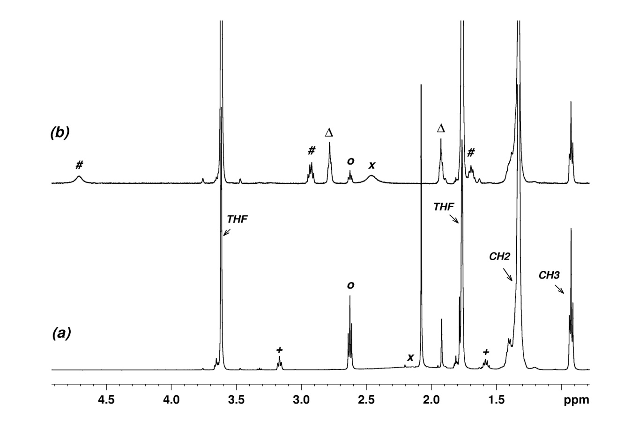
o: HDA; #: AuCl(HDA); ∆: THT; +: unknown HDA impurity; x: labile protons (NH₂, H₂O,…).

