Optimizing the immobilization of gold nanoparticles on functionalized silicon surfaces: amine- vs thiol- terminated silane

Maroua Ben Haddada^{1,2}, Juliette Blanchard^{1,2}, Sandra Casale^{1,2}, Jean-Marc Krafft^{1,2}, Anne Vallée^{1,2}, Christophe Méthivier^{1,2}, and Souhir Boujday^{1,2,*}

¹ UPMC Univ Paris 6, UMR CNRS 7197, Laboratoire de Réactivité de Surface, F75005 Paris, France
² CNRS, UMR 7197, Laboratoire de Réactivité de Surface, F75005 Paris, France

Supplementary material

Figure S 1: UV-Visible spectrum and TEM image of the gold nanoparticles solution
Figure S 2: XP survey spectra after APTES (a), APTES/MUA (b), and MPTES (c) grafting on silicon surfaces
Figure S 3: XP spectra S2s signal after MPTES grafting on silicon surfaces without (a) and with (b) ethanediamine

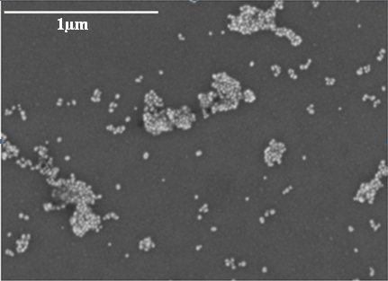
Figure S 4: .SEM image of the gold nanoparticles desposited on MPTES catalyzed by ethylendiamine modified surfaces

