Supplementary Figures

Effect of biofabricated gold nanoparticle based antibiotic conjugates on Minimum Inhibitory Concentration of bacterial isolates of clinical origin

Roshmi Thomas, Soumya KR, Jyothis Mathew and Radhakrishnan EK**

c
b
a
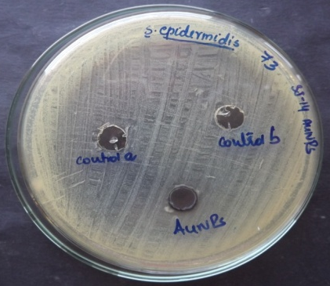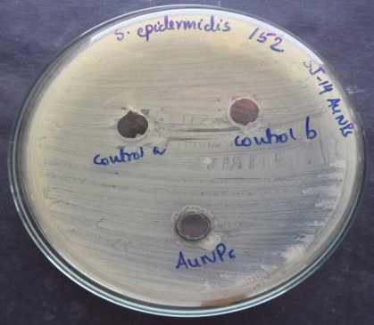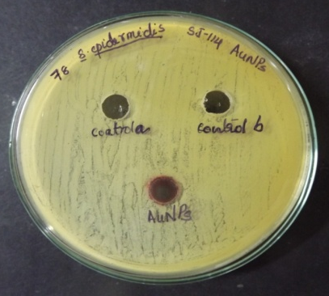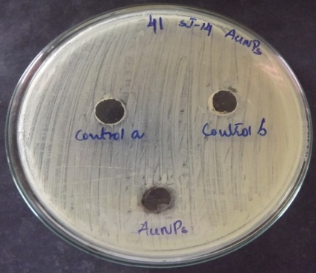
d
a
Fig. 1. Biosynthesized AuNPs with no toxicity towards a (a) S.epidermidis 73(b) S.epidermidis 152 (c) S.epidermidis 78 and (d) S.haemolyticus 41

