Effect of biofabricated gold nanoparticle based antibiotic conjugates on Minimum Inhibitory Concentration of bacterial isolates of clinical origin

Roshmi Thomas, Soumya KR, Jyothis Mathew and Radhakrishnan EK**

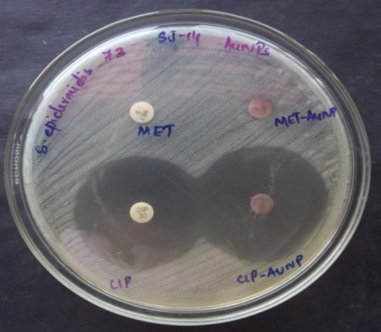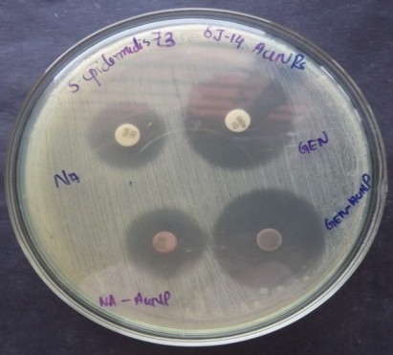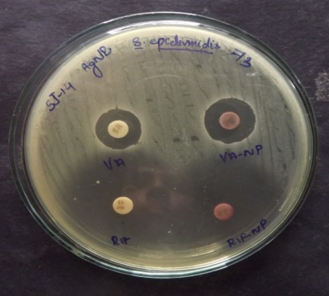
e
f
c
b
a
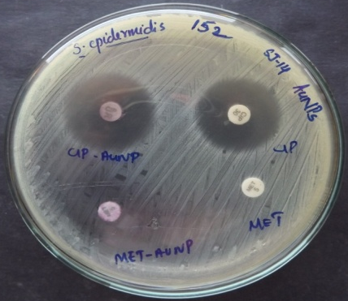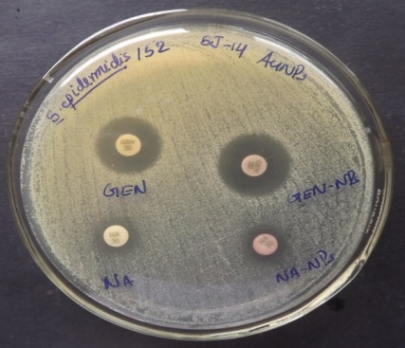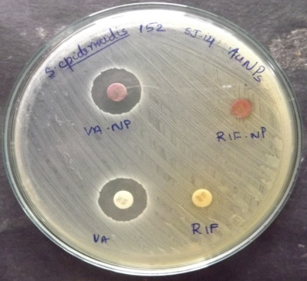
g
d
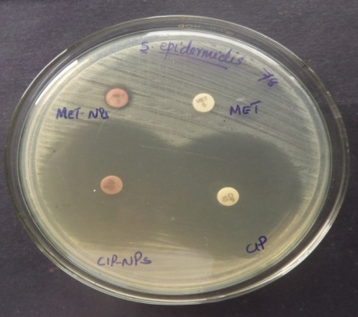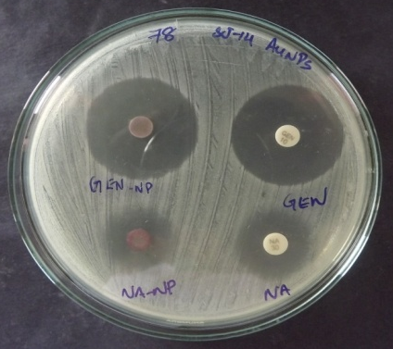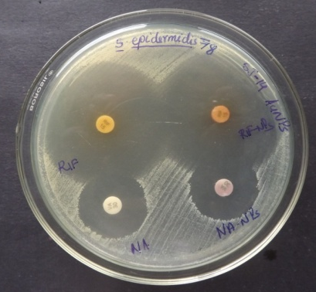
h
i
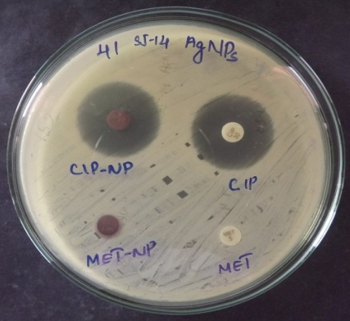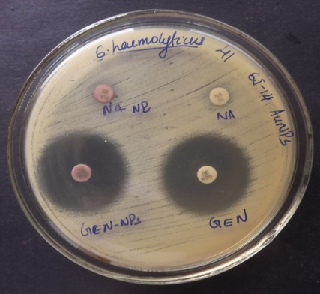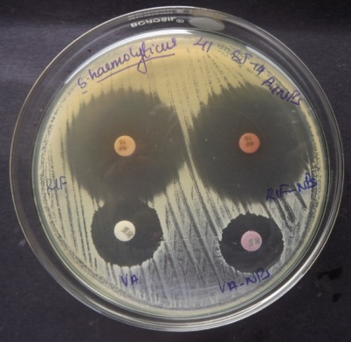
k
l
j
Fig. 2. Antibacterial activity of biosynthesized AuNPs with different antibiotics against (a,b,c) S.epidermidis 73 (d,e,f) S.epidermidis 152 (g,h,i) S.epidermidis 78 (j,k,l) S.haemolyticus 41

