Design and Validation of an Angular Dependent Interatomic Potential for Nickel

Douglas Soares Oliveira*

Universidade Federal do Paraná, Campus Avançado de Jandaia do Sul, 86900-000 Jandaia do Sul, Paraná, Brazil
*Corresponding author: douglas.oliveira@ufpr.br

DFT Computational Details and Convergence Tests

General Parameters
The calculations employed the Projector Augmented-Wave (PAW) method with the Perdew–Burke–Ernzerhof (PBE) exchange-correlation functional, accounting for spin polarization effects. The electronic self-consistency loop was considered converged when the energy difference between steps dropped below 10⁻⁶ eV. For structural relaxations, the ionic minimization was stopped when the forces on all atoms were smaller than 10⁻³ eV/Å. The integration over the Brillouin zone employed Methfessel-Paxton smearing with a broadening width (σ) of 0.1 eV.
Convergence Tests
The plane-wave energy cutoff (ENCUT) and the k-point mesh density were selected based on systematic convergence tests performed on the FCC supercell containing 216 atoms.
1. Energy Cutoff (ENCUT)
Table S1 summarizes the total energy convergence as a function of the cutoff energy. We calculated the energy difference per atom (ΔE) relative to the value obtained at 500 eV.

Table S1. Convergence of total energy with respect to the plane-wave energy cutoff (ENCUT)
ENCUT (eV) | Total Energy (eV) | ΔE (meV/atom)
300 | -1189.10 | 4.01
350 | -1188.24 | 4.94
400 | -1187.17 | 1.67
450 | -1186.81 | 0.10
500 | -1186.78 | 0

As shown in Table S1, increasing the cutoff from 450 eV to 500 eV results in a negligible energy change of only 0.10 meV/atom. Consequently, 450 eV was chosen as it provides accuracy well within the desired chemical precision (< 1 meV/atom) while maintaining computational efficiency.
2. K-Point Sampling
Table S2 presents the convergence with respect to the Monkhorst-Pack k-point grid size for the supercell simulation. The energy difference (ΔE) is calculated relative to the 4x4x4 mesh.

Kpoints | Total Energy (eV) | ΔE (meV/atom)
1x1x1 | -1186.81 | 24.61
2x2x2 | -1181.49 | -2.44
3x3x3 | -1182.02 | 1.72
4x4x4 | -1181.65 | 0

The 3x3x3 mesh yields an energy difference of approximately 1.72 meV/atom relative to the denser 4x4x4 grid. Based on this convergence, a 3x3x3 mesh was adopted for all fully periodic bulk structures, offering an optimal balance between computational cost and the resolution required to accurately capture the potential energy surface. For surface slab configurations, where periodicity is broken along the surface normal, the sampling was adjusted to a 3x3x1 mesh (where the single k-point corresponds to the vacuum direction).

Equation of State
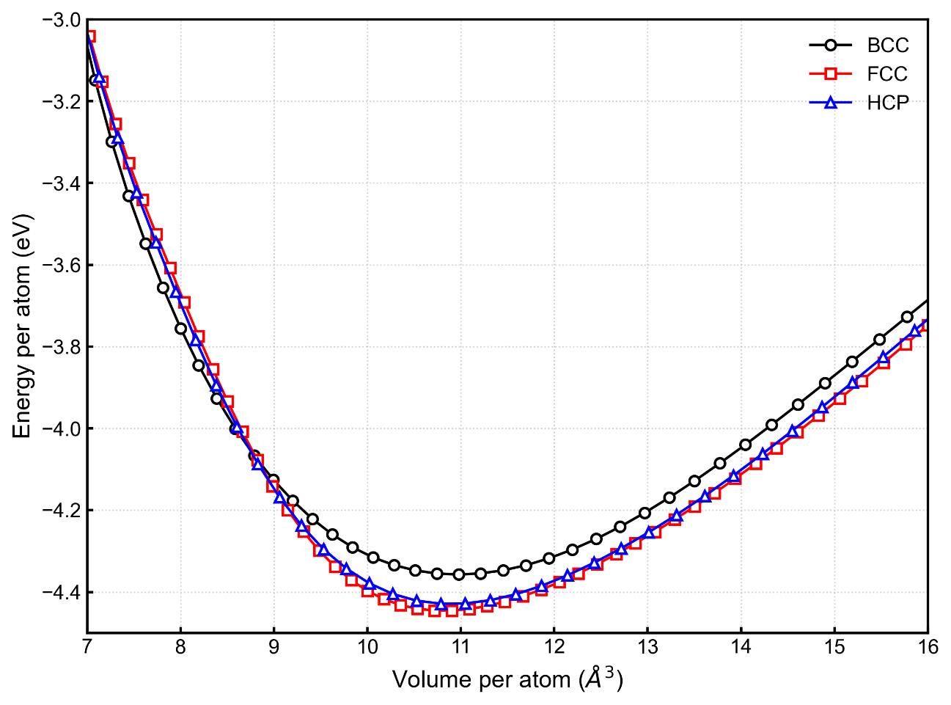
Figure S1. Energy versus Volume curves for FCC, HCP, and BCC Nickel calculated using the ADP potential at 0 K. While FCC is the stable phase at equilibrium volumes (~10.9 Å³/atom), the potential predicts a crossover where the BCC phase becomes energetically favored at highly compressed volumes (< 8.5 Å³/atom). This indicates the limit of validity of the potential for extreme high-pressure applications.

Stress-Strain Graph Analysis
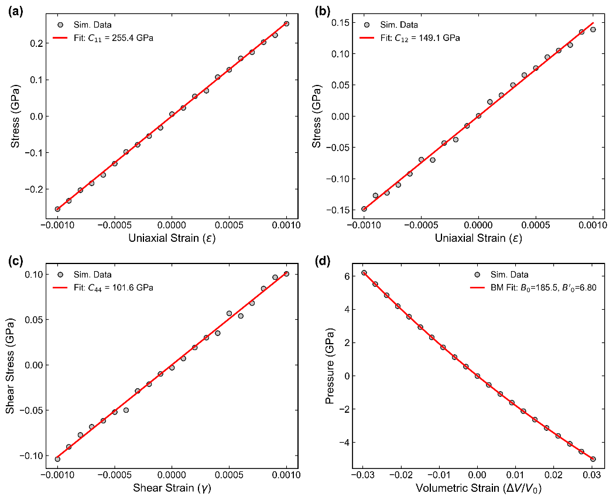
Figure S2. Stress-strain relationships for FCC Nickel computed using the ADP potential (this work) at 300 K. The plots display the stress response as a function of applied strain for: (a) C₁₁, (b) C₁₂, (c) C₄₄, and (d) the Bulk Modulus (B).
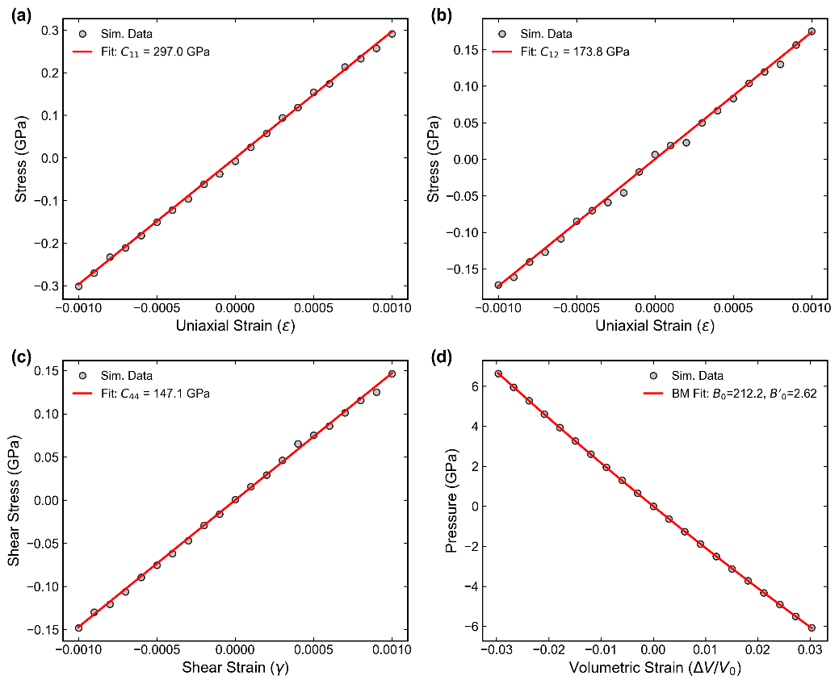
Figure S3. Stress-strain relationships for FCC Nickel computed using the EAM99 potential at 300 K. Panels show the response for: (a) C₁₁, (b) C₁₂, (c) C₄₄, and (d) the Bulk Modulus (B).

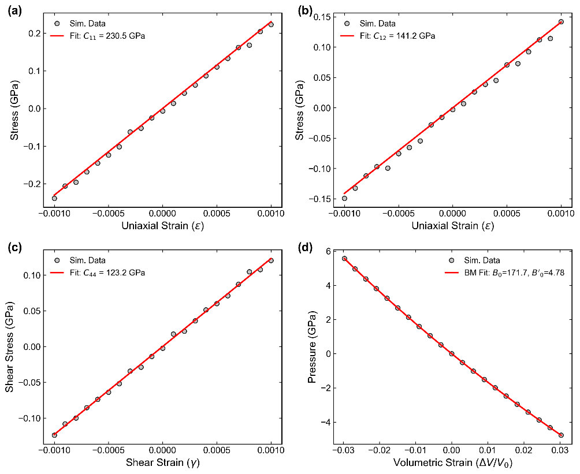
Figure S4. Stress-strain relationships for FCC Nickel computed using the ADP05 potential at 300 K. Panels show the response for: (a) C₁₁, (b) C₁₂, (c) C₄₄, and (d) the Bulk Modulus (B).

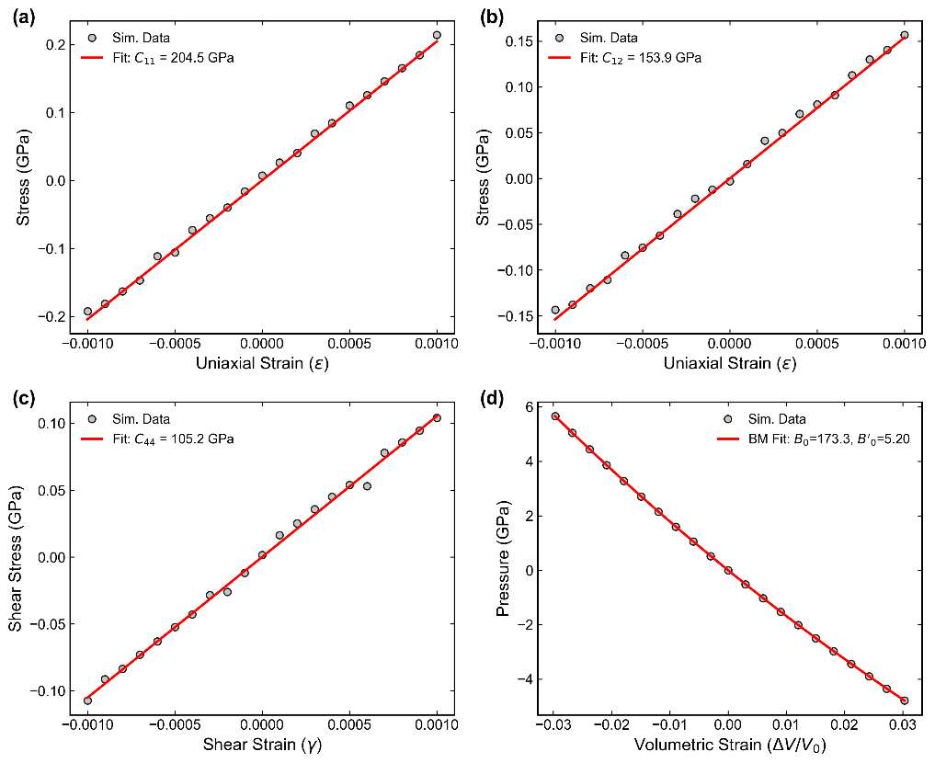
Figure S5. Stress-strain relationships for FCC Nickel computed using the MEAM25 potential at 300 K. Panels show the response for: (a) C₁₁, (b) C₁₂, (c) C₄₄, and (d) the Bulk Modulus (B).

