Binary mixtures of 4-acetylpyridine and 4-n-alkyloxybenzoic acids (4Ac.Py:nOBA): Investigations on mesomorphism
Suma Ramachandra Gopady¹, Srikrishna H Damodar Kedlaya², Krishna S.V.S.R. Bandaru¹, Mallikarjun Bhavanari¹, Venkata Naga Ashok Kumar Atluri³, Shivananda Bhushan⁴ and Srinivasulu Maddasani^{1,}*
¹Manipal Institute of Technology, Manipal Academy of Higher Education, Manipal, India
²Department of Public Health and Genomics, Manipal School of Life Sciences, Manipal Academy of Higher Education, Manipal – 576 104, Karnataka, India
³Department of Physics, University College of Engineering, Jawaharlal Nehru Technological University: Kakinada, Kakinada – 533 003, Andhra Pradesh, India.
⁴Department of Nuclear Medicine, Manipal College of Health Professions, Manipal Academy of Higher Education, Manipal – 576 104, Karnataka, India
*Email: s.maddasani@manipal.edu

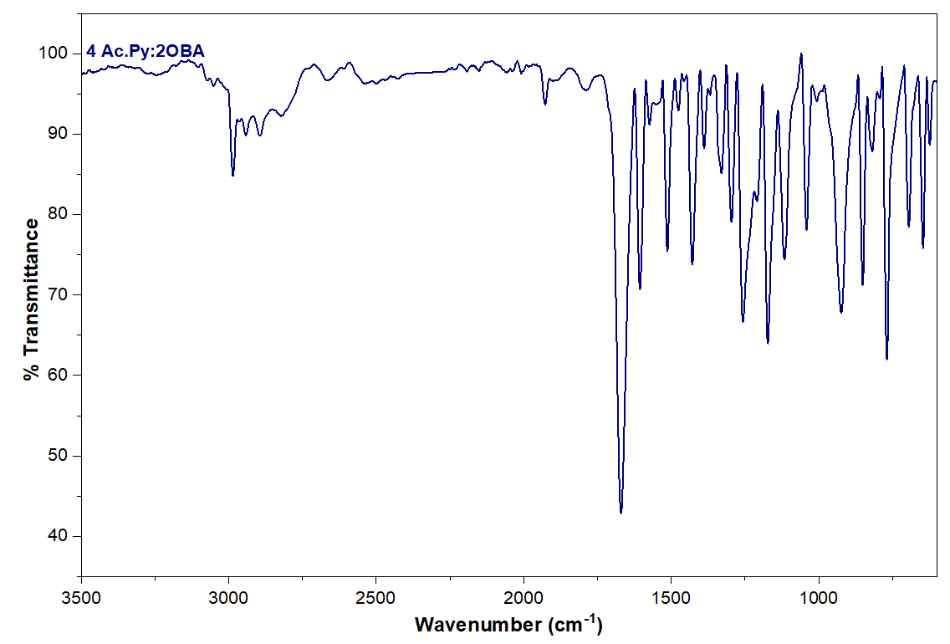  (a) | 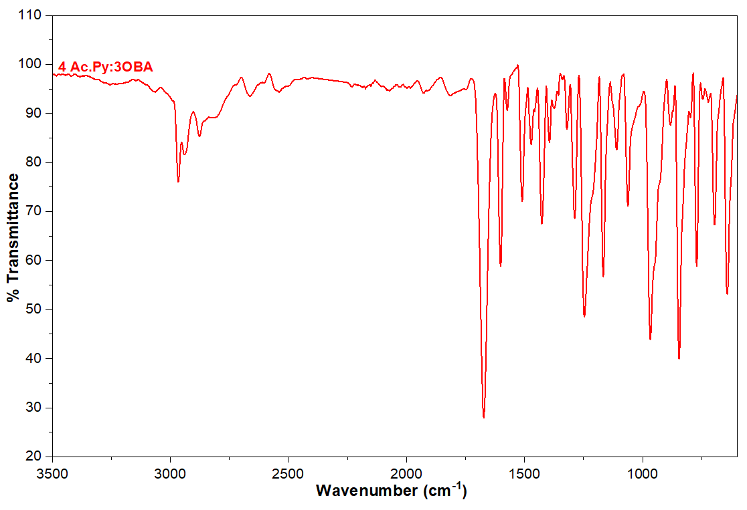  (b)
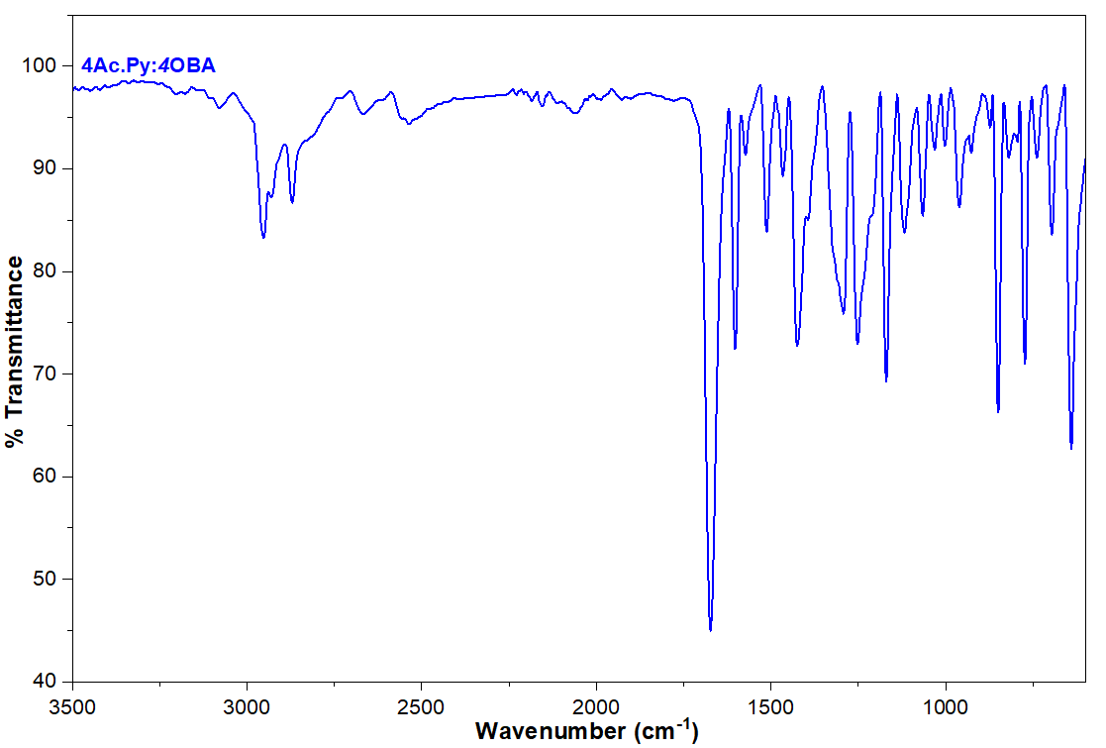  (c) | 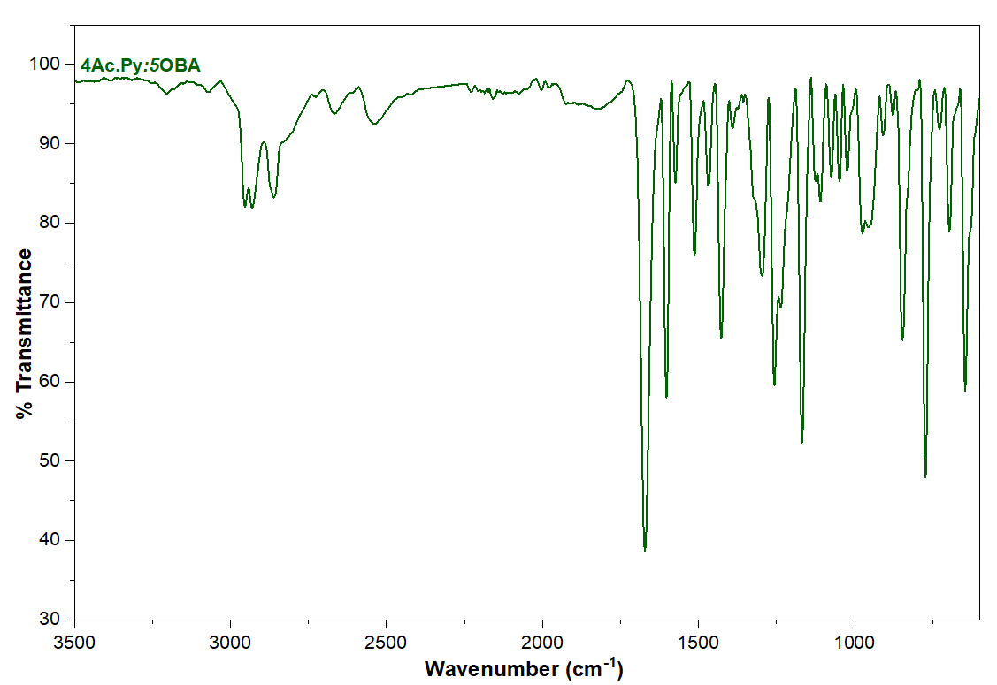  (d)
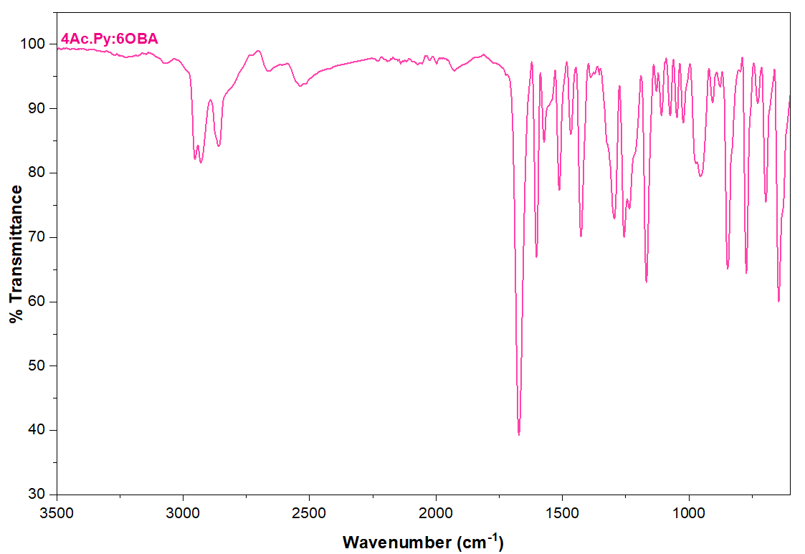  (e) | 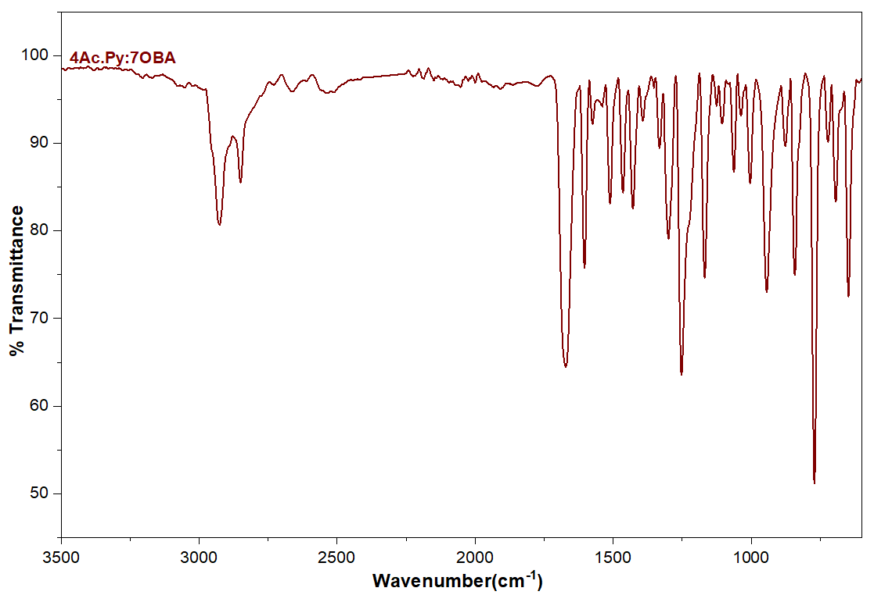  (f)
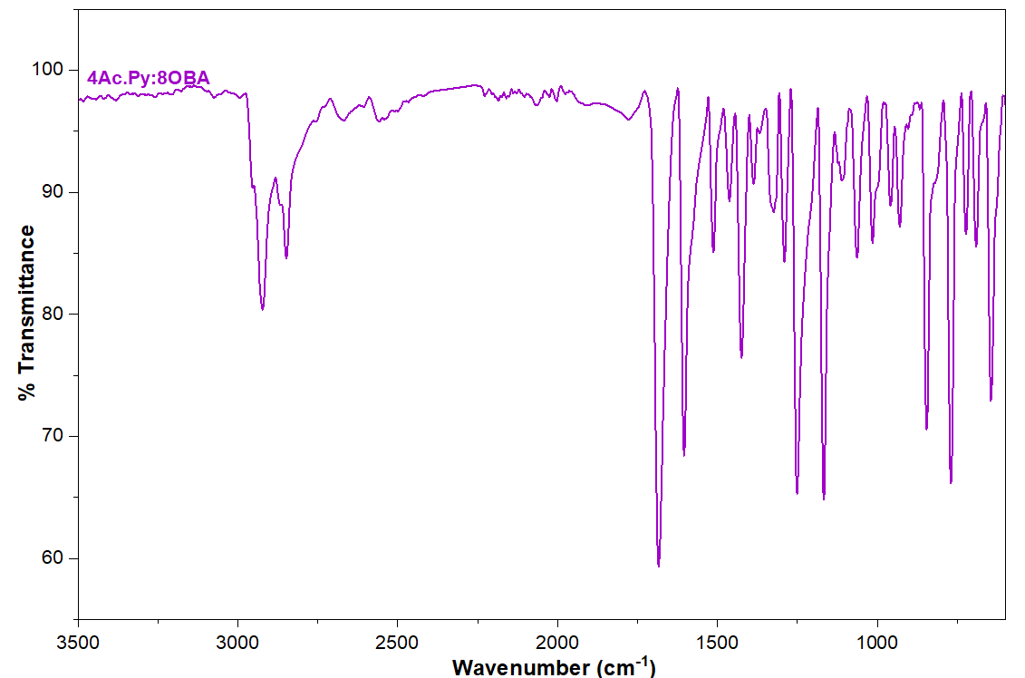  (g) | 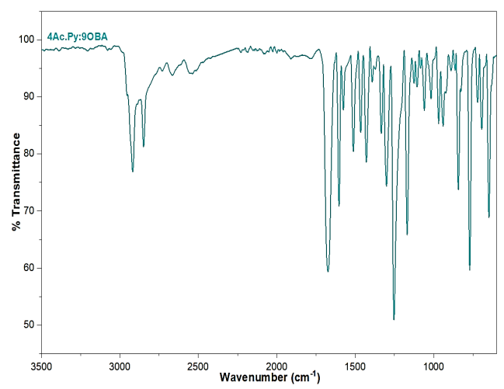  (h)
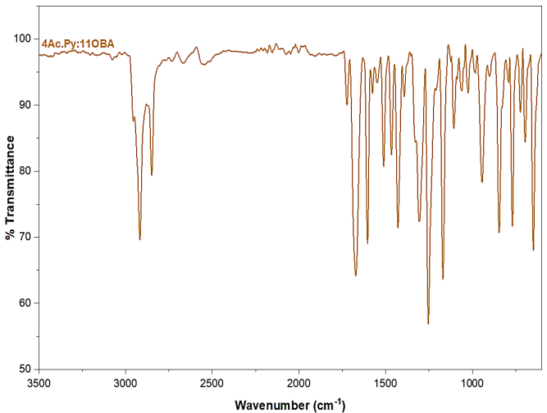
(i)
Figure S1: FTIR spectra of the HB complexes, 4Ac.Py:nOBA (a) n = 2 (b) n = 3 (c) n = 4 (d) n = 5 (e) n = 6 (f) n = 7 (g) n = 8 (h) n = 9 (i) n = 11.

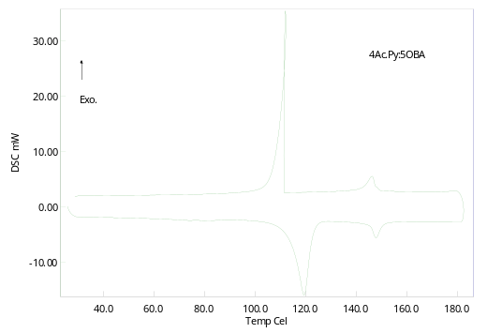  (a) DSC thermograms of 4Ac.Py:5OBA | 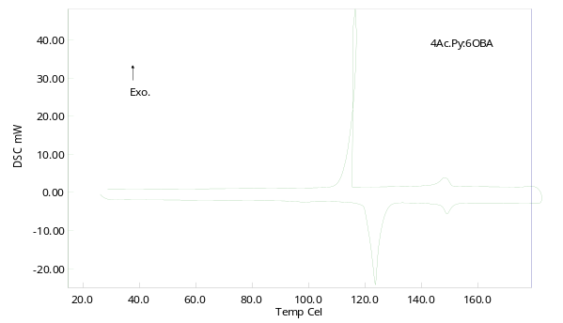  (b) DSC thermograms of 4Ac.Py:6OBA
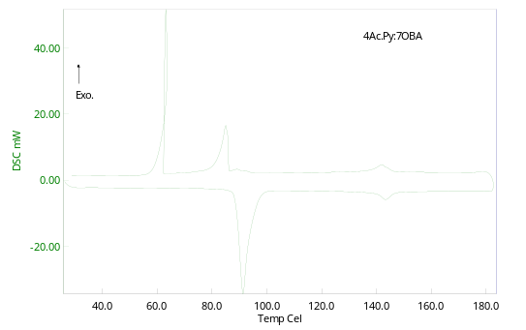  (c) DSC thermograms of 4Ac.Py:7OBA | 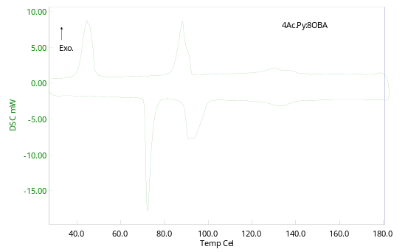  (d) DSC thermograms of 4Ac.Py:8OBA
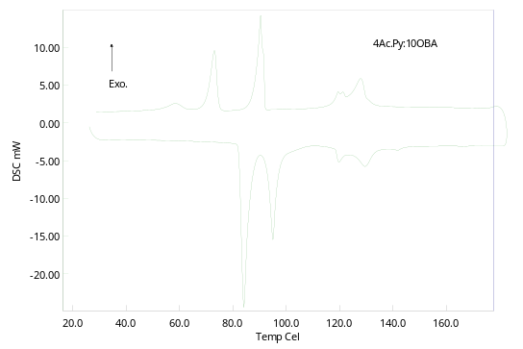  (f) DSC thermograms of 4Ac.Py:10OBA | 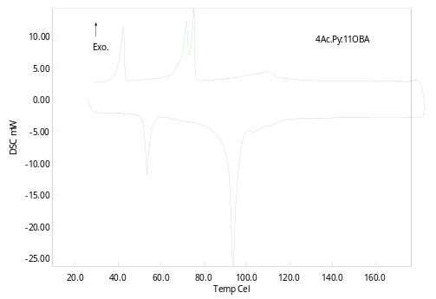  (g) DSC thermograms of 4Ac.Py:11OBA
Figure S2: DSC thermograms of 4Ac.Py:nOBA complexes

Table S1: FTIR spectral data (cm⁻¹) of 4Ac.Py:nOBA complexes
HB Complex | ν_{C-H}  Stretch of aromatic | ν_{C-H} of alkyl chain | ν_{N…OH} of HB  (weak) | ν_{C=O} | ν_{C=N} | ν_{C-H} of aryl and alkyl | ν_{C-O} of alkyl | ν_{C-H} bending of benzene ring | ν_{C-H} bending of pyridine ring
4Ac.Py:  2OBA | 3051.7 | 2986.1 | 2541.1  1928.0 | 1669.9 | 1605.7 | 1475.9 | 1172.1 | 851.3 | 694.5
4Ac.Py:  3OBA | 3064.5 | 2966.1 | 2539.6  2072.0 | 1672.7 | 1601.4 | 1471.6 | 1166.5 | 845.6 | 694.4
4Ac.Py:  4OBA | 3080.2 | 2951.9 | 2535.8  2154.7 | 1672.7 | 1602.9 | 1466.0 | 1169.3 | 849.9 | 695.9
4Ac.Py:  5OBA | 3068.8 | 2953.3 | 2539.8  2002.1 | 1672.7 | 1602.8 | 1467.4 | 1167.9 | 847.1 | 685.9
4Ac.Py:  6OBA | 3064.7 | 2953.3 | 2535.4  1997.9 | 1672.7 | 1602.9 | 1466.0 | 1167.9 | 847.0 | 695.9
4Ac.Py:  7OBA | 3072.1 | 2926.2 | 2539.8  2000.7 | 1672.7 | 1604.8 | 1464.5 | 1167.9 | 841.3 | 693.0
4Ac.Py:  8OBA | 3074.5 | 2921.9 | 2556.9  2002.1 | 1684.1 | 1604.3 | 1461.6 | 1167.9 | 845.6 | 690.2
4Ac.Py:  9OBA | 3014.5 | 2917.6 | 2535.4  1903.7 | 1674.2 | 1602.8 | 1464.5 | 1169.3 | 842.7 | 694.5
4Ac.Py:  11OBA | 3028.0 | 2954.7 | 2541.2  2002.2 | 1672.7 | 1604.2 | 1511.6 | 1164.3 | 845.6 | 694.4

Table S2: Geometry optimized coordinates of 4Ac.Py (x, y, z)
O 1.217555 -0.391893 0.763184
C 2.185838 -0.094856 0.074233
C 2.741758 1.319207 0.053078
C 2.859409 -1.147435 -0.781632
C 3.974396 -0.893115 -1.606159
C 4.515631 -1.951997 -2.357122
N 4.031173 -3.204841 -2.336953
C 2.966169 -3.442805 -1.547747
C 2.348540 -2.461340 -0.758790
H 2.138118 1.951216 0.728987
H 2.713356 1.743945 -0.972212
H 3.802035 1.335476 0.381580
H 4.424917 0.108333 -1.672935
H 5.389401 -1.774492 -3.010125
H 2.582059 -4.478883 -1.544326
H 1.478704 -2.685959 -0.123412

Table S3: Geometry optimized coordinates of 5OBA (x, y, z)
O 3.187653 -0.239704 0.894781
C 3.068966 -0.067796 -0.302158
O 2.740756 -1.118842 -1.113452
C 3.257038 1.261857 -0.972899
C 3.275582 2.418609 -0.157421
C 3.455267 3.684035 -0.710941
C 3.643937 3.836471 -2.107703
O 3.795239 5.112993 -2.544904
C 4.025763 5.386900 -3.933333
C 5.494916 5.234381 -4.335455
C 5.750491 5.627089 -5.797981
C 7.222385 5.500414 -6.220467
C 7.475684 5.895194 -7.679536
C 3.654966 2.687313 -2.931827
C 3.461216 1.421111 -2.358976
H 2.552435 -0.782309 -2.011866
H 3.140819 2.288384 0.926715
H 3.457625 4.588931 -0.085591
H 3.361096 4.758281 -4.568473
H 3.700802 6.439144 -4.066905
H 5.825475 4.186703 -4.163823
H 6.108264 5.865979 -3.656614
H 5.122007 4.997372 -6.469238
H 5.409754 6.674538 -5.966186
H 7.560877 4.453651 -6.050830
H 7.848440 6.128933 -5.548256
H 6.893485 5.258885 -8.379254
H 8.546353 5.793259 -7.949945
H 7.182629 6.949139 -7.870745
H 3.826532 2.765954 -4.013718
H 3.511379 0.544001 -3.026927

Table S4: Geometry optimized coordinates of 4AcPy.5OBA (x, y, z)
O -5.834362 13.161767 -1.517238
C -5.069559 12.434261 -0.897798
C -3.795132 12.963885 -0.266423
C -5.391975 10.958074 -0.748483
C -4.574337 10.043741 -0.053871
C -4.970476 8.698318 0.017966
N -6.101776 8.241003 -0.546849
C -6.890796 9.112536 -1.208998
C -6.577180 10.471005 -1.336616
O -8.473954 4.013761 -0.071524
C -7.529316 4.771125 -0.225300
O -7.727035 6.053341 -0.597193
C -6.105416 4.321767 -0.019014
C -4.986336 4.970279 -0.590056
C -3.693296 4.473063 -0.401791
C -3.480291 3.308044 0.372665
O -2.181019 2.925301 0.518880
C -1.857866 1.720891 1.223556
C -1.989732 0.468044 0.353367
C -1.602094 -0.816161 1.100708
C -1.671568 -2.079909 0.229500
C -1.301092 -3.362991 0.981482
C -4.594643 2.641009 0.934305
C -5.884799 3.145192 0.725028
H -3.713983 14.045836 -0.473920
H -2.902653 12.442612 -0.671589
H -3.797657 12.799043 0.831519
H -3.638204 10.357954 0.430008
H -4.353494 7.953810 0.549547
H -7.811771 8.691087 -1.646397
H -7.229039 11.170282 -1.880992
H -6.928398 6.657650 -0.488007
H -5.130743 5.866982 -1.211668
H -2.818236 4.962644 -0.854806
H -0.803412 1.856533 1.541588
H -2.468104 1.636044 2.151294
H -1.347431 0.597972 -0.544789
H -3.032831 0.384608 -0.022381
H -0.571596 -0.711876 1.512322
H -2.265674 -0.945602 1.986455
H -0.999788 -1.952494 -0.648793
H -2.697605 -2.175790 -0.191196
H -0.265769 -3.315489 1.380755
H -1.363184 -4.253905 0.323884
H -1.979423 -3.537370 1.843340
H -4.466542 1.725025 1.527477
H -6.763477 2.625111 1.135646

*****

